

Better, Faster & Smarter Banks





Bank Business Process Management System

Interface User Manual

Collection & Debts Management System

Confidential Information: All information contained herein is strictly confidential. The information contained in this document is intended for your use only. Its contents are private and confidential and anyone other than the addressee is informed that they are prohibited to use, divulge, or reproduce the contents hereof. The client may not publicize this information, under any circumstances, without the written permission of Pioneers Information Technologies Co. Ltd (PIO-TECH).

Copyright 2025-2035 Pioneers Information Technologies Co.Ltd. (Pio-Tech). All rights reserved

# General Introduction

****BPM® technology is a framework of applications that effectively tracks and orchestrates the business process.

BPM® solutions automatically manage processes, allow manual intervention, extract customer information from a database, add new customer information, generate transactions in multiple related systems, and support straight-through processing without human intervention when needed.

BPM® allows you to automate tasks involving information from multiple systems, with rules to define the sequence in which the tasks are performed as well as responsibilities, conditions, and other aspects of the process. BPM® not only allows a business process to be executed more efficiently, but it also provides the tools to allow you to measure performance and identify opportunities for improvement – as well as to make changes in processes to act upon those opportunities easily.

## Purpose and Target Audience

This user manual provides step-by-step instructions for users of the Collection System, aimed at guiding them toward optimal system utilization by explaining the various screens and tabs available.

It also supports the administration of authorized users, enabling secure access and effective use of the system.

This manual is intended for authorized users involved in collection operations and their supervision, as well as the Program administrator or their delegate within the IT department.

* This guide encompasses all the functions and screens available in the system, regardless of whether they are currently accessible to the customer. The visibility of these features to the current user depends on the permissions granted or the functions purchased by the entity implementing the system.

## Prerequisites and Usage Conditions

The Collection System can function as a standalone solution or be integrated with the core banking system (Core System) to enable automatic retrieval of shared data, thereby simplifying data entry processes.

The system also includes administrative tools such as:

|  |  |  |
| --- | --- | --- |
| * Lookups | * Admin Panel | * Process Design Studio |

Comments:

The system must be installed and configured by our team

The system must be linked to the related database to reflect the design.

 This document is necessarily brief and cannot address all the issues users may encounter while using the Bank-BPM Collection® application. Several avenues remain for those with questions beyond those addressed in this guide. Specific questions can be addressed to <mailto:support@pio-tech.com> as a support channel.

Table of Content

1 General Introduction 2

1.1 Purpose and Target Audience 2

1.2 Prerequisites and Usage Conditions 2

2 Introduction to Collection & Debts Management System 6

2.1 General Features 6

2.2 System Navigation Structure 8

3 Detailed View of System pages and Features 9

3.1 Credit Portfolio (Job Basket) 9

3.1.1 Job Basket 13

3.1.2 Ad Hoc 14

3.1.3 Flags Cases 14

3.1.4 Approval 15

3.1.5 Escalation Cases 16

3.1.6 Consultations Cases 17

3.1.7 Studies JobBasket 18

3.1.7.1 Study Request Work Follow 19

3.2 Customer Follow-Up 22

3.2.1 Related Actions / Operations 23

3.2.1.1 Hot Note 23

3.2.1.2 Fast Path 24

3.2.1.3 Consultations 27

3.2.1.4 Escalation 28

3.2.1.5 Add Flag 29

3.2.1.6 Reminder 30

3.2.1.7 Send SMS 31

3.2.1.8 Send Email 32

3.2.1.9 Reassign 33

3.2.1.10 Next Follow-up Date 33

3.2.1.11 Reason of Delinquent 34

3.2.1.12 Write Off 35

3.2.1.13 Internal Settlement 36

3.2.1.14 Legal Fees 37

3.2.1.15 Registering New Case 38

3.2.1.16 Account Evaluation 62

3.2.1.17 Transfer Customer 63

3.2.1.18 Manager’s Notes 64

3.2.1.19 Account Classification 65

3.2.1.20 Schedule and Structures 66

3.2.1.21 Calculate Customer Liability 67

3.2.2 Related Tabs 70

3.2.2.1 Follow-up History 71

3.2.2.2 Collaterals 71

3.2.2.3 Facility Information 73

3.2.2.4 System Notes 74

3.2.2.5 Transaction Collection 74

3.2.2.6 Partial Payments 75

3.2.2.7 Write-Off 75

3.2.2.8 Scheduling and Structures 76

3.2.2.9 Calculating Customer Liabilities 76

3.2.2.10 System Private Notes 76

3.2.2.11 Management Notes 76

3.2.2.12 Emails 76

3.2.2.13 Promise Schedule 77

3.2.2.14 Attachment 77

3.2.2.15 Contact Details 78

3.2.2.16 Customers Behavior 78

3.2.2.17 Customer Basic Information 79

3.2.2.18 Salary Details 79

3.2.2.19 Guarantors Details 80

3.2.2.20 SMS 80

3.2.2.21 Negated Account Info 80

3.2.2.22 Next Follow-up Details 81

3.2.2.23 Write off Info 81

3.2.2.24 Account Lien Inquiry 81

3.2.2.25 Approval/Rejected Cases 81

3.2.2.26 Deceased Information 82

3.2.2.27 WF Studies Status 83

3.2.2.28 Reason of Delinquent 83

3.2.2.29 Activities from Old System 83

3.2.2.30 Address Information 83

3.2.2.31 Manager Notes 84

3.3 Bulk SMS / Email 85

3.4 Civil 86

3.5 Customers History 87

3.6 Dashboard 88

3.7 Notification 89

3.8 Reassign 90

3.9 Remove Freeze Task 91

3.10 Report Viewer 92

3.10.1 Manager Notes 93

3.10.2 Current Account Balances (Credit Balances) 93

3.10.3 Write-off Account List Report 94

3.10.4 Monthly Collections of Branches 94

3.10.5 Mortgage Bond Report 95

3.10.6 Write-off Report 95

3.10.7 Facilities Balance Report 96

3.10.8 Loan Portfolio Report 96

3.10.9 Partial Payments Report 97

3.10.10 Collections Report 97

3.10.11 Customers Over 90 Days 98

3.10.12 Customer Handling 98

3.11 Reports 99

3.11.1 Collector Actions Report 99

3.11.2 Collector Productivity Report 99

3.11.3 JobBasket History Report 100

3.11.4 Paid Cases Report 100

3.11.5 No Action Report 100

3.11.6 Next Follow-up Action Report 101

3.12 Request Initiation 102

3.12.1 Request Initiation Process 103

3.13 Studies Job Basket 105

3.14 Suggest Write Off 106

3.15 Workflow Status 108

3.16 Administration 110

3.16.1 Job Basket Checker 110

3.16.2 Definition Screens 111

3.16.2.1 Dunning Letter 112

3.16.2.2 Account Status 113

3.16.2.3 Excuse Code 114

3.16.2.4 Party Contacted 115

3.16.2.5 Place Call 116

3.16.2.6 SMS Definition 117

3.16.2.7 Flag Definition 118

3.16.2.8 PTP Definition 119

3.16.2.9 Activity 120

3.16.2.10 Email Template 121

3.16.2.11 Reason of Delinquent 122

3.16.3 Define Parameters 123

3.16.4 Define Groups 125

3.16.5 Account Classification 127

3.16.6 Group Assign 128

3.16.7 Commissions Definition 131

3.16.8 Incentive Definition 133

3.16.9 Incentive 134

3.16.10 Calculated Commissions 135

3.16.11 Task Action Plan 136

3.16.12 Manager Def 138

3.16.13 Tasks Priority 139

3.16.14 Not Assign Tasks 140

3.16.15 Primary Account 140

3.16.16 Change Password 141

3.16.17 Financial Provision 142

3.17 General System Features 143

3.17.1 Access The System. 143

3.17.2 Filtering Mechanisms 144

3.17.2.1 Data View Sorting - Ascending Or Descending 144

3.17.2.2 Hide or View existed Columns 144

3.17.2.3 Add View Filters Craiteria on The Column Level 145

3.17.3 Page Navigation Bar 145

3.17.4 Add, Edit or Delete Records 146

3.17.5 Add Query Process (Query Builder) 147

3.17.6 Mandatory Fields 148

3.17.7 Calander 148

3.17.8 Active Page Content Report 149

# Introduction to Collection & Debts Management System

The Bank-BPM® Platform provides a comprehensive solution for managing delinquent debts from initiation to recovery. It aims to minimize the risk of debt deterioration by ensuring timely interventions through an efficient Collection & Debts Management System.

This system effectively manages non-performing debts throughout the collection process while facilitating the write-off of uncollectible debts. Additionally, it features dynamic customer classification mechanisms, optimizes workforce management, and distributes tasks based on the duration of default or required actions. The platform also ensures full compliance with regulatory frameworks established by central banks, aligning all actions with the latest legal and financial guidelines.

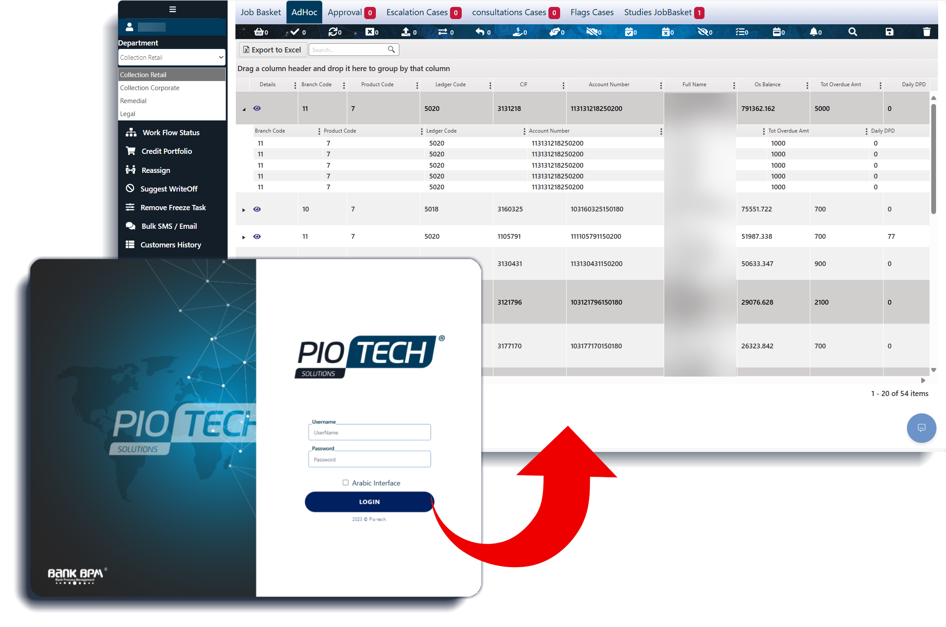

## General Features

The system delivers a comprehensive suite of features that streamline operations, enhance cross-departmental collaboration, and improve user experience such as:

* The system interface supports bilingual functionality, offering both Arabic and English.
* Users can add comments and upload attachments (e.g., Word, Excel, images, PDFs) at the case level. These documents are accessible from a centralized location and can be edited or deleted through a two-factor authentication process (Maker/Checker mechanism).
* All functions, procedures, and data referenced in this document are applicable as long as they align with the core systems and integration standards of the implementing institution.
* Field values are dynamically fetched from the institution’s existing systems to ensure data consistency and eliminate manual entry.
* All system reports and grid data can be exported in Word, Excel, or PDF formats for further use or analysis.
* Every data grid in the system is equipped with advanced search filters, enabling users to quickly locate relevant records.
* To identify mandatory fields during data entry, users can click the Save button. Required fields will be highlighted with a red border.
* The system is designed to serve multiple departments (e.g., Retail, Corporate, Legal) based on the scope of each project and the implementing entity's requirements.
* Certain screens, tabs, and procedures are visible only when integrated with the Legal System provided by Bank-BPM.
* Several modules/ functions follow a Maker/Checker workflow, where an action initiated by a Maker user must be reviewed and approved by a Checker user. Upon submission, the task is transferred from the Maker’s dashboard to the Checker’s for final approval. For more details, refer to the Maker/Checker Workflow section.

## System Navigation Structure

This section describes the structure of the system’s user interface, highlighting its key components such as screens, tabs, and menus. The structure outlined below provides a comprehensive view of all available modules within the system. It is important to note that the visibility of certain components may vary based on user roles, assigned permissions, and client-specific configurations. Additionally, some features will only be displayed when the system is integrated with the legal management module delivered by Bank-BPM.

# Detailed View of System pages and Features

## Credit Portfolio (Job Basket)

This page serves as the central hub for users, designed to streamline task management by displaying assigned tasks based on user permissions. Its intuitive interface organizes tasks across customizable tabs, each reflecting specific task types or stages, tailored to the user’s role in the workflow. Beyond task tracking, this page offers real-time insights into the status and progress of each case, ensuring users have full visibility of their responsibilities. Acting as the primary access point to customer follow-up utility. The tabs provided are:

|  |  |  |  |
| --- | --- | --- | --- |
| * Job Basket | * Ad Hoc | * Approval | * Escalation Cases |
| * Consultation Cases | * Flags Cases | * Studies JobBasket |  |

Layout:

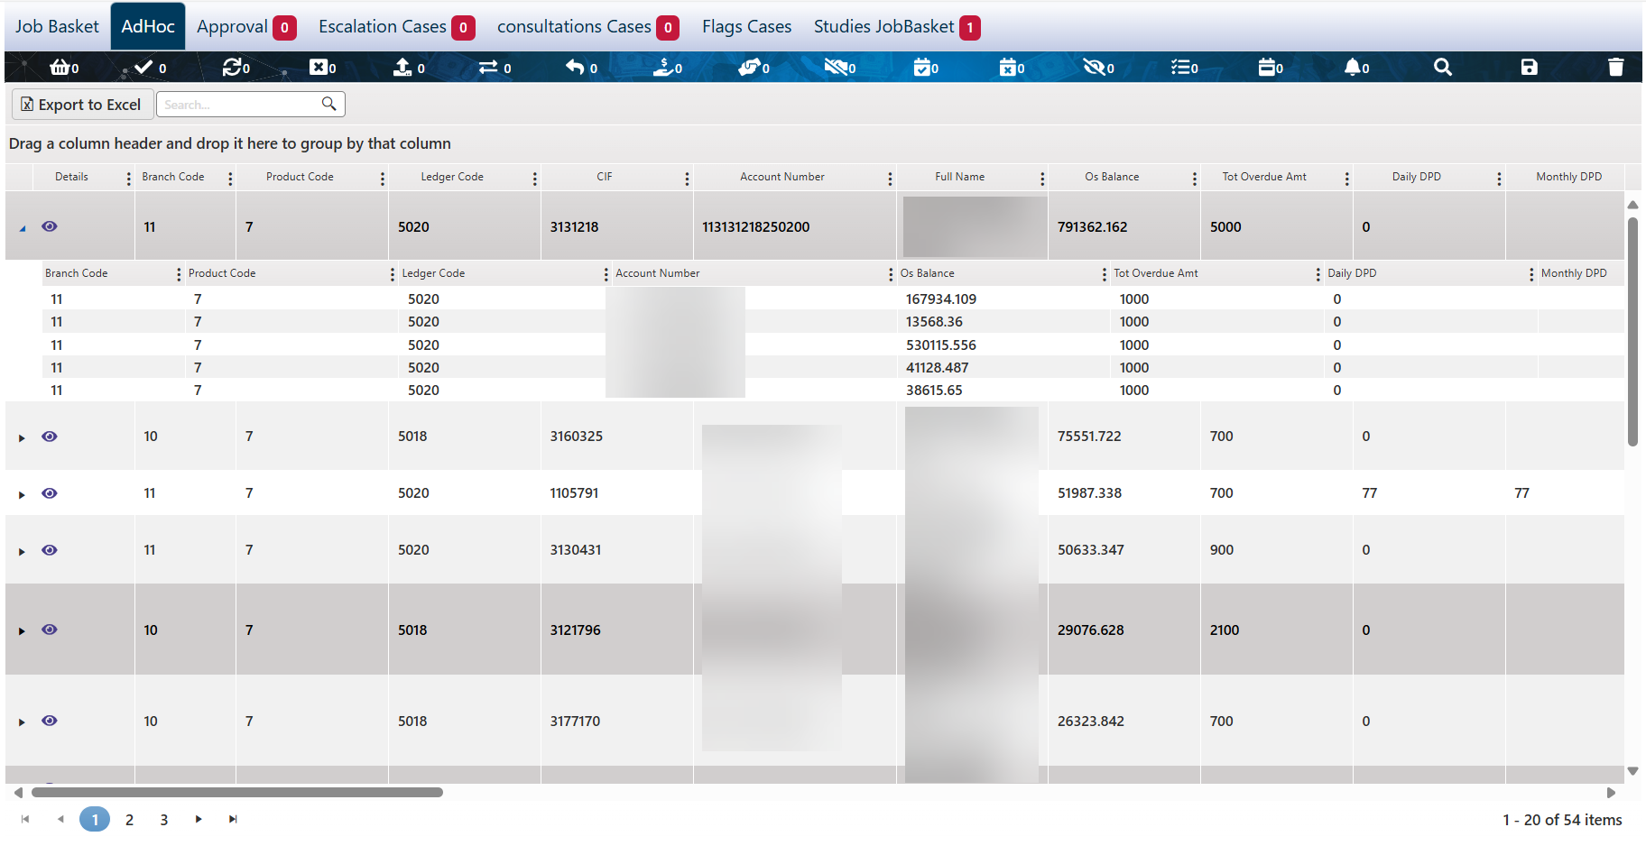

Comment: Display of these tabs is controlled based on the privileges granted to the current user.

The following is a description of the control icons available on the Credit Portfolio (Job Basket) page.



|  |  |
| --- | --- |
| Play with solid fill | To view more details about the task, simply click on it, and the customer's details will be displayed as follows: |
|  | Navigate to the Customer Follow-Up Page |
|  | Total number of tasks assigned to the user |
|  | Number of approved tasks, clicking this button filters the display area to show only approved tasks. |
|  | Number of tasks rejected by the reviewer. Clicking this button displays only the rejected tasks. |
|  | Number of pending tasks. These are tasks sent to the reviewer for approval. Clicking this button displays only pending tasks. |
|  | Number of escalated tasks. Clicking this button displays only tasks that have been escalated. |
|  | Number of consultation request tasks. |
|  | Number of returned consultation requests. |
|  | Number of tasks transferred to another user for follow-up. Clicking this button displays only the transferred tasks. |
|  | Number of tasks marked with a “Promise to Pay” action. Clicking this button displays only these tasks. |
|  | Number of tasks marked with a “Promise Fulfilled” action, (i.e., the customer promised to pay and completed the payment). Clicking this button displays only these tasks. |
|  | Number of tasks marked with a “Promise Broken” action, (i.e., the customer promised to pay but failed to do so). Clicking this button displays only these tasks. |
|  | The number of tasks not yet reviewed by the user. Clicking this button displays only unreviewed tasks. |
|  | Number of tasks where action has been taken, (e.g., email sent, phone call made, promise to pay recorded, etc.). Clicking this button displays only these tasks. |
|  | Number of tasks where the customer is compliant and has made scheduled payments. Clicking this button displays only compliant tasks. |
|  | The number of tasks where scheduled payments have been missed. Clicking this button displays only these tasks. |
|  | The number of tasks that were reviewed but have not been followed up. These tasks have no scheduled follow-up, or the follow-up date has passed without action. |
|  | Notifications and reminders related to specific actions on a task. Clicking this icon opens a screen displaying all task-specific reminders.     * Cancel all task-related notifications/reminders by clicking the "Cancel All" button at the bottom of the screen. * Clicking the Close button will close the notification screen. * Cancel a single notification/reminder by clicking the delete button next to it, then confirming the deletion. |
|  | Advanced search functionality enables users to search for one or more tasks using specific criteria. The search screen allows users to define filters, with the following buttons:    The search screen allows users to define filters, with the following buttons:   * Search: Executes the search and displays the result. * Search/Save: Executes the search and saves the view settings for consistent navigation across screens. * Clear: Resets the saved search. |
|  | Save Display Preferences, users can customize and save which fields are shown in the display area, so the same layout is preserved for each login session. |
|  | Export to Excel, this button generates an Excel report showing the current contents of the active tab. |
|  | Reset Columns Layout, reset any custom column adjustments and return the view to the default layout. |

### Job Basket

Centralized view of assigned tasks to the logged user.

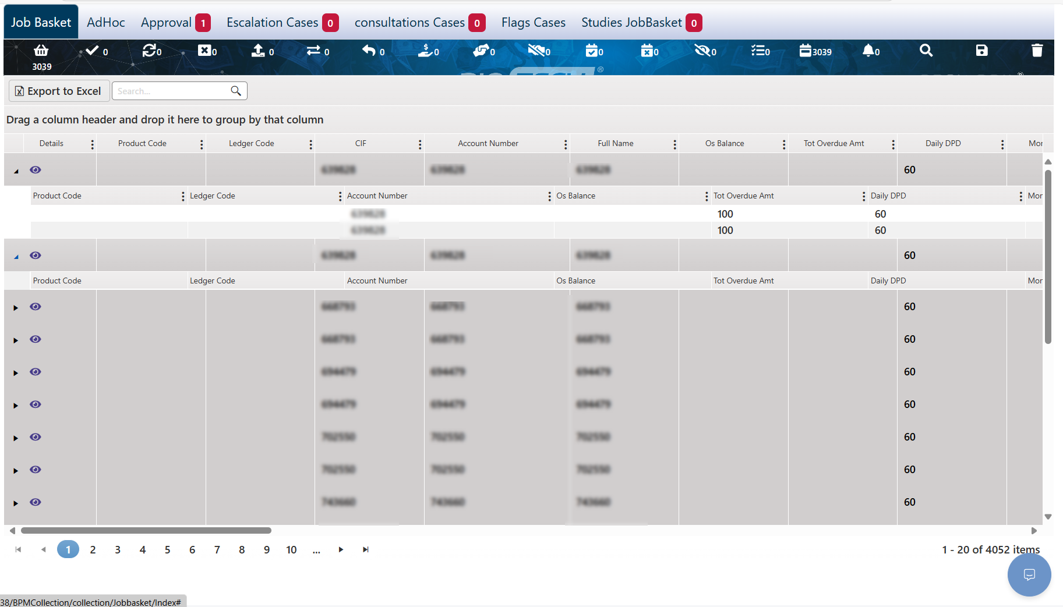

The user can follow up on each record by clicking the 'View' button next to it, which will navigate the system to the Customer Follow-Up page to perform the follow-up process.

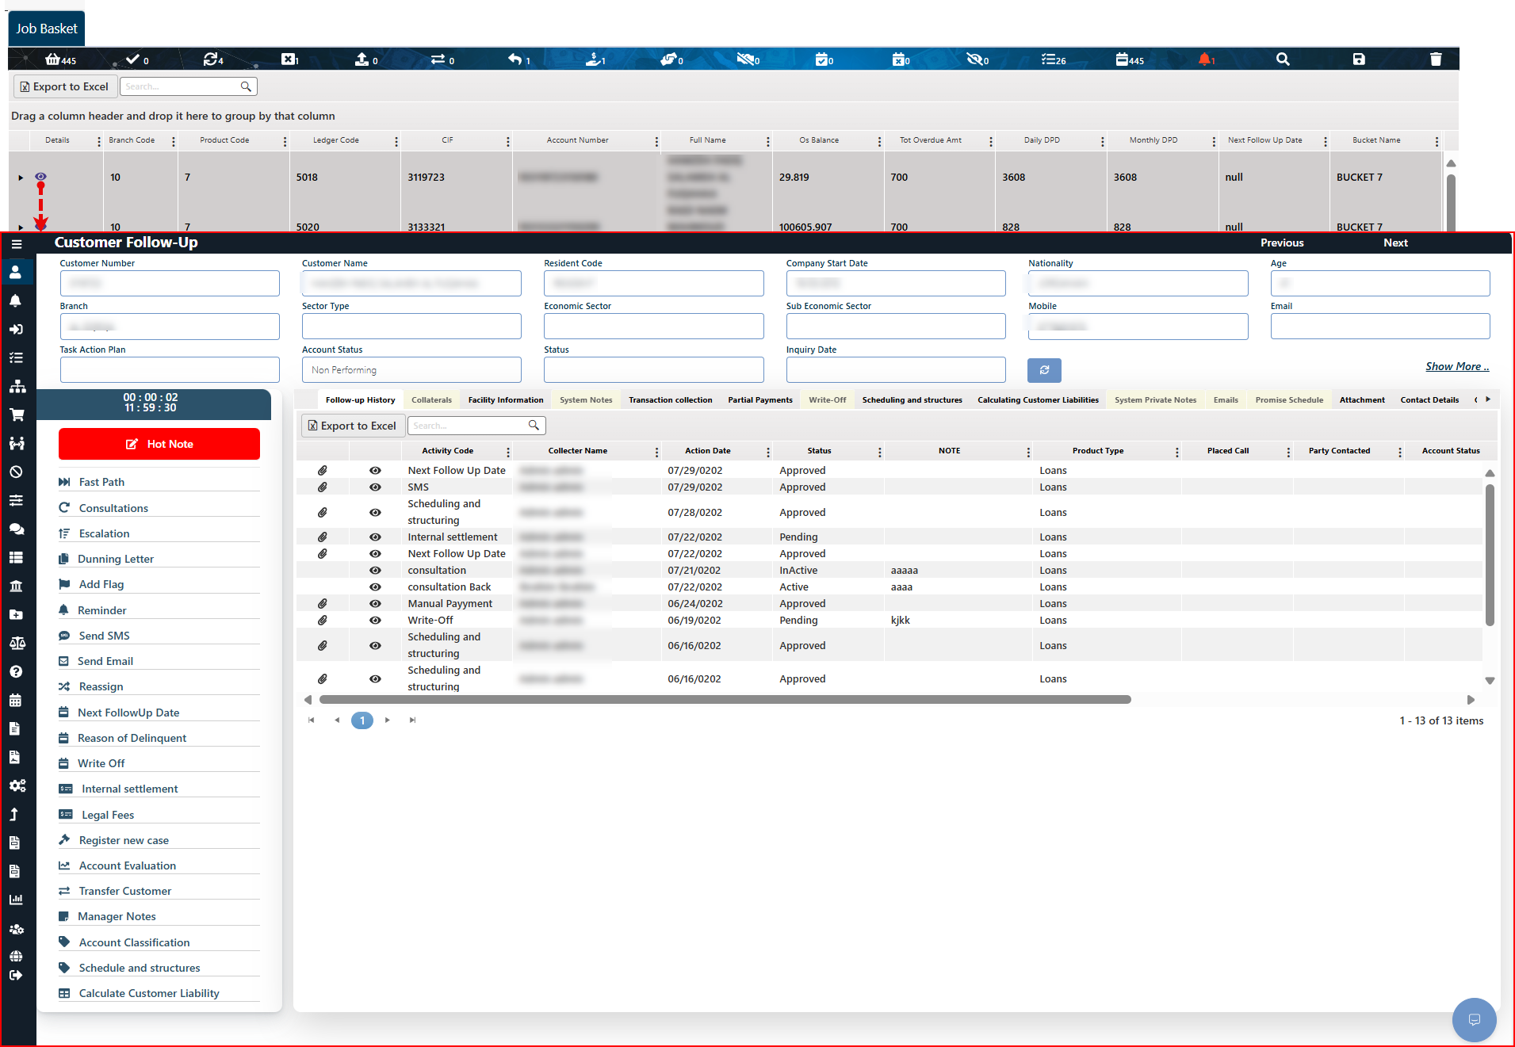

### Ad Hoc

Centralized view of all requests and tasks across the system, with no exception.

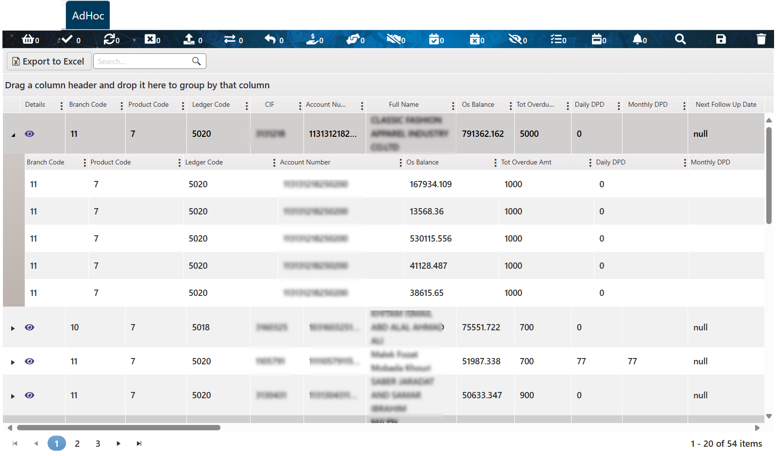

The user can approach the task from the customer follow-up page using the view icon.

Comment: From this page, each user can respond to tasks according to their granted authorizations.

### Flags Cases

Centralized view of special cases marked with a priority flag. The flag is applied through the follow-up page using the "Add Flag" procedure.

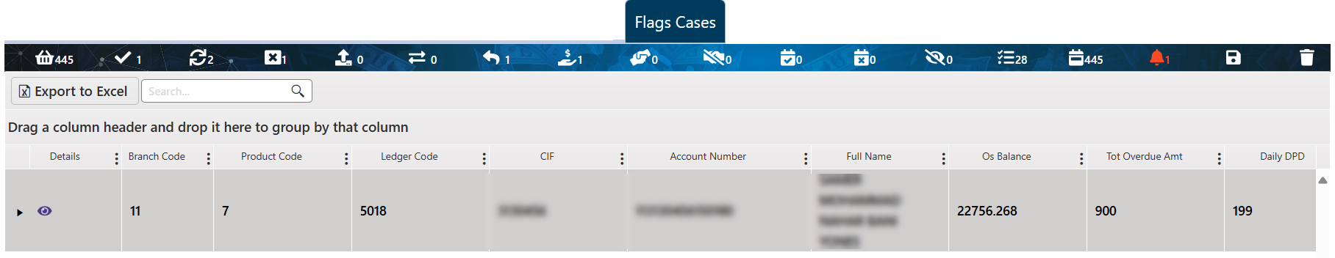

The user can approach the task from the customer follow-up page using the view icon.

### Approval

This tab is visible only to users with the appropriate permissions and is used by the Collection Supervisor "Checker" to make decisions regarding delinquent customer accounts. It allows supervisors to navigate to the Customer Follow-Up screen to view the customer’s personal and financial information, and to verify all actions taken by the collector in handling the case. The supervisor, "Checker," can then approve or reject the applied action and add comments if necessary. By clicking the button to view customer information (which navigates to the Customer Follow-Up page), a real-time screen appears, displaying record updates with the option to approve or reject the action directly from the same screen.

Layout:

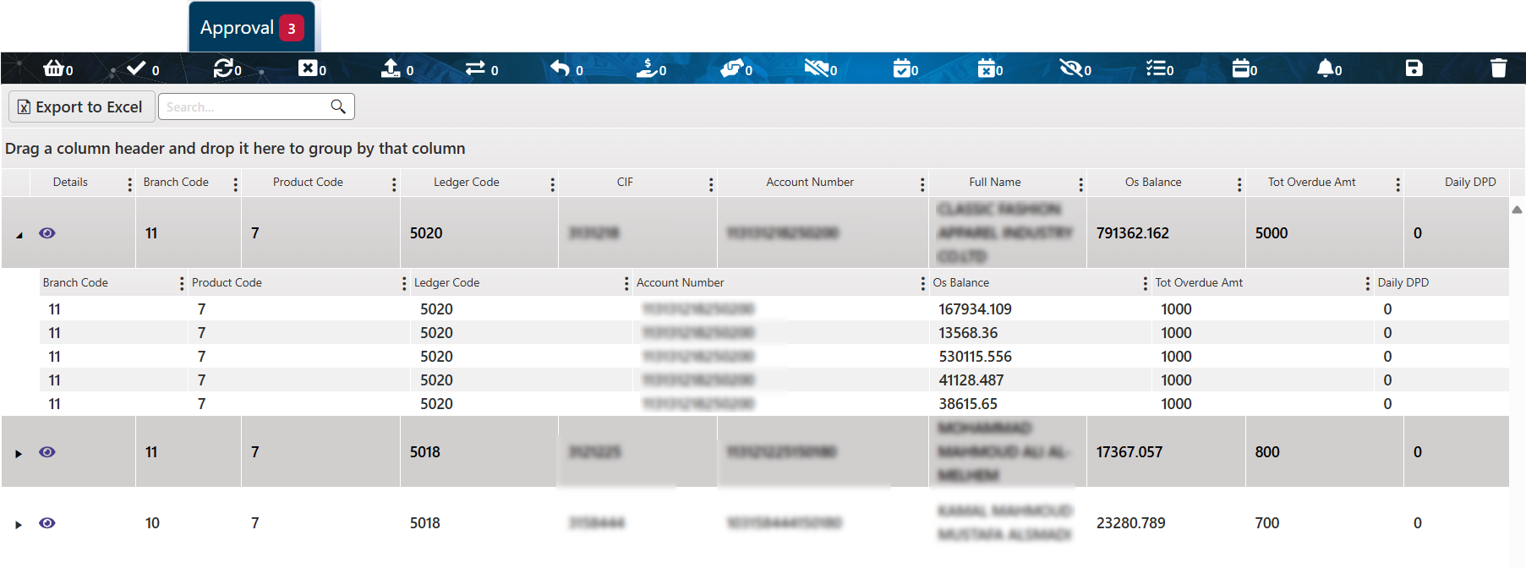

Upon clicking the "Details" button and navigating to the Customer Follow-Up page, a corresponding screen appears, allowing authorized users to approve or reject the proposed action. Depending on the user's privileges and the defined workflow, the user may also have the ability to end or save the task. Additionally, users can include related comments or attachments to support their decision by using the Comment and Attachment button.

Comment: The available actions are dynamically determined based on the current stage of the case and the permissions granted to the active user.

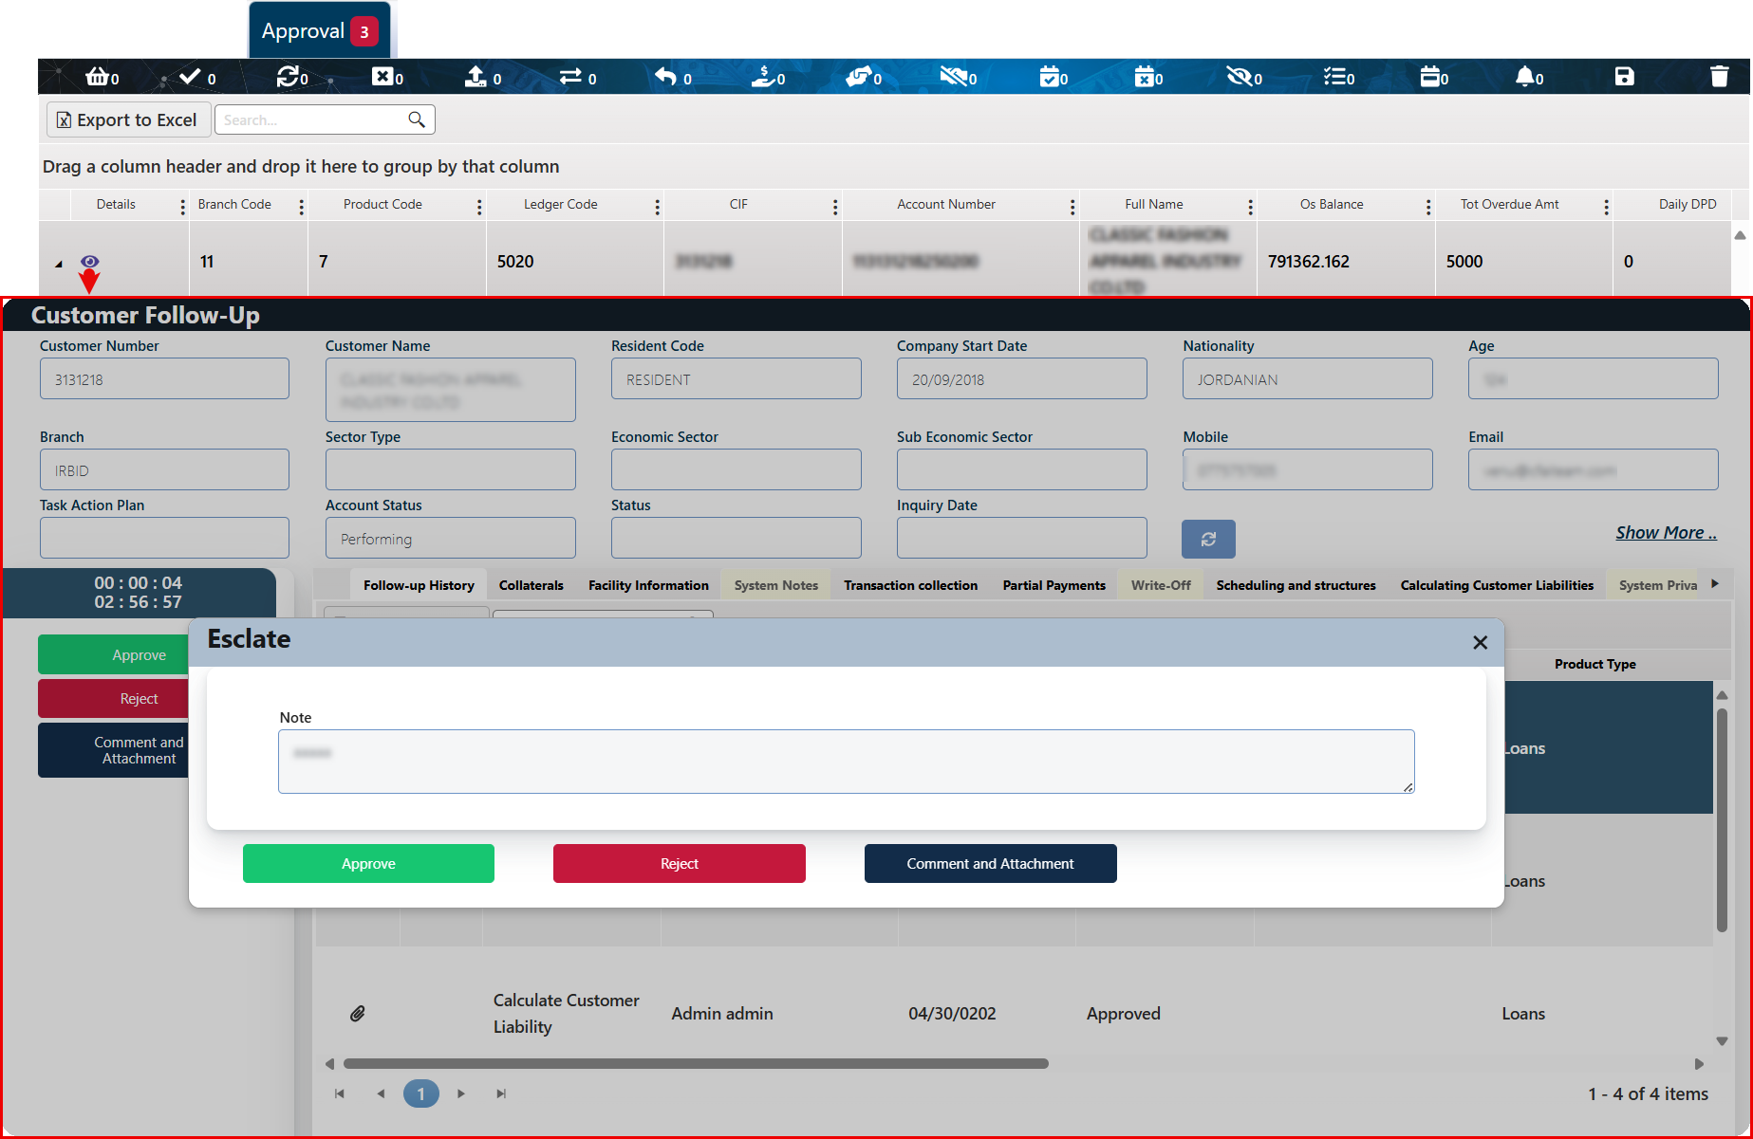

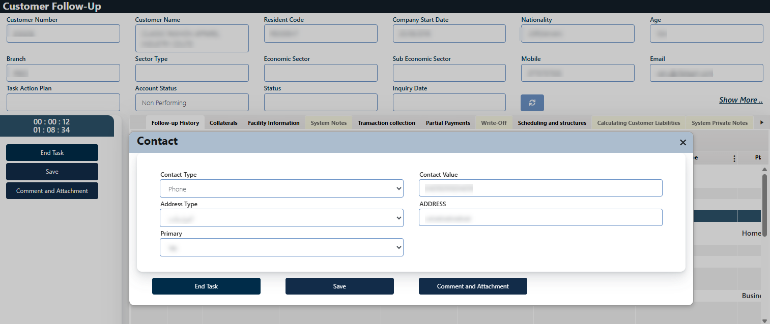

* To approve the action, the user “Checker user type” must click the Approve button shown on the screen. Once approved, the request proceeds to its designated path.
* To reject the action, the user “Checker user type” must click the Reject button, and the operation will be canceled.
* The checker can include attachments or comments related to his decision using the Comment and attachment button.

### Escalation Cases

This tab provides a centralized view of requests that have been escalated by a user to their direct manager for follow-up. It is visible only to the direct managers of the collectors.

Escalation requests are initiated from the Follow-up page using the Escalation Procedure. The direct manager can then proceed with the required follow-up actions on the task.

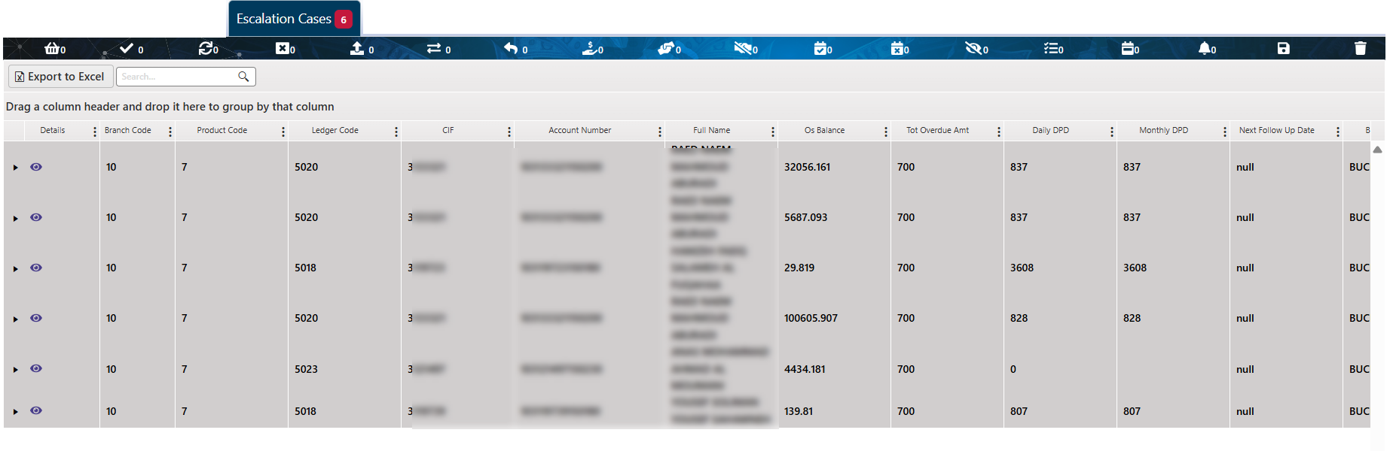

### Consultations Cases

Centralized view of cases that requests for expert opinions or reviews. The Consultations request is initiated in the follow-up page using the "consultation" procedure.

Layout:

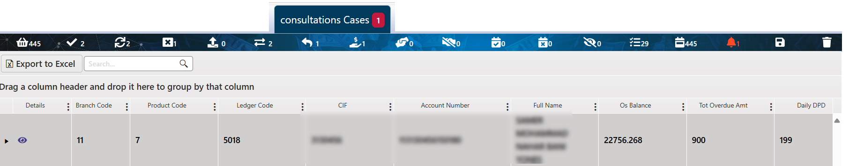

The user can approach the task from the customer follow-up page by using the view icon.

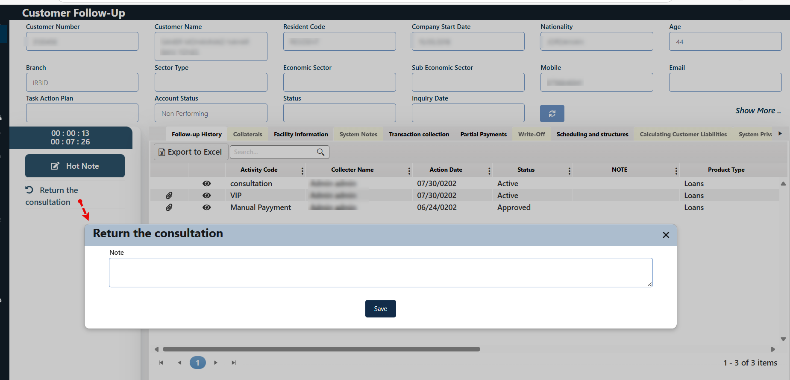

The authorized user can enter the required consultation and click the Save button. The consultation will then be sent to the original requestor and displayed in the Customer Follow-up screen under the "Follow-up History" tab.

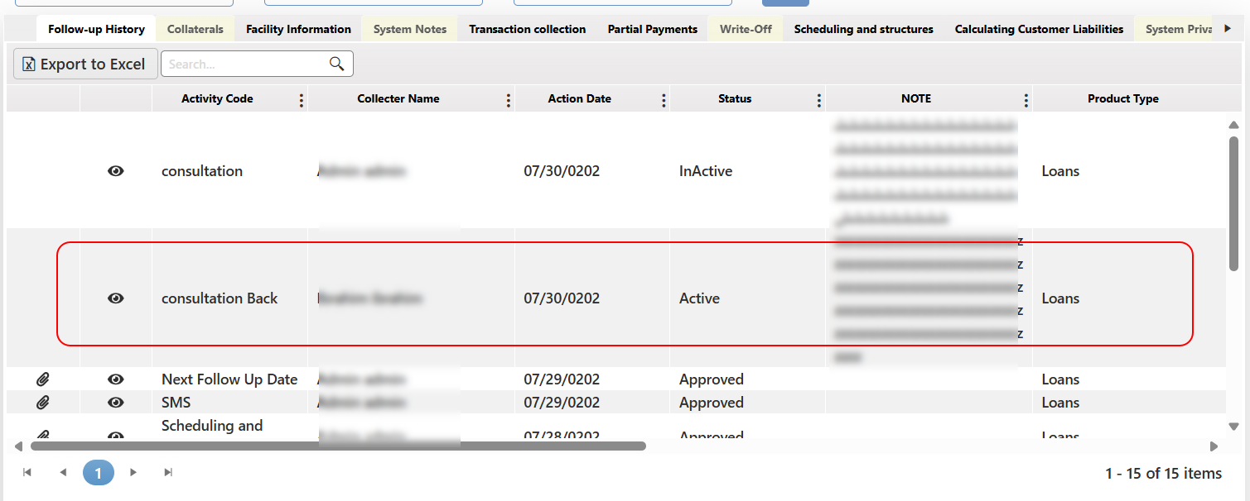

### Studies JobBasket

This page is designed to display and track accounts for which a study request has been submitted. Access is granted to authorized users based on their user type and position within the request's workflow. The components of the page—including control buttons and fields—vary according to the form type selected during the request setup phase, as well as the active user's role and permissions.

Layout:

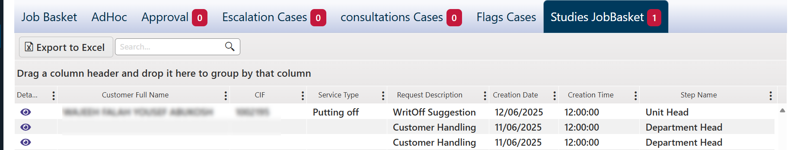

The "Step Name" field indicates the current stage of the request within the workflow, showing the transition between different roles or approval levels. This helps the user understand the exact status of the request. Meanwhile, the "Service Type" field specifies the nature of the action required for the request, based on the established process flow.

To view the task the user needs to click the details button near to it “ ”, then the task will be viewed as below:

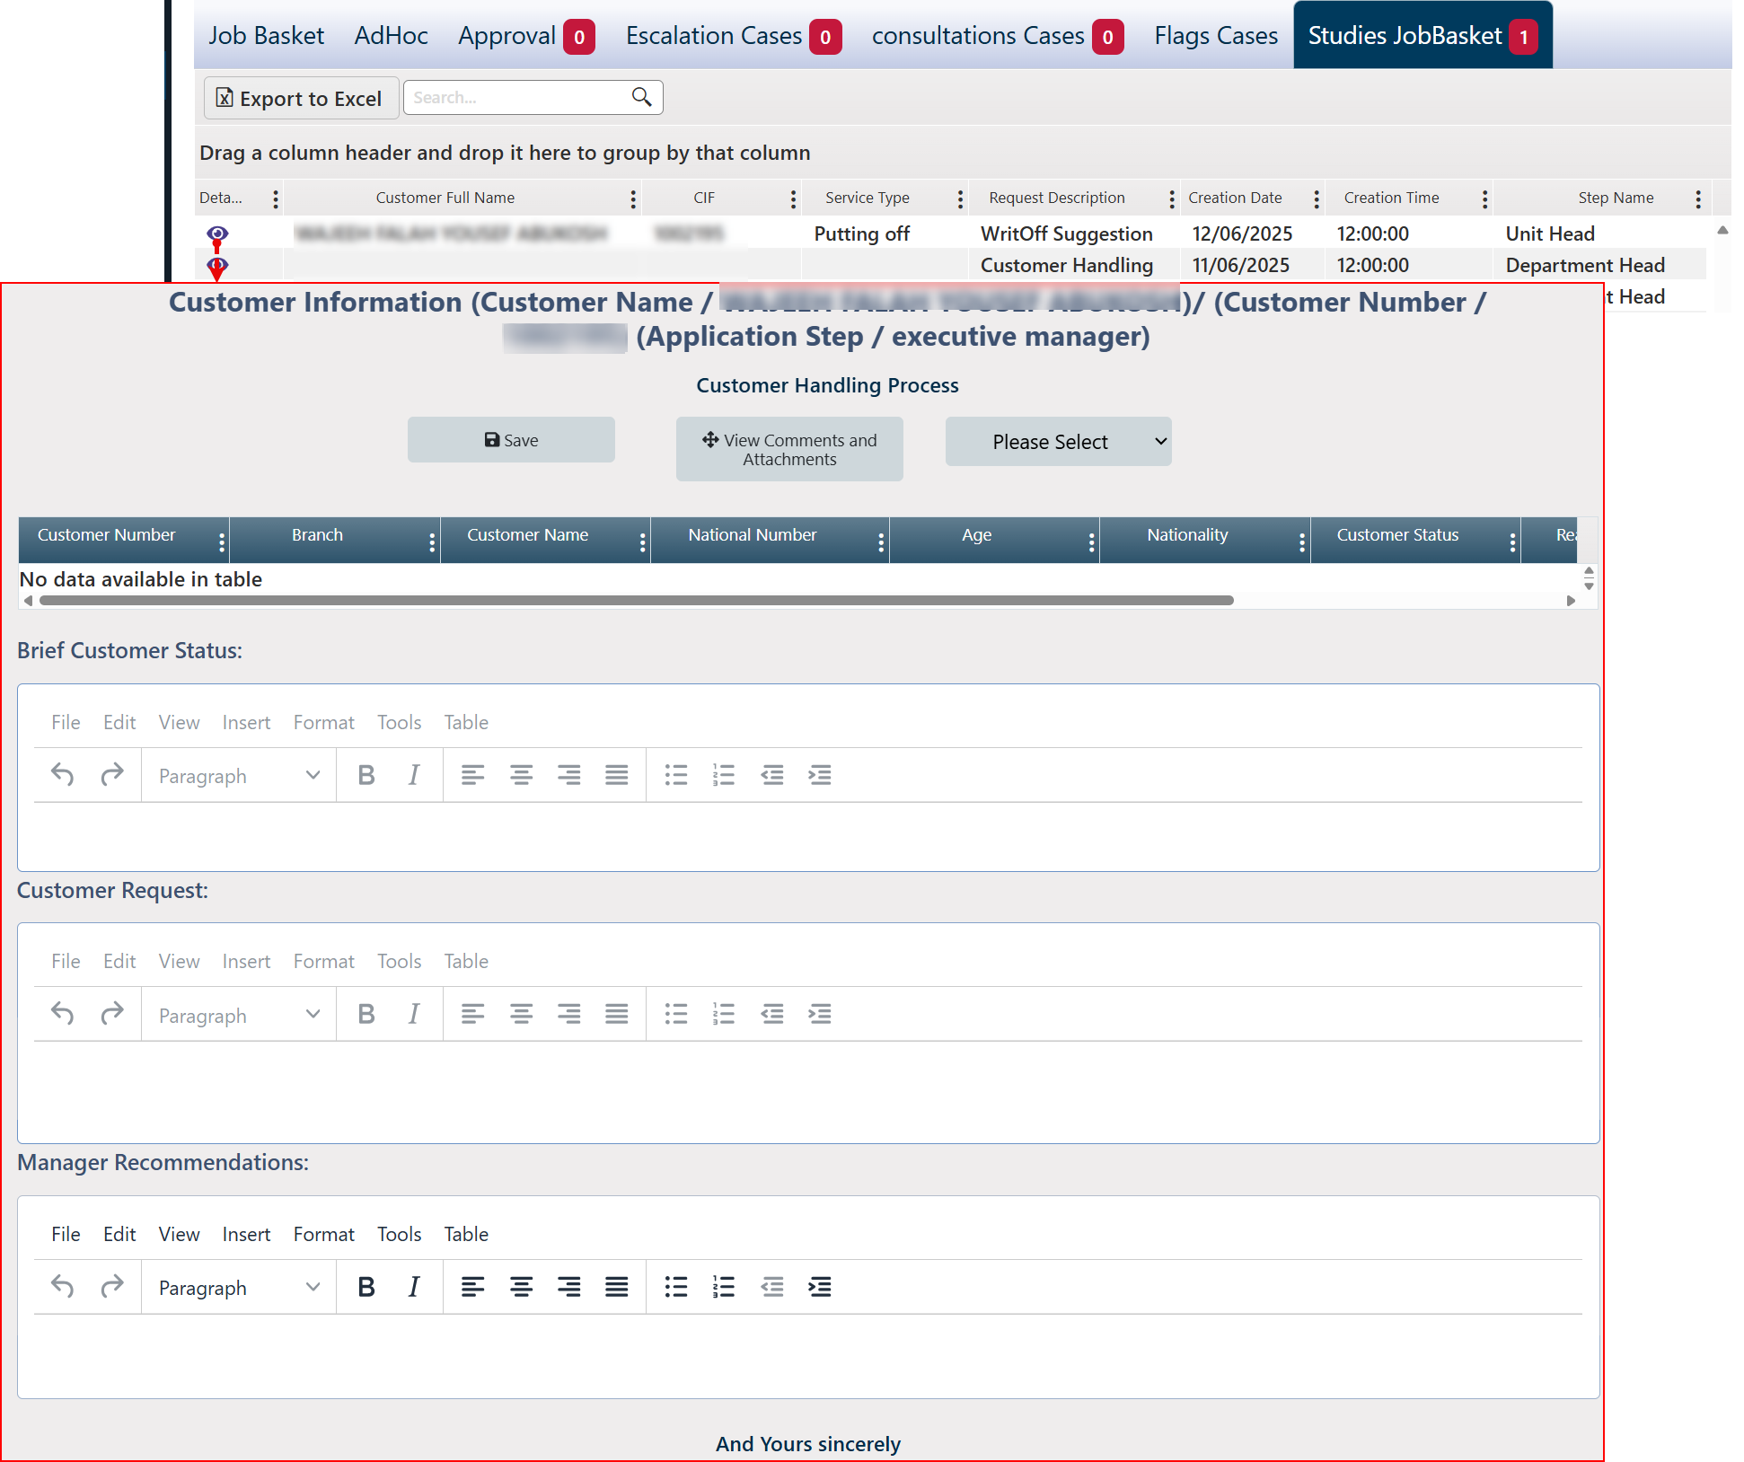

#### Study Request Work Follow

The study request adheres to the approved workflow, and each level contains actions that rely on the privileges granted to users. The approval phases can be summarized as follows:

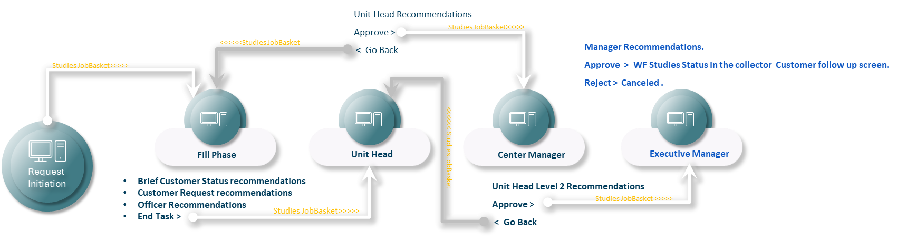

1. Request Initiation - Step: Request Infestation (Study Request Creation): The request is created from the Study Request screen and submitted to the Studies JobBasket. The request moves directly to the Officer Fill Phase.
2. Officer Fill Phase
   1. Inputs Required: the inputs here depend on the user’s privileges, but mostly they could be :
      1. Brief Customer Status Recommendations
      2. Customer Request Recommendations
      3. Officer Recommendations
      4. Any supporting documents or notes

The user is required to enter the necessary recommendations and complete the task. Once finalized, the request will automatically proceed to the next level: the Unit Head Phase.

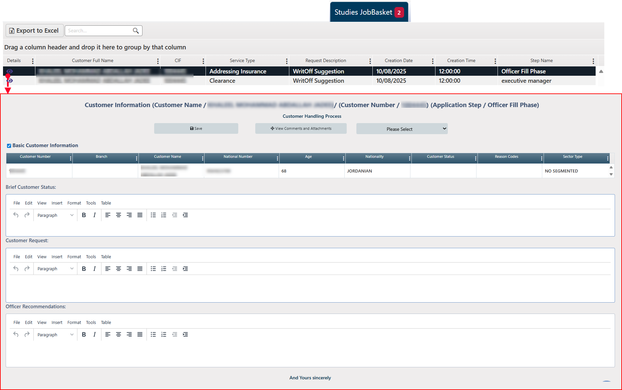

3. Unit Head Phase

In this level the user can:

1. Enter mandatory recommendations.
2. Approve → Sends the request forward to the Center Manager Phase.
3. Go Back → Returns the request to the Officer Fill Phase with a justification note.

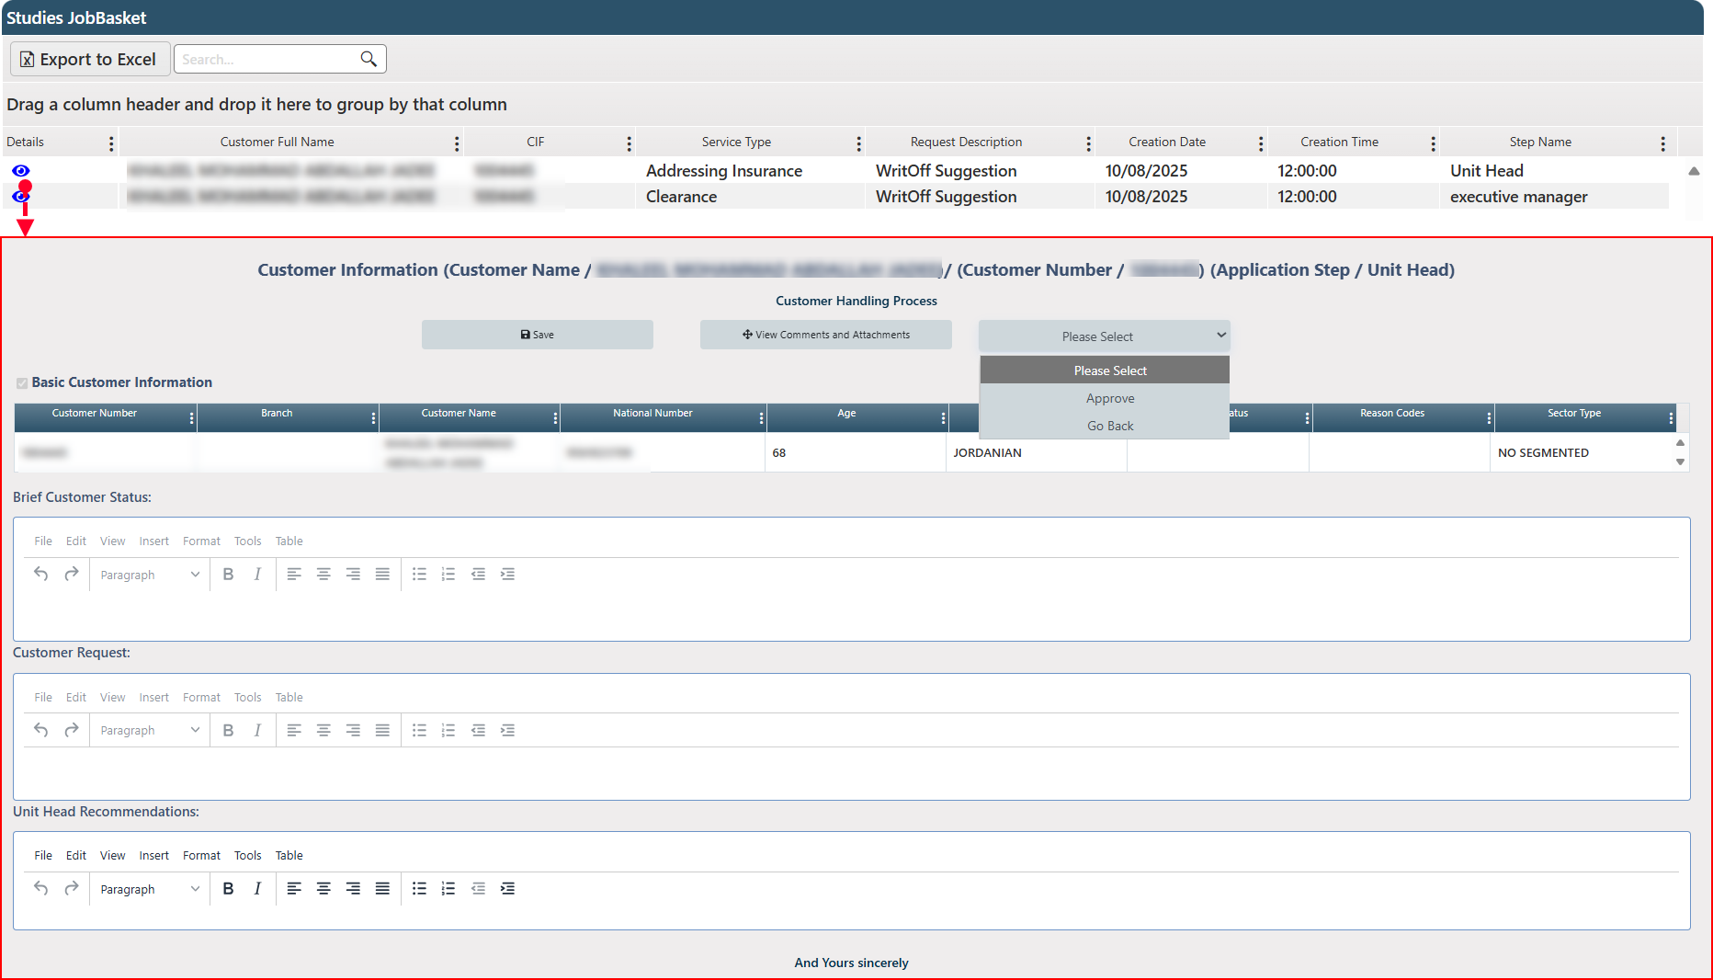

4. Center Manager Phase

In this level the user can:

1. Enter mandatory recommendations.
2. Approve → Forwards the request to the Executive Manager Phase.
3. Go Back → Returns the request to the Unit Head Phase for revision.

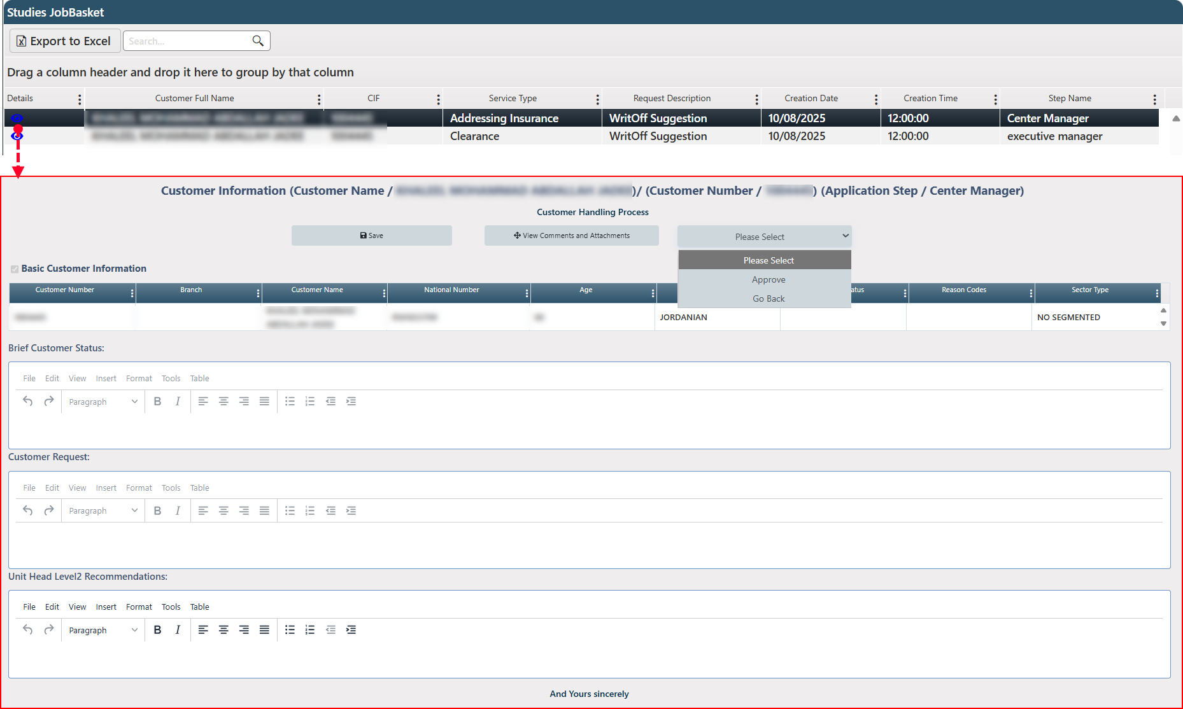

5. Executive Manager Phase (Final Stage)

In this level the user can:

1. Enter mandatory recommendations.
2. Approve → Final approval; request is accepted and closed successfully, the study status will be displayed in the collector screen (in the request initiator screen)- WF Studies Status
3. Reject → Request is canceled and marked as rejected in the system.

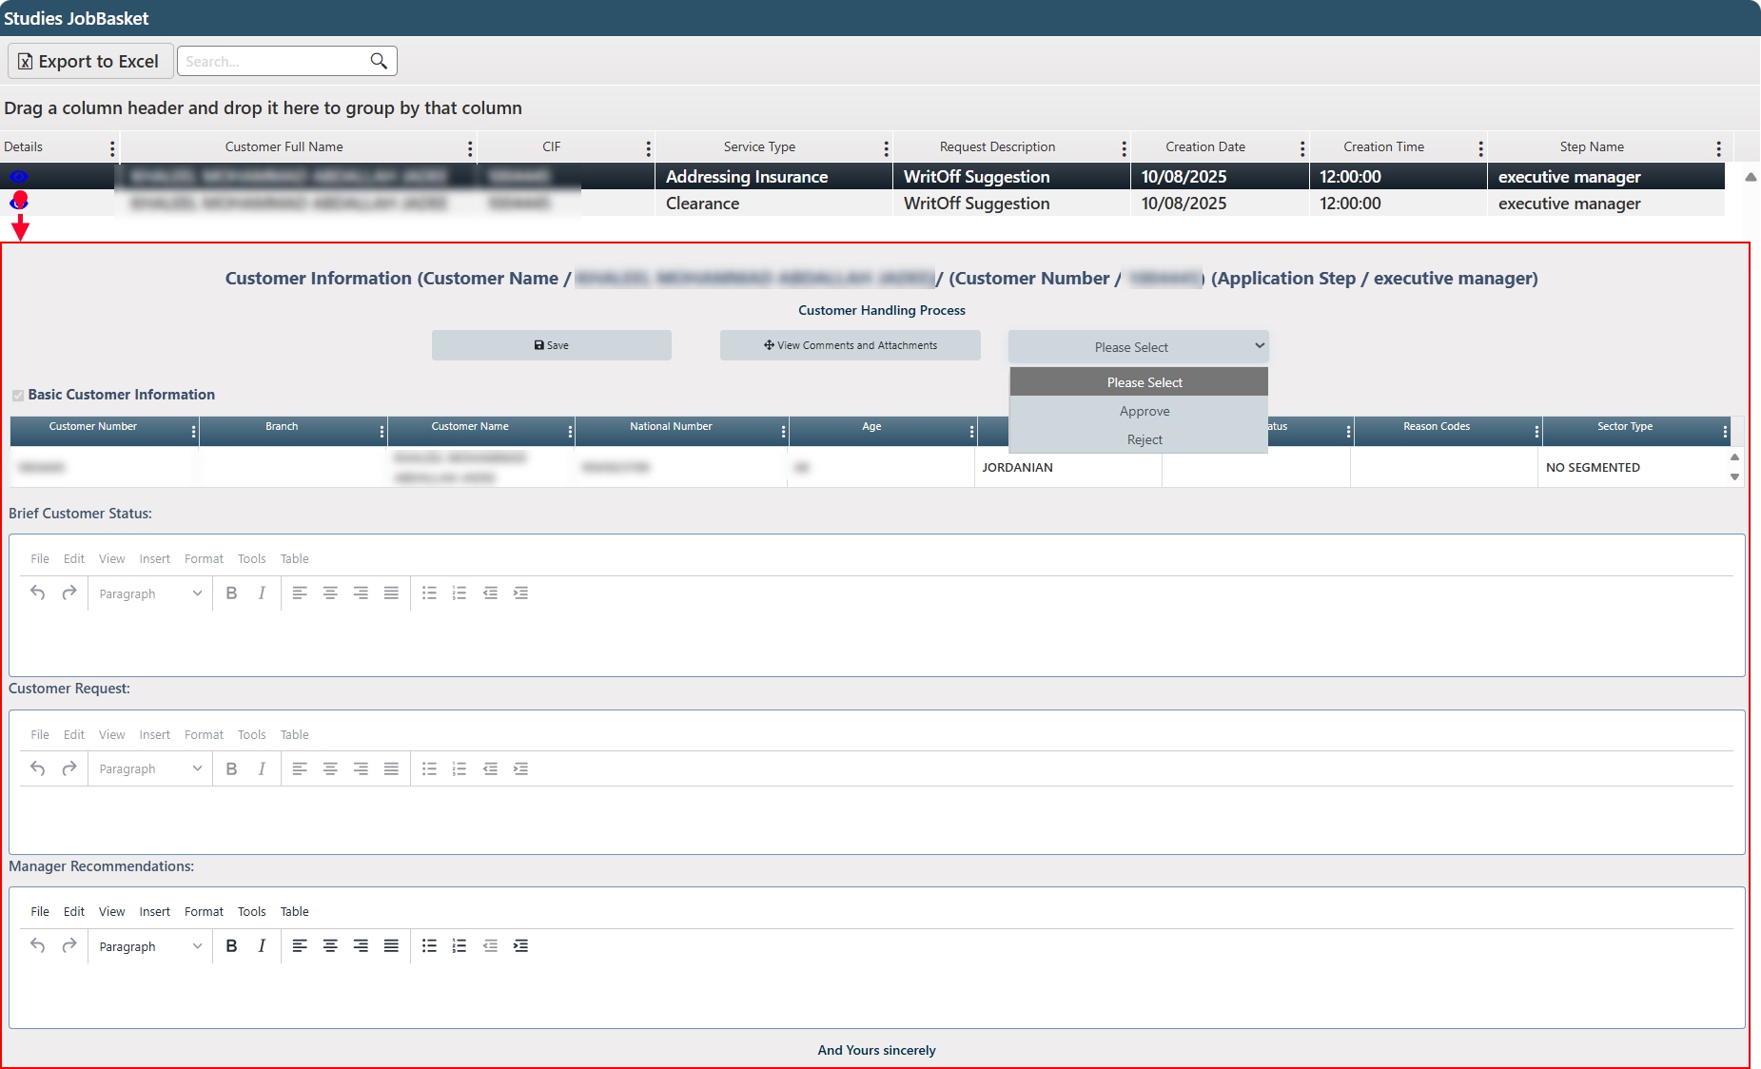

Comment: At each stage where the user clicks "Accept" or "End Task," the system will display a process confirmation screen. This screen includes the attachments associated with the request, the ability to attach additional files, and a dedicated field for adding any relevant notes. All of these items are automatically included with the request as it moves to the next stage.

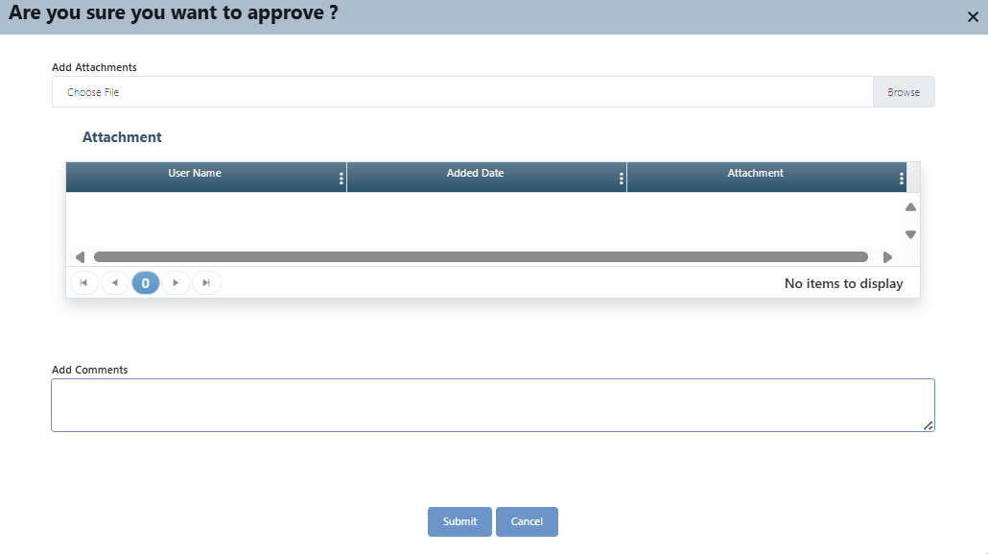

## Customer Follow-Up

This page is the backbone of the collection and customer follow-up processes, consolidating all the information needed for efficient customer management. It includes specific actions for follow-up and several specialized tabs that organize details based on information type, with the ability to modify some tab contents. The available procedures are displayed with the user's permission. Additionally, a timer tracks the total time spent on each request, enabling users to assess the time cost of completing the collection process.

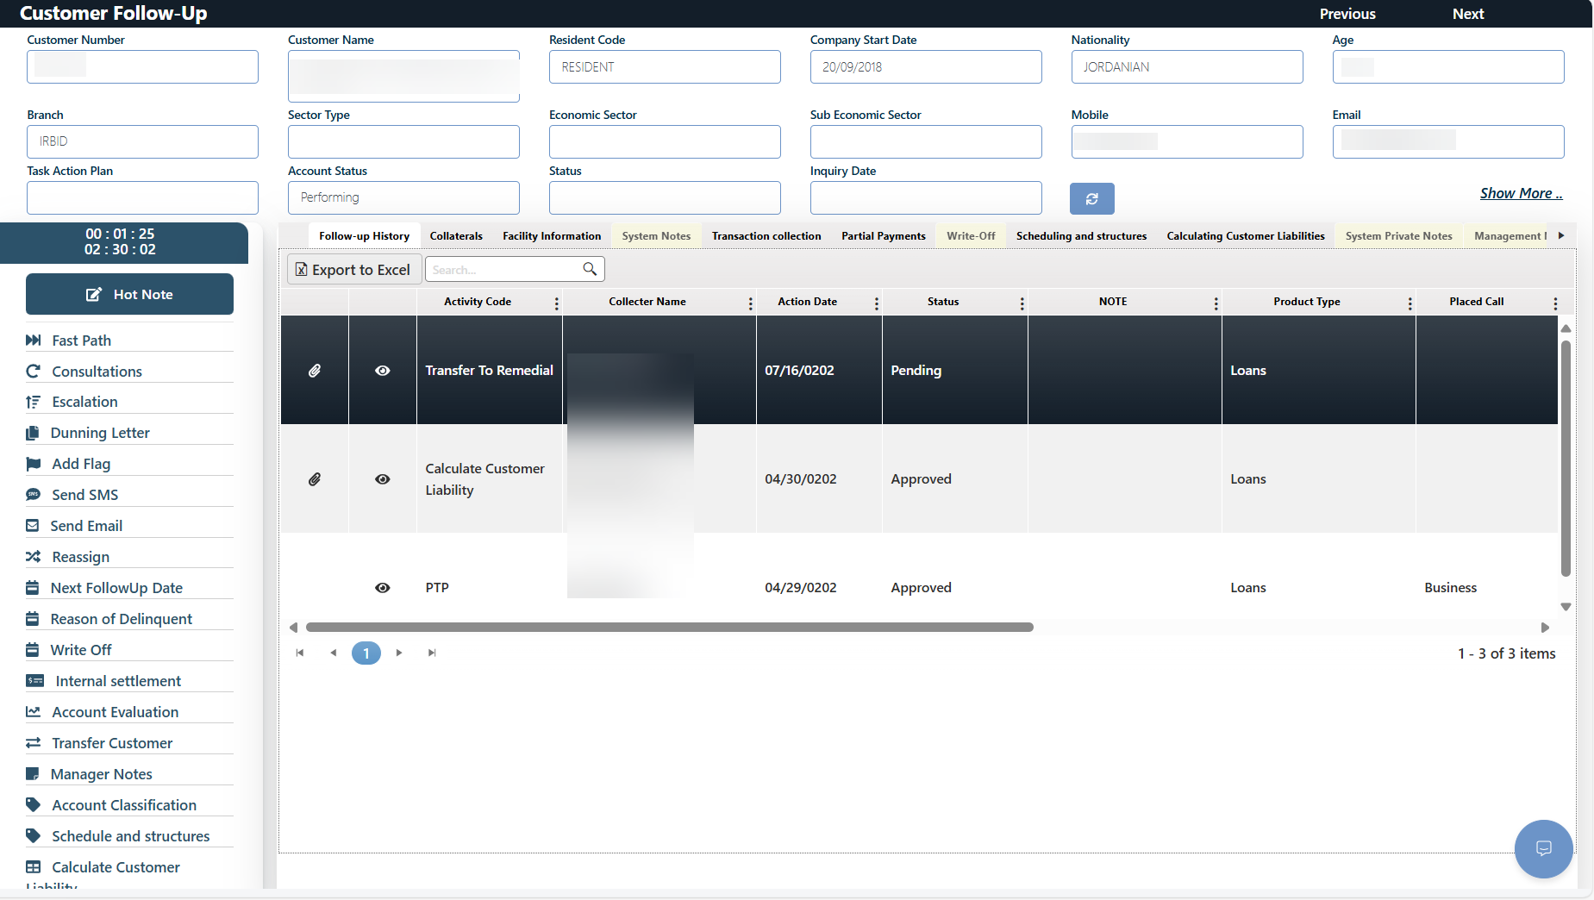

Comment: The screen displays information retrieved from the system about the customer. By clicking 'View More', all details are displayed together on a single screen as follows:

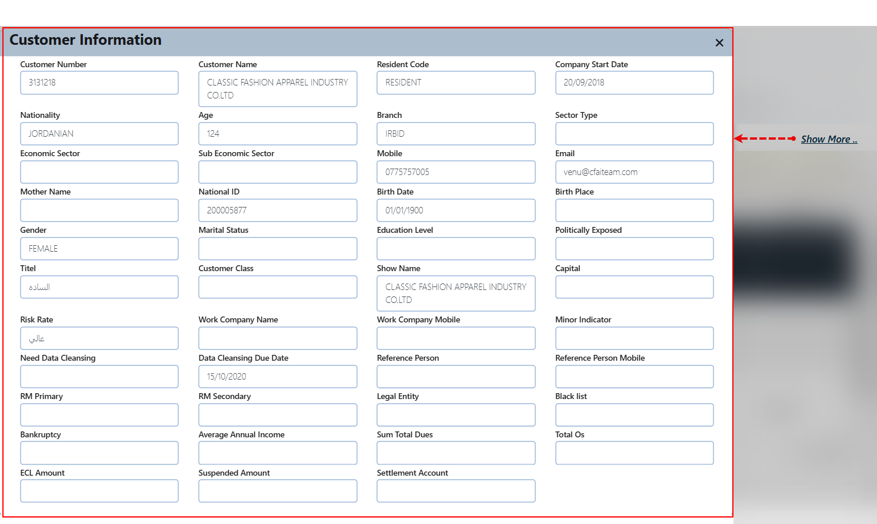

### Related Actions / Operations

This is a series of actions that the system uses to interact with requests, enabling the collector to oversee and manage the collection process. These actions are presented to users according to their assigned permissions. Below are detailed descriptions of these actions and instructions on how to use them:

#### Hot Note

The Hot Note button allows users to add important, request-specific notes that assist in tracking and collaboration.

To Add a Hot Note:

1. Click the Hot Note button, a popup window titled "Hot Note" will appear.

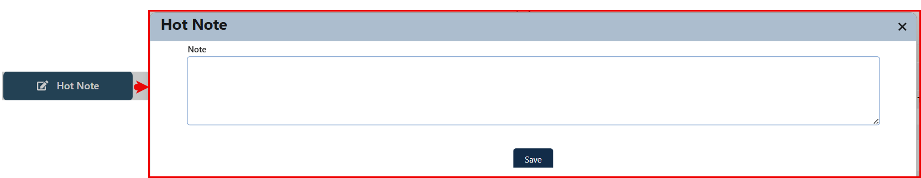

1. In the Note field, type the relevant note.
2. Click Save to store the note. Once saved, it becomes part of the request record and follows it throughout the process.

To View or Edit a Hot Note:

1. Click the Hot Note button again to view any previously added notes.
2. The note will appear in the same screen and can be edited if needed.
3. Click Save again after making changes.

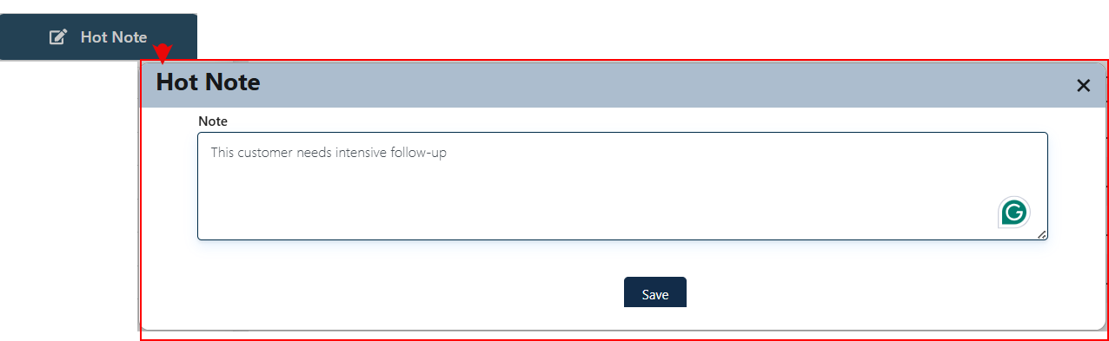

#### Fast Path

This function is used daily by each collector to monitor overdue payments and document the sequence of follow-up actions taken with the customer. Collectors can also upload relevant attachments and enter notes related to the request or the procedures followed.

Layout:

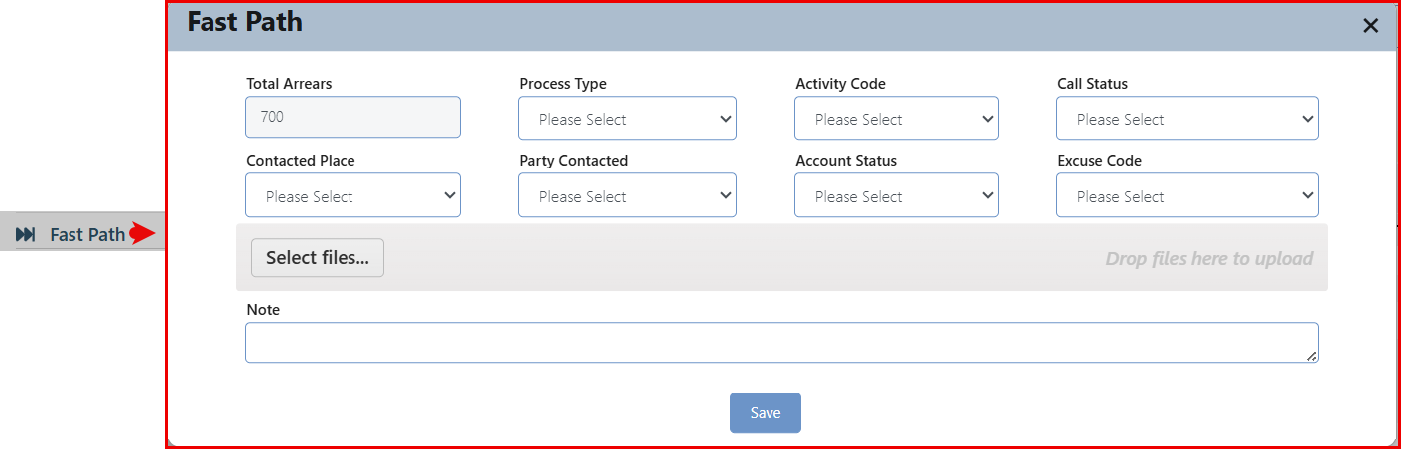

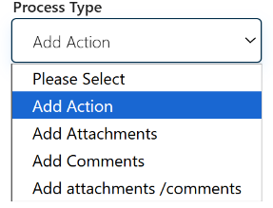This screen contains interactive field, where its selection dynamically affects the displayed content. The 'Process Type' field includes the available processes that the user can perform, and the screen content will adjust accordingly based on the selected process.

This field provides the following options.

* **Add Action:** This option allows users to insert actions related to the active case and document their outcomes. The input is based on predefined selections to ensure clear and concise data entry for effective process tracking.

The screen interacts with this option so that it appears as follows and displays the following fields:

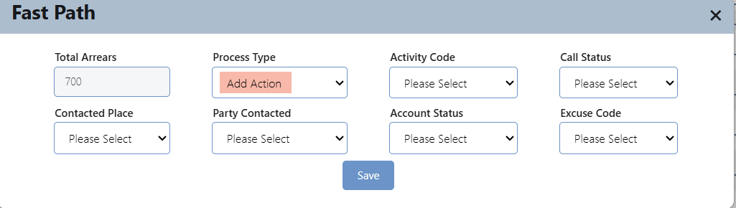

The following are the default selection values for each field.

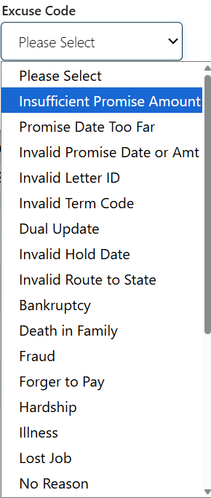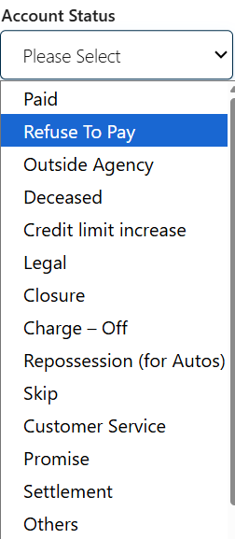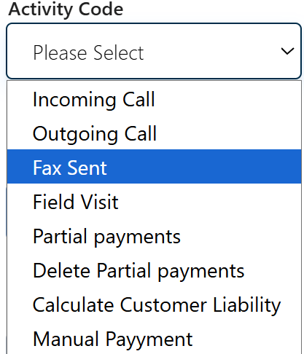 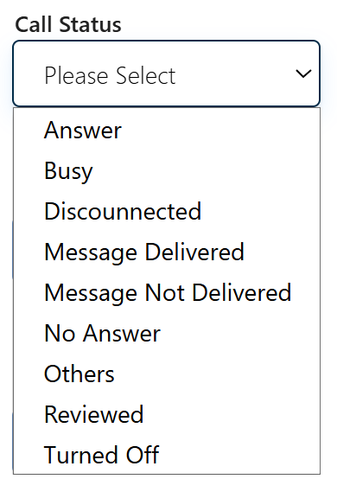 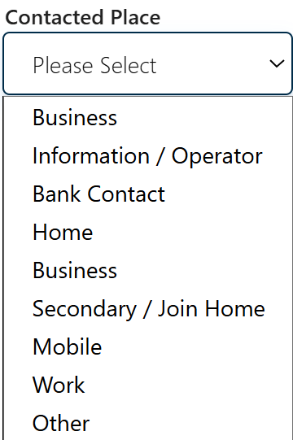 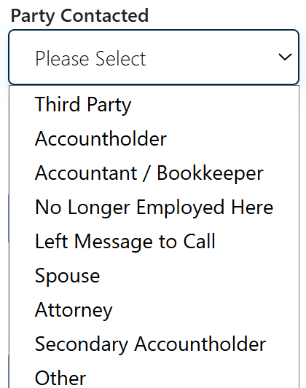

Comment: All submitted inputs are automatically recorded and displayed under the "Previous Follow-up Log" tab, ensuring a clear and traceable history of interactions and updates for each case.

An exception occurs when the user selects "Account Status" as "Promise"; the screen will dynamically update to display the relevant fields for entering the promise details, as shown below.

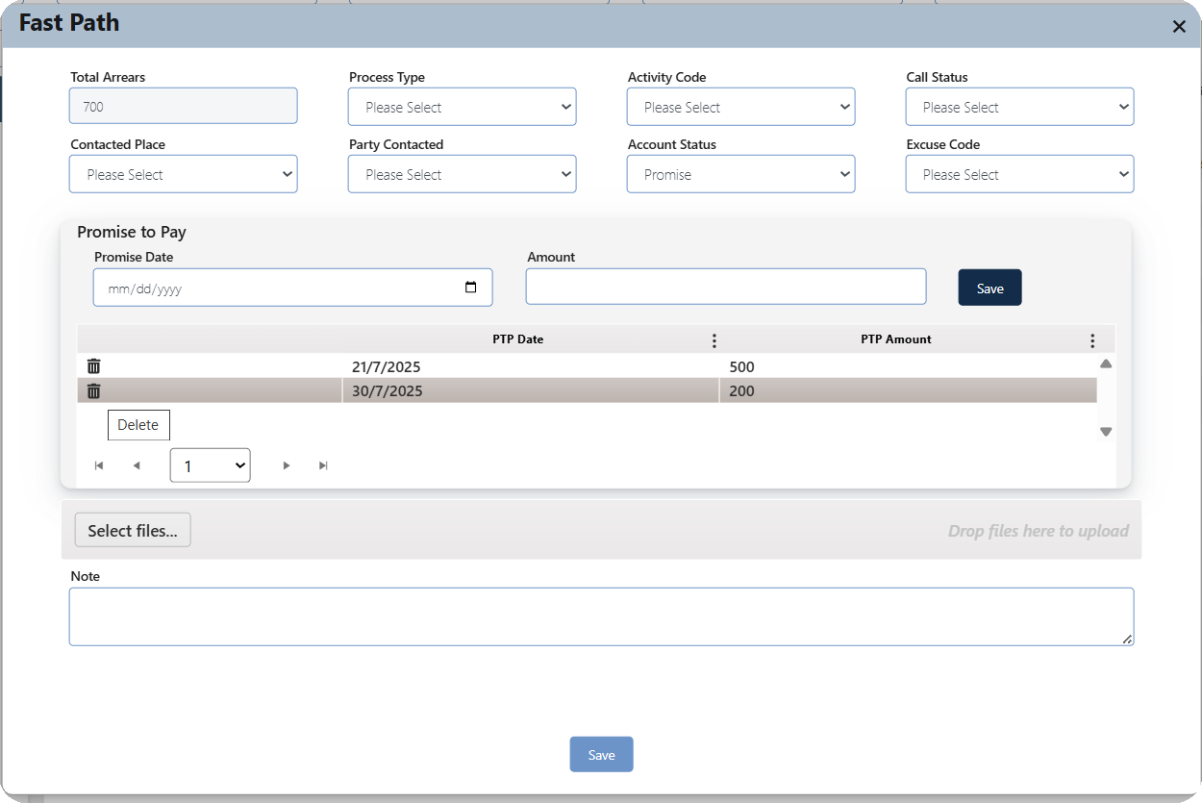

The user can enter the promise date and amount, then click "Save" to insert the record into the designated area. The record can be deleted by clicking the delete button next to it.

* **Add Attachments:** The screen interacts with this option so that it appears as follows allowing the user to Attaching related document.

Comment: The insertion process can be done by selecting the file or by dragging and dropping it into the designated area.

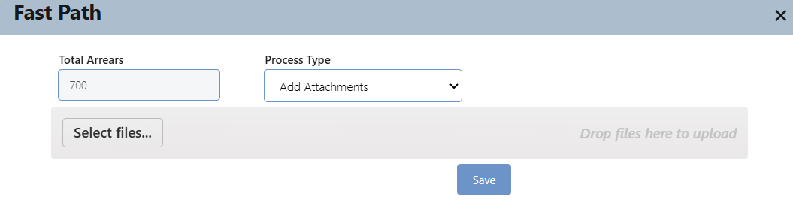

The system allows multiple selections for different types of files. The user can delete an inserted file by clicking the "X" button next to it.

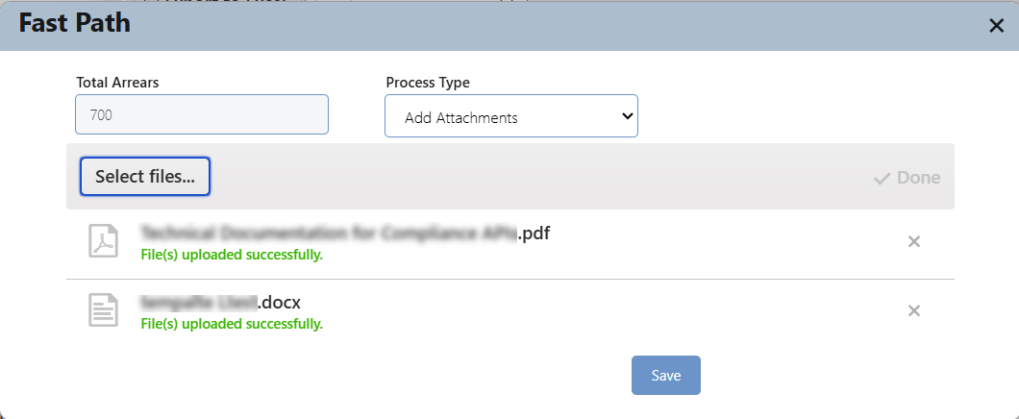

* **Add Comments:** The screen interacts with this option so that it appears as follows allowing the user to insert a related note

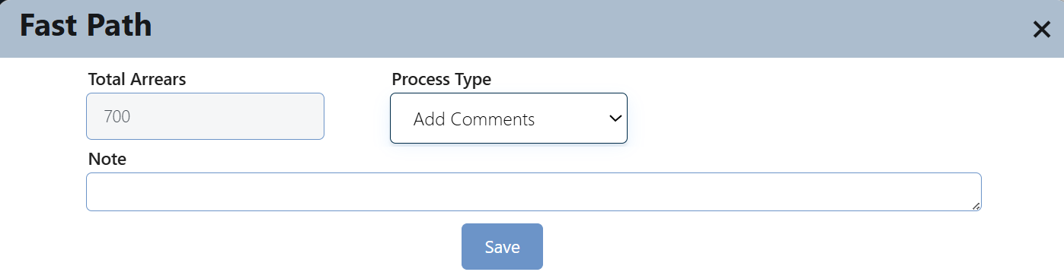

* **Add Attachments /Comments:** The screen interacts with this option so that it appears as follows allowing the user to add both a comment or note and an attachment.

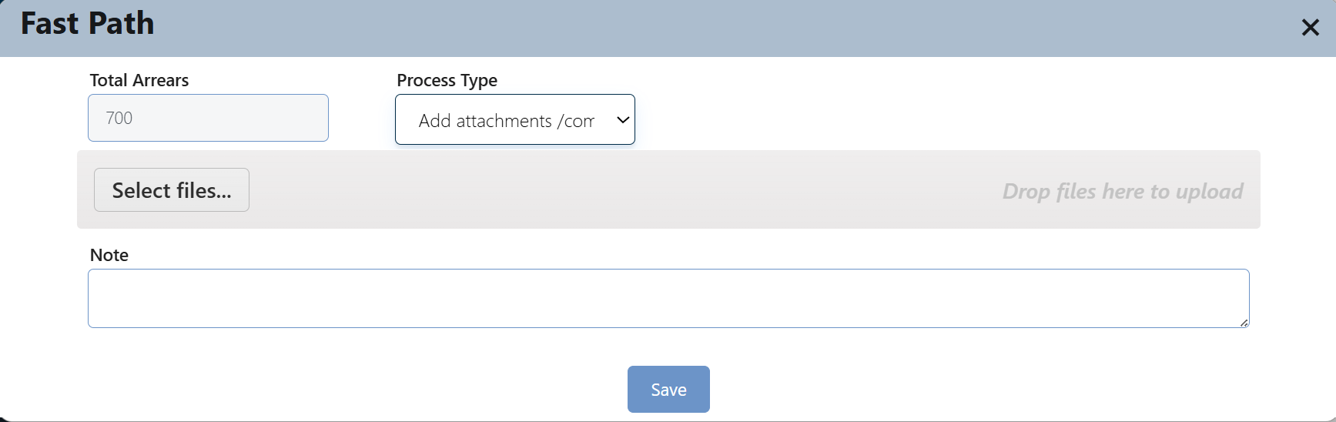

#### Consultations

This action is used to request a consultation from another user regarding the active request record. It transfers the request from the current user to another user for feedback or advice. The referred user is not granted any authority to take action, except for attaching a document and adding a note. The request then automatically returns to the user who initiated the referral. This is a consultation-only action without granting decision-making privileges.

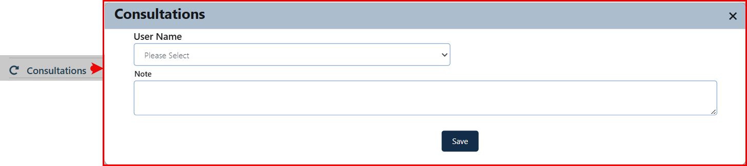

**To initiate a consultation request, the user should:**

1. Click the Consultations button.
2. From the displayed screen, select the name of the user to whom the request will be referred for consultation.
3. Enter notes explaining the request and the reason for the referral.
4. Click the Save button.

The user receiving the consultation request will review the case and provide feedback by adding a note only. A Return the Consultation button will appear to allow the user to send the request back to the original sender.

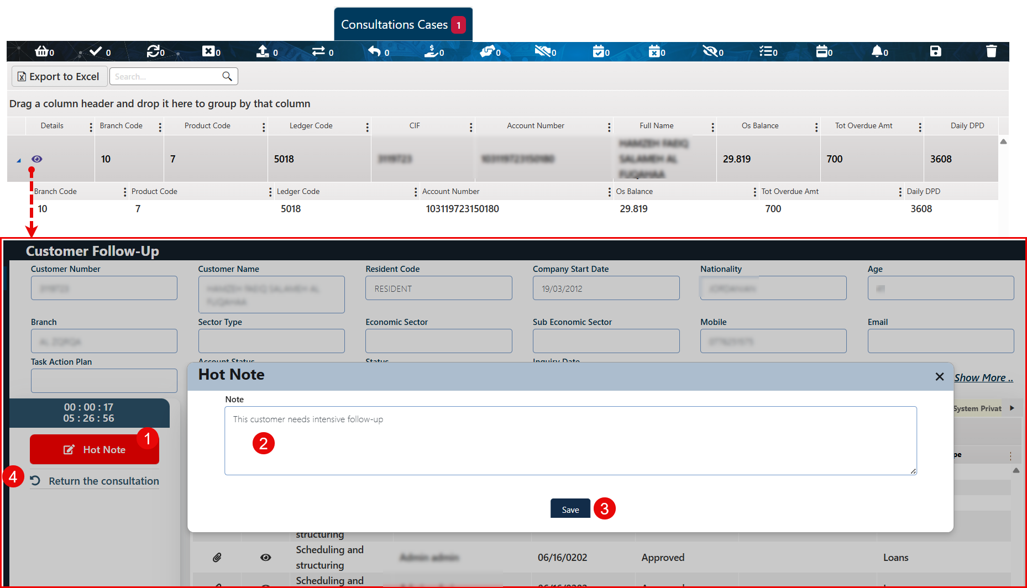

#### Escalation

Escalating the request to a higher-ranking and more experienced user for full follow-up.

This action transfers the task from the active user to the manager or direct supervisor.

*This action needs the approval of the direct supervisor.*

Comment: The approval process is initiated by the user who holds the appropriate approval authority. Once submitted, the task is automatically escalated to the direct manager/ supervisor.

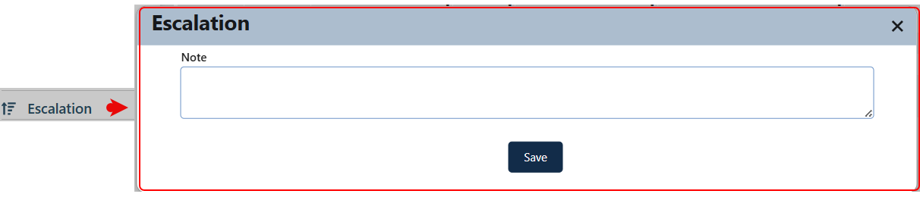

**To initiate a task escalation, the user should:**

1. Click the Escalation button.
2. Enter a relevant comment in the provided field.
3. Click the Save button to confirm and submit the escalation.

The user then selects a predefined dunning letter template—which must have been created in advance under: Administration > Definition Screens > Dunning Letter.

After choosing the template, the user assigns the letter to the appropriate customer account with overdue payments.

Comment: Once completed, the letter can be printed or sent manually or via mail, depending on the institution's procedures.

#### Add Flag

This action allows users to assign a flag to a specific request, helping categorize and prioritize tasks based on custom labels.

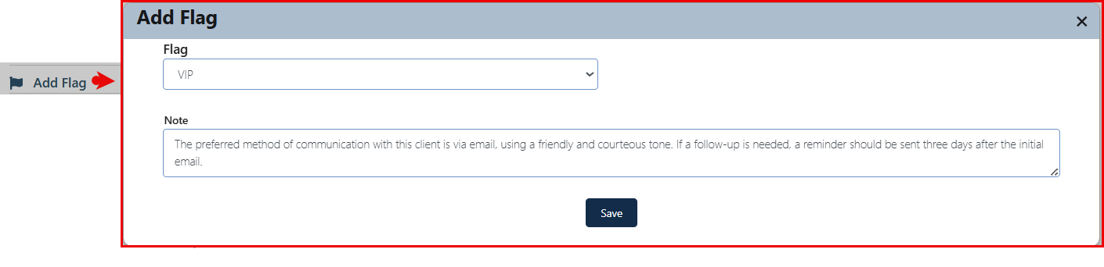

**To add a flag to a specific request**, the user should follow these steps:

1. Click on the "Add Flag" button. The flag addition screen will appear as follows:
2. Select the type of flag to assign to the request.
3. Enter relevant notes in the flag notes field.
4. Click the "Save" button.

Comment: Assigning a flag to any request allows it to appear in the Flags tab of the Credit Portfolio (job basket) page. This gives the request priority based on the flag type, helping users easily identify and prioritize tasks.

* This action is dependent on the Flag Definition page. Defining the flag is a prerequisite for this process.

#### Reminder

This button allows the user to add a reminder, enabling them to set a personal notification for taking specific action on an active request related to certain conditions, by performing the following steps:

1. Click the Reminder button to open the reminder creation screen.

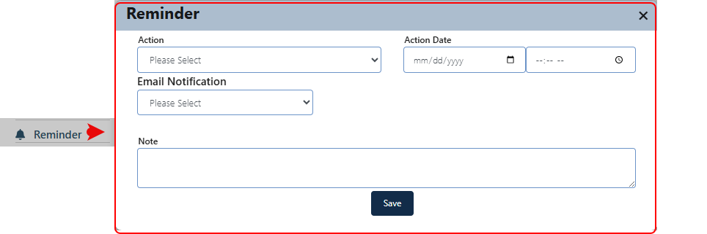

1. Select the type of action.
2. Specify the date.
3. Specify the time.
4. Choose whether the reminder should be linked to an email notification.
5. Enter a note related to the reminder.
6. Click the Save button.

The reminder will appear under the "Reminder" filter in the Credit Portfolio (Work Basket) screen.

The user can cancel the reminder by clicking the Delete button next to it.

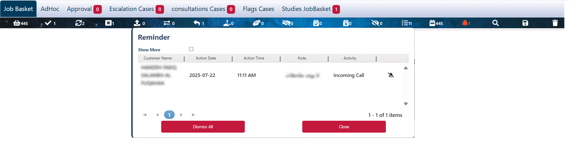

Comment: Multiple reminders can be added for the same action or request.

#### Send SMS

This action enables the user to send an SMS to the mobile number listed in the customer’s contact details, serving as prompt notification for customers who are behind on their payments.

Comment: The message content can either be based on a pre-defined template or written manually at the time of sending. SMS templates are defined in the Definition Screens – SMS Template section.

**To send an SMS to a specific customer,** the user should follow these steps:

1. Click the SMS button to open the SMS interface screen.

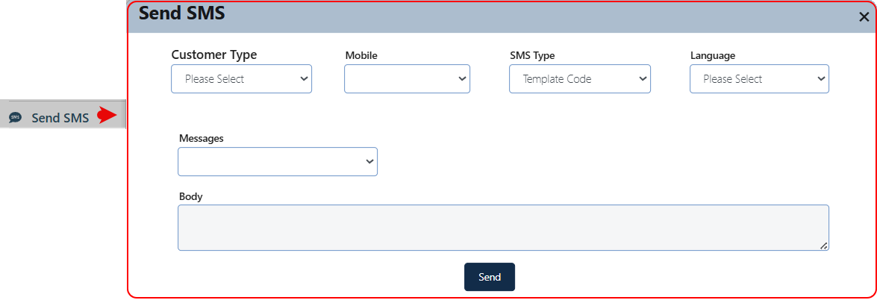

1. Select the Customer Type (Customer / Guarantor).
2. The phone number will be automatically retrieved from the system. If multiple numbers are available, the user can select the appropriate one.
3. Choose the Message Type (Template or Custom).
   1. If Template is selected:
      * + Choose the language.
        + Select the appropriate template; the pre-defined message will appear in the body field and will be non-editable “not active”.
        + Click the Send button.
   2. If Custom is selected:
      * + The language and message template fields will disappear.
        + The body field will be activated for manual entry.
        + Write the desired message, then click Send.

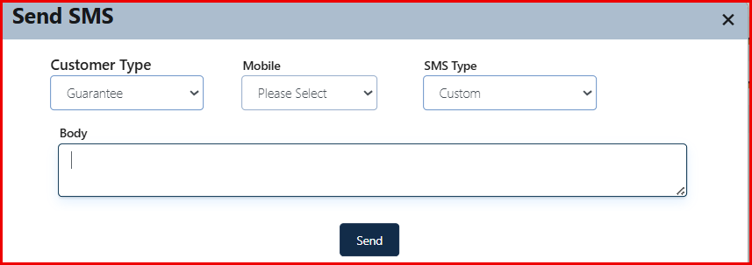

#### Send Email

This procedure is for notifying customers who have defaulted on payments by sending an email to the address listed in their contact details. Emails can be based on predefined templates or composed manually at the time of sending.

**To Send an Email:**

1. Click the "Send Email" button, the Send Email screen will appear.

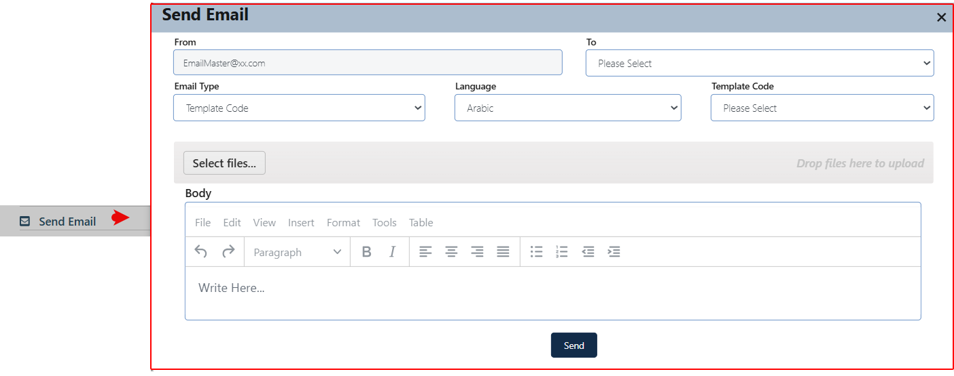

Comment: The sender’s email address is automatically retrieved from the system.

1. In the "To" field, select the customer’s email address. *If the address is not available, it must be entered first under the Customer Contact Details tab on the Customer Follow-up screen.*
2. Choose the Email Type:
3. Template-based:
   * + - Select the language.
       - Choose the template. The email message will appear in a non-editable "Body" field.
       - Use the "Insert" button to attach files.
       - Click "Send" to deliver the email.
4. Customs:
   * + - The template filed will be hidden.
       - The "Body" field becomes editable. Enter your message and click "Send".
       - The text box becomes active to support customer-specific formatting and interaction with the message text.

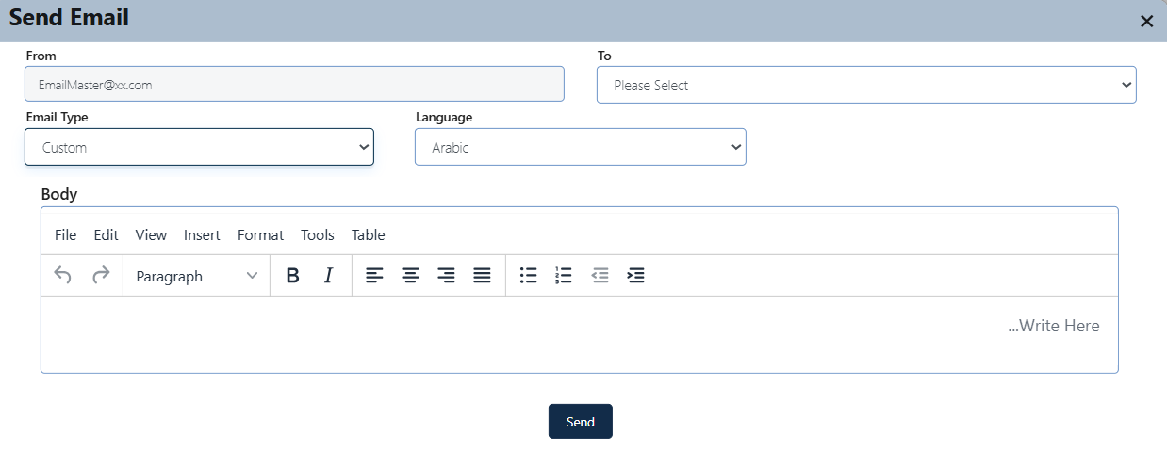

#### Reassign

This procedure reassigns the current task to another user and requires approval from the direct supervisor.

**To reassign a task to another user,** the current user should follow these steps:

1. Click the "Reassign Task" button.
2. In the Reassignment screen, select the intended user to continue the task, then click "Save".
3. The request is forwarded to the approval screen in the direct supervisor's task inbox for review.

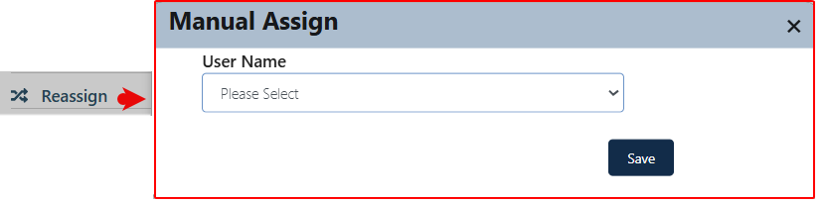

1. If approved, the task is moved to the selected user job basket to continue the process.
2. If rejected, the task returns to the user job basket of the user who initiated the reassignment.

#### Next Follow-up Date

This button sets a date for a specific follow up action.

**To add a next follow-up date**, the current user should follow these steps:

1. Click the " Next Follow-up Date " button. Then the related screen will appear.

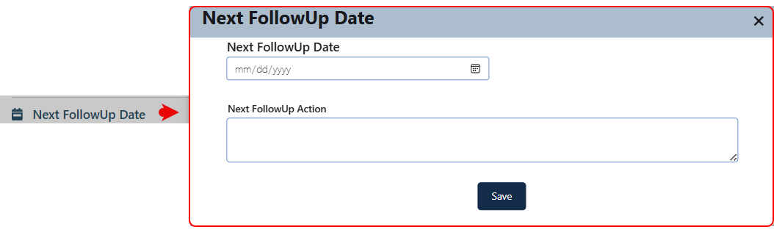

1. The user selects the desired date.
2. Enters notes related to the action.
3. Click the "Save" button.

This action required approval from the direct supervisor

Once it’s approved it will be in the reminder" filter in the remedial system - JobBasket) screen.

#### Reason of Delinquent

This action allows the collector to select the reason for delinquency for the active case. Once the reason is saved, it will be displayed under the Delinquency Reasons tab.

**To insert a reason of delinquent**, the current user should follow these steps:

1. Click the " Reason of Delinquent " button. Then the related screen will appear.

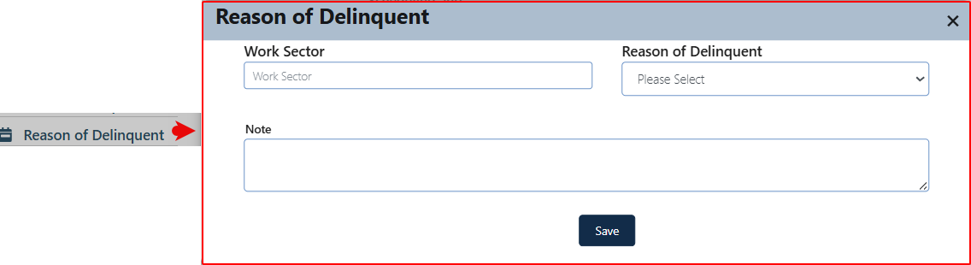

1. The user selects the reason for the delinquency.
2. Insert a note about the reason.
3. Click the Save button.

#### Write Off

This action is available to authorized users and allows them to submit a request for debt write-off. When the action is clicked, a dedicated screen will open to complete the debt write-off process. Users can enter relevant notes and attach any necessary supporting documents.

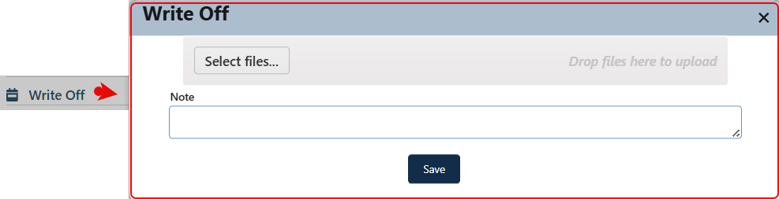

This process is subject to review. After saving the process, the request is sent to the checker. It is then displayed on the Credit Portfolio screen - Approval tab.

If approved, the user who initiated the process is then notified in the Previous Follow-up History tab, where the task is displayed and the status is Accepted.

If rejected, the process is rejected. The user who initiated the process is then notified in the Previous Follow-up History tab, where the task is displayed and the status is Rejected.

#### Internal Settlement

This action allows users to manually track and schedule payment installments. By clicking the "Internal Settlement" button, a dedicated screen appears, enabling the manual entry of payment details.

**To insert an Internal Settlement**, the current user should follow these steps:

1. Click the " Internal Settlement " button. Then the related screen will appear.

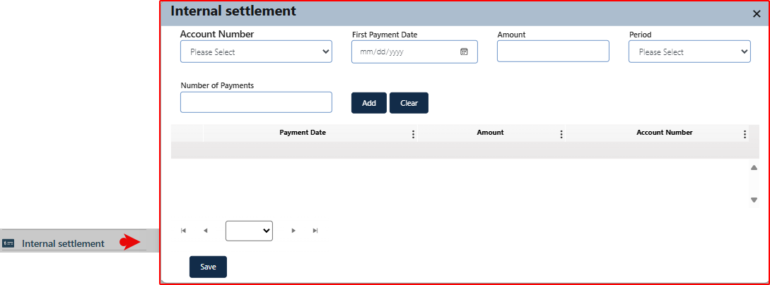

1. Select the account number associated with the case.
2. Enter the scheduled payment date for the first payment.
3. Specify the payment amount.
4. Select the payment interval, choosing from the following options:

|  |  |  |  |
| --- | --- | --- | --- |
| * Monthly | * Every 3 months | * Every 6 months | * Annually |

1. Enter the number of expected installments.
2. Click the "Add" button to insert the entry into the Payment Schedule Display section.

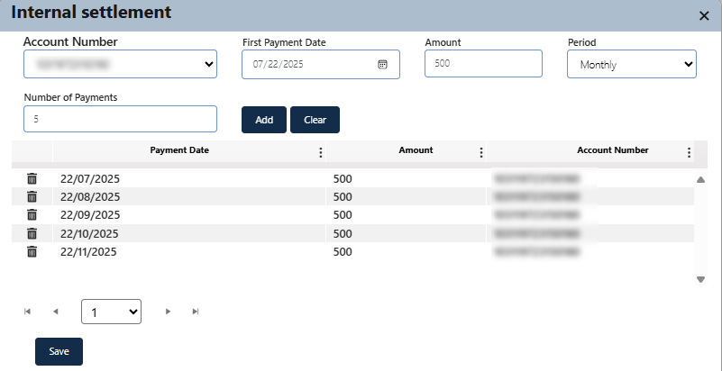

Comment: The "Clear" button is used to reset the operation and clear all entered fields on the screen.

1. In the Payment Schedule Display area, users can edit or delete individual payment entries using the respective action buttons next to each record.
2. Once all entries are finalized, click the "Save" button to confirm and store the schedule.

#### Legal Fees

This action is used to enter the legal expenses and fees incurred by the customer, which will be calculated and tracked within the legal system.

* This action becomes available when the current user belongs to the remedial and the system is integrated with the Bank-BPM Legal Case Management System.

**To insert a legal phase record**, the current user should follow these steps:

1. Click the " Legal Fees" button. Then the related screen will appear.

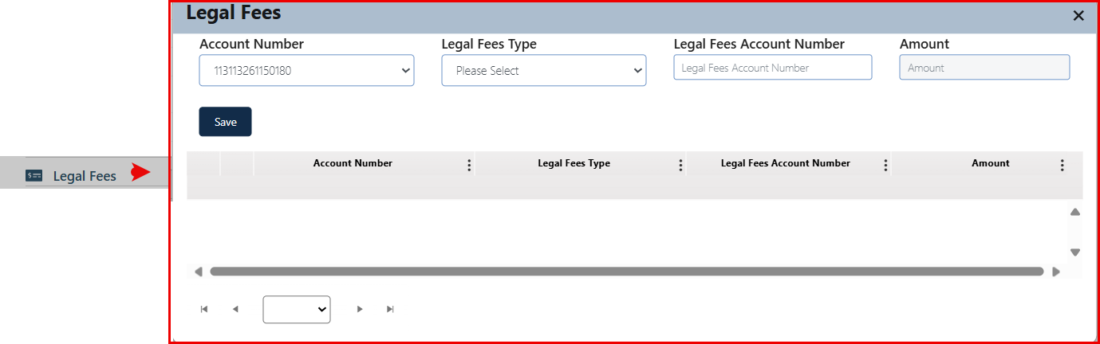

1. Select the account number related to the customer.
2. Choose the legal fees type (e.g., Type 1 / Type 2).
3. Enter the Legal Fees Account Number, which is the account to which the charges will be transferred (linking the expense account to the customer’s account).
4. The amount of the legal fees will appear or can be entered.
5. Click the "Save" button. The record will appear in the display section below, with the ability to edit or delete the entry if needed.

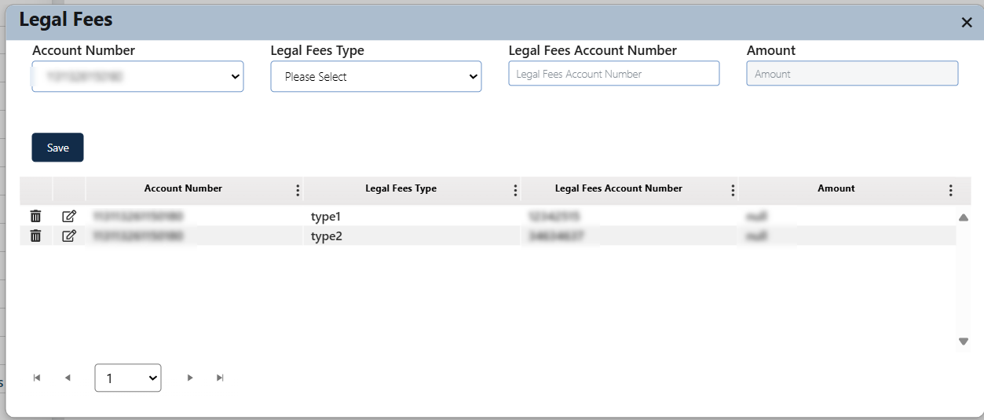

#### Registering New Case

Comments:

* This action is related to the Remedial system.
* Authorized users can initiate a legal case for the selected customer through this function. Once submitted, the case will be forwarded for tracking and management within the integrated Legal Case Management System.
* This option is only visible when the system is integrated with the Bank-BPM Legal Case Management System.

This feature allows authorized users to actively register legal cases related to the implementing organization. It provides a platform for entering detailed case information that can later be followed in the legal system.

This process is divided into several stages which are: Opponent Info, Case Basic Info, Case Details, Case Parties, Bonds, Disclosures, and Attachment

The case registration process involves filling out the necessary information at each stage and then submitting the request to the authorized user JobBasket within the legal case management system.

Layout:

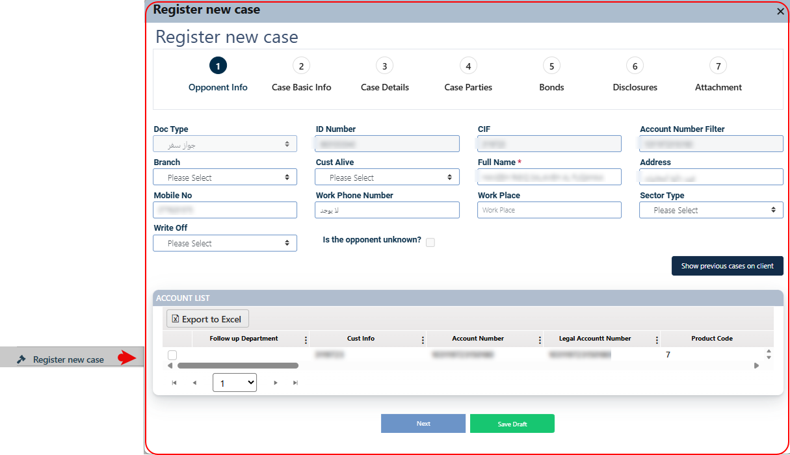

This screen features several tabs related to the subject at hand, along with a Progress Indicator that shows the current stage of the case registration process. The indicator moves forward with each click of the "Next" button and moves back with each click of the "Previous" button, highlighting the active stage currently displayed on the screen.

* Stage-Specific Content Area: Each stage contains a different layout depending on its focus. Some stages include data entry fields, while others allow users to add related records, upload attachments, or enter notes.



* **Next Button**: Allows the user to proceed to the next stage. This button is enabled only when all required fields in the current stage are correctly filled. If any mandatory information is missing or entered incorrectly, the system will display an alert highlighting the required fields.
* **Save Draft Button**: Available in all stages preserve their current progress in the registration process, allowing them to resume and complete it later without losing any entered information.
* **Previous Button**: Enables users to return to the previous stage. This button is hidden on the first stage.
* **Submit Button**: Appears only at the final stage of the process. When clicked, the system registers the case and routes it to the approval workflow through the Task Inbox – Approval screen, following the predefined workflow scheme.



Comment: The user must complete all required fields to proceed to the subsequent tabs. Additionally, clicking the 'Submit' button is necessary for the system to register the case in the legal system and forward it to the staff member responsible within the Legal Case Management System.

**To insert a register a new case**, the current user should follow these steps:

1. Click the " **Register New Case** " button. Then the related screen will appear.

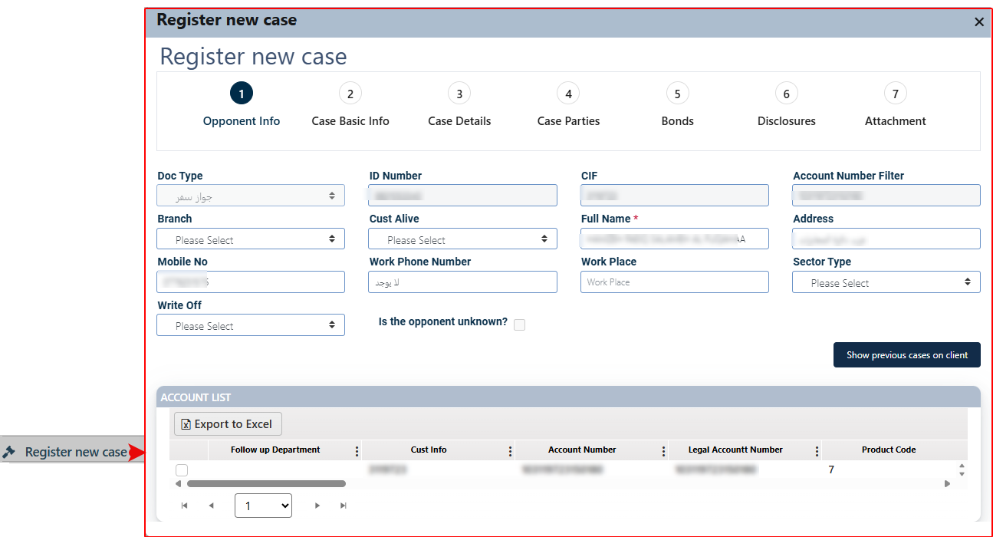

The following is a detailed description of each tab and its respective content:

##### Opponent Info

Record detailed information about the opposing party involved in the case.

Layout:

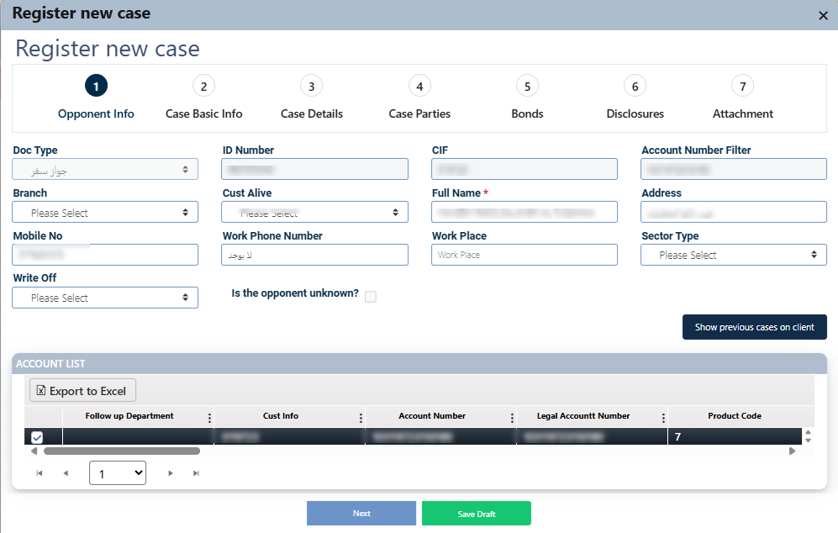

Comments:

* The user must fill in all required fields. Any field marked with an asterisk (*) is mandatory and must be completed before proceeding.
* The user is required to select at least one account from the Account List to move to the next step.
* The values displayed in the dropdown fields can be modified via the Admin Panel – Lookups. The current values were initially configured based on the client's specific requirements during system setup.
* To export the account list, the user can click the "Export to Excel" button located above the data grid.
* To view any past legal cases related to the selected opponent, the user may click the "Show previous cases on client" button. This action opens a dedicated screen displaying a list of relevant cases as presented below:

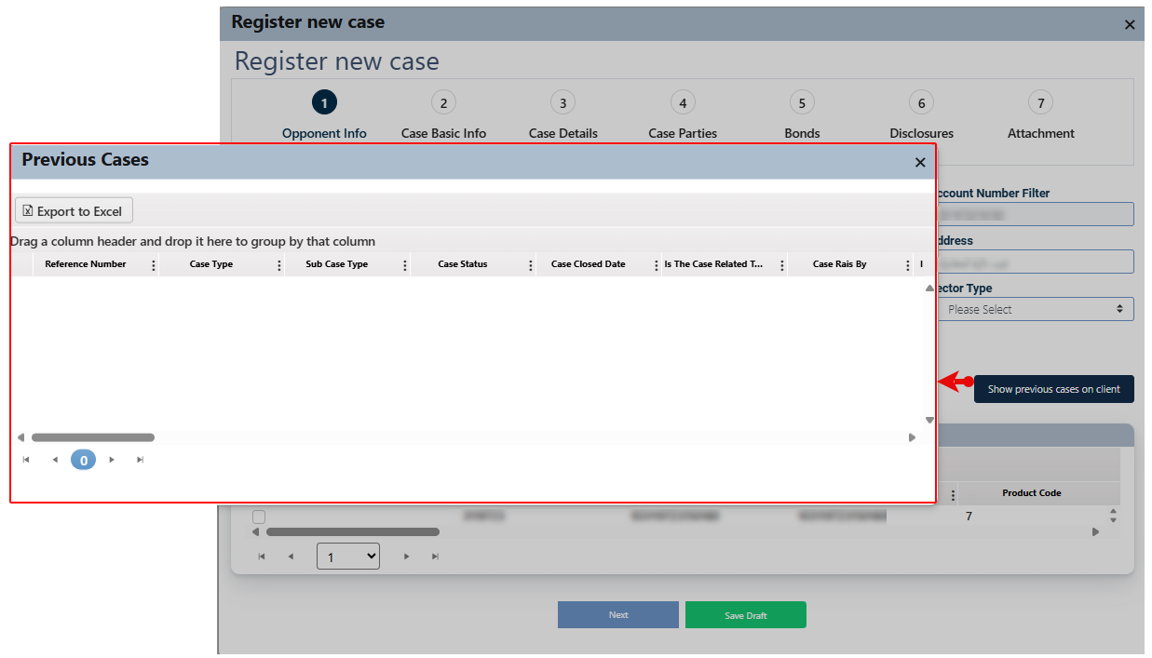

**Insert the necessary information and click next.**

##### Case Basic Info

To capture and display essential details about each legal case, such as Case Type, Case Status, Case Approval Reason, Case Classification, and other information.

Insert the necessary information and click next.

Layout:

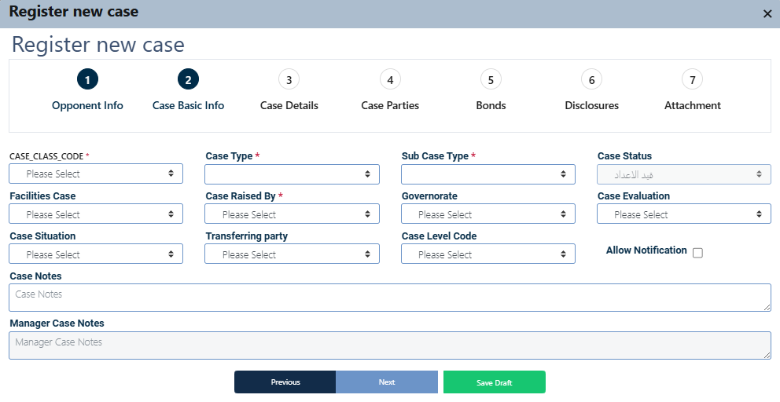

The following is a detailed explanation of the field and its related default values.

|  |  |
| --- | --- |
| Field | Comments |
| Case Class | Select the legal case class: Cases / Executive. |
| Case Type * | Select the legal case type:  If the case class = “Cases” then the provided values will be:   * Civil Financial Claim Case قضية مطالبة مالية حقوقية- * Legacy System - النظام السابق * Property Eviction Case - قضية اخلاء عقارات * Criminal Case - قضية جزائية * Civil and Criminal Case- قضية حقوقية وجزائية * Mortgage Bond Enforcement Case- قضية تنفيذ سند رهن - ***This option will control the visibility of the Bonds tab on the registration screen.*** * Electronic Crimes - الجرائم الالكترونية * Civil Case - قضية حقوقية   If the case class = “Executive” then the value provided will be:   * Enforcement Case قضية تنفيذية |
| Sub Case Type * | The values in this field depend on the previous option. Below are the corresponding values for each choice:   1. Civil Financial Claim Case - **قضية مطالبة مالية حقوقية**  |  |  | | --- | --- | | * Commercial Bills | * كمبيالات تجارية | | * aid Guarantees | * كفالات مدفوعة | | * Letters of Credit | * اعتمادات مستندية | | * Cheque – Civil Aspect | * شيك بالشق الحقوقي | | * Other Financial Claim | * مطالبة مالية أخرى | | * Compensation for Damages | * مطالبة ببدل العطل والضرر | | * Counterclaim | * ادعاء متقابل | | * Financial Claim – Safe Deposit Box Rent | * مطالبة مالية ببدل ايجار صندوق امانات | | * Termination of Safe Deposit Box Lease | * فسخ عقد ايجار صندوق حديدي | | * Nullification of Lifting of Precautionary and Executive Seizure | * ابطال رفع اشارة الحجز التحفظي والتنفيذي | | * Third-Party Objection | * اعتراض الغير | | * Accounting Expert Opinion | * خبرة محاسبية | | * Claim Prevention | * منع مطالبة | | * Claim Prevention and Accounting Expert Opinion | * منع مطالبة وخبرة محاسبية | | * Financial Claim – Retail Facilities | * مطالبة مالية تسهيلات افراد | | * Financial Claim – Commercial Facilities | * مطالبة مالية تسهيلات تجارية | | * Financial Claim – Credit Cards | * مطالبة مالية بطاقات |  1. **Legacy System - النظام السابق**  * Legacy System - النظام السابق -  1. **Property Eviction Case - قضية اخلاء عقارات**  |  |  | | --- | --- | | * Mortgage Bond Execution / Financial Claim Post-Collateral Transfer | * تنفيذ سند رهن / مطالبة مالية بعد احالة الضمان | | * Property Eviction | * اخلاء عقار | | * Fair Market Rent | * اجرة بدل المثل | | * Termination of Sale Contract | * فسخ عقد بيع | | * Claim for Damages | * مطالبة بالأضرار | | * Utility Bills Claim (Electricity and Water) | * مطالبة بفواتير الكهرباء والمياه | | * Real Estate Tax Claim | * مطالبة بضريبة المسقفات | | * Property Usurpation | * غصب عقار | | * Rent Claims | * مطالبة بالإيجارات | | * Partition Termination | * ازالة شيوع | | * Opposition Prevention | * منع معارضة | | * Legal Expenses Claim | * مطالبة بالمصاريف القانونية | | * Compensation for Damages | * مطالبة ببدل العطل والضرر | | * Counterclaim | * ادعاء متقابل | | * Annulment of Sale Transaction | * ابطال معاملة بيع | | * Third-Party Objection | * اعتراض الغير | | * Accounting Expert Opinion | * خبرة محاسبية | | * Claim Prevention | * منع مطالبة | | * Claim Prevention and Accounting Expert Opinion | * منع مطالبة وخبرة محاسبية | | * Rented Property Eviction | * اخلاء مأجور | | * Urgent Property Status Disclosure | * كشف مستعجل لإثبات واقع حال عقار |  1. **Criminal Case - قضية جزائية**  |  |  | | --- | --- | | * Cheque – Criminal Aspect | * شيك بالشق الجزائي | | * Money Laundering | * تهريب أموال | | * Forgery | * تزوير | | * Fraud | * احتيال | | * Embezzlement | * اختلاس | | * Theft | * سرقة | | * Breach of Banking Secrecy | * افشاء سرية مصرفية | | * False Certification | * مصدقة كاذبة | | * Perjury | * شهادة زور | | * Fabrication of Crimes | * اختلاق جرائم | | * Forgery and Use of Forged Documents | * تزوير واستعمال مزور | | * Counterclaim | * ادعاء متقابل | | * False Oath | * حلف يمين كاذب |  1. **Civil and Criminal Case- قضية حقوقية وجزائية**  |  |  | | --- | --- | | * Demand Promissory Notes | * شيك جزائي وحقوقي | | * Cheque – Criminal and Civil Aspects | * ادعاء متقابل |  1. **Mortgage Bond Enforcement Case- قضية تنفيذ سند رهن**  |  |  | | --- | --- | | * Mortgage Bond Execution – Real Estate | * تنفيذ سند رهن عقاري | | * Mortgage Bond Execution – Shares | * تنفيذ سند رهن أسهم | | * Mortgage Bond Execution – Vehicle | * تنفيذ سند رهن مركبة | | * Mortgage Bond Execution – Machinery and Equipment | * تنفيذ سند رهن الآلات وماكينات | | * Counterclaim | * ادعاء متقابل | | * Mortgage Bond Execution – Statements | * تنفيذ سند رهن / مستخلصات | | * Execution of Company Shares | * تنفيذ حصص شركات | | * Delegated Execution – Real Estate Seizure | * انابة تنفيذ حجوزات / عقارية | | * Delegated Execution – Non-Real Estate Seizure | * انابة تنفيذ حجوزات / غير عقارية | | * Execution of Other Mortgage Bonds | * تنفيذ سندات رهن اخرى |  1. **Electronic Crimes - الجرائم الالكترونية**  |  |  | | --- | --- | | * Cybercrime | * جرائم الكترونية | | * Audio-Visual Media Crimes | * جرائم اعلام مرئي ومسموع | | * Counterclaim | * ادعاء متقابل |  1. **Civil Case - قضية حقوقية**  |  |  | | --- | --- | | * Money Laundering | * تهريب أموال | | * Fraud | * احتيال | | * Embezzlement | * اختلاس | | * Theft | * سرقة | | * Counterclaim | * ادعاء متقابل | | * Compensation for Damages | * بدل عطل وضرر | | * Insolvency Declaration | * اشهار اعسار | | * Bankruptcy | * افلاس | | * Non-Enforceability of Disposition | * عدم نفاذ التصرف |  1. **قضية تنفيذية**  |  |  | | --- | --- | | * Promissory Note Execution | * تنفيذ كمبيالات | | * Counterclaim | * ادعاء متقابل | | * Demand Promissory Notes | * كمبيالات غب طلب | |
| Case Status | The value will be retrieved automatically and is not editable at this stage. |
| Facilities Case | Yes/ No |
| Case Raised By * | Select the related value:   * From Bank * Against Bank * Other * Case Involving Others Against Other Parties * Issues Involving Others from Other Parties |
| Governorate | -------------------------------------------------------------------------------------- |
| Case Evaluation | Select the related value: Good, Medium or Weak. |
| Case Situation | Select the related value: Gain or lose. |
| Transferring party | Select the related value. |
| Case Level Code | -------------------------------------------------------------------------------------- |
| Allow Notification | -------------------------------------------------------------------------------------- |
| Case Notes | -------------------------------------------------------------------------------------- |
| Manager Case Notes | This field will be active for users who have the appropriate authority. |

**Insert the necessary information and click next.**

##### Case Details

To insert comprehensive and detailed information for each legal case, ensuring all pertinent details are meticulously documented. The user can click on the add button “+ ” to insert new related record.

Layout:

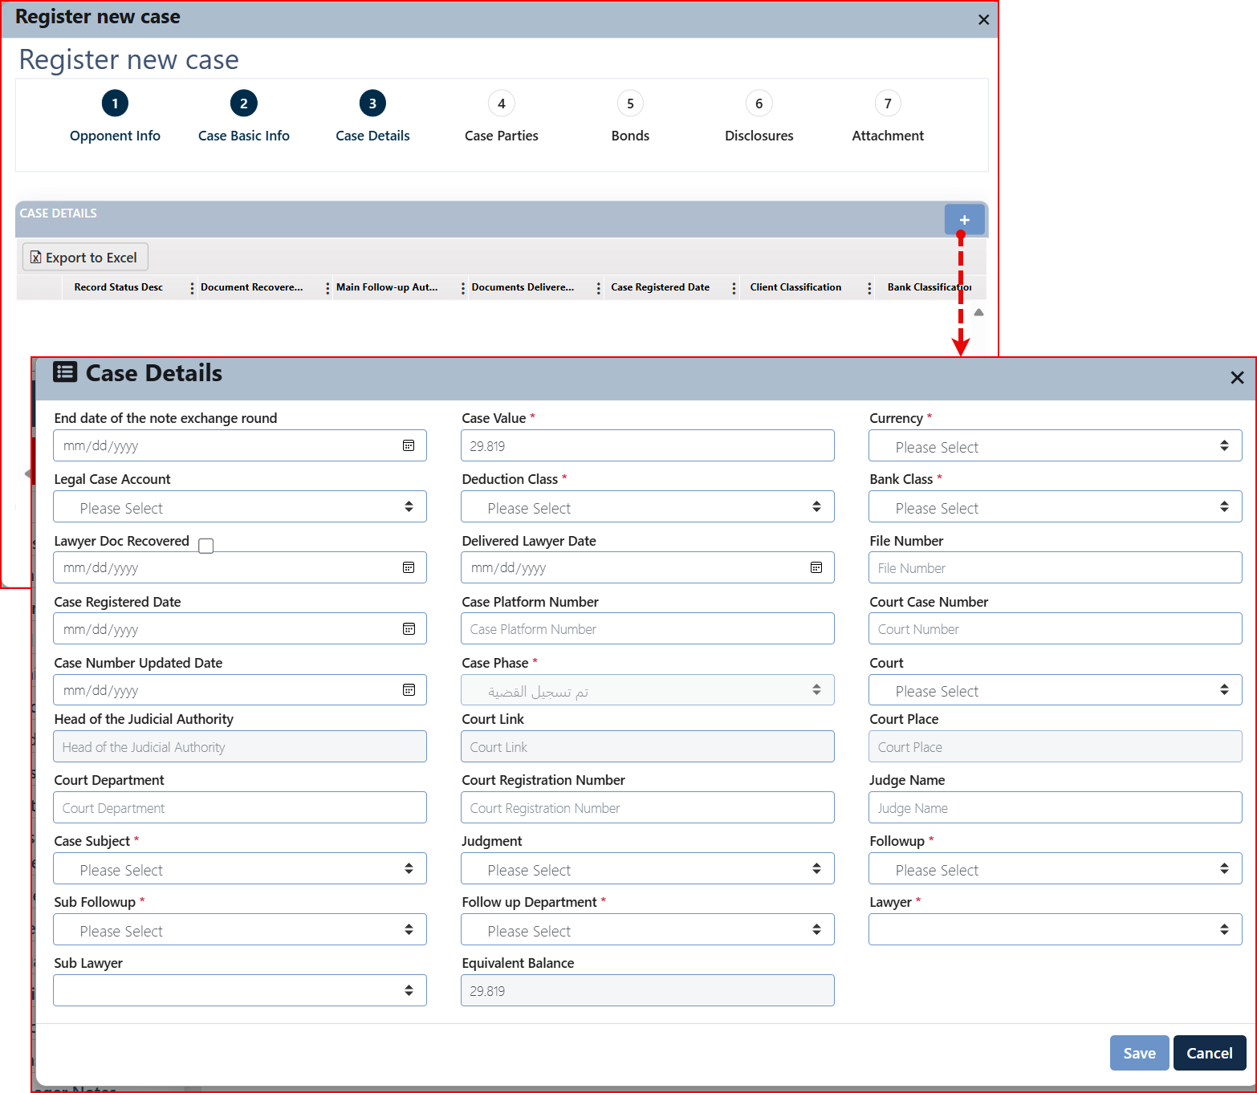

The following is a detailed explanation of the field and its related default values.

|  |  |
| --- | --- |
| Field | Comments |
| End date of the note exchange round |  |
| Case Value * | |  | | --- | | If the case is filed **against the bank**, the amount must appear in **Jordanian Dinar**. When the case is initiated through the **Remedial system**, this field becomes **mandatory**. |  |  | | --- | |  | |
| Currency * | Select the currency from the CURRENCY list. |
| Legal Case Account | Select the appropriate account to which the legal expenses will be charged. |
| Deduction Class * | Select the appropriate value based on the specific circumstances of the case.   |  |  | | --- | --- | | * Appellant | * مستأنف | | * Judgment Debtor | * محكوم عليه | | * Judgment Creditor | * محكوم له | | * Defendant | * مدعي عليه | | * Plaintiff | * مدعي | | * Accused | * مشتكى عليه | | * Notified Party | * المنذر له | | * Petitioner | * مستدعى | | * Respondent | * مستدعى عليه | | * Complainant | * مشتكي | | * Accused/Defendant in Personal Rights | * مشتكى عليه/مدعى عليه بالحق الشخصي | | * Notifier | * منذر | | * Appellee | * مميز ضده | | * Appellant (in Cassation) | * المميز | | * Respondent to Appeal | * مستأنف ضده | | * Legacy Case / Historical Case | * قضايا قديمة | |
| Bank Class * | Select the appropriate value based on the specific circumstances of the case.   |  |  | | --- | --- | | * Appellant | * مستأنف | | * Judgment Debtor | * محكوم عليه | | * Judgment Creditor | * محكوم له | | * Defendant | * مدعي عليه | | * Plaintiff | * مدعي | | * Accused | * مشتكى عليه | | * Notified Party | * المنذر له | | * Petitioner | * مستدعى | | * Respondent | * مستدعى عليه | | * Complainant | * مشتكي | | * Accused/Defendant in Personal Rights | * مشتكى عليه/مدعى عليه بالحق الشخصي | | * Notifier | * منذر | | * Appellee | * مميز ضده | | * Appellant (in Cassation) | * المميز | | * Respondent to Appeal | * مستأنف ضده | | * Legacy Case / Historical Case | * قضايا قديمة | |
| Lawyer Doc Recovered | -------------------------------------------------------------------------------------- |
| Delivered Lawyer Date | -------------------------------------------------------------------------------------- |
| File Number | -------------------------------------------------------------------------------------- |
| Case Registered Date | This field appears when the case number is changed. It becomes mandatory and non-editable once entered. |
| Case Platform Number |  |
| Court Case Number | Enter the case number registered with the court |
| Case Number Updated Date |  |
| Case Phase * | Select the related phase based on the circumstances of the case.   |  |  | | --- | --- | | * Judgment Issued | * صدر قرار حكم | | * Appeal | * استئناف | | * Judgment Executed | * تم تنفيذ قرار الحكم | | * Case Registered | * تم تسجيل القضية | | * Under Hearing | * منظورة جلسات | | * Cassation | * تمييز | | * Notification of Execution Orders | * تبليغ اخطارات تنفيذية | | * Case Abandoned | * القضية متروكة | | * File Renewal | * تجديد ملف القضية | | * Possession | * وضع يد | | * Other | * اخرى | | * Auction Announcements | * إعلانات البيع بالمزاد العلني | | * Property Transfer | * إحالة عقار | | * Financial Claim after Collateral Transfer | * مطالبة مالية بعد إحالة الضمان | | * Execution Process Cancellation | * فسخ إجراءات التنفيذ | | * Eviction | * اخلاء | | * Under Preparation | * قيد الاعداد | | * Execution of Non-Real Estate Mortgages | * تنفيذ سندات رهن غير عقارية | |
| Court | -------------------------------------------------------------------------------------- |
| Head of the Judicial Authority | -------------------------------------------------------------------------------------- |
| Court Link | -------------------------------------------------------------------------------------- |
| Court Place | -------------------------------------------------------------------------------------- |
| Court Department | -------------------------------------------------------------------------------------- |
| Court Registration Number | -------------------------------------------------------------------------------------- |
| Judge Name | -------------------------------------------------------------------------------------- |
| Case Subject * | Select the appropriate value based on the specific circumstances of the case:   |  |  | | --- | --- | | * Non-enforceability of Disposition | * عدم نفاذ تصرف | | * Theft | * سرقة | | * Eviction and Rent Claim | * إخلاء و مطالبة بأجور | | * Request to Intervene | * طلب تدخل بالدعوى | | * Other | * Other | | * Annulment of Debt Instrument Execution | * ابطال اجراءات تنفيذ سند دين | | * Forgery | * تزوير | | * Invalid Notification | * بطلان تبليغات | | * Assault | * ايذاء | | * Funds Recovery | * استرداد مبالغ | | * Bankruptcy | * الافلاس | | * Illegal Employment of Foreign Worker | * استخدام عامل اجنبي بصورة مخالفة | | * Labor Rights | * حقوق عمالية | | * Retrial Request | * إعادة محاكمة | | * Urgent Disclosure Request | * طلب كشف مستعجل | | * Claim Prevention + Financial Claim | * منع مطالبة + مطالبة ماليه | | * Delegations | * انابات | | * Opposition Prevention | * منع معارضة | | * Not Available | * غير متوفر | | * Claim Prevention & Accounting | * منع مطالبة ومحاسبة | | * Defamation | * تشهير | | * Debt Instrument Execution | * تنفيذ سند دين | | * Unjust Enrichment | * اثراء بلا سبب | | * Financial Claim & Precautionary Seizure | * مطالبة مالية وحجز تحفظي | | * Promissory Note | * سند كمبيالة | | * Financial Claim | * مطالبة مالية | | * Money Transfers | * حوالات | | * Compensation for Damages | * تعويض عن عطل وضرر | | * Preemption Ownership | * تملك بالشفعة | | * Causing Harm | * التسبب بالإيذاء | | * Cybercrimes | * جرائم الكترونية | | * Defamation and Compensation Claim | * الشتم والذم والمطالبة ببدل العطل والضرر | | * Eviction | * إخلاء | | * Annulment of Sale Procedures | * ابطال اجراءات البيع | | * Compensation Claim | * مطالبة بالتعويض | | * Real Estate Mortgage | * سند رهن عقار | | * Fraud | * الاحتيال | | * Claim Prevention | * منع مطالبة | | * Mortgage Release Request | * طلب فك رهن | | * Directly Executed Promissory Notes (Execution Dept.) | * كمبيالات نفذت مباشرة بدائرة الاجراء | | * Procedure Annulment + Accounting | * ابطال الاجراءات + محاسبة | | * Pledged Equipment | * رهن حيازي معدات | | * Guarantee Claim | * مطالبة بكفالة | | * Fair Rent | * أجر بالمثل | | * Material & Moral Damage Compensation | * مطالبة بالتعويض عن الضرر المادي والمعنوي | | * Unjustified Receipt | * قبض غير مستحق | | * Bounced Cheque & Personal Rights Claim | * شيك بدون رصيد وادعاء بالحق الشخصي | | * Cheque Presentation | * طرح شيكات | | * Property Usurpation | * اغتصاب عقار | | * Property Damage | * الحاق الضرر بمال الغير | | * Car Mortgage | * سند رهن سيارة | | * Labor Rights Claim | * مطالبة بحقوق عمالية | | * Third Party Objection | * اعتراض الغير | | * Defamation, Slander, and Contempt | * ذم و قدح و تحقير | | * Forgery and Breach of Trust | * تزوير واساءة الائتمان | | * Bankruptcy Debtor Restriction | * الحجر على المدين المفلس | | * Financial Claim / Delegation | * مطالبة مالية/انابة | | * Bounced Cheque | * شيك بدون رصيد | | * Accounting Case | * دعوى محاسبة | | * Partition Termination | * ازالة الشيوع | | * Execution of Debt Security against Immovable Assets | * تنفيذ سند تأمين دين مقابل اموال غير منقولة | | * Notary Warning | * انذار موجه بواسطة كاتب عدل | | * Guarantee | * كفاله | | * Share Mortgage | * سند رهن اسهم | | * Mortgage Release and Compensation | * فك رهن وعطل وضرر | | * Bankruptcy Declaration | * اشهار افلاس | | * Cheque Delivery | * تسليم شيكات | | * Bad Debt | * دين هالك | | * Safe Deposit Box | * صندوق حديدي | | * Embezzlement | * اختلاس | | * Trespass and Damage Removal | * ازالة التعدي والضرر | | * Machinery Mortgage | * سند رهن اليات | | * Procedure Annulment | * ابطال الاجراءات | | * Violation | * مخالفة | | * Inspection | * test | | * Breach of Trust | * اساءة ائتمان | | * Compulsory Specific Performance | * التنفيذ العيني الجبري | | * Criminal Complaint & Personal Rights Claim | * شكوى جزائية وادعاء بالحق الشخصي | | * Insurance | * تأمين | |
| Judgment |  |
| Follow up * |  |
| Sub Follow up * | Select the appropriate value based on the specific circumstances of the case:   |  |  | | --- | --- | | * Financial Institutions Division | * دائرة المؤسسات المالية | | * Treasury Sector | * قطاع الخزينة | | * External Credit Processing Center / External Unit | * مركز معالجة الائتمان الخارجي / وحدة الخارجي | | * Foreign Branches and Subsidiaries Division | * دائرة الفروع الخارجية والشركات التابعة | | * Internal Credit Processing Center / Debt Execution Unit | * مركز معالجة الائتمان الداخلي / وحدة تنفيذ الدين | | * Credit Real Estate Processing Center / Bank Real Estate Unit | * مركز معالجة الائتمان عقارات البنك والمتابعة / وحدة عقارات البنك | | * Real Estate Portfolio Center | * مركز المحفظة العقارية | | * Internal Credit Processing Center / Internal Unit | * مركز معالجة الائتمان الداخلي / وحدة الداخلي | | * External Credit Processing Center / Off-Balance Sheet Unit | * مركز معالجة الائتمان الخارجي / وحدة خارج الميزانية | | * General Administration | * الادارة العامة | | * Finance Department | * الادارة المالية | | * Digital Channels Center | * مركز القنوات الالكترونية | | * Retail Credit Division | * دائرة ائتمان الافراد | | * Branch Affairs Center | * مركز شؤون الفروع | | * Human Resources Division | * دائرة الموارد البشرية | | * Property & Administrative Affairs Division | * دائرة الممتلكات والشؤون الإدارية | | * Corporate Credit Division | * دائرة ائتمان الشركات | |
| Follow up Department * | -------------------------------------------------------------------------------------- |
| Lawyer * | Select the assigned lawyer. |
| Sub Lawyer | Select the secondary lawyer. |
| Equivalent Balance | Auto-calculated by the system based on currency equivalence |

Upon entering the required information, please click the Save button. The information record will subsequently appear in the display box as outlined, and the Add button will become inactive.

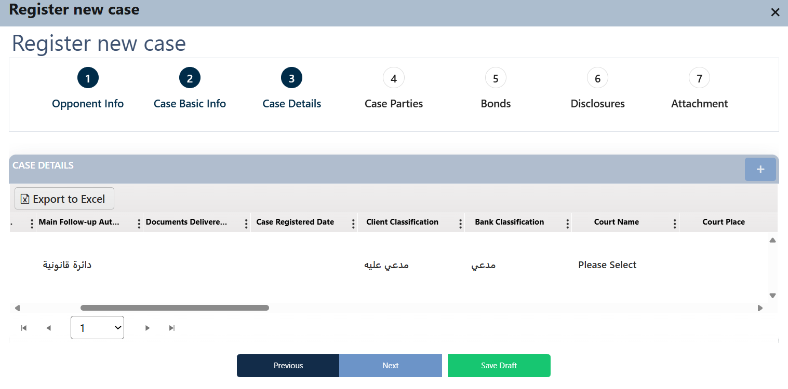

Comment: It is not possible to add an additional record.

**Insert the necessary information and click next.**

##### Case Parties

To insert the legal case partes information. The user can click on the add button “+” to insert new related records.

Layout:

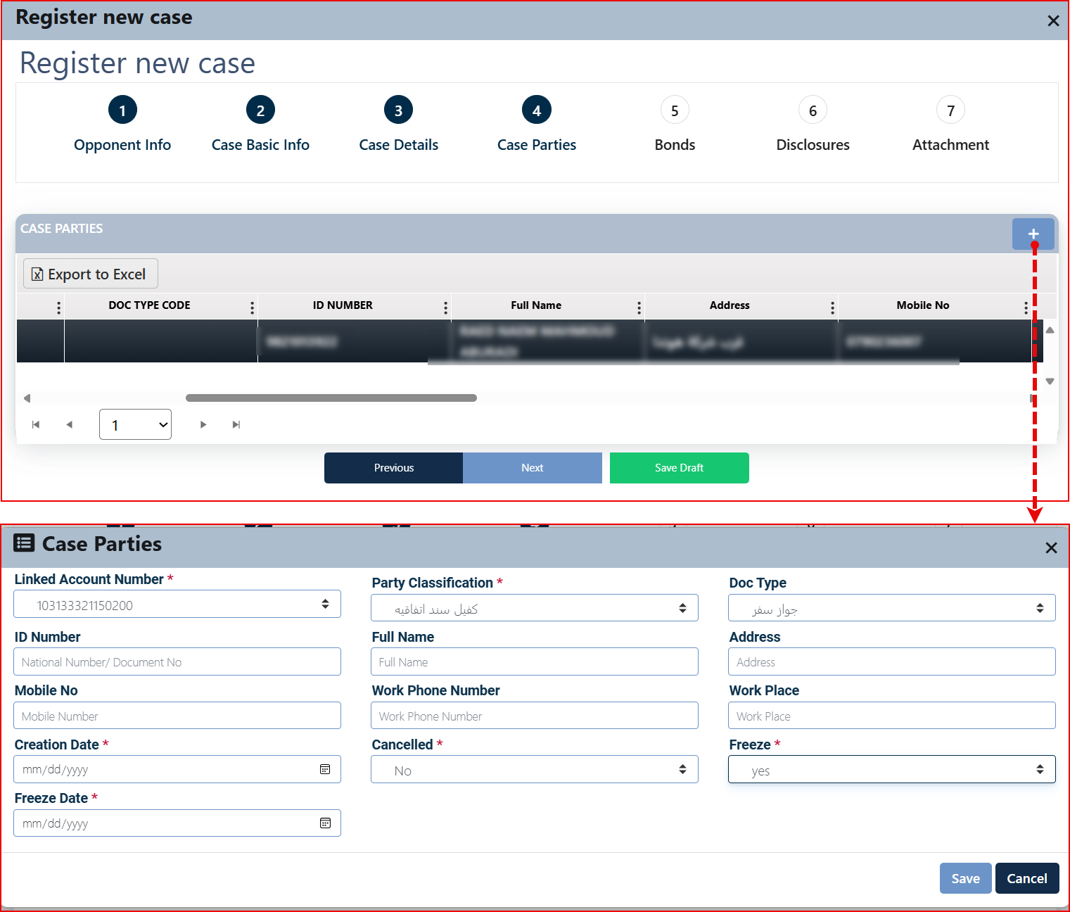

The following is a detailed explanation of the field and its related default values.

|  |  |
| --- | --- |
| Field | Comments |
| Linked Account Number * | If the identified party is a bank customer and is linked to a specific account, the account that needs to be linked to the identified party is selected. |
| Party Classification * | Select one of the following options:   |  |  | | --- | --- | | * Endorser | * المجير | | * Guarantor | * كفيل / الضامن | | * Debtor | * مدين | |
| Doc Type | Select a document number or passport number. |
| National Number/ Document No | If you select a national number from the "Document Type" list, the field will only allow numbers and 10 digits. Otherwise, you can enter up to 15 digits. |
| Full Name | -------------------------------------------------------------------------------------- |
| Address | -------------------------------------------------------------------------------------- |
| Mobile No | -------------------------------------------------------------------------------------- |
| Work Phone Number | -------------------------------------------------------------------------------------- |
| Work Place | -------------------------------------------------------------------------------------- |
| Creation Date * | -------------------------------------------------------------------------------------- |
| Cancelled * | Yes/No, if yes the cancellation date field will appear if no the freeze field will appear |
| Cancellation Date * | -------------------------------------------------------------------------------------- |
| Freeze * | Yes/No, if yes the freeze date field will appear |
| Freeze Date * | -------------------------------------------------------------------------------------- |

Insert the necessary information and click save.

Repeat the process to add all the necessary parties.

After inserting all the parties, click on the next button to proceed with the case registration process

##### Bonds

Comment: This tab becomes accessible if the 'Case Type' in the 'Case Details' tab is set to "Execution" ("تنفيذ"), allowing for the entry of bond-related information.

At this stage, the bonds related to the case are identified, along with the type of mortgage each bond is subject to. Information about these mortgage types is then recorded. The system processes the following types of mortgages:

|  |  |  |  |  |  |  |
| --- | --- | --- | --- | --- | --- | --- |
| * Stocks | * Machinery | * Cars | * Real Estate | * OPIC | * Life Insurance | * Cash |

The user inserts bond records by clicking the Add button “+” at the top of the display box on the page. A new screen then appears, allowing the user to enter bond details. The fields displayed vary depending on the **type** "type of bond" selected.

Layout:

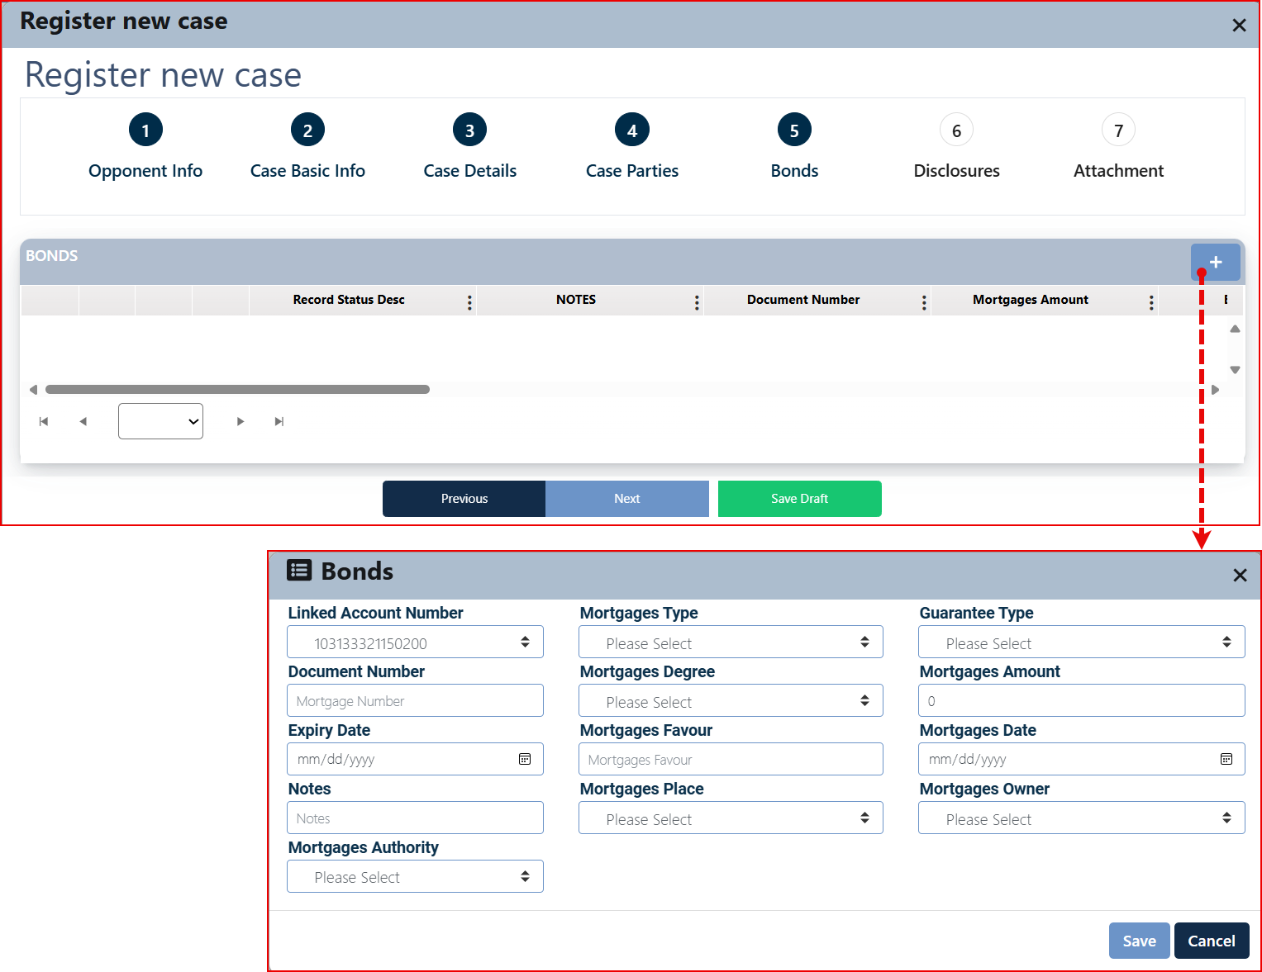

The following is a detailed explanation of the field and its related default values.

|  |  |
| --- | --- |
| Field | Comments |
| Linked Account Number | -------------------------------------------------------------------------------------- |
| Mortgages Type | Select the appropriate value based on the specific circumstances of the case:  The components of a screen differ based on the selected option. A detailed explanation will follow this table for each mortgage type.   |  |  |  |  |  |  |  | | --- | --- | --- | --- | --- | --- | --- | | Stocks | Machinery | Cars | Real Estate | OPIC | Life Insurance | Cash | |
| Guarantee Type | Select the appropriate value based on the specific circumstances of the case:   |  |  | | --- | --- | | * Court Promissory Note | * سند لأمر / محكمة | | * Promissory Note | * سند لأمر | | * Contract | * العقد | | * Dispute Decision | * قرار منازعات | | * Decision/Deed | * قرار/صك | | * Decision from Judicial Committees | * قرار صادر من لجان قضائية | | * Electronic Bond | * سند الكتروني | |
| Document Number | -------------------------------------------------------------------------------------- |
| Mortgages Degree | -------------------------------------------------------------------------------------- |
| Mortgages Amount | -------------------------------------------------------------------------------------- |
| Expiry Date | -------------------------------------------------------------------------------------- |
| mortgage in favor | -------------------------------------------------------------------------------------- |
| Mortgages Date | -------------------------------------------------------------------------------------- |
| Notes | -------------------------------------------------------------------------------------- |
| Mortgages Place | -------------------------------------------------------------------------------------- |
| Mortgages Owner | Select the appropriate value based on the specific circumstances of the case:   |  |  | | --- | --- | | * Clint | * عميل | | * Guarantor | * كفيل / الضامن | | * The Bank | * البنك | |
| Mortgages Authority | -------------------------------------------------------------------------------------- |

###### Mortgage Type Insertion Details

Mortgage Type = Cars

Once the user selects Mortgage Type = Cars, the screen components will dynamically change based on this selection as follows:

The user need to insert related mortgage record information by click on the add button “+”, the related screen will appear as below:

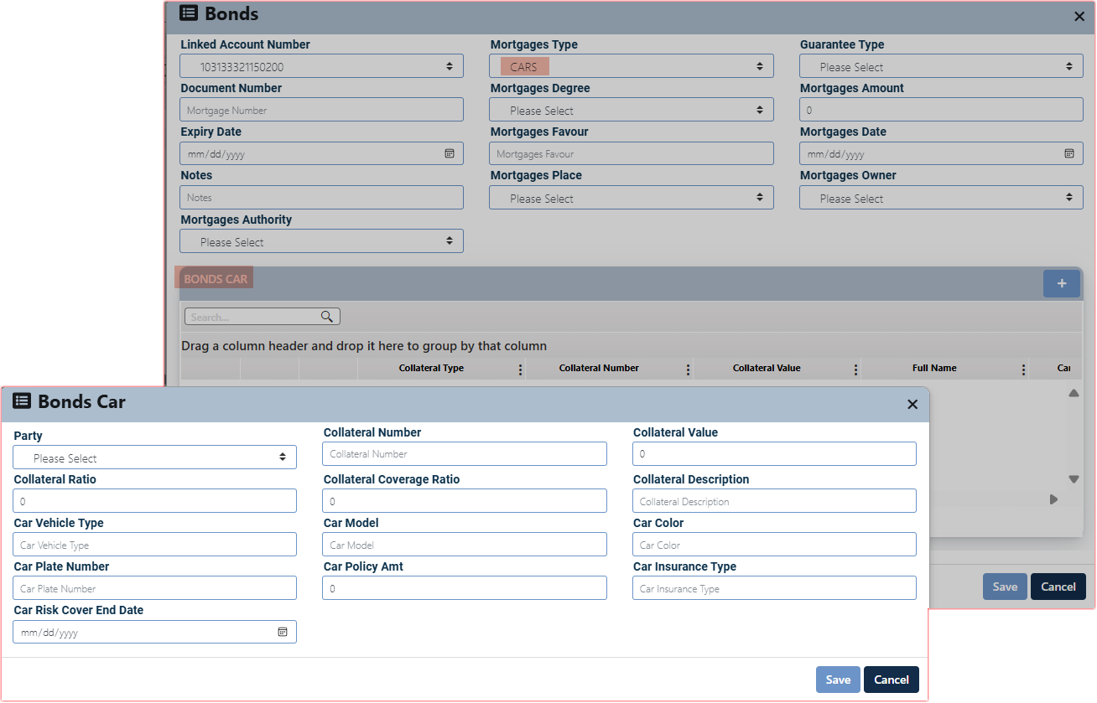

The user is required to enter the necessary car information and click the Save button to complete the insertion process.

Related fields are:

|  |  |  |
| --- | --- | --- |
| * Party | * Collateral Number | * Collateral Value |
| * Collateral Ratio | * Collateral Coverage Ratio | * Collateral Description |
| * Car Vehicle Type | * Car Model | * Car Color |
| * Car Plate Number | * Car Policy Amt | * Car Insurance Type |
| * Car Risk Cover End Date |  |  |

The records will be displayed in the related grid view, allowing the user to manage the entries using the Edit, View, and Delete control buttons provided for each record.

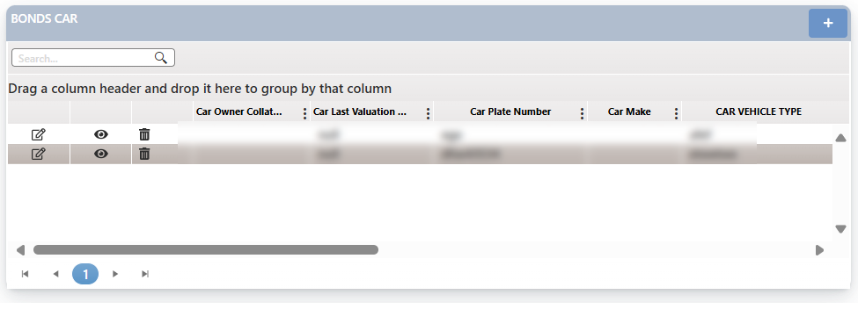

After clicking the Save button, the record will be displayed under the Bond tab as shown below.

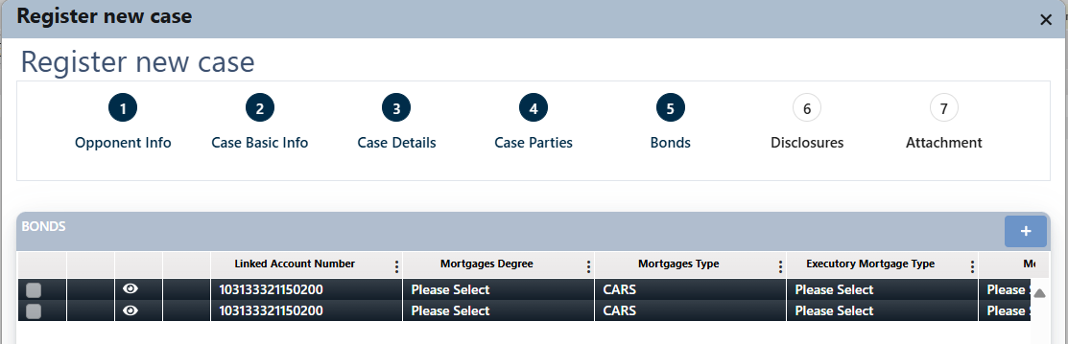

Mortgage Type = Cash

Once the user selects Mortgage Type = cash, the screen components will dynamically change based on this selection as follows:

The user needs to insert related mortgage record information by click on the add button “+”, the related screen will appear as below:

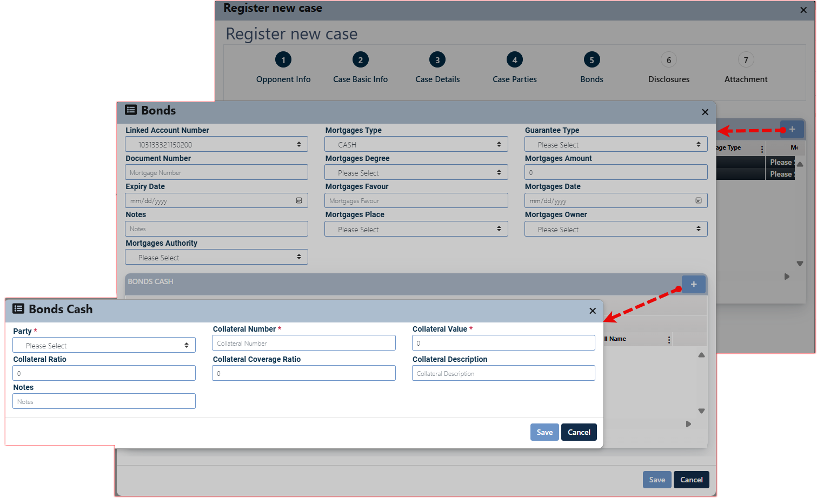

The user is required to enter the necessary information and click the Save button to complete the insertion process.

Related fields are:

|  |  |  |
| --- | --- | --- |
| * Party * | * Collateral Number * | * Collateral Value * |
| * Collateral Ratio | * Collateral Coverage Ratio | * Collateral Description |
| * Note |  |  |

The records will be displayed in the related grid view, allowing the user to manage the entries using the Edit, View, and Delete control buttons provided for each record.

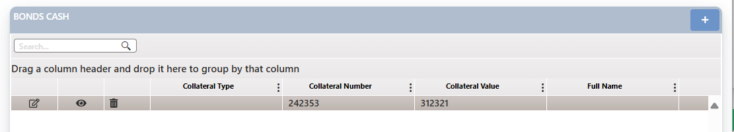

After clicking the Save button, the record will be displayed under the Bond tab as shown below.

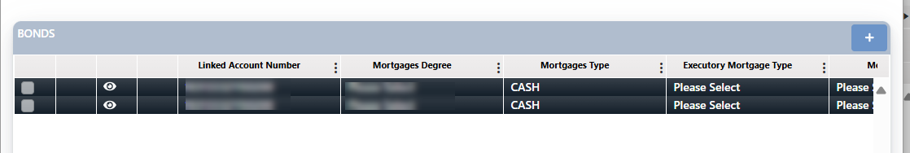

Mortgage Type = Life Insurance

Once the user selects Mortgage Type = life insurance, the screen components will dynamically change based on this selection as follows:

The user needs to insert related mortgage record information by click on the add button “+”, the related screen will appear as below:

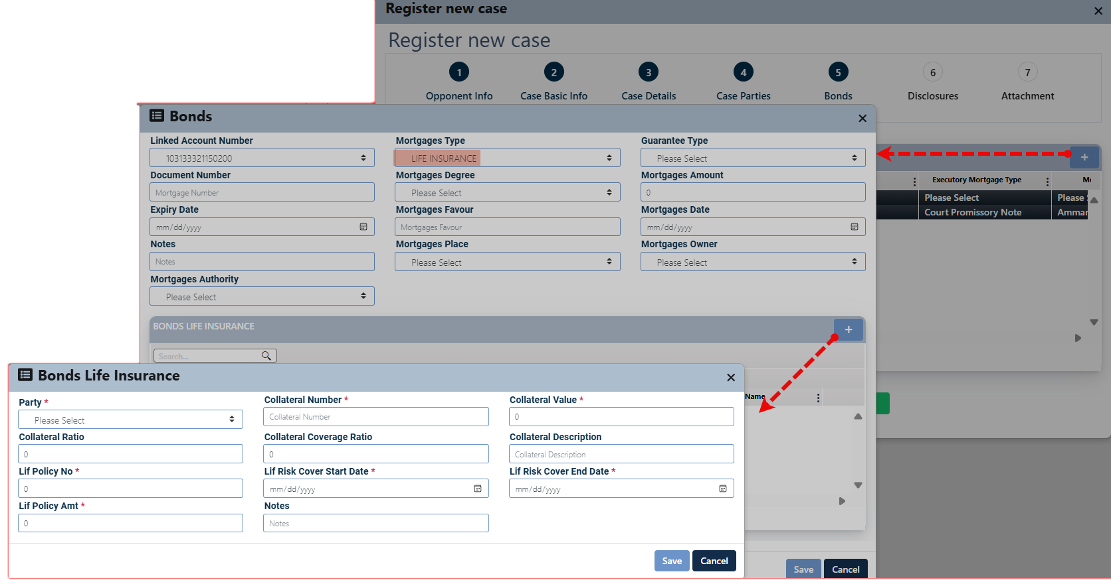

The user is required to enter the necessary information and click the Save button to complete the insertion process.

Related fields are:

|  |  |  |
| --- | --- | --- |
| * Party * | * Collateral Number * | * Collateral Value * |
| * Collateral Ratio | * Collateral Coverage Ratio | * Collateral Description |
| * Lif Policy No * | * Lif Risk Cover Start Date * | * Lif Risk Cover End Date * |
| * Lif Policy Amt * | * Notes |  |

The records will be displayed in the related grid view, allowing the user to manage the entries using the Edit, View, and Delete control buttons provided for each record.

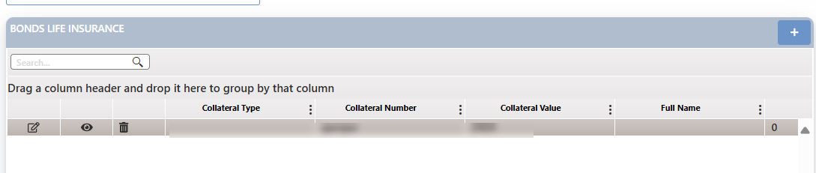

After clicking the Save button, the record will be displayed under the Bond tab as shown below.

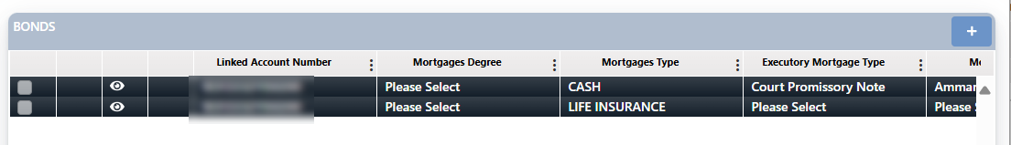

Mortgage Type = Machin

Once the user selects Mortgage Type = Machin, the screen components will dynamically change based on this selection as follows:

The user needs to insert related mortgage record information by click on the add button “+”, the related screen will appear as below:

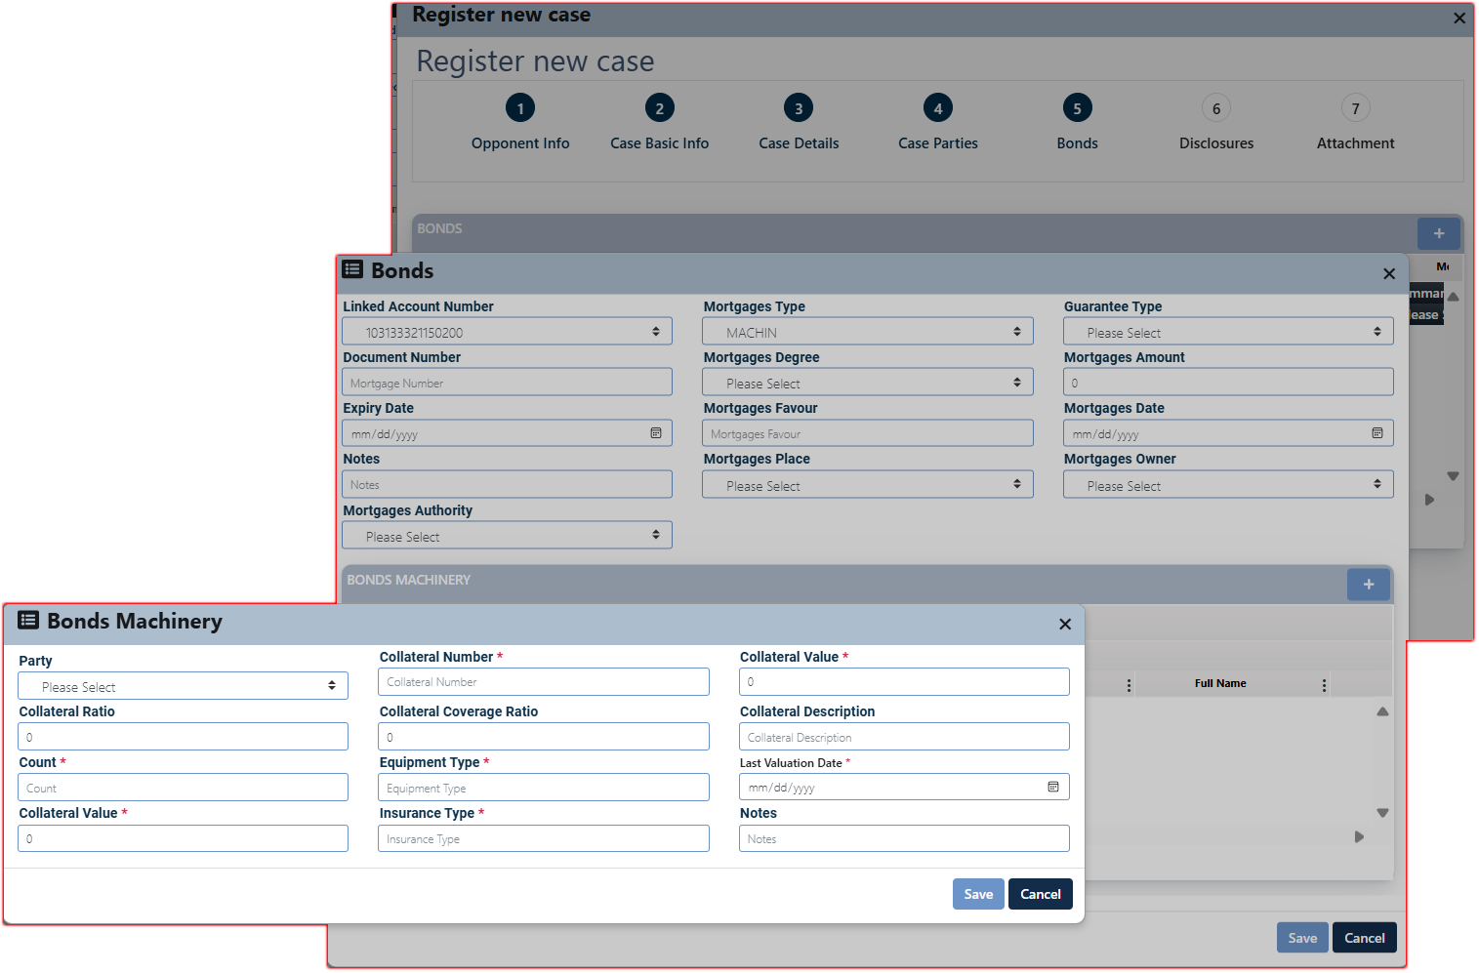

The user is required to enter the necessary information and click the Save button to complete the insertion process.

Related fields are:

|  |  |  |
| --- | --- | --- |
| * Party | * Collateral Number * | * Collateral Value * |
| * Collateral Ratio | * Collateral Coverage Ratio | * Collateral Description |
| * Count * | * Equipment Type * | * Last Valuation Date * |
| * Collateral Value * | * Insurance Type * | * Notes |

The records will be displayed in the related grid view, allowing the user to manage the entries using the Edit, View, and Delete control buttons provided for each record.

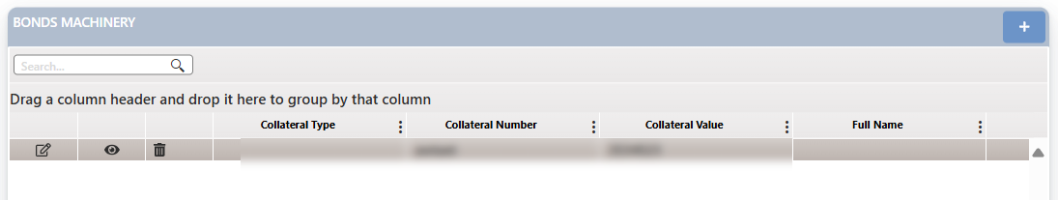

After clicking the Save button, the record will be displayed under the Bond tab as shown below.

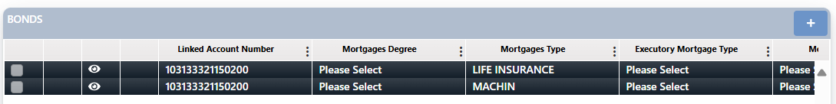

Mortgage Type = OPIC

Once the user selects Mortgage Type = OPIC, the screen components will dynamically change based on this selection as follows:

The user needs to insert related mortgage record information by click on the add button “+”, the related screen will appear as below:

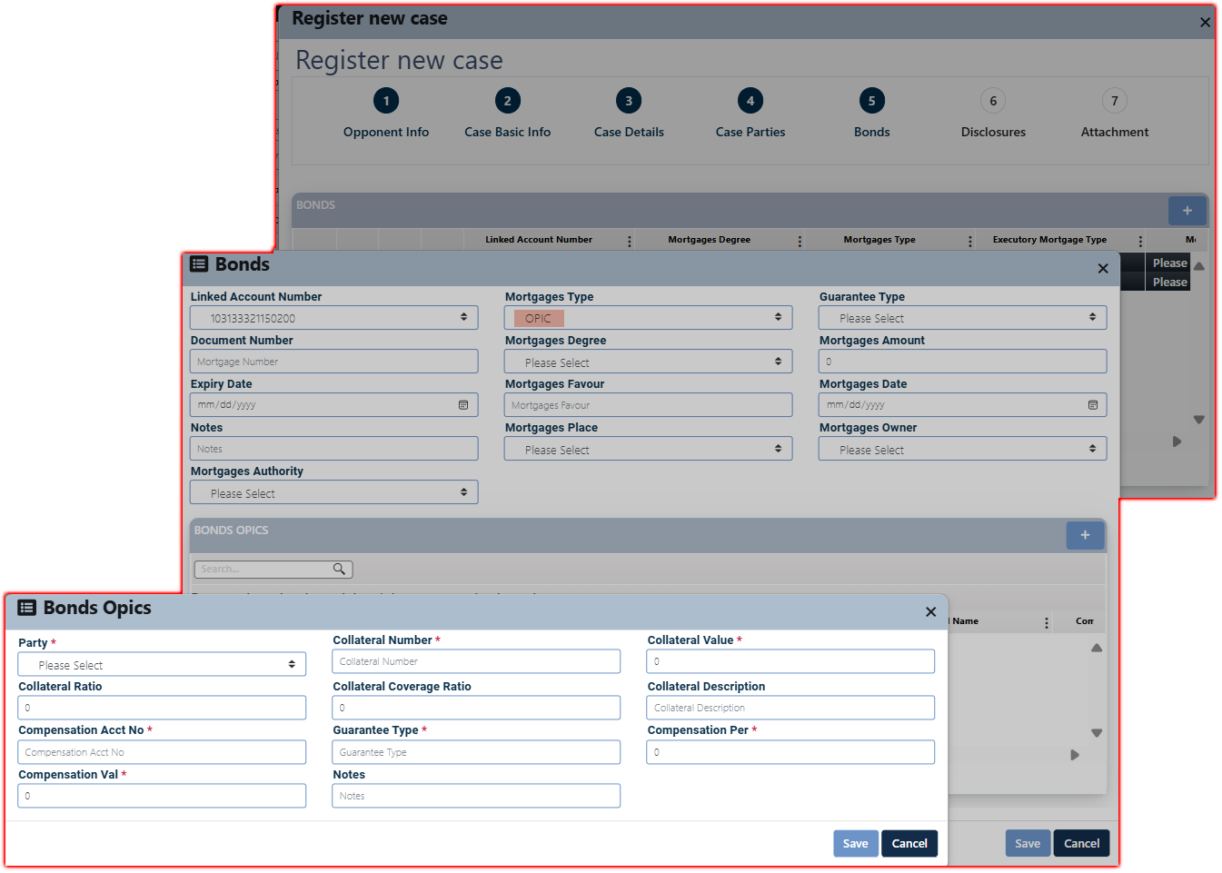

The user is required to enter the necessary information and click the Save button to complete the insertion process.

Related fields are:

|  |  |  |
| --- | --- | --- |
| * Party * | * Collateral Number * | * Collateral Value * |
| * Collateral Ratio | * Collateral Coverage Ratio | * Collateral Description |
| * Compensation Acct No * | * Guarantee Type * | * Compensation Per * |
| * Compensation Val * | * Notes |  |

The records will be displayed in the related grid view, allowing the user to manage the entries using the Edit, View, and Delete control buttons provided for each record.

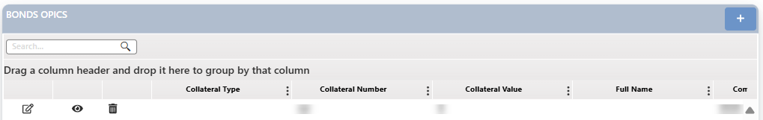

After clicking the Save button, the record will be displayed under the Bond tab as shown below.

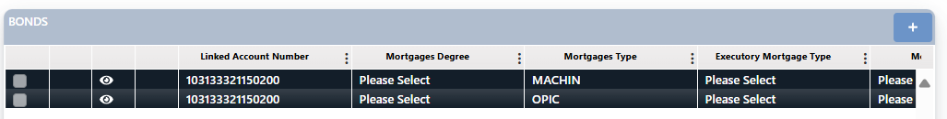

Mortgage Type = Real Estate

Once the user selects Mortgage Type = Real Estate, the screen components will dynamically change based on this selection as follows:

The user needs to insert related mortgage record information by click on the add button “+”, the related screen will appear as below:

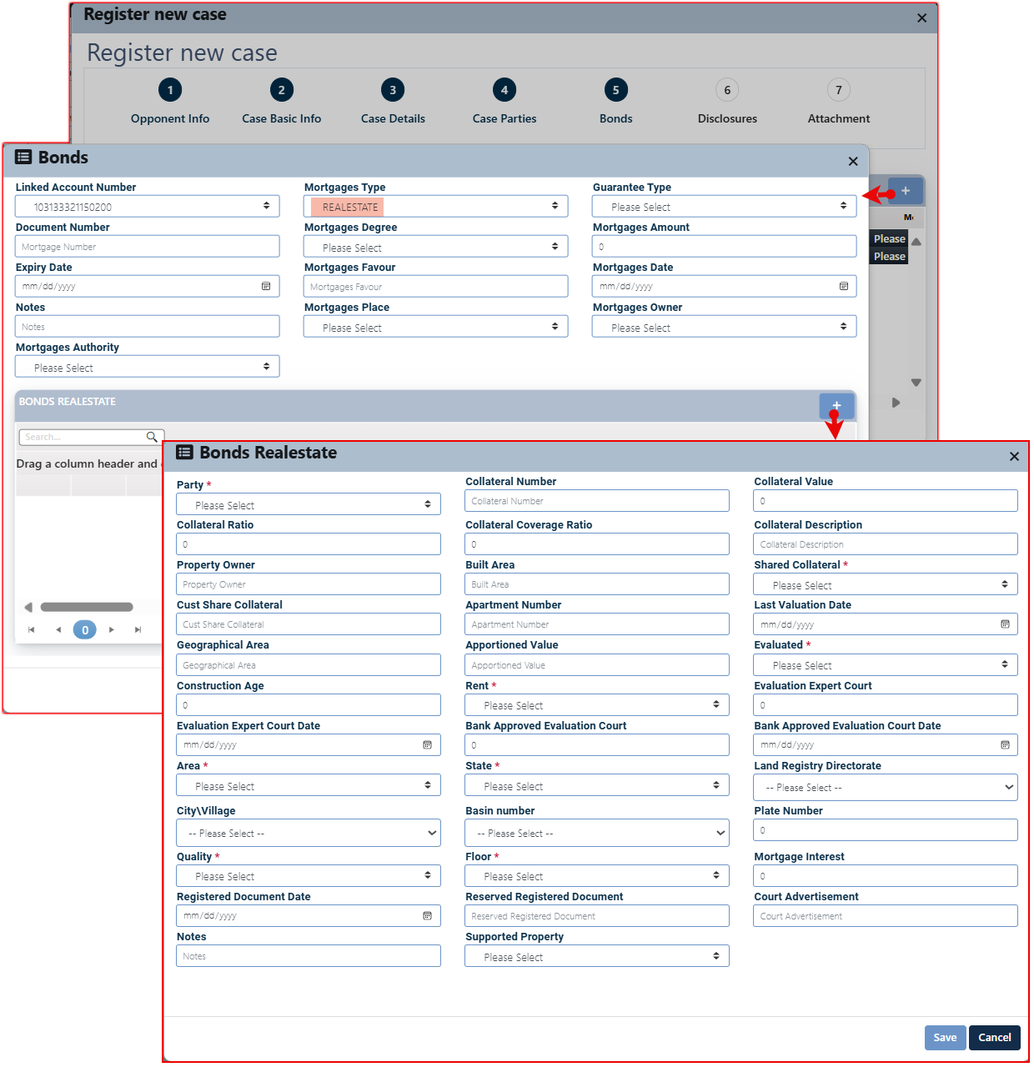

Related fields are:

|  |  |  |
| --- | --- | --- |
| * Party * | * Collateral Number | * Collateral Value |
| * Collateral Ratio | * Collateral Coverage Ratio | * Collateral Description |
| * Property Owner | * Built Area | * Shared Collateral * |
| * Cust Share Collateral | * Apartment Number | * Last Valuation Date |
| * Geographical Area | * Apportioned Value | * Evaluated * |
| * Construction Age | * Rent * | * Evaluation Expert Court |
| * Evaluation Expert Court Date | * Bank Approved Evaluation Court | * Bank Approved Evaluation Court Date |
| * Area * | * State * | * Land Registry Directorate |
| * City\Village | * Basin number | * Plate Number |
| * Quality * | * Floor * | * Mortgage Interest |
| * Registered Document Date | * Reserved Registered Document | * Court Advertisement |
| * Notes | * Supported Property |  |

The user is required to enter the necessary information and click the Save button to complete the insertion process.

The records will be displayed in the related grid view, allowing the user to manage the entries using the Edit, View, and Delete control buttons provided for each record.

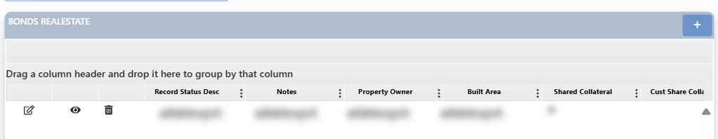

After clicking the Save button, the record will be displayed under the Bond tab as shown below.

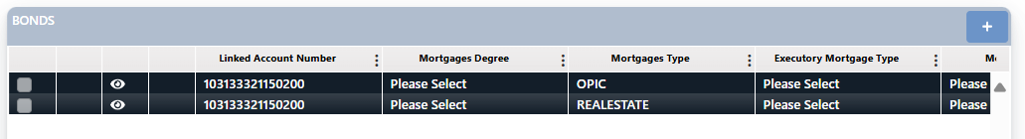

Mortgage Type = Stocks

Once the user selects Mortgage Type = stocks, the screen components will dynamically change based on this selection as follows:

The user needs to insert related mortgage record information by click on the add button “+”, the related screen will appear as below:

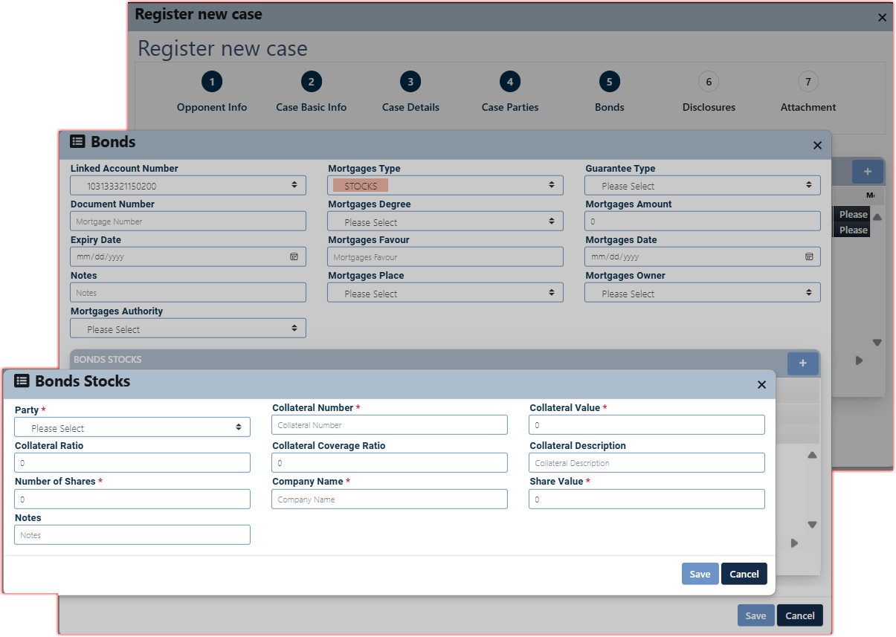

The user is required to enter the necessary information and click the Save button to complete the insertion process.

Related fields are:

|  |  |  |
| --- | --- | --- |
| * Party * | * Collateral Number * | * Collateral Value * |
| * Collateral Ratio | * Collateral Coverage Ratio | * Collateral Description |
| * Number of Shares * | * Company Name * | * Share Value * |
| * Notes |  |  |

The records will be displayed in the related grid view, allowing the user to manage the entries using the Edit, View, and Delete control buttons provided for each record.

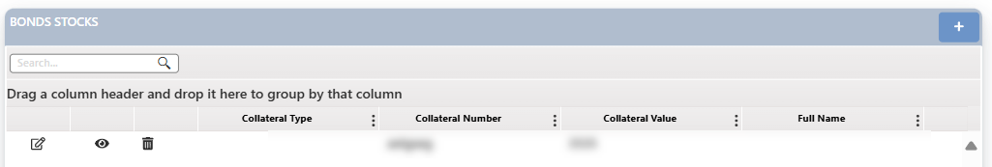

After clicking the Save button, the record will be displayed under the Bond tab as shown below.

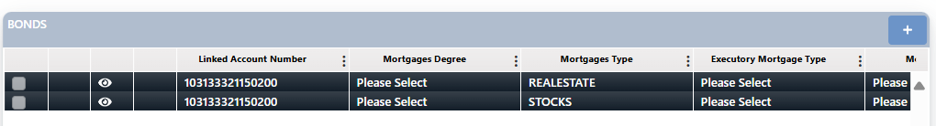

##### Disclosures

This stage allows users to insert and manage financial provisions related to legal case filed against the bank.

The user needs to insert related record by click on the add button “+”, the related screen will appear as below:

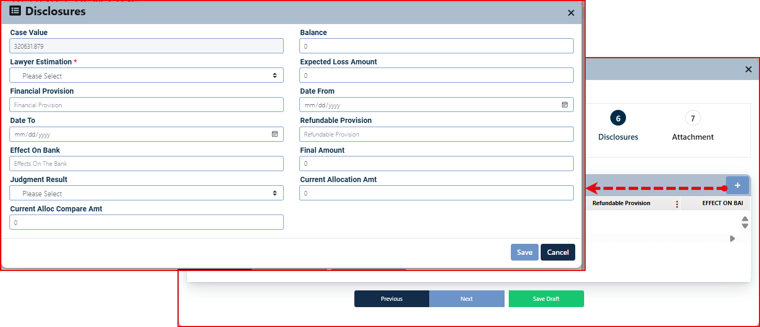

The user is required to enter the necessary information and click the Save button to complete the insertion process.

Related fields are:

|  |  |  |
| --- | --- | --- |
| * Case Value | * Balance | * Lawyer Estimation * |
| * Expected Loss Amount | * Financial Provision | * Date From |
| * Date To | * Refundable Provision | * Effect On Bank |
| * Final Amount | * Judgment Result | * Current Allocation Amt |
| * Current Alloc Compare Amt |  |  |

After clicking the Save button, the record will be displayed under the disclosures tab as shown below.



Comment, The Add button will be hidden after the record is inserted, as only one record is allowed per case in this tab.

Insert the necessary information and click next.

##### Attachment

This stage is designated for adding attachments related to the case. The screen for this stage is designed to support multiple entries. Users can view each entry by clicking on its name, and they also have the option to delete one or more records simultaneously.

The user needs to insert attachment record by click on the add button “+”, the related screen will appear as below:

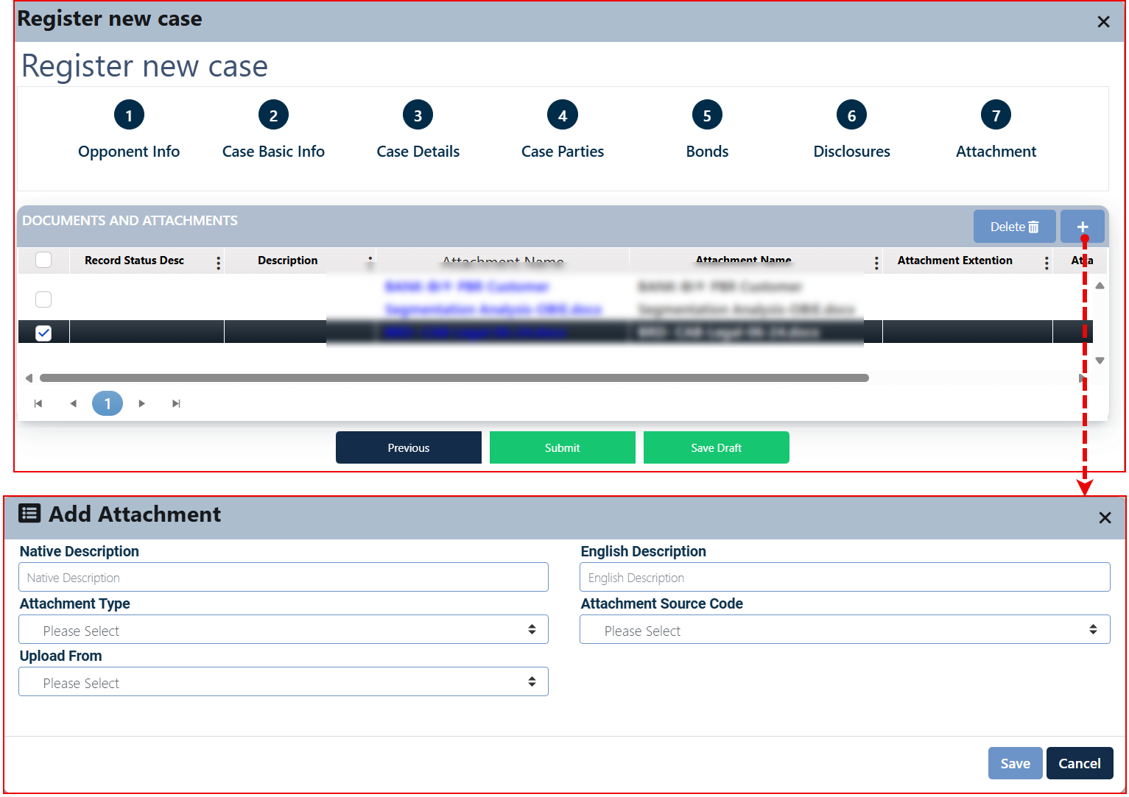

The user is required to enter the necessary information and click the Save button to complete the insertion process.

Related fields are:

|  |  |  |  |
| --- | --- | --- | --- |
| * Native Description | * English Description | * Attachment Type | * Attachment Source Code |
| * Upload From: Devise / OnBase, if the value selected wase from Device, the user can upload the attachment from the active device. | | | |

After clicking the Save button, the record will be displayed under the Attachment tab as shown above.

* The user needs to click the Submit button to finalize the case registration process.

To view an attachment, click on its name. The system will then download the attachment to your device.

To delete a previously added attachment, select the attachment or a group of attachments, and then click the "Delete" button.

#### Account Evaluation

This button displays a dashboard visualization that presents the customer's interaction with the applied follow-up actions and procedures taken on the active case, as illustrated in the following graph.

**To view an account evaluation**, the current user should follow these steps:

1. Click the " Account Evaluation " button. Then the related screen will appear.

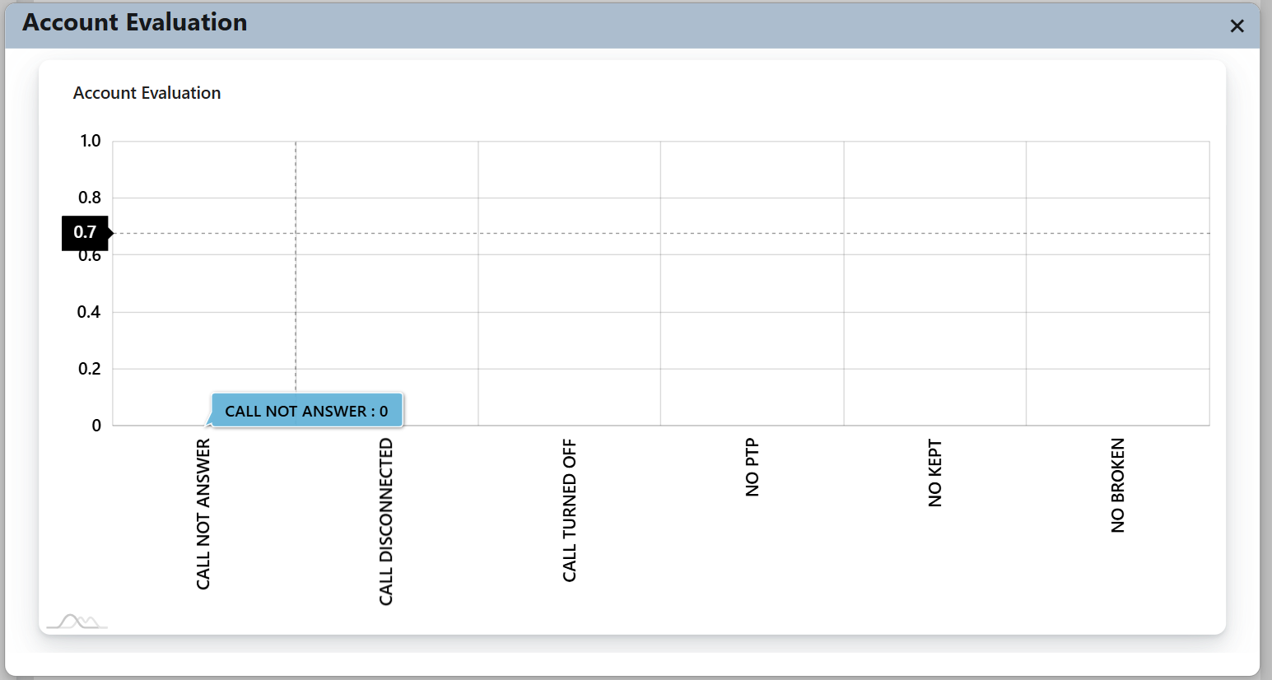

#### Transfer Customer

This procedure allows users to transfer a task between the Remedial and Collection departments, provided they meet the specified transfer conditions.

* This procedure must be approved by the direct supervisor.

To initiate the transfer, the user clicks the "Transfer Client" button, which brings up a support screen for this process.

.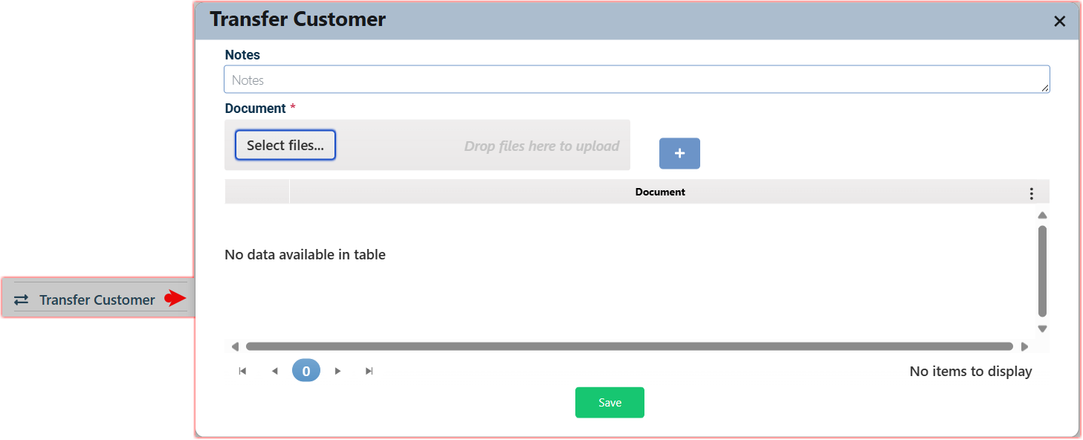

On this screen, users can add justifications for the transfer, including notes or attachments. Once the user clicks the "Save" button, the transfer will be executed if the user meets all the necessary conditions

Comments:

* A task cannot be transferred if it has already been transferred and is still awaiting checkers approval.
* The transfer will not occur if the current user lacks the necessary authorization for this action.
* A task will not be transferred if the user does not meet the conditions established within the system.

#### Manager’s Notes

This action is visible only to authorized users and allows the direct manager to add case-specific remarks.

**To add a manager’s notes**, the current user should follow these steps:

Click the " Manager’s Notes " button. Then the related screen will appear.

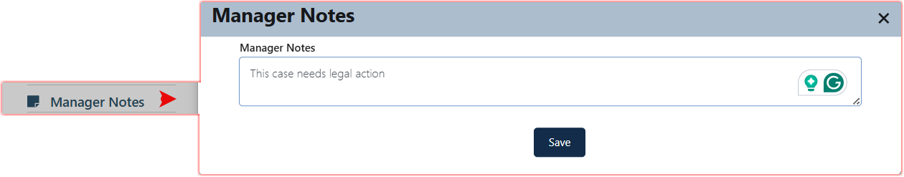

The authorized manager can enter the required notes and click the "Save" button.

The note is then stored and automatically added under the "Manager Notes" tab within the same customer record, ensuring that managerial input is properly documented and centrally accessible within the system.

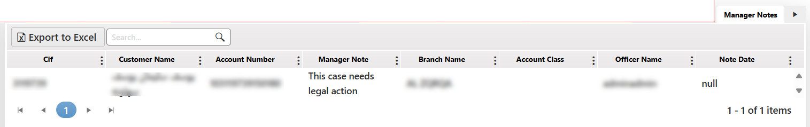

#### Account Classification

This action is available to authorized users, typically those assigned to branch offices.

It enables the classification of a customer account for follow-up by a designated office and according to specific tracking needs.

When the user clicks the "Account Classification" button, the related screen appears, allowing the user to categorize the account under one of these options: Individuals, Account Classification, Written-Off Accounts, Rescheduled Accounts, or Settled Accounts.

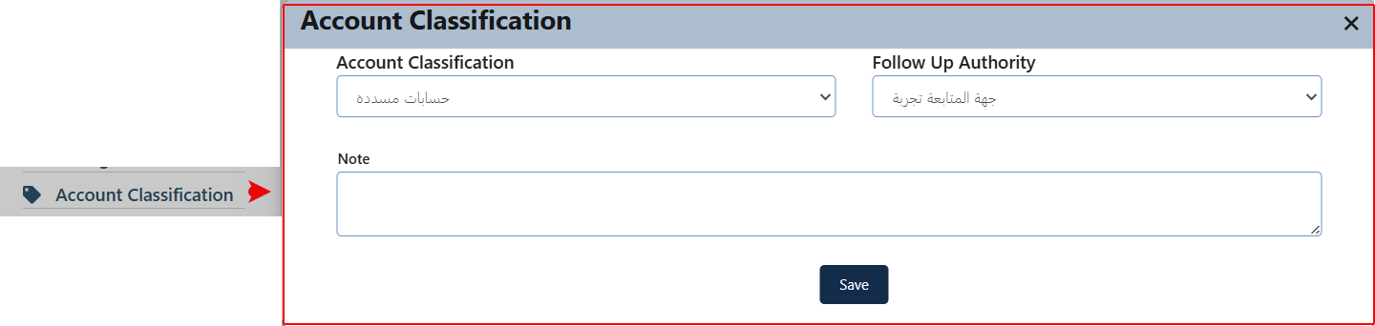

The user then selects the follow-up authority and may add any relevant notes in the designated comments field to ensure full documentation of the action. The request is then submitted for approval.

Note: This action requires approval from the direct manager (according to the approved workflow). Once the classification is submitted by a “Maker”-type user, the request is routed to the Credit Portfolio screen – specifically to the “Approval” tab for the direct manager, who can either: Approve the task by clicking “Complete Task,” or, Reject and return it by clicking “Return” with mandatory remarks explaining the reason.

This sequence may vary if the implementing institution modifies the workflow structure.

#### Schedule and Structures

* This procedure is a prerequisite for calculating customer liability procedure.

This action modifies the customer's payment plan and provides details for future reference regarding their debt rescheduling.

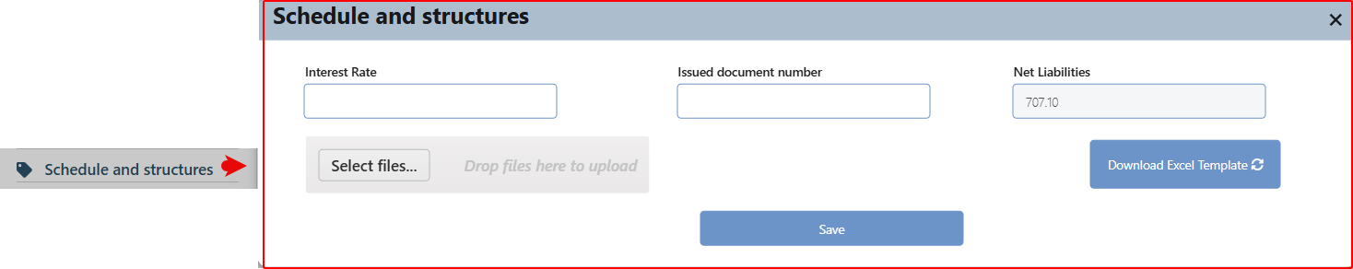

The user initiating the action must input the transaction information displayed on the screen, after which a specific Excel file will be downloaded. The format of the submitted file is as follows:

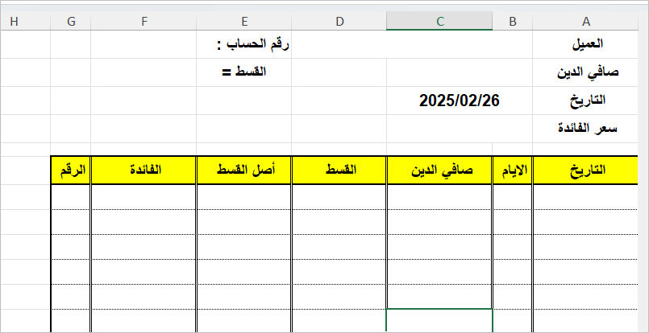

He needs to fill out and save this file, then upload it to the system and save the transaction. This action will then appear in the "Previous Follow-up History" tab of the employee who created the transaction.

This action is subject to review. After the user clicks the "Save" button, the request will be sent to the checker. So, he can access it from the Credit Portfolio screen, specifically in the Approval tab, where they will select the submitted task.

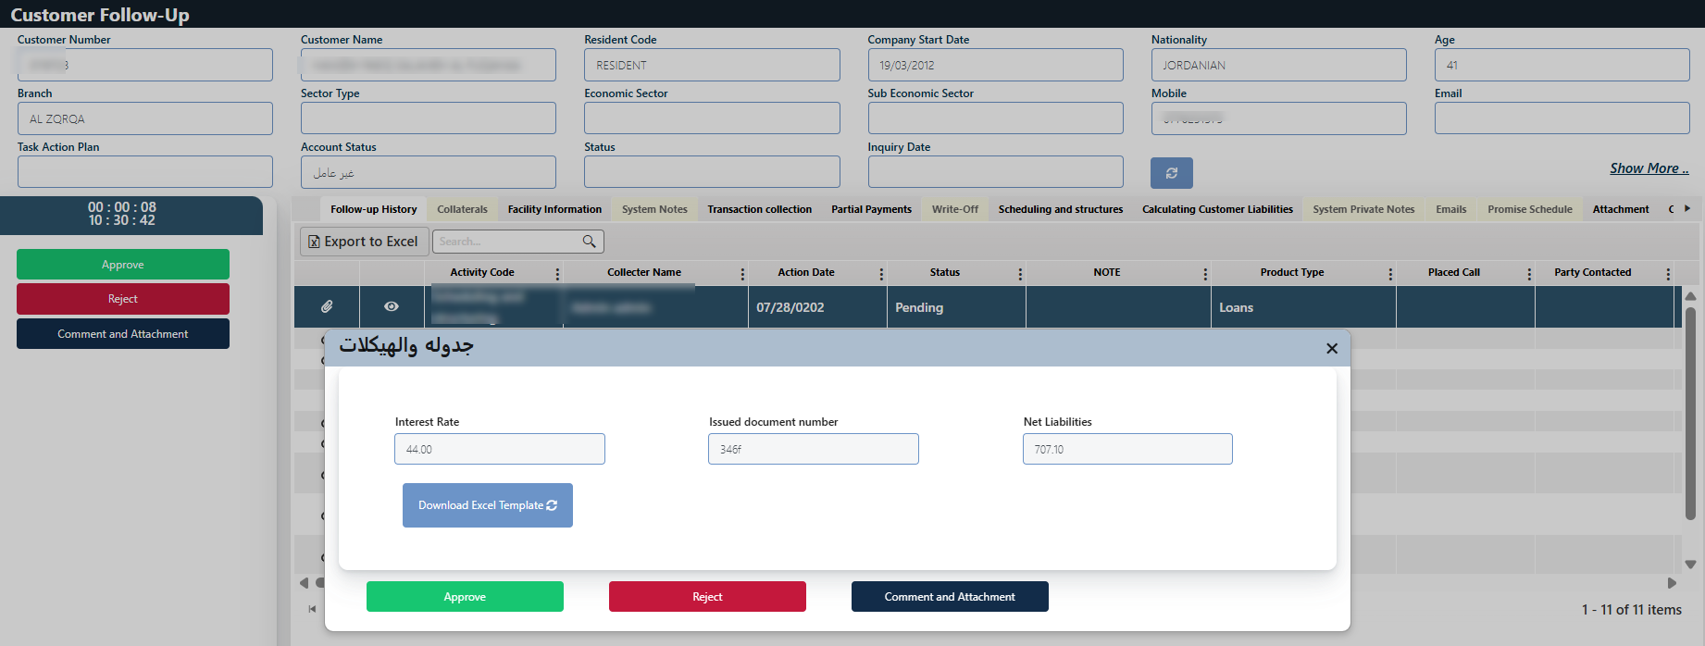

Once the checker decides, the outcome will appear in the "Previous Follow-up History" tab of the employee who created the transaction. This will be reflected in the "Status" field as either approved or rejected.

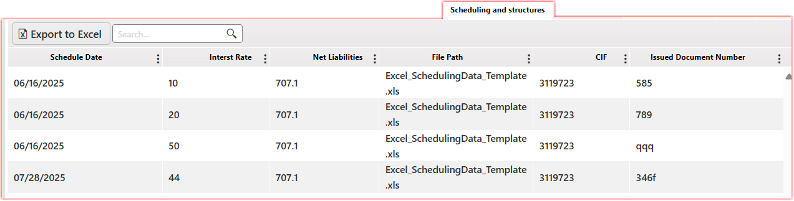

#### Calculate Customer Liability

* The prerequisite for this procedure is scheduling and structuring.

This action is used to calculate the customer’s total outstanding financial obligations within the collection system, including both debit and credit interest, to determine their net liability.

Click the " Calculate Customer Liability " button. Then the related screen will appear.

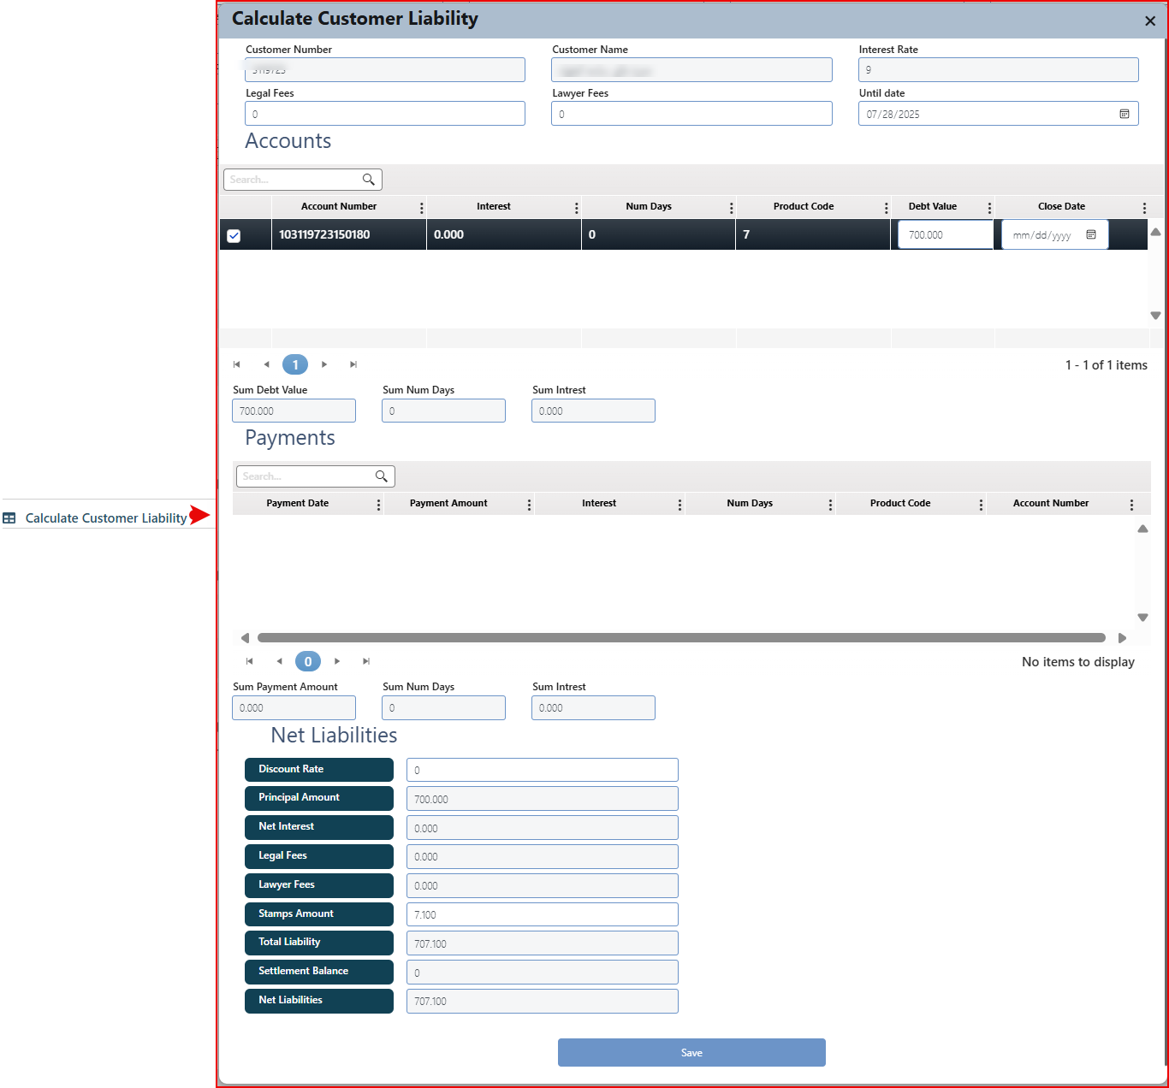

Comment: The fields on this screen vary between auto-filled fields retrieved from the system and active fields that depend on user input.

The screen is divided into several sections. The first section displays system-retrieved information about the customer, such as the interest rate, along with fields for entering legal expenses and attorney fees.

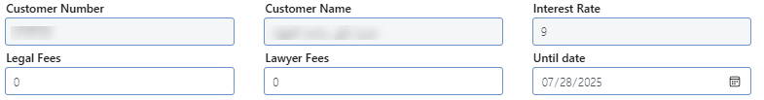

The second section is a data grid listing the accounts linked to the customer, where the system retrieves all delinquent accounts at the customer level. The user is allowed to select multiple retrieved accounts. In this section, the user enters the outstanding amount and the closure date.

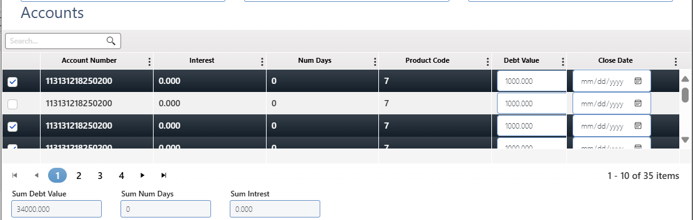

The third section presents summaries at the interest level for the selected accounts in the above section. The presentation will cover the following values:

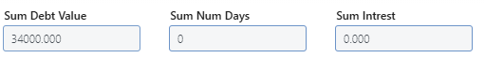

The fourth section displays a list of the customers payments. The system will display all cash payments made by the customer, related to delinquent accounts, and then fields for the totals of these payments, the days, and the interest as follows:

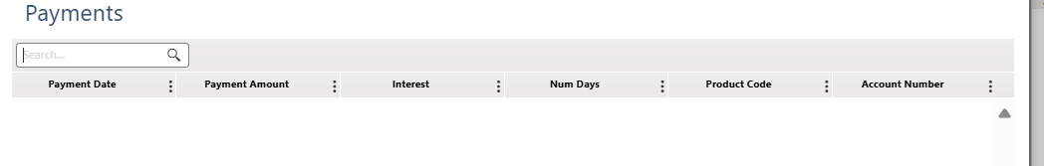

Then the net liabilities for the selected accounts will be displayed, some of which can be changed by the user. These are the active fields for both the discount rate and the stamp amount. They will be displayed vertically as follows:

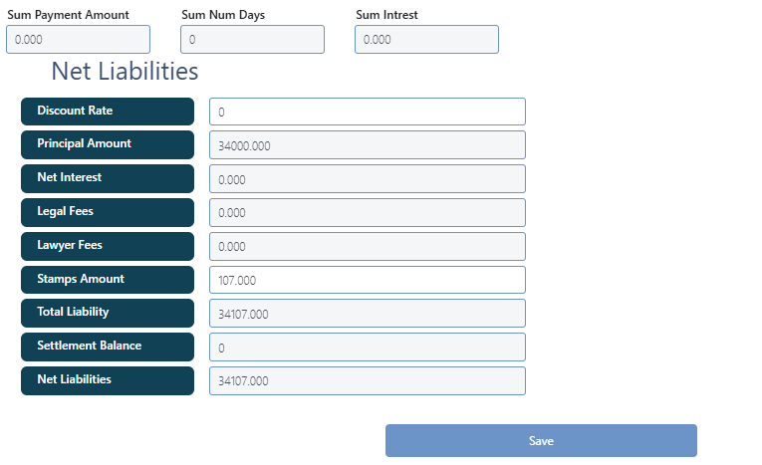

After the user enters the required information and saves the process, it will automatically proceed to the review stage and simultaneously appear under the "Follow-up History" tab for the user who initiated the process.

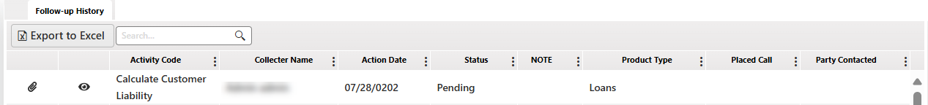

Since this action is subject to review, once the "Save" button is clicked, the request is sent to the checker JobBasket to accesses it from the Credit Portfolio screen – Approval tab – where the submitted task is selected and displayed as follows:

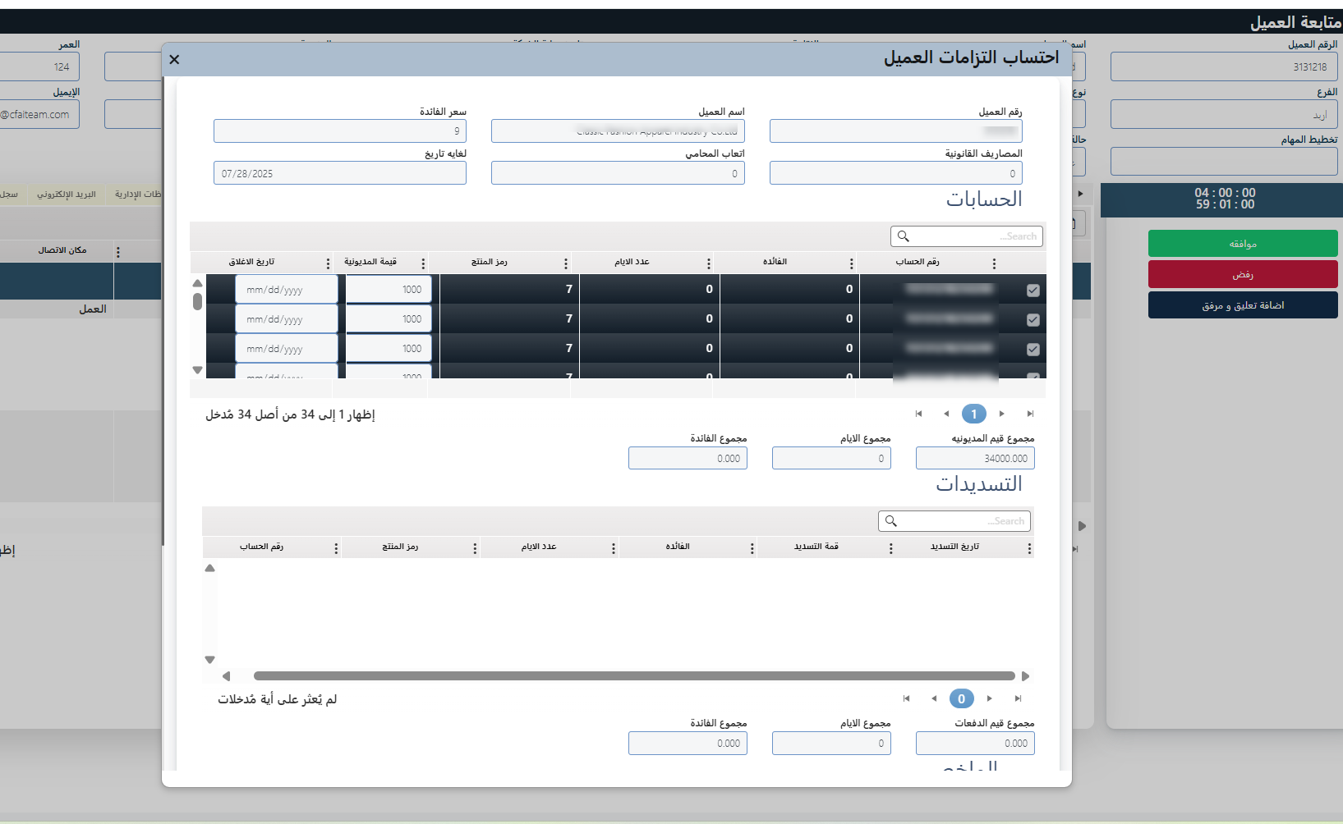

After the reviewer makes a decision, the outcome (approval or rejection) will be reflected for the initiating user in the "Follow-up History" tab under the "Status" field.

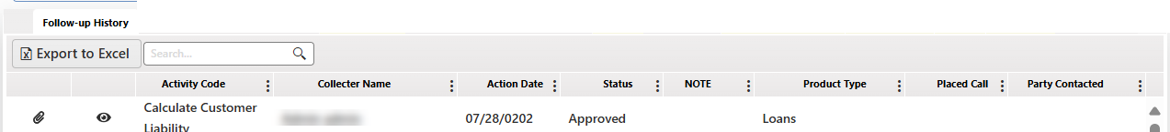

### Related Tabs

The main tabs listed on the customer follow-up page represent the procedures undertaken with the customer, along with their information stored in the system (retrieved from the core). Users have the option to add or modify some of this information. Below is a list of these tabs, followed by a detailed description of each.

|  |  |
| --- | --- |
| 1. Follow-up History | 1. Collaterals |
| 1. Facility Information | 1. System Notes |
| 1. Transaction collection | 1. Partial Payments |
| 1. Write-Off | 1. Scheduling and structures |
| 1. Calculating Customer Liabilities | 1. System Private Notes |
| 1. Emails | 1. Promise Schedule |
| 1. Attachment | 1. Contact Details |
| 1. Customers Behavior | 1. Customer basic information |
| 1. Salary Details | 1. Guarantors Details |
| 1. SMS | 1. Negated Account info |
| 1. Management Notes | 1. Next Follow-up Details |
| 1. Account Lien inquiry | 1. Approval/Rejected Cases |
| 1. Deceased information | 1. WF Studies Status |
| 1. Reason of Delinquent | 1. Activities from old system |
| 1. Address Information | 1. Manager Notes |

Comment: Some tabs are exclusive to the remedial system, other tabs are available only if the collection System is integrated with the legal case management system from Bank-BPM, this will be indicated under each relevant tab.

The listed tabs will be active if they contain relevant information or if the user has the required permission; otherwise, they will remain inactive and not accessible.



To access a certain tab just click on its name.

#### Follow-up History

Presents a comprehensive list of follow-ups conducted with the customer, detailing the actions taken during previous interactions**.**

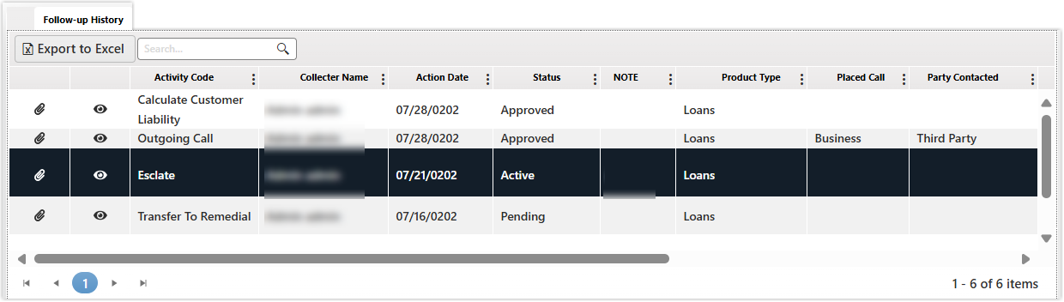

* This page outlines all actions taken on the active case and their statuses, indicating if they are pending, approved, or rejected.
* From this tab, the user can view the details of the action by clicking the adjacent "Details" button (👁) and access its attachments by clicking the related view attachments button.

#### Collaterals

Displays the collaterals associated with the customer’s request, with the ability to modify collateral information based on its type. The information presented here is retrieved from the system or can be inserted by the user using the "Register New Case - Bonds" tab within the system.

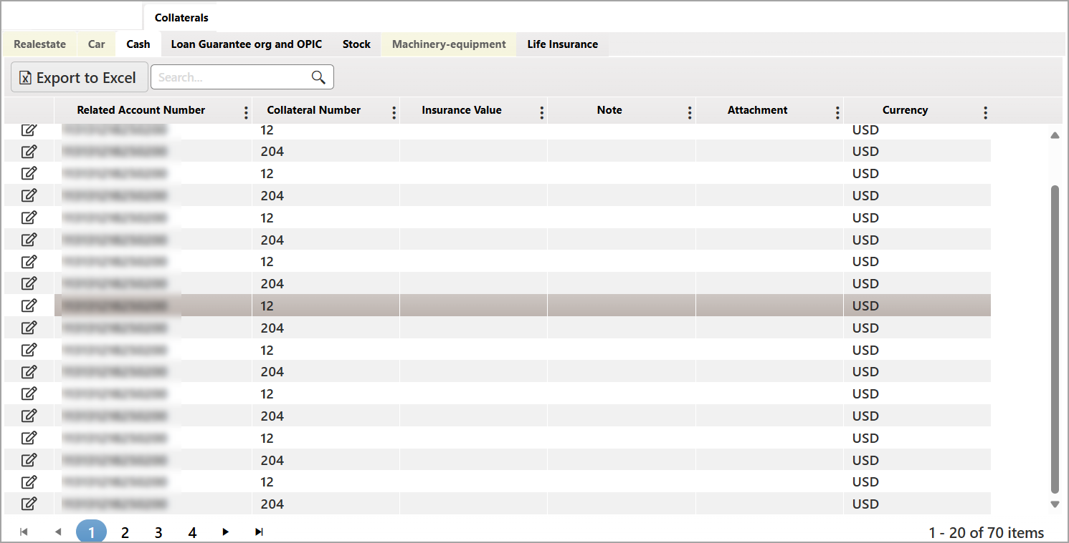

This tab organizes collaterals into sub-tabs based on their type, with each sub-tab displaying related collateral records accordingly. The layout and displayed fields within each sub-tab vary depending on the collateral type. Users can edit individual collateral records by clicking the corresponding "Edit" button, which opens a dedicated editing screen. This screen allows the user to modify active fields, add relevant notes, and upload supporting documents as needed.

Comment: Any information modified will be reflected both in the core system and across the collection system.

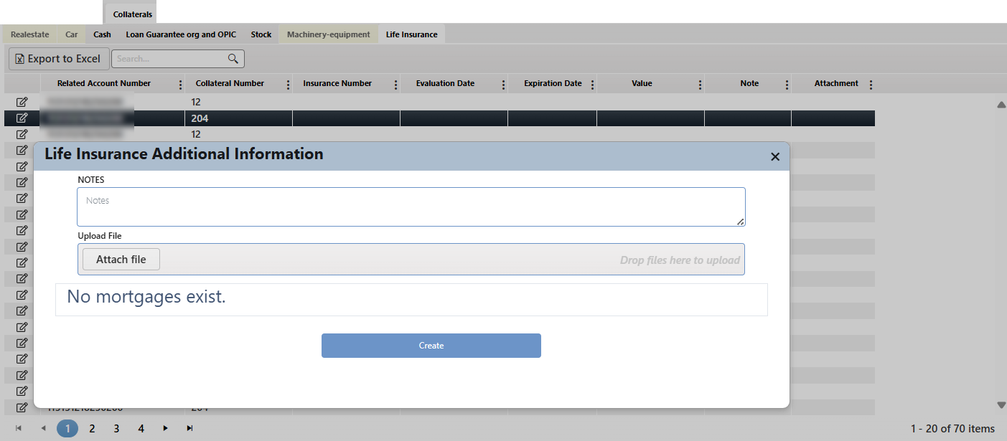

#### Facility Information

The system displays information about the financial facilities provided to customers, organized into several sub-tabs based on the type of facility. The covered facilities include Loans (LAA), Cards, Current Accounts (CAA), Revolving Loan Accounts (PCA), Overdraft Accounts (ODA), Paid Letters of Credit (LC), Paid Letters of Guarantee (LG), Paid Bank Guarantees (BC), Unpaid Letters of Credit (LC), Unpaid Letters of Guarantee (LG), and Unpaid Bank Guarantees (BC).

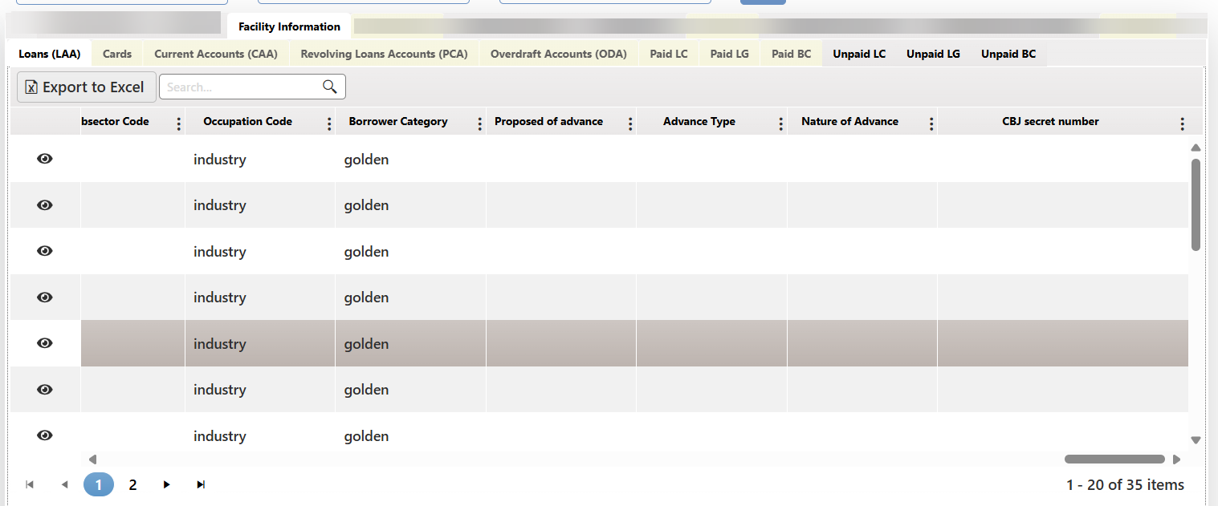

The layout and fields displayed will vary depending on the selected facility type. Please note that editing is not permitted in this section. Users can view the installment information for each loan record in the Loans sub-tab by clicking the "View" icon next to the corresponding record.

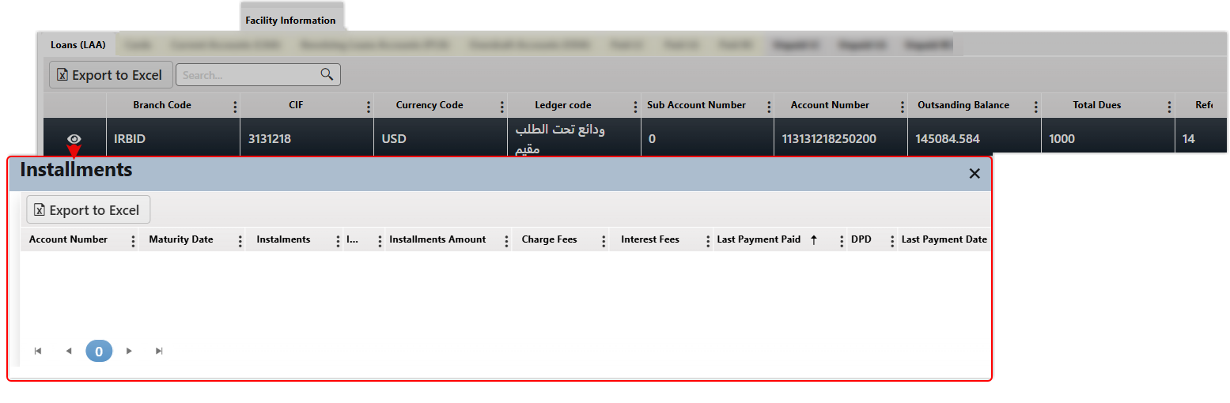

#### System Notes

Displays the customer's order notes. This tab lists all order notes, which have been recorded in the fast track, sequentially according to the following information



#### Transaction Collection

This tab provides a comprehensive overview of customer payment transactions, capturing key details such as the transaction type, amounts, dates, and payment sources. It offers a clear view of each transaction's status and relevant information, helping to streamline transaction management and provide valuable insights for further analysis.

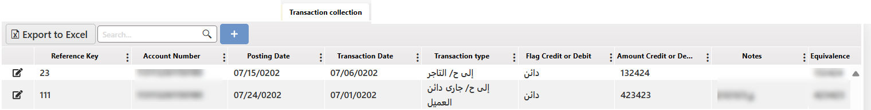

To insert a transaction, record the user needs to click on the add button “+”, a related screen will appear as below:

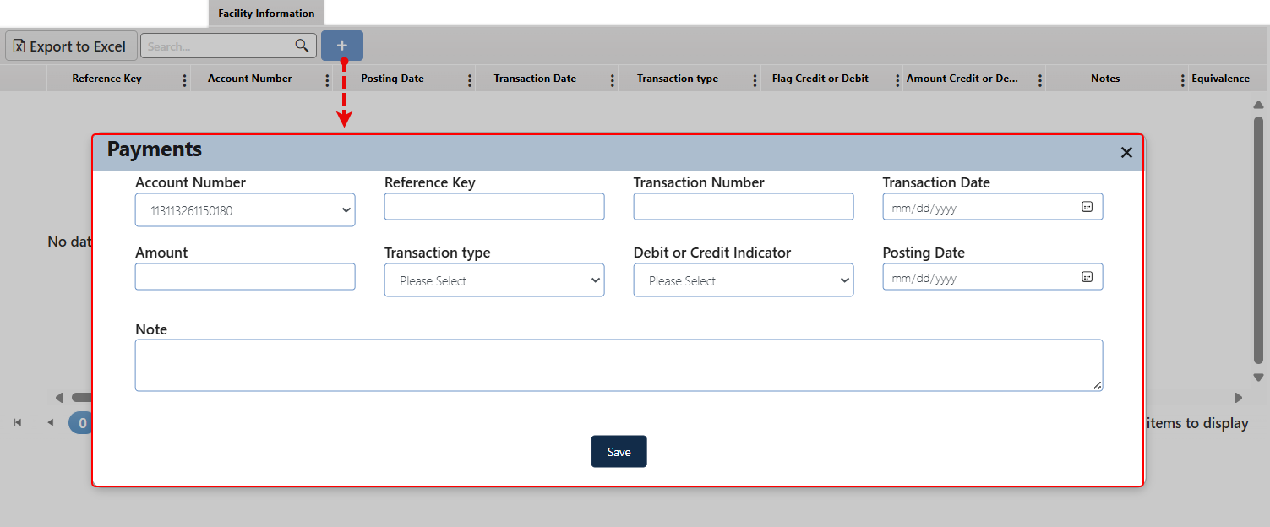

The user must enter the required information and click "Save." The inserted record will then appear in the relevant grid within the tab, allowing the user to edit each record as needed.

#### Partial Payments

This tab is a useful tool to manage and monitor each client's partial payments effectively. It allows the user to insert new payments records while also displaying previous payments.

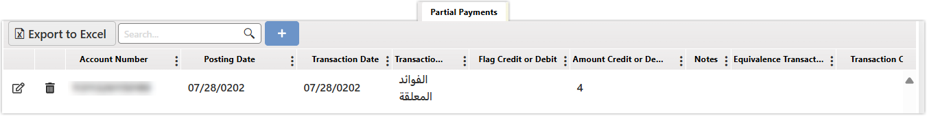

To insert a new payment, record the user needs to click on the add button “+”, a related screen will appear as below:

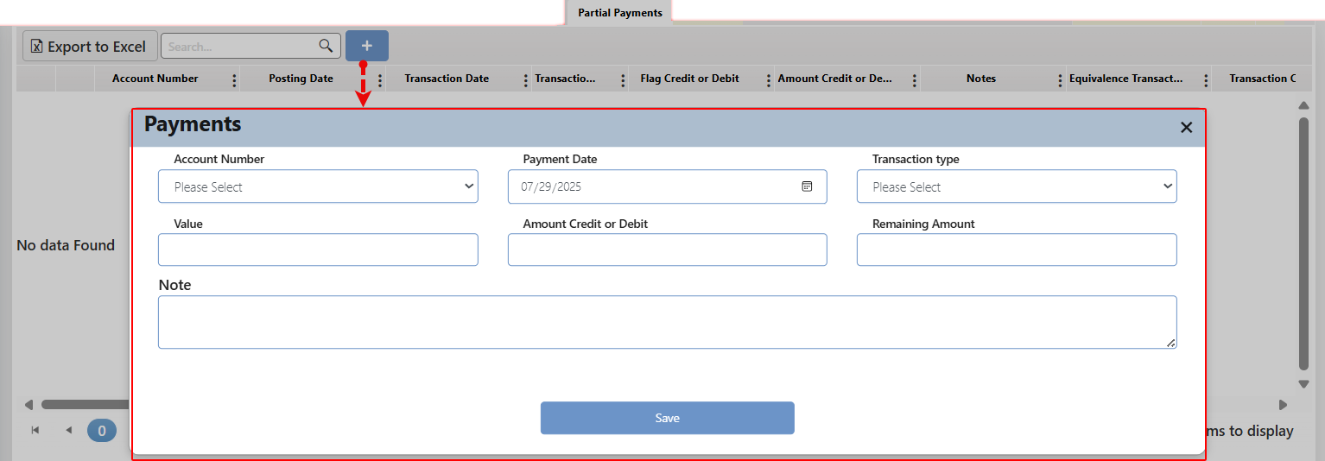

The user must enter the required information and click "Save." The inserted record will then appear in the relevant grid within the tab, allowing the user to edit or delete each record as needed.

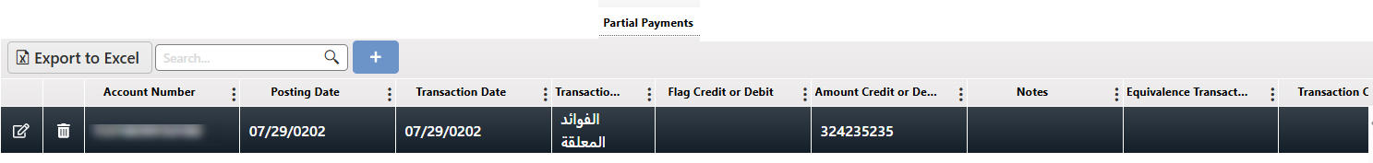

#### Write-Off

This tab is dedicated to displaying information related to the customer's written-off debts, and it is linked to the "Debt Write-Off" procedure.

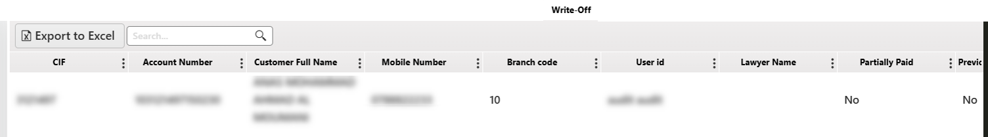

#### Scheduling and Structures

This tab is dedicated to displaying information related to the customer's scheduling and structures for his payments, and it is linked to the " Schedule and Structures" procedure.

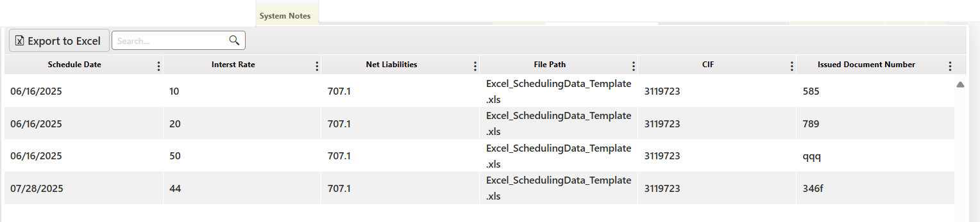

#### Calculating Customer Liabilities

This tab is dedicated to displaying information related to the calculation of the customer's liabilities, and it is linked to the "Calculate Customer Liabilities" procedure.



#### System Private Notes

This tab displays system-generated notes related to the freezing of the customer's account. These notes are retrieved from the bank’s core system.

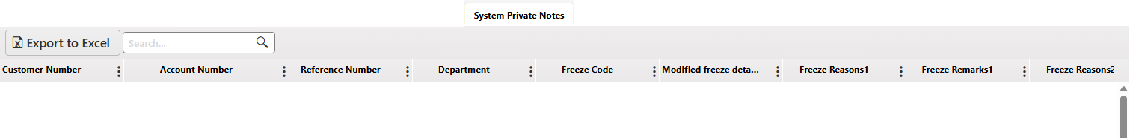

#### Management Notes

This tab displays the administrative notes related to the customer. These notes are retrieved from the bank’s core system

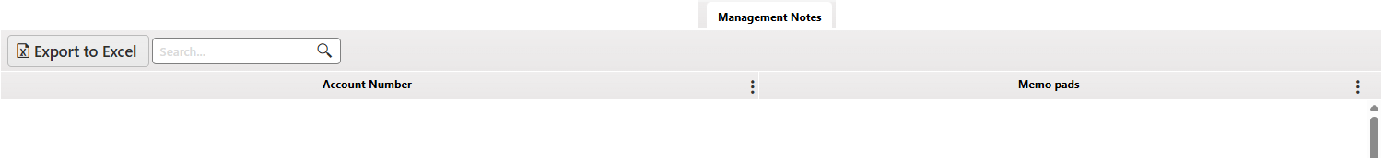

#### Emails

This tab displays a log of the emails sent to the customer, with the option to view each message.

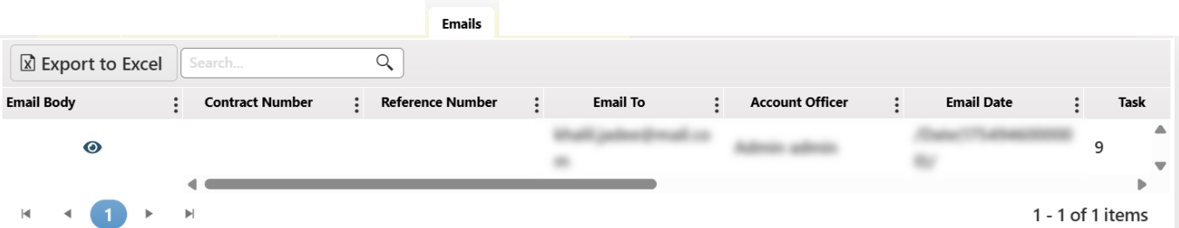

#### Promise Schedule

a log of the payment promises made by the customer and their status—whether fulfilled or not. The information is entered through the customer follow-up screen and the procedures taken to monitor the request.

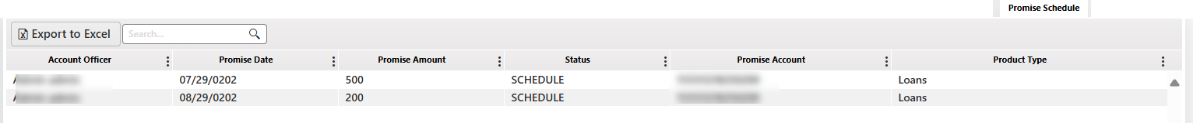

The tab remains inactive if no related entries exist. However, if there are entries, clicking on the tab will open an automatic screen showing the customer's status in case of default or delayed payments, as illustrated in the screenshot below:

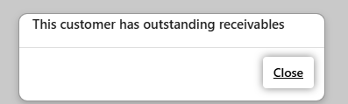

#### Attachment

This tab displays attachments related to the request and associated with the customer.

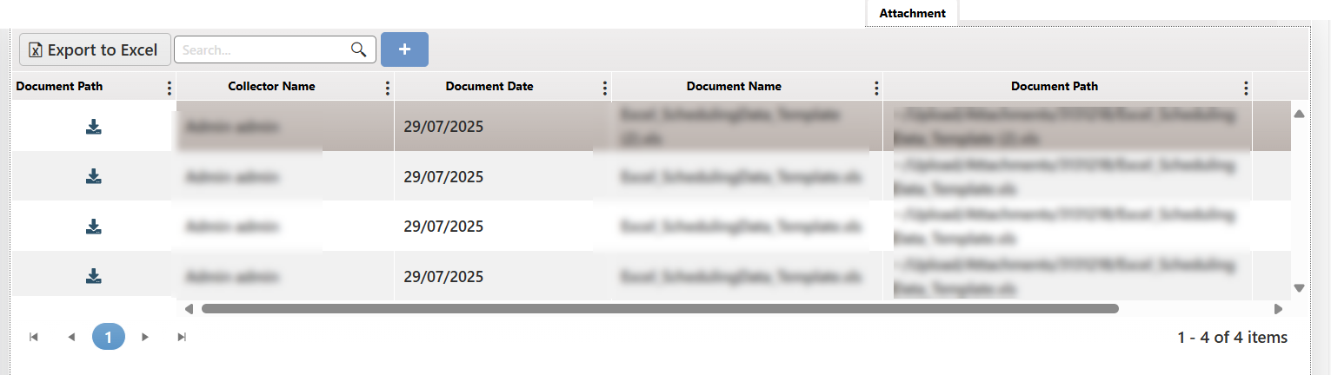

It also allows the user to upload new attachments by clicking the “+” (Add) button.

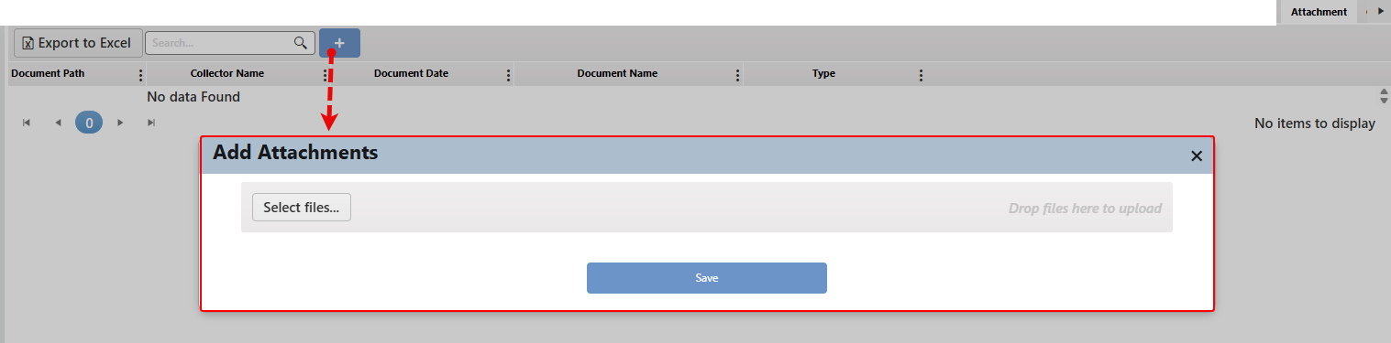

The user can download an attachment by clicking the designated related button.



#### Contact Details

This tab displays the customer's contact details stored in the system, with the ability to add new contact entries.

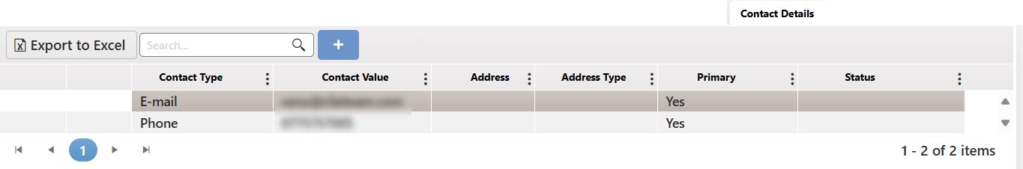

Users can click the "+" button to add new contact details as needed.

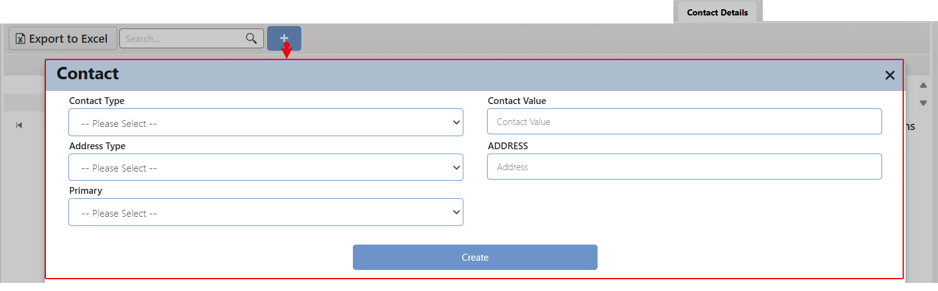

The user must enter the required information and click "Save." Then the user will be sent to the checker for approval request.

#### Customers Behavior

This tab presents a detailed history of the customer's payment behavior, specifically highlighting instances of delays or defaults. It captures each occurrence where the customer failed to meet payment obligations, providing collectors with valuable insights into the customer's commitment and reliability

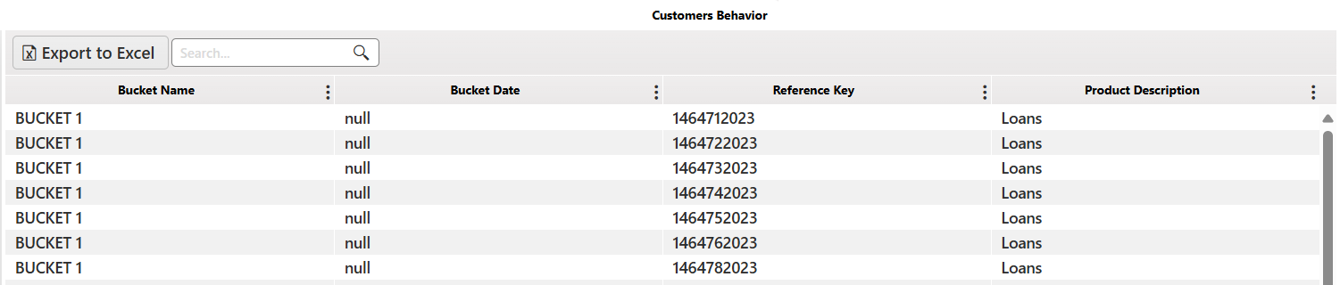

#### Customer Basic Information

This tab provides all the information related to the customer from the system.

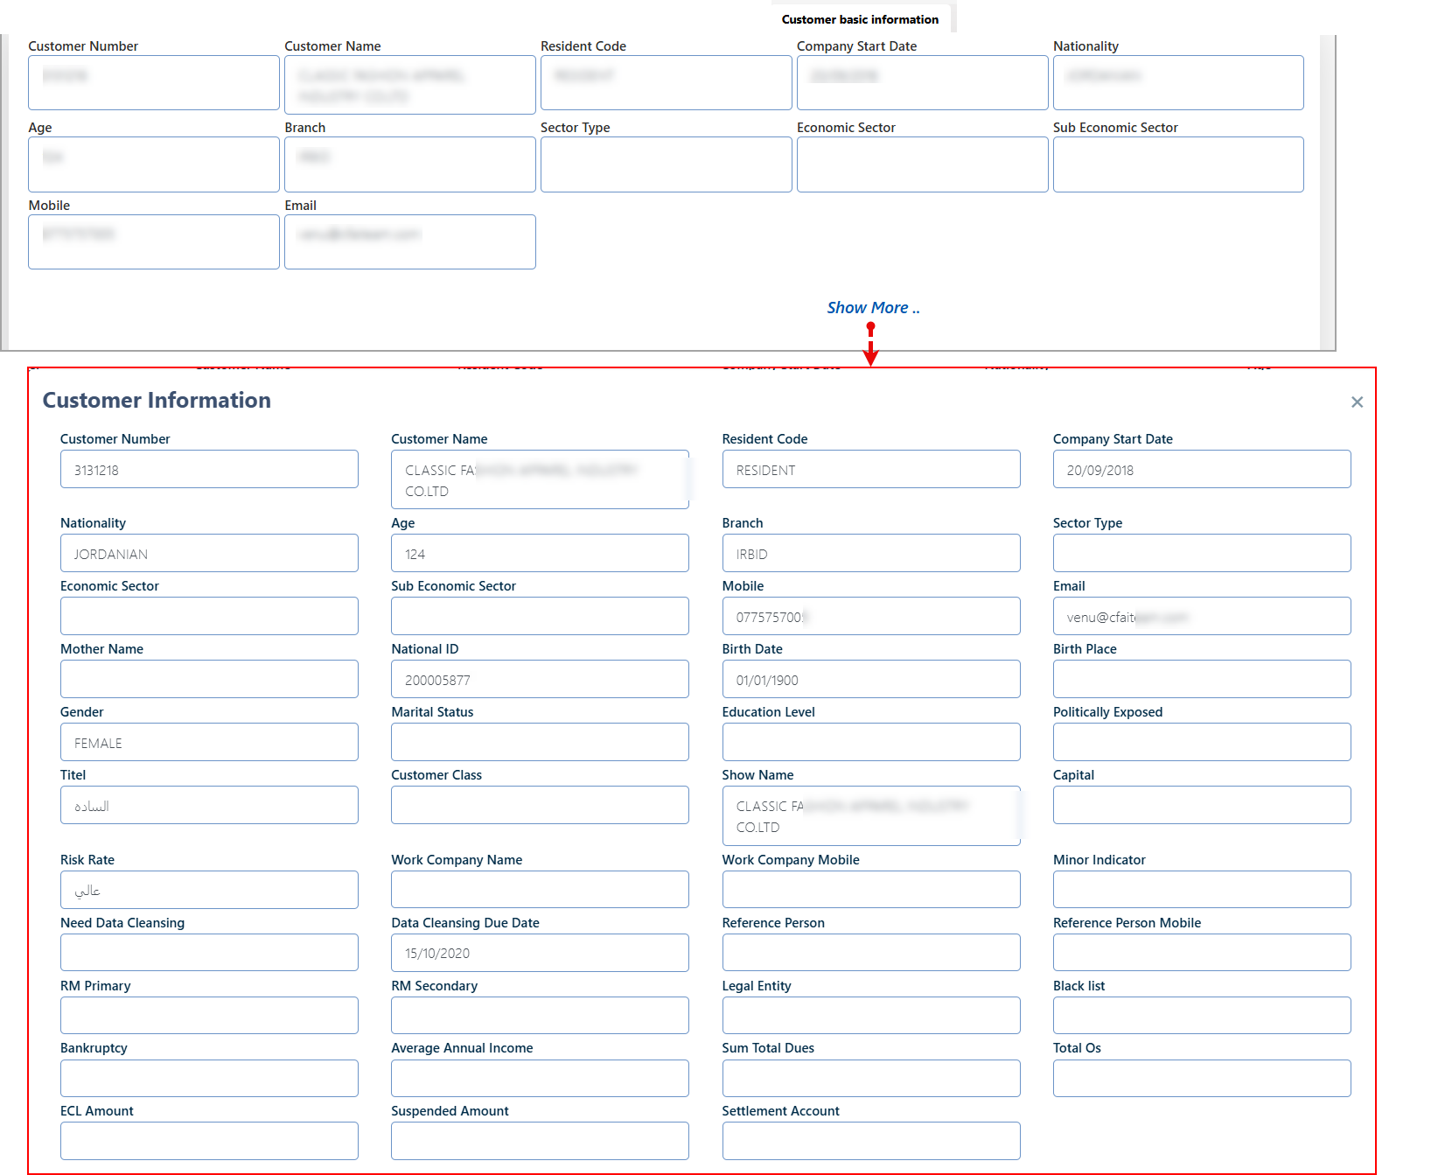

#### Salary Details

This tab displays the client's salary information according to the following details: Last Salary Amount

Last Salary Date and Salary Sender Name.

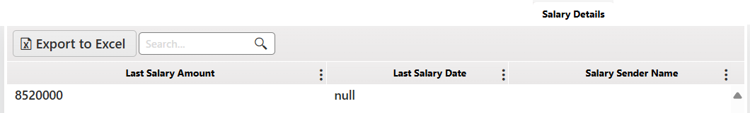

#### Guarantors Details

This tab displays guarantors details categorized by type and organized into several sub-tabs: Main Information, Accounts List, and Salary. If a particular type detail does not exist, the corresponding sub-tab will be inactive.

Layout

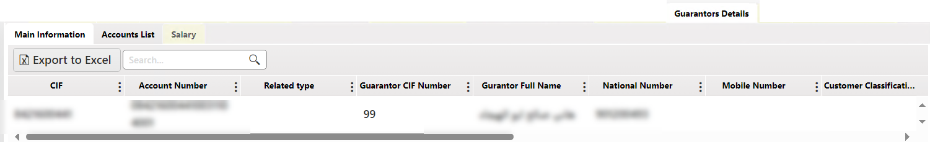

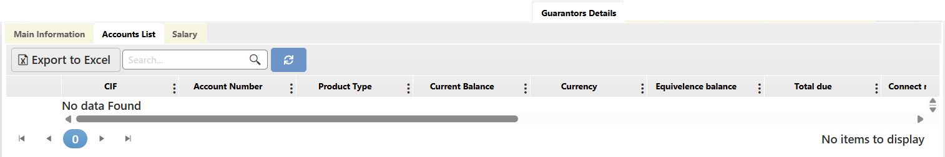

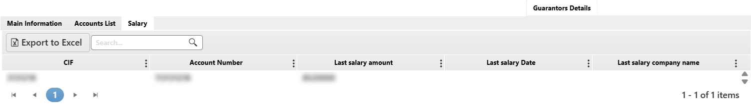

#### SMS

Displays records of SMS sent to the customer regarding reminders, alerts, or follow-ups, with the ability to view each record.

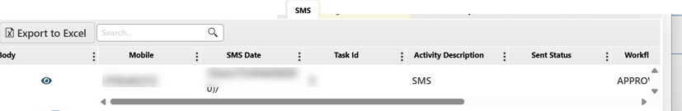

#### Negated Account Info

This tab displays information about the customer's cancelled account (accounts with negative balance).

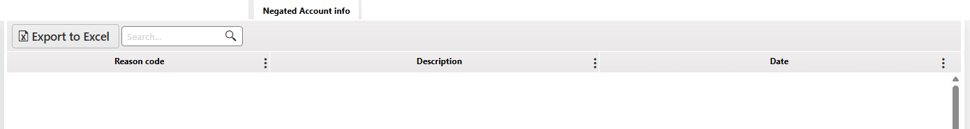

#### Next Follow-up Details

This tab displays information about the next follow up procedures with the customer, its linked with the Next Follow-up date procedure.

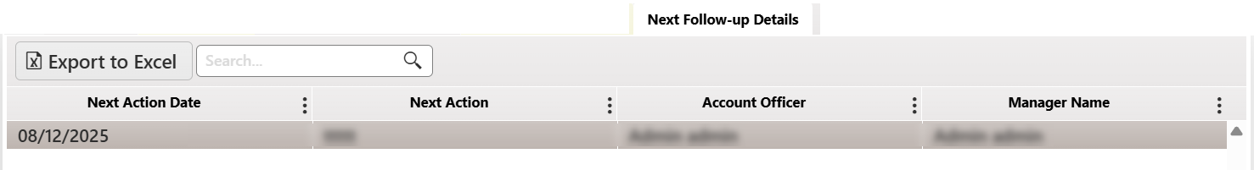

#### Write off Info

This tab displays detailed information related to the write-off of the customer’s outstanding balances, including the amounts, dates, and reasons for write-off actions taken.

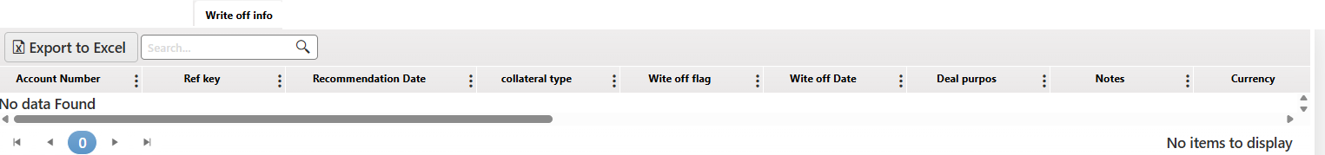

#### Account Lien Inquiry

This tab displays detailed information related to the account line inquiry.

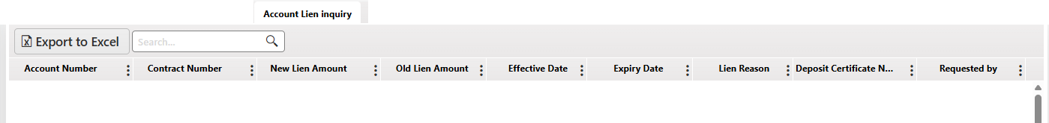

#### Approval/Rejected Cases

This tab shows all actions related to the customer that need approval or rejection from the direct supervisor, regardless of whether they have been approved. It provides a comprehensive list of proposed actions for handling the customer, along with their current status (approved or not approved).

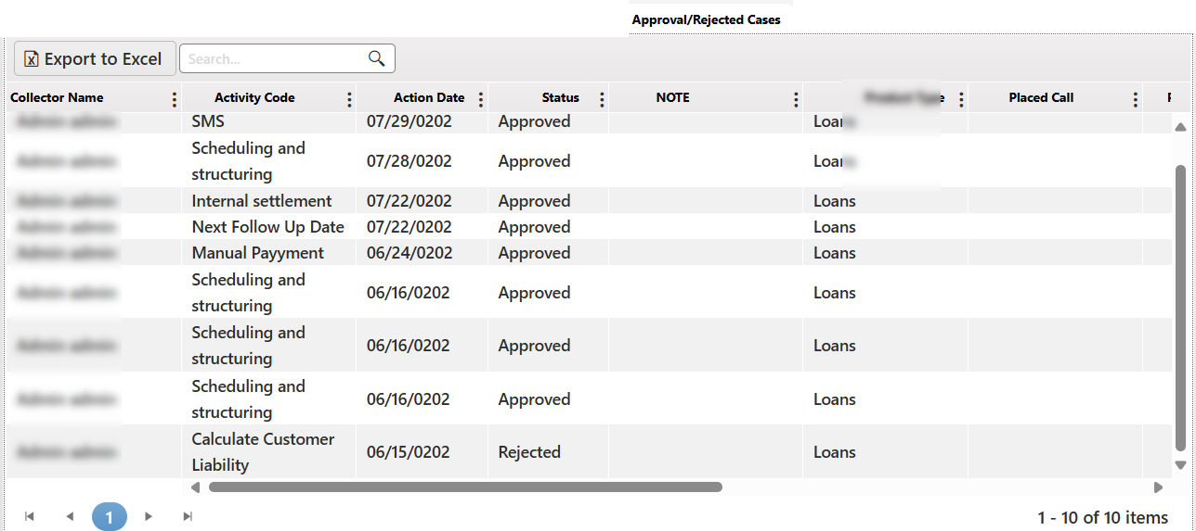

#### Deceased Information

This tab shows the death information of the customer. If the customer is still alive, the tab will remain empty. In case of the customer's death, the required information can be entered by clicking the add button as presented below:

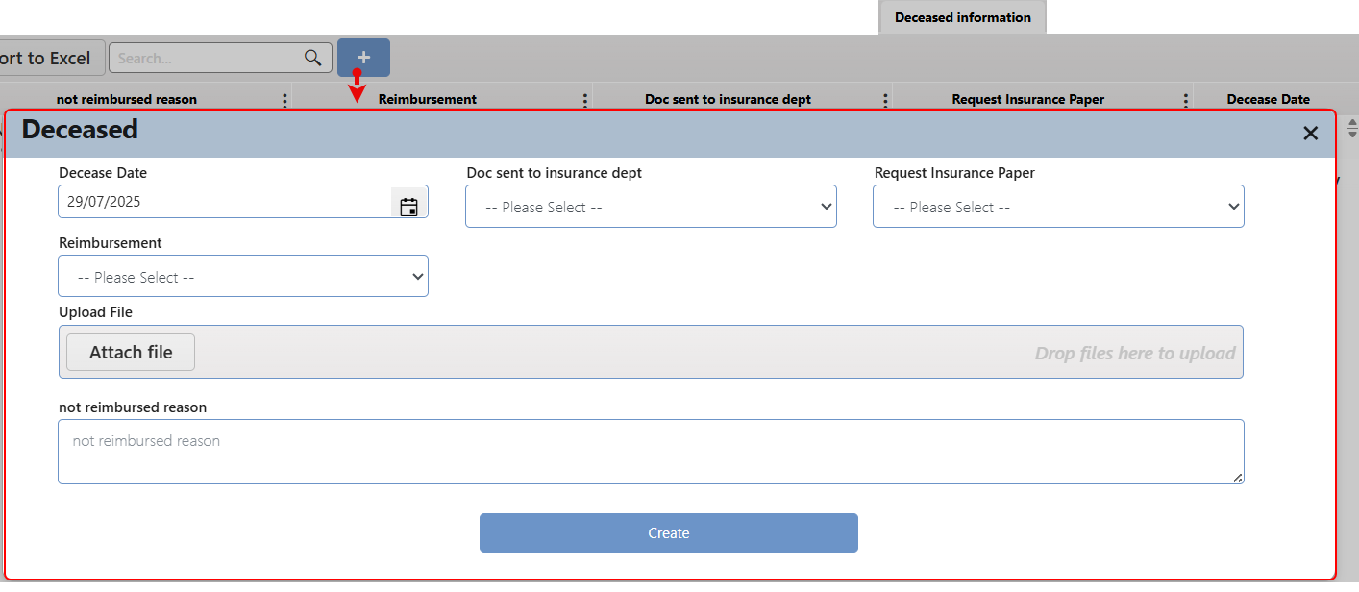

#### WF Studies Status

This tab provides an overview of the workflow studies related to the active case, if available. It displays key information including the user name, customer name, workflow form type, and the current status of the workflow. Users can easily identify whether a workflow is still in progress (Running) or has been completed (End).

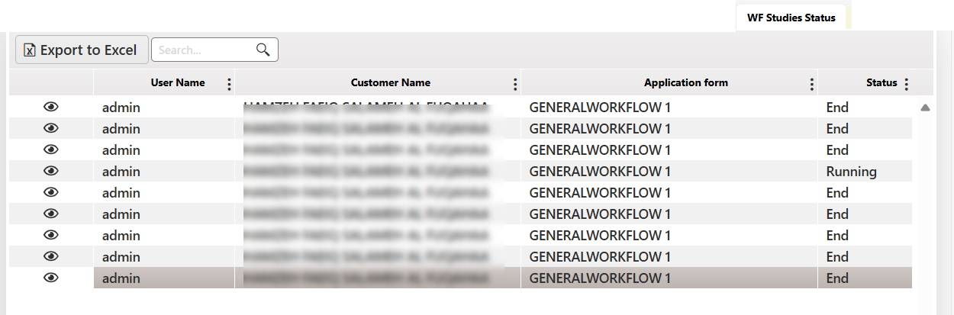

#### Reason of Delinquent

This tab outlines the reasons for delinquency related to the active case. It is directly linked to the "Reason for Delinquency" procedure and synchronized with its inputs.

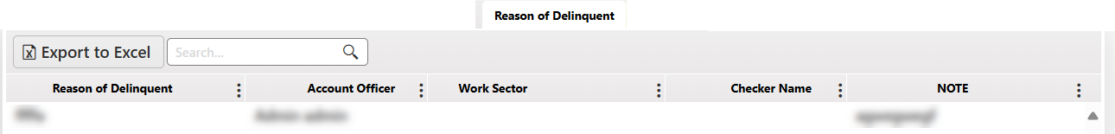

#### Activities from Old System

This tab shows information from the legacy system, reflecting procedures that were previously completed and stored in the old system.

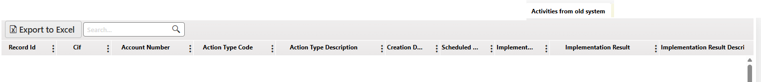

#### Address Information

This tab outlines the customer active address in the system.

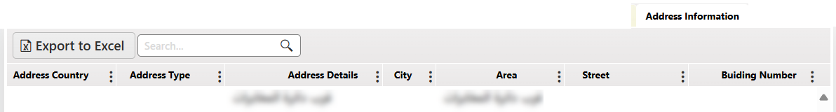

#### Manager Notes

This tab outlines the manger notes entered to the active case. It is directly linked to the " Manager Notes" procedure and synchronized with its inputs.

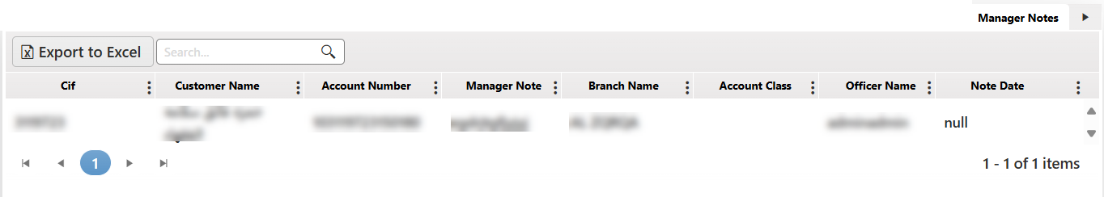

## Bulk SMS / Email

On this screen, the user can send a bulk message of a specific type (either SMS or email) to multiple customers at once.

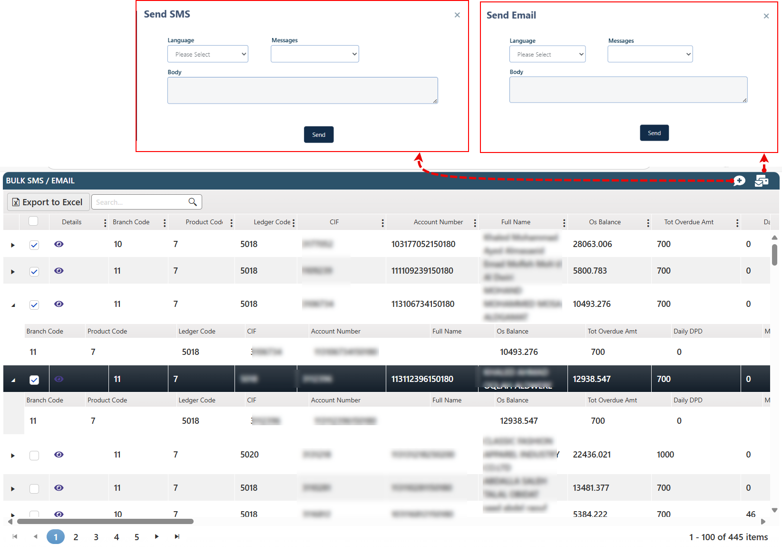

To send a message to multiple customers, the user should follow these steps:

* Select the customers.
* Click on the message type, which will open a screen specific to that type.
* Choose the language.
* Select a pre-created template.
* Click the Send button.

## Civil

This page displays the customers’ status in coordination with the department responsible for updating the following information:

* CIF
* Customer Name
* National ID
* Alive Status
* Last Modified Date

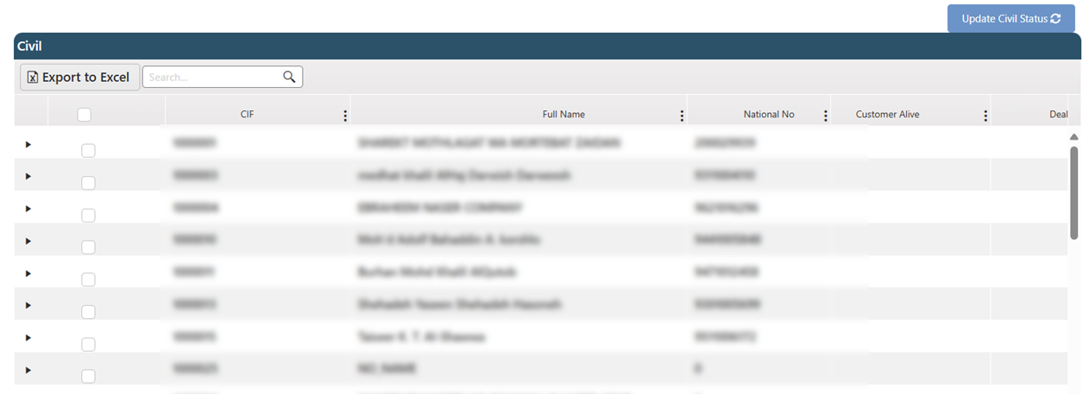

The user can select specific customers to update their status by marking them and then clicking the Update button at the top of the screen.

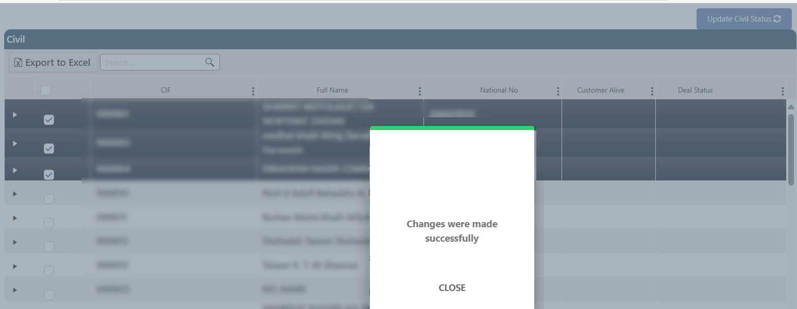

## Customers History

This page provides the users with a comprehensive view of customers who were previously delinquent but have since resolved their outstanding obligations. It enables users to easily look into past delinquency cases per customer and track settlement histories, which helps in analyzing customer repayment behavior over time.

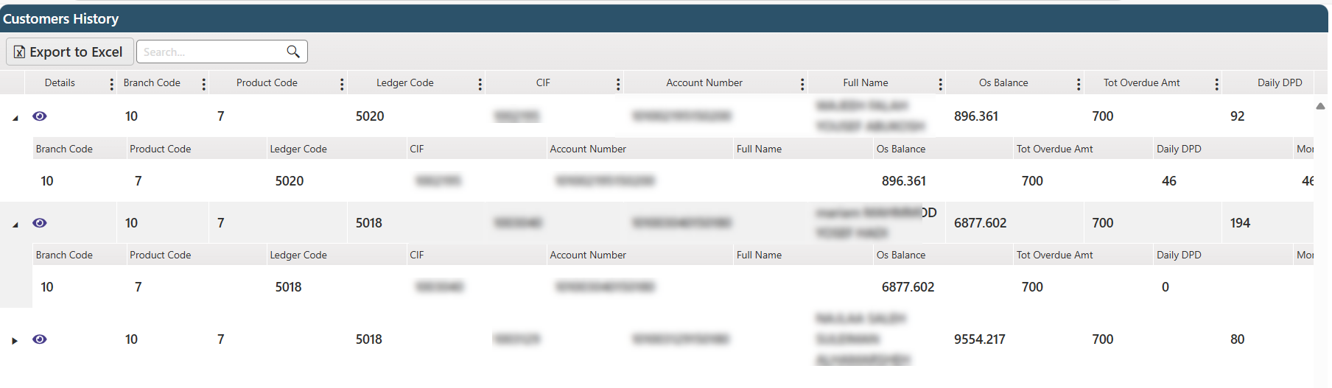

The user can view each customer file by clicking on the view button .

## Dashboard

The dashboard presents key visualizations including Collector Performance, Collector / Total Outstanding, Bucket / Number of Not Assigned Cases, Bucket / Number of Cases, and Bucket / Total Outstanding. These visuals provide authorized users with clear insights into collection activities, case distribution, and outstanding amounts, enabling effective monitoring and management of the collection process.

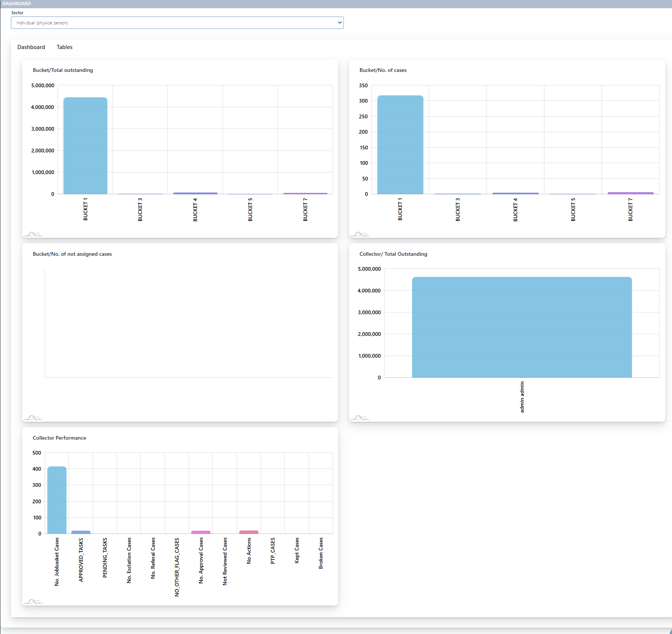

The layout of the chart corresponds to the information presented in the tables.

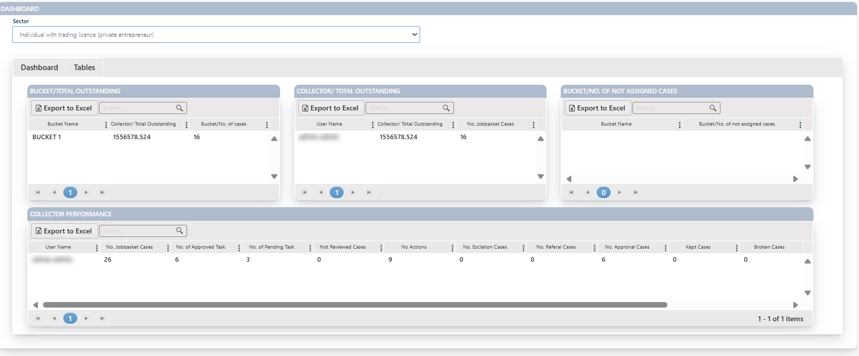

## Notification

A dynamic activity log that enhances transparency and accountability by tracking actions performed on the administration screen. Each action is recorded in real-time, with the newest at the top of the list, and includes an acknowledgment button for users to confirm they’ve reviewed or addressed the action. Once acknowledged, the action disappears from the list, keeping the log clean and up to date. This feature ensures that all administrative activities are monitored and reviewed, promoting accountability and providing an efficient way to track changes in the system.

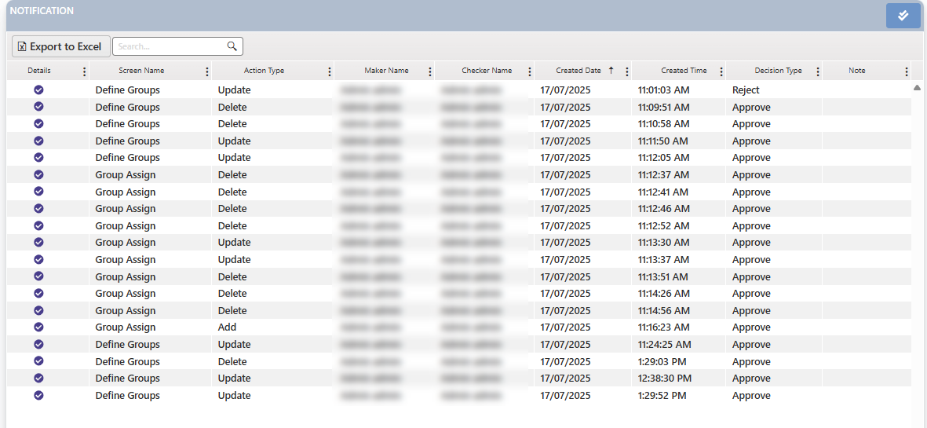

The control button that the user clicks to hide the action from the list. Upon clicking, a confirmation message will appear. If confirmed, the notification will be removed from the screen.



Clicking this button will clear all notifications.



## Reassign

This page is intended to facilitate the assignment of tasks to designated users. Individuals authorized with the requisite permissions are permitted to assign tasks to others.

Layout:

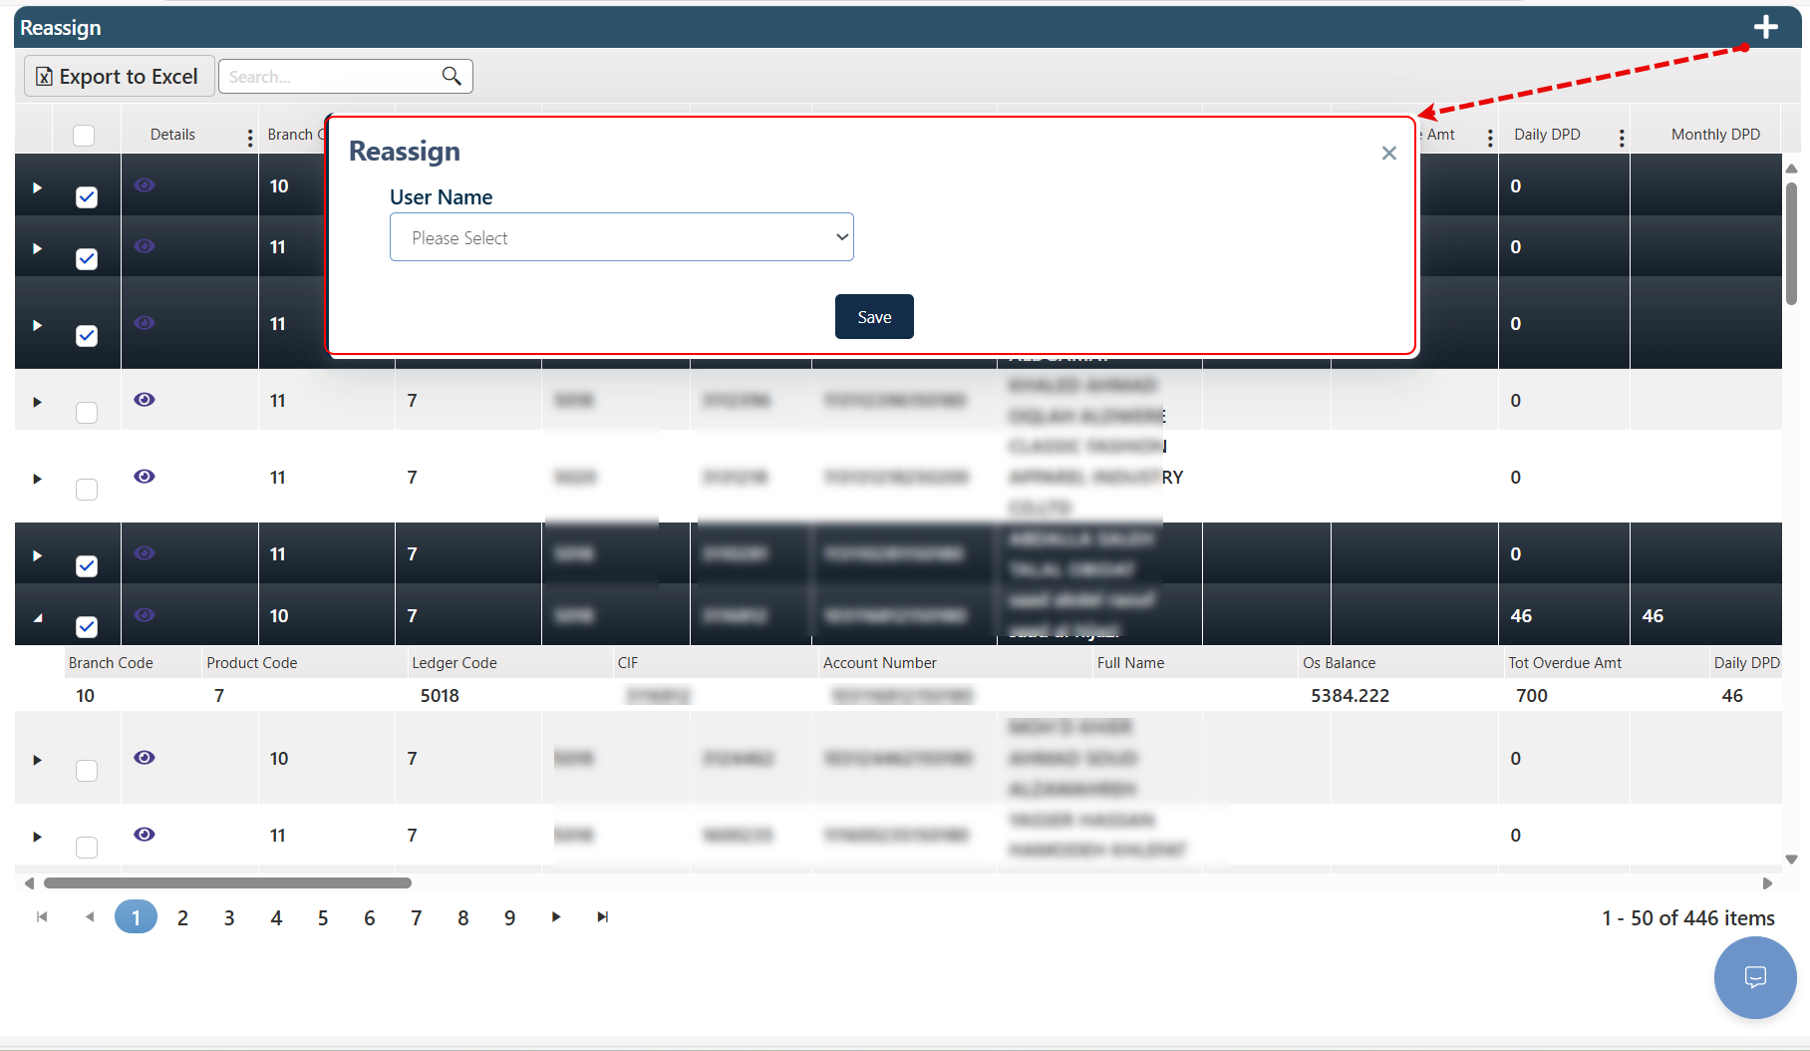

Comment: The user can navigate to the Customer Follow-up screen by clicking the button under the Details column.

Comment: Clicking the triangle next to a record will display additional details as shown below.

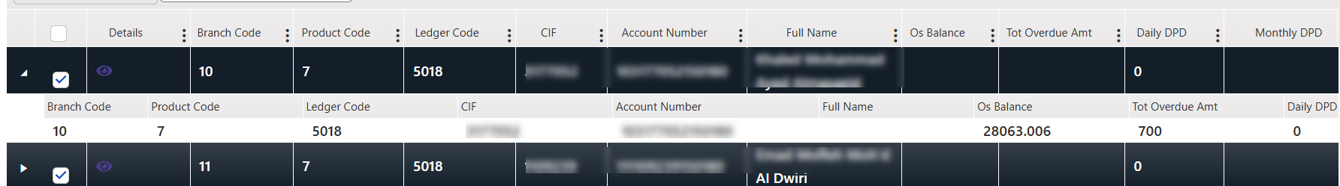

To reassign a group of tasks to a specific user, the current user selects the desired tasks by checking the corresponding boxes “ After selecting the tasks, the user clicks the Add (+) button at the top of the page. A screen will appear to choose the user to whom the tasks will be reassigned.”.

Select the alternative user to handle the tasks

Finally, the user clicks the Save button to complete the reassignment.

Then the task will appear in the JobBasket tab for the selected user.

## Remove Freeze Task

This page is used to remove the freeze status from one or multiple accounts within the Collection System.

It is accessible to authorized users only. The user selects the frozen account(s) to be processed, clicks the Remove Freeze button at the top of the screen, and confirms the action to complete the task.

Layout:

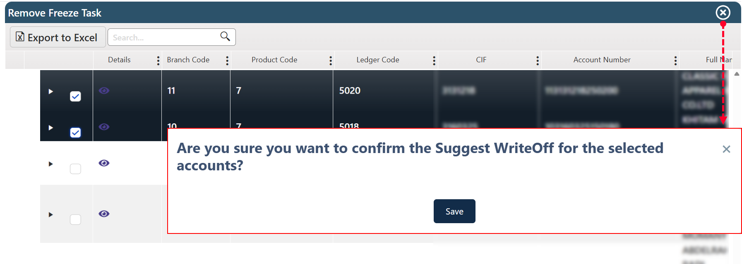

## Report Viewer

This page is dedicated to displaying pre-built reports, each providing information relevant to its specific title.

Users can click on the desired report and utilize available display customization tools, such as selecting a specific time period, branch, or other filtering options. Additionally, users have the ability to save the report in various formats, including PDF and Excel, by clicking the corresponding button provided on the screen.

Layout:

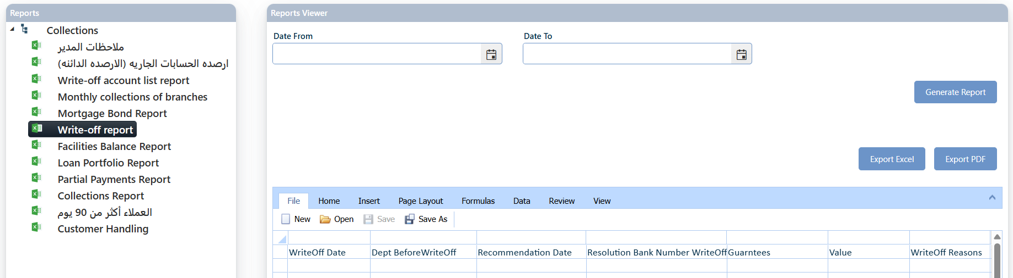

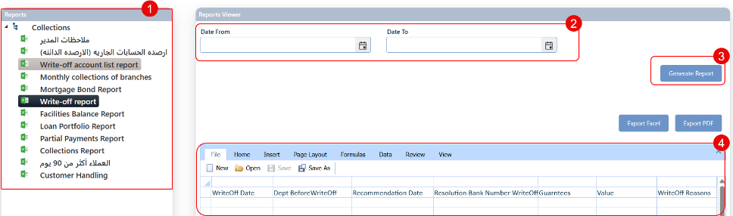

1. Available Report Names.
2. Filtering Criteria.
3. Report Generation Button
4. Data Grid View.

**Comment:** The reports displayed on this screen are not necessarily active in the currently deployed system for the logged-in user. Their availability depends on client-specific requirements as well as the permissions granted to the active user and department.

Reports listed on this page include:

|  |  |
| --- | --- |
| * Manager Notes | * Current Account Balances (Credit Balances) |
| * Write-off Account List Report | * Monthly Collections of Branches |
| * Mortgage Bond Report | * Write-off Report |
| * Facilities Balance Report | * Loan Portfolio Report |
| * Partial Payments Report | * Collections Report |
| * Customers Over 90 Days | * Customer Handling |

### Manager Notes

To display the notes entered by authorized users on cases or requests using the "Manager Notes" procedure on the Customer Follow-Up page. The user selects one or more customer numbers, upon which a list of manager notes linked to the selected customer(s) will be displayed, based on the following information:

|  |  |  |  |
| --- | --- | --- | --- |
| * CIF | * Account Number | * Customer Name | * Manager Note |
| * Branch | * Account Class | * Officer Name | * Note Date |

Layout:

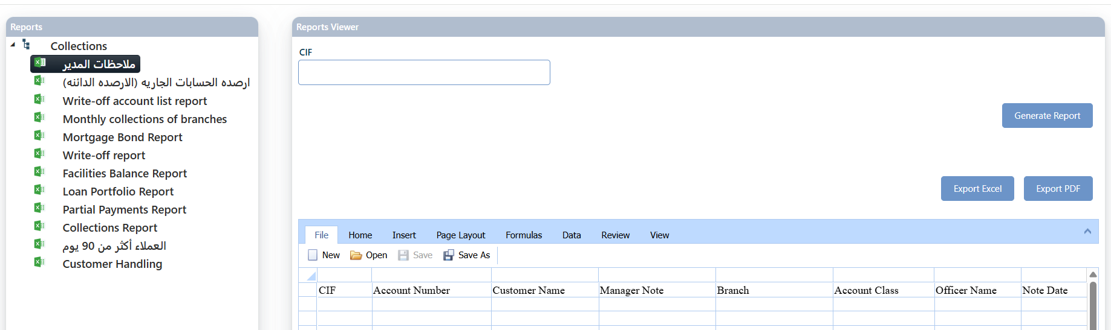

### Current Account Balances (Credit Balances)

A list of the current account balances (credit balances) according to the following information:

|  |  |  |  |
| --- | --- | --- | --- |
| * CIF | * Account Officer | * Customer Name | * Legal Fees Amount |
| * Balance | * TOT Overdue Amount | * Last Flag | * Last Action |
| * Last Flag Date | * Last Action Date | * Next Follow Up Date | * PAYMENTS CESSATION DATE |
| * Event Type | * Current Installment Amount | * Account Number | * Disbursed ID |
| * Branch | * Product Code | * Ledger code | * Monthly DPD |
| * Daily DPD | * Bucket | * IFR9 Stage | * Cust Alive |
| * Customer Type | * Deal Department | * Economic Sector | * Customer Class |
| * Review Flag | * Promise To Pay | * Hold Flag | * Suspended Amount |
| * ECL Amount | * Product Code | * Group Type | * Due Date |
| * Legal | * Salary Flag | * Staff flag | * Write-off Flag |
| * Collateral Type | * Currency Code | * Deal Status |  |

Layout:

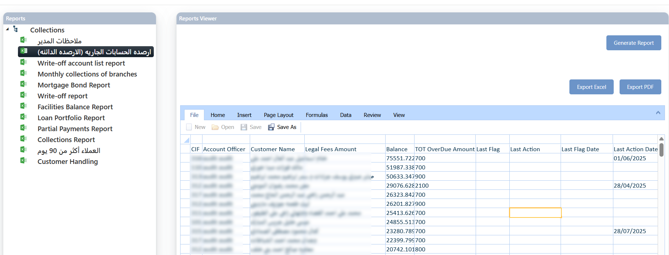

### Write-off Account List Report

A list of accounts that have been written off, based on the following information:

|  |  |  |  |  |
| --- | --- | --- | --- | --- |
| * Account Number | * Full Name | * Branch Code | | * Write-off Amount |
| * Guar Full Name | * Deal Department Code | * Write-off Date | | * Suspended Amount |
| * Under Follow-up | * Customer Situation Summary | | * Mobile | |

Layout:

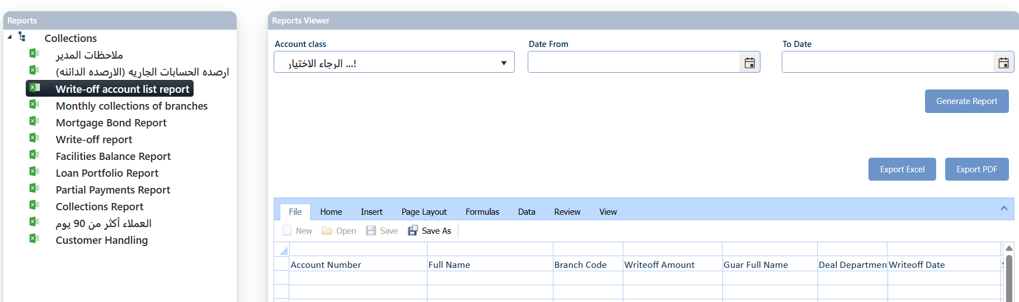

### Monthly Collections of Branches

This report presents the total amounts collected by each branch over a specified period, organized by month and year. It also offers the option to categorize the accounts included in the report, such as those that are written off, rescheduled, or settled. It simply provides the Branch Name and Total for each branch.

Layout:

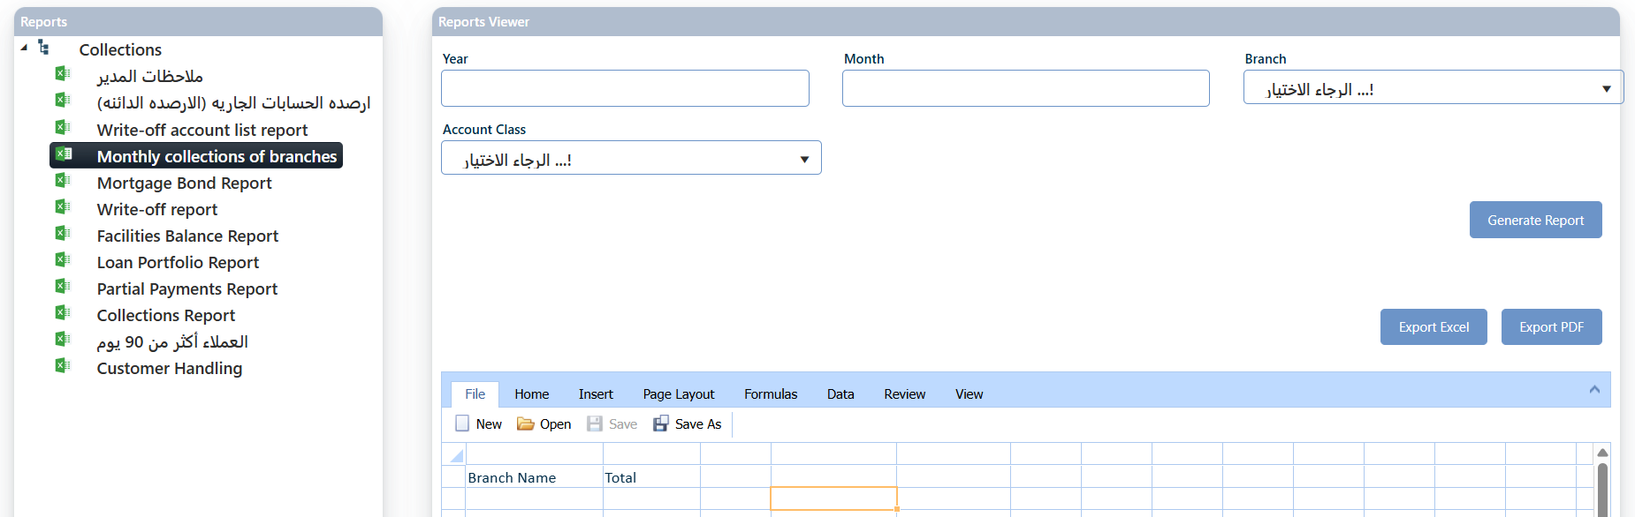

### Mortgage Bond Report

This report displays information about mortgage bonds linked to customer accounts in the collection system. It provides the following details for each record:

|  |  |  |  |  |  |  |  |  |
| --- | --- | --- | --- | --- | --- | --- | --- | --- |
| * Estimator Name | * Basin Number | | * RLS Apartment number | | | * Mortgage Amount | | * Mortgage Degree |
| * Mortgage Date | * Collateral Description | | | | * Estimator Date | * Market Value | | * Collateral Type |
| * Settlement Balance | | * Debt Balance | | * Deal Department Code | | | * Branch Code | * Full Name |

Layout:

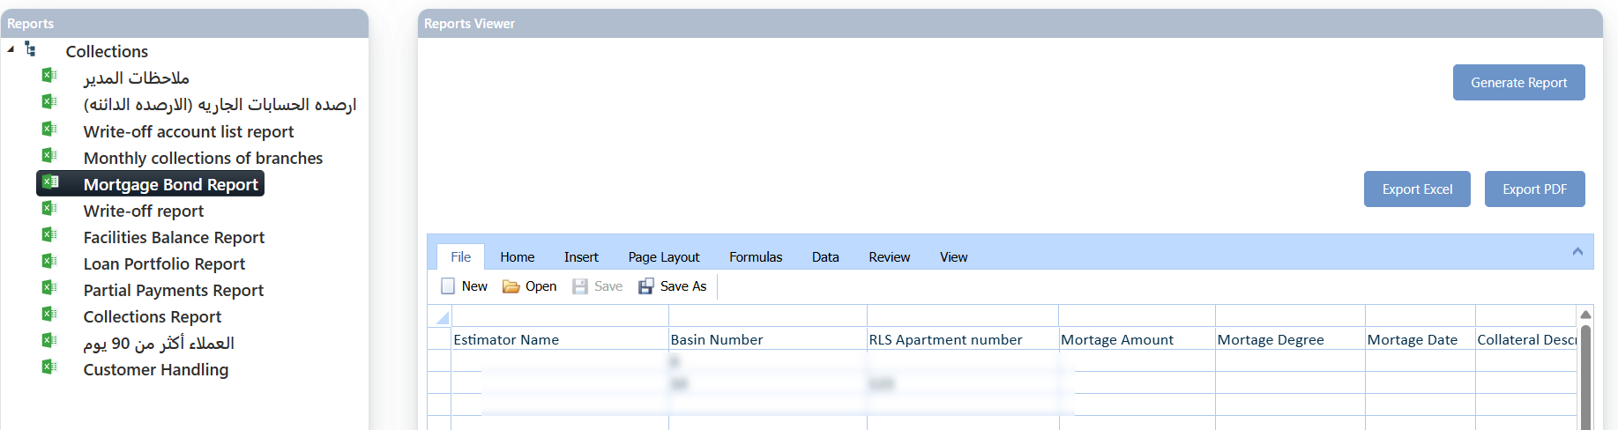

### Write-off Report

This report details all credit facilities that have been written off by the bank.

|  |  |  |  |
| --- | --- | --- | --- |
| * Bank Code | * CIF | * Granting Entity number | * Economic Sector Code |
| * Total Fac Balance | * Current Fac Balance | * Write-off Collection | * Suspended Amount |
| * Deferred Profits | * Current Write-off Amount | * Write-off Date | * Dept Before Write-Off |
| * Recommendation Date | * Resolution Bank Number Write-off | * Guarantees | * Value |
| * Write-off Reasons | * Write-off Amount | * Total Current Fac Balance | * Second Fac |

Layout:

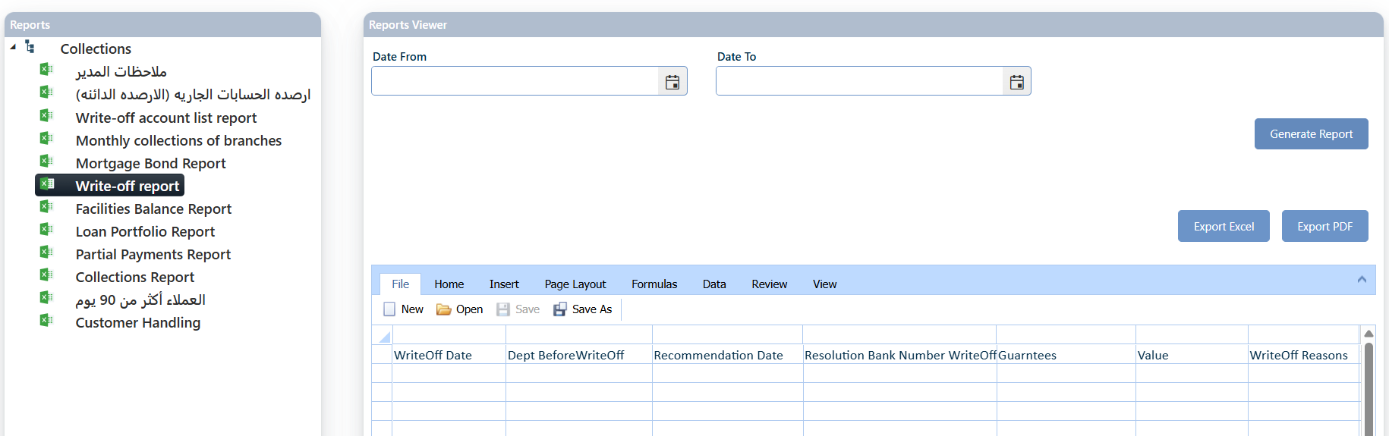

### Facilities Balance Report

This report provides the Facilities Balance for each customer depinding on the customer CIF.

Layout:

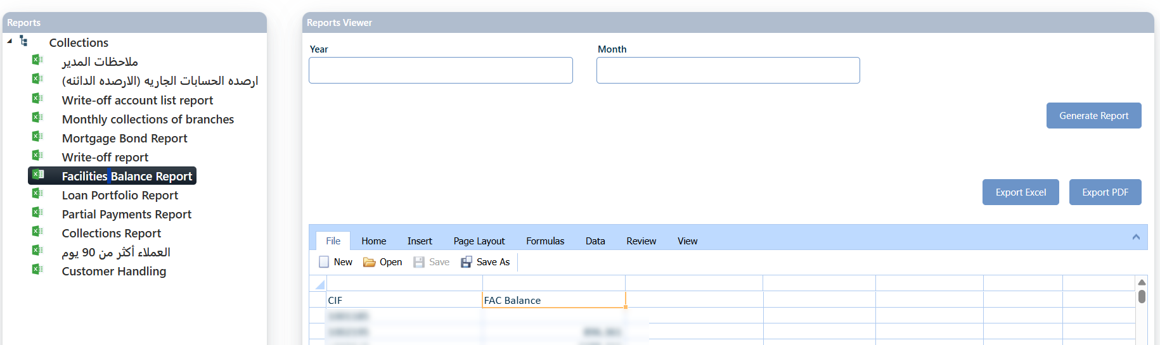

### Loan Portfolio Report

* This report related to the remedial system, this report will be available if the system is integrated with the Bank-BPM Legal Case Management System.

This report displays detailed information about the loans referred to the Legal Department. It includes the following data:

|  |  |  |  |
| --- | --- | --- | --- |
| * CIF | * Full Name | * Deal Department Code | * Legal Date Transfer |
| * Account Number | * Officer Name | * Collateral type | * Estimated Value |
| * Mortgage Amount | * Mortgage Degree | * Customer Situation Summary | |

Layout:

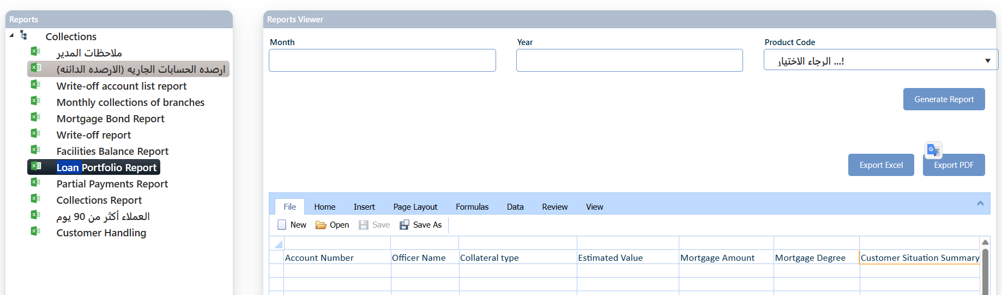

### Partial Payments Report

It is a report used to track all partial payments made by customers on their accounts or loans, displaying the following information:

|  |  |  |  |
| --- | --- | --- | --- |
| * CIF | * Full Name | * Transaction Date | * Transaction Amount |
| * Branch Code | * Transaction Manual Type | |  |

Layout:

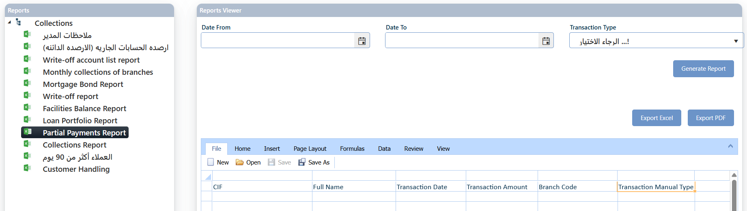

### Collections Report

A detailed summary of the collection processes completed in the system, including the following information:

|  |  |  |  |
| --- | --- | --- | --- |
| * CIF | * Account Number | * Full Name | * Transaction Amount |
| * Branch Code | * Lawyer Name |  |  |

Layout:

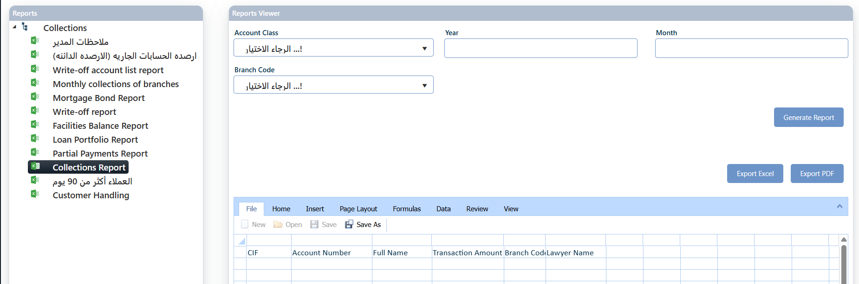

### Customers Over 90 Days

A list of customers with overdue payments exceeding 90 days, this list provides the following information for each customer:

|  |  |  |  |
| --- | --- | --- | --- |
| * CIF | * Account Number | * Full Name | * Total Legal Fees |
| * Equ Balance | * Tot Overdue Amt | * Last Flag | * Last Flag Date |
| * Last Action Date | * Next Follow Up Date | * Payments Cessation Date | * Installment Per Frequency |
| * Installment Amount | * Reference Key | * Branch Code | * Product Num |
| * Led Code | * Monthly DPD | * Daily DPD | * Buket Name |
| * IFR9 Stage | * Customer Alive Flag | * Deal Department | * Sector Type |
| * Customer Class | * Review Flag | * Broken Flag | * Hold Flag |
| * Suspended Amount | * ECL Amount | * Product Code | * Group Type |
| * Maturity Date | * Legal Flag | * Salary Flag | * Staff Flag |
| * Write Off Flag | * Collateral Type | * Cur Code | * Deal Status |

Layout:

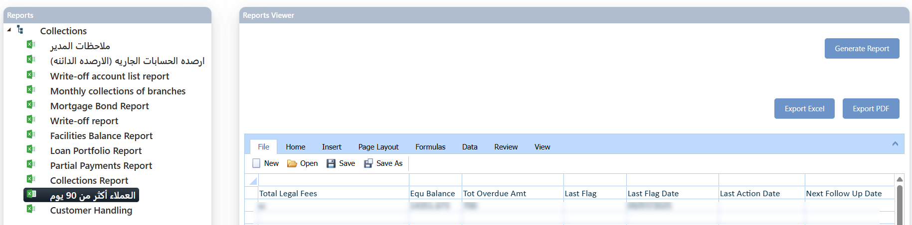

### Customer Handling

This report presents the study details for a specific user, based on the following information:

|  |  |  |  |  |  |
| --- | --- | --- | --- | --- | --- |
| * CIF | * Customer Full Name | | * Branch | * Mobile | * Customer Status |
| * Recommendation | | * Recommendation 2 | * Recommendation 3 | * Recommendation 4 | * Recommendation 5 |
| * Recommendation 6 | |  |  |  |  |

Layout:

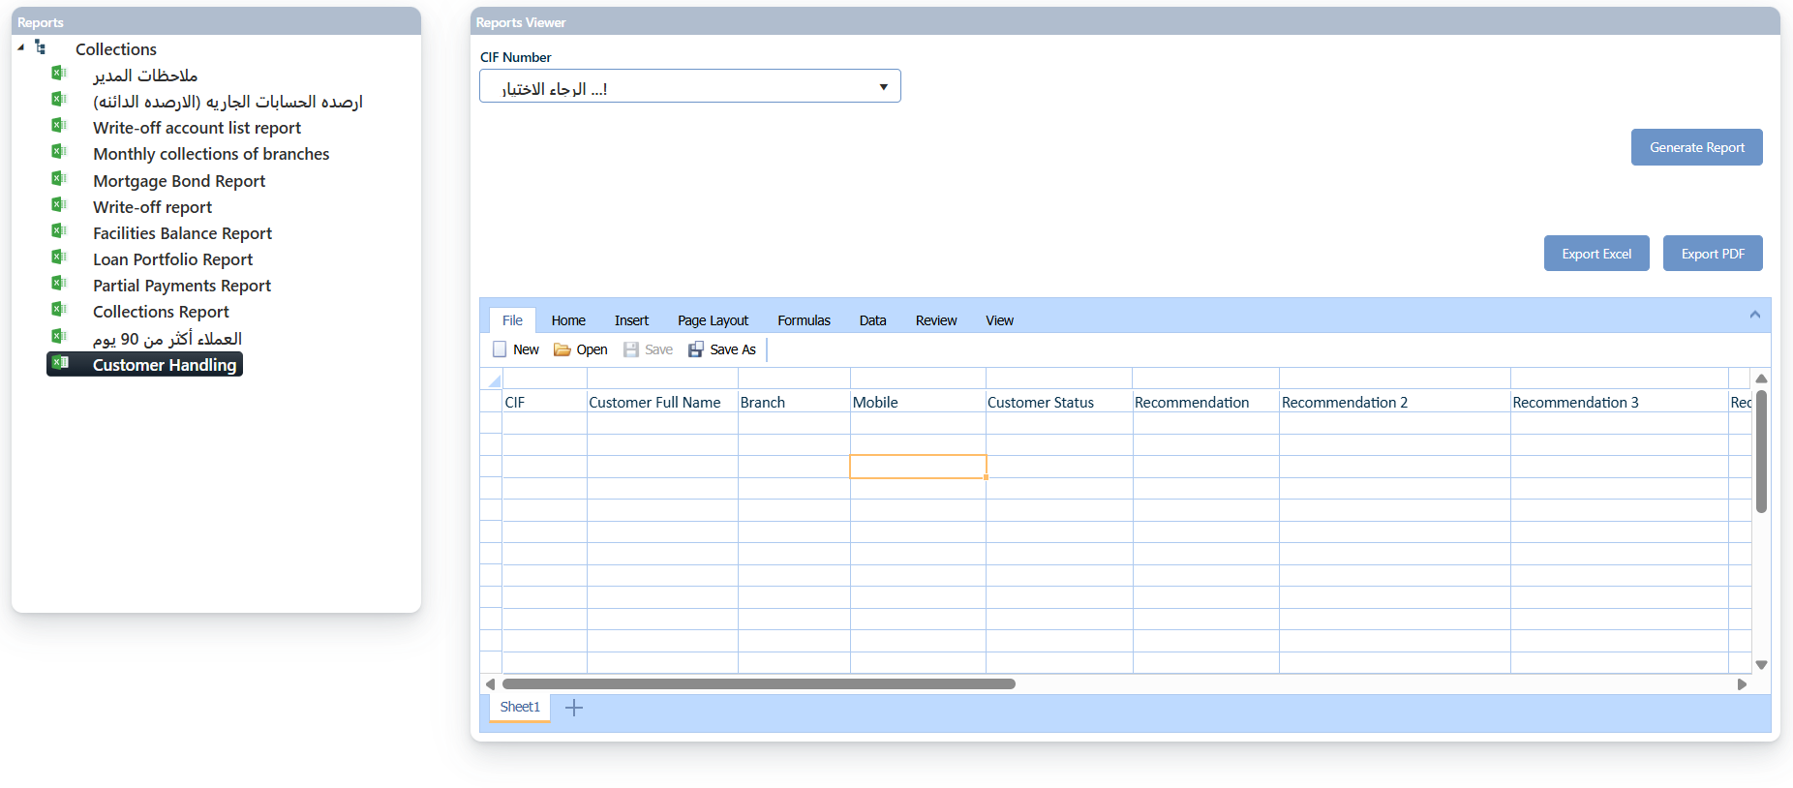

## Reports

### Collector Actions Report

This report is designed to display all paid cases (whether full or partial payments) for each delinquent account, categorized by each collector.

Layout:

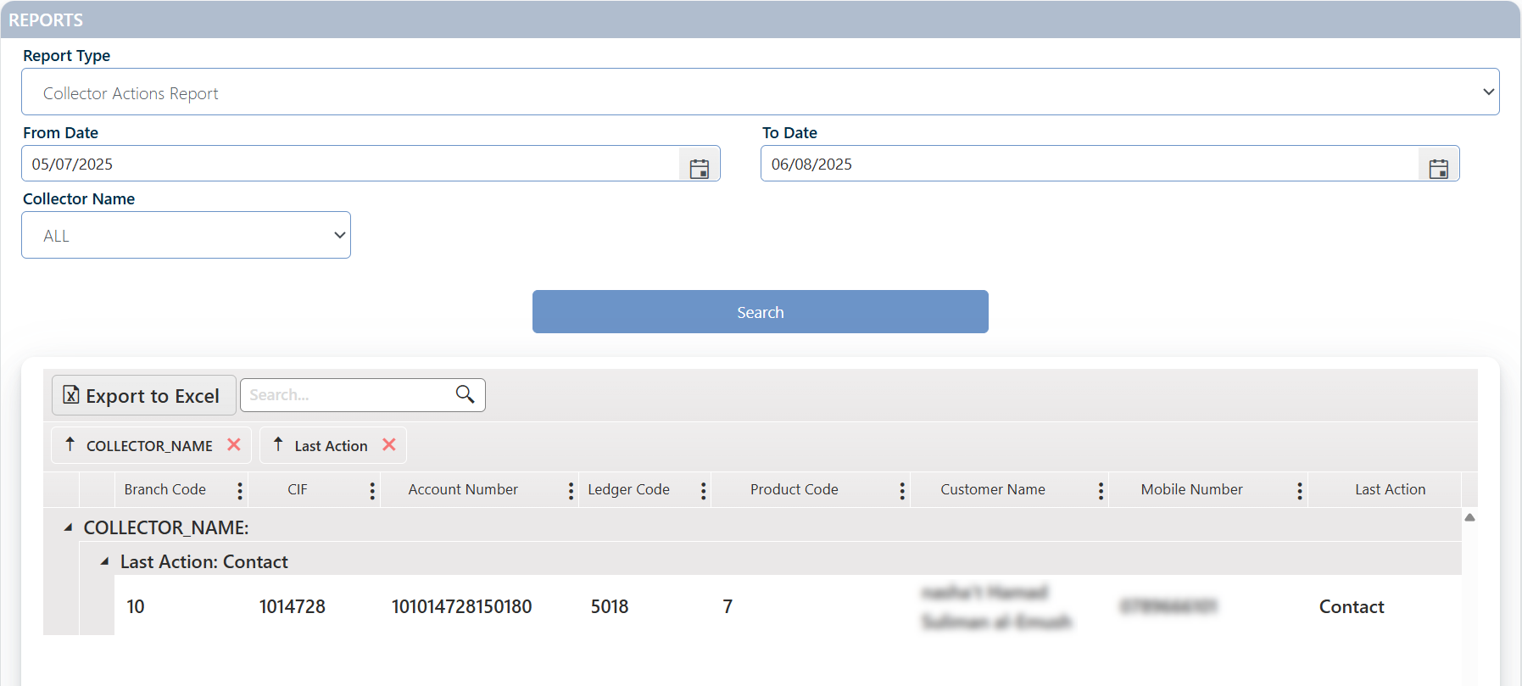

### Collector Productivity Report

This report provides a summary of collectors’ performance and productivity, either on a daily basis or over a specified period.

Layout:

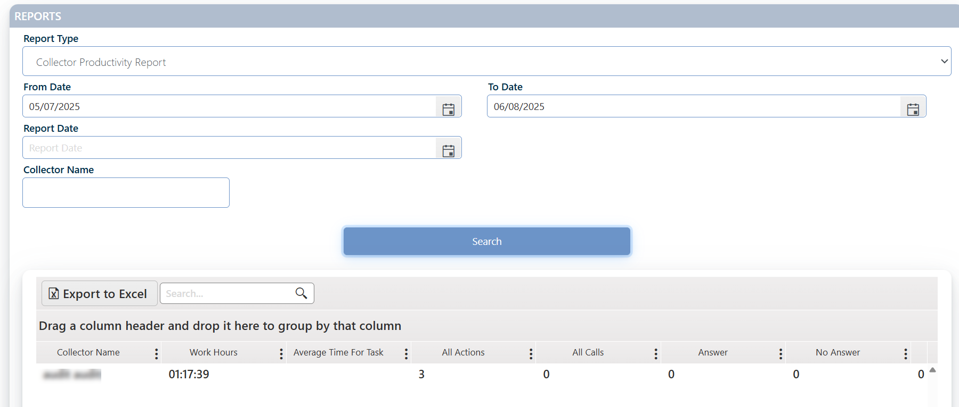

### JobBasket History Report

This report is designed to display all delinquency cases that meet the applied search criteria.

Layout:

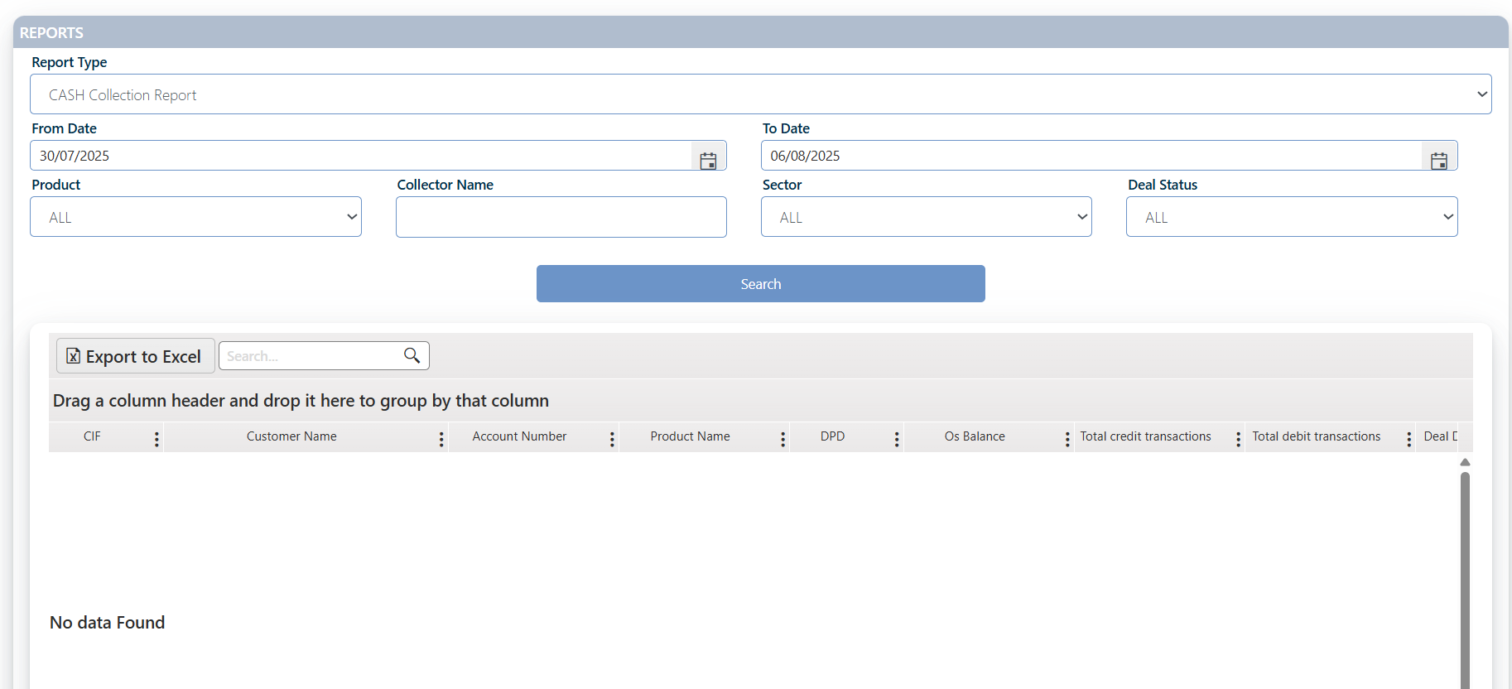

### Paid Cases Report

This report displays all cases that have been fully settled, with all outstanding installments paid in full—i.e., cases that have moved to "Bucket 0"—based on the applied search criteria.

Layout:

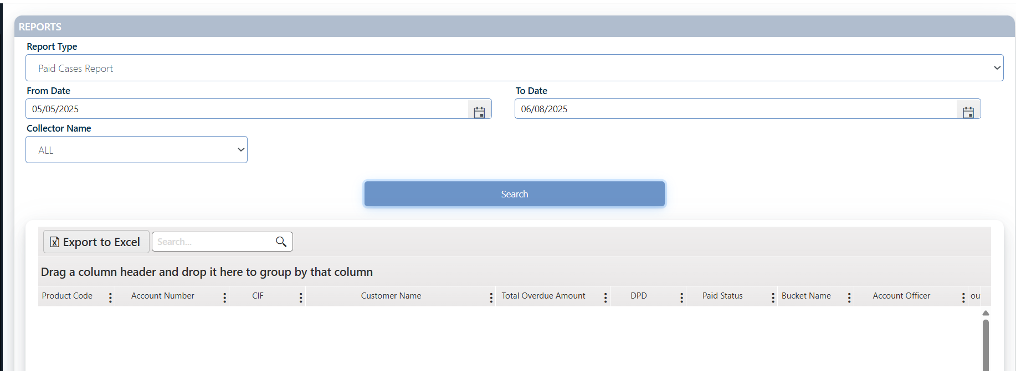

### No Action Report

This report is designed to display requests for which the current collector has not taken any action, based on the specified search criteria. The main search parameter provided in this report is the number of days.

Layout: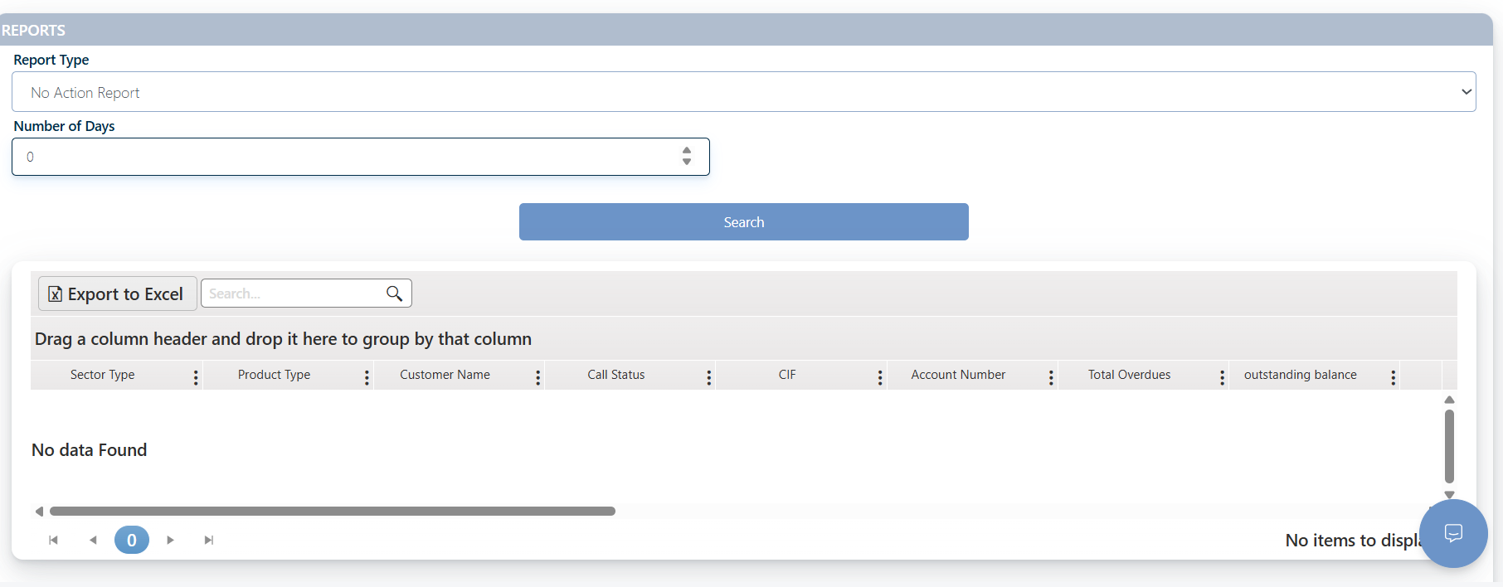

### Next Follow-up Action Report

This report is designed to display all cases that require the next follow-up action.

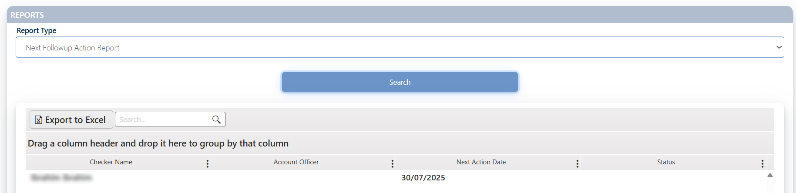

## Request Initiation

A study request is an official inquiry initiated to utilize specialized services for accounts that have exceeded one missed payment (indicating multiple delinquent payments and unfulfilled repayment commitments). The primary objective of this follow-up process is to address the customer's non-payment issues, which may include options such as rescheduling payment arrangements or developing tailored repayment plans.

On this interface, an authorized user selects the delinquent account holder, specifies the desired service for follow-up, and assigns a designated user responsible for executing the follow-up actions (the assigned user must possess the necessary permissions to manage study requests).

Layout:

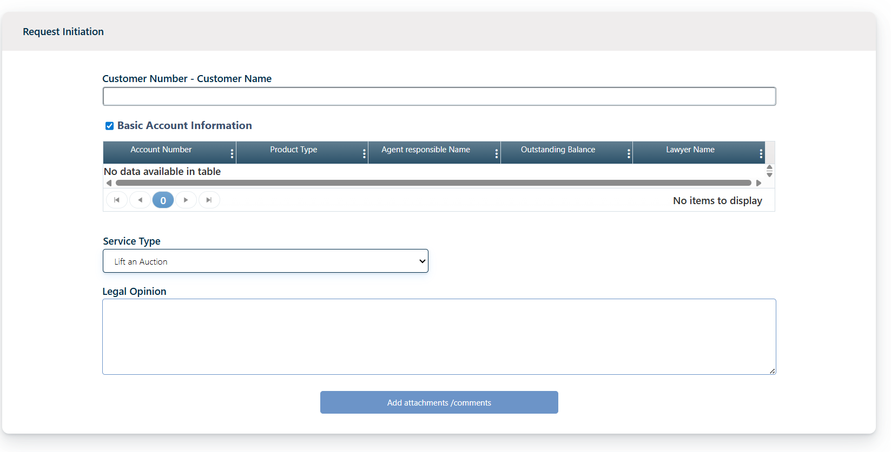

**Request Creation Process**

Only users granted the necessary permissions can create a study request. These permissions differ based on the user type:

* Internal users (bank employees) can select the employee responsible for following up on the request directly within the request creation screen.
* External users (such as external lawyers) operate outside the bank and do not have this option.

**The study request process consists of two stages:**

* Creating the request — performed on the New Study Request page.
* Completing the request — mostly done through the Study Tasks Basket, not the request screen itself.
* Screen navigation for tracking the request varies depending on whether the requester is internal or external, and on the specific workflow scenario. For detailed workflow guidelines and bank requirements, please consult the Business Requirements Document (BRD).

### Request Initiation Process

| Internal User | External User (Lawyer) |
| --- | --- |
| 1. The authorized user logs into the Study Request page. | 1.The authorized user logs into the Study Request page. |
| 1. Enter the customer number; the customer information will appear on the screen. | 2 Enter the customer number; the customer information will appear on the screen. |
| 1. Select the type of service. | 3. Select the type of service. |
| 1. Assign the employee responsible for following up on the request (the request will be transferred to this collector’s job basket). | 4.Enter the legal opinion. |
| 1. To complete the task, click the Attachments / Comments button. | 5.To complete the task, click the Attachments / Comments button. |
| 1. Add any relevant comments, if necessary. | 6. Add any relevant comments, if necessary. |
| 1. Attach any documents related to the request. | 7.Attach any documents related to the request. |
| 1. Click the Save button. | 8. Click the Save button. |

1. For internal users, task distribution happens as described above; for external users, task distribution is managed through the job basket of the user authorized to assign tasks.
2. If the requester has external user permissions (external lawyer), the Legal Opinion field is enabled and mandatory; if the requester has internal user permissions, this field is disabled.
3. To add attachments or comments related to the request, click the Attachments button.

Comment:

* If the request is submitted by an external lawyer, all tasks will be grouped and assigned manually.
* If the request is submitted internally, the tasks will be automatically assigned to a specific collector, who will be notified via email.
* At any stage, if a task is returned, it will go back to the collector with Officer privileges.
* Handling and classification of the study type are done within the Study Work Basket.
* The selected Service Type relies on the business requirements, please refer to the BRD for more information. The services provided are:
  + Addressing Insurance
  + Analysis
  + Auction Control / Final Referral
  + Auction insurance differences
  + Cancel Guarantee
  + Clearance
  + Clearance letter
  + Client Inclusion
  + Close Account
  + Deceased Client
  + Entering an Auction
  + Establishing a case
  + Extend Guarantee
  + Notification of the publication of advertisements
  + Ownership transfer differences
  + Payment of Guarantee
  + Payment of ownership transfer fees + Auction stamps + Roofs
  + Putting off
  + Putting the referee's decision for execution
  + Query
  + Raising the name of a suspended client
  + Registration of attorney's fees
  + Release of attachment / Mortgage
  + Renewal of cancellation of insurance policy
  + Request for witnesses
  + Reverse Balance
  + Reverse Benefits
  + Reverse legal expenses
  + Scheduling
  + Settlement
  + Structuring
  + Study
  + Study an accounting experience report
  + Study of cassation of the referee's decision
  + Studying the appeal of the judgment decision
  + Termination of enforcement procedures on real estate guarantees
  + Transfer/Transfer of Ownership
  + Write off
  + Write off restriction

## Studies Job Basket

This page is designed to display and track accounts for which a study request has been submitted. Access is granted to authorized users based on their user type and position within the request's workflow. The components of the page—including control buttons and fields—vary according to the form type selected during the request setup phase, as well as the active user's role and permissions.

Layout:



The "Step Name" field indicates the current stage of the request within the workflow, showing the transition between different roles or approval levels. This helps the user understand the exact status of the request. Meanwhile, the "Service Type" field specifies the nature of the action required for the request, based on the established process flow.

To view the task the user needs to click the details button near to it “ ”, the n the task will be viewed as below:



## Suggest Write Off

This page is designed for proposing and managing the manual write-off of delinquent debts, based on specific criteria established by the financial institution using the system. It is intended for cases in which debt recovery is considered either impossible or not financially viable.

Access to this screen is restricted to authorized users who possess the necessary permissions to manage delinquent collection accounts (Remedial or Collections) and are authorized to submit write-off proposals.

Layout:

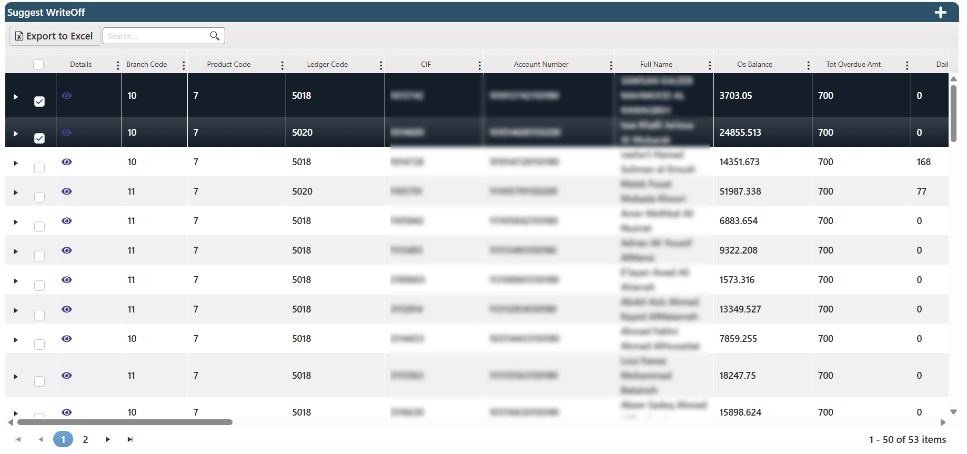

Given the sensitivity and financial implications of this process, a dedicated workflow has been implemented. This workflow consists of a sequence of predefined steps and approvals among authorized users to ensure that the final decision is made in accordance with the institution’s approved procedures.

The following diagram outlines the agreed-upon workflow steps for executing the write-off process, from initiation to final decision.

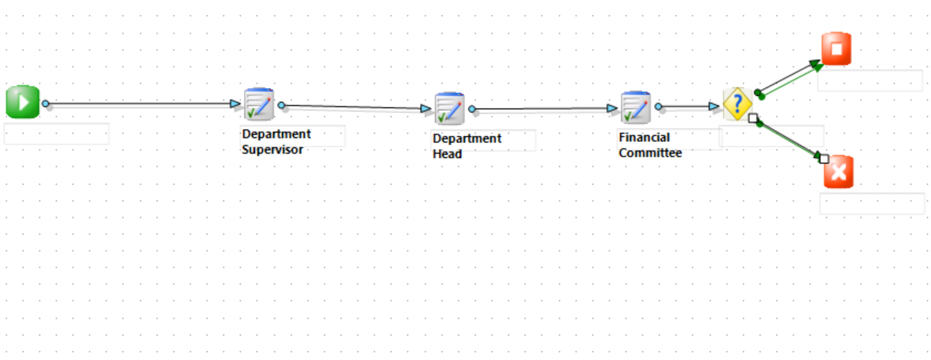

**Manual Write-Off Workflow**

1. Initiation: The manual write-off request is initiated by an authorized user. The user selects the accounts to be written off, clicks the ‘+’ button at the top of the screen, and confirms the action. The request is then routed through the workflow to the user with approval authority.

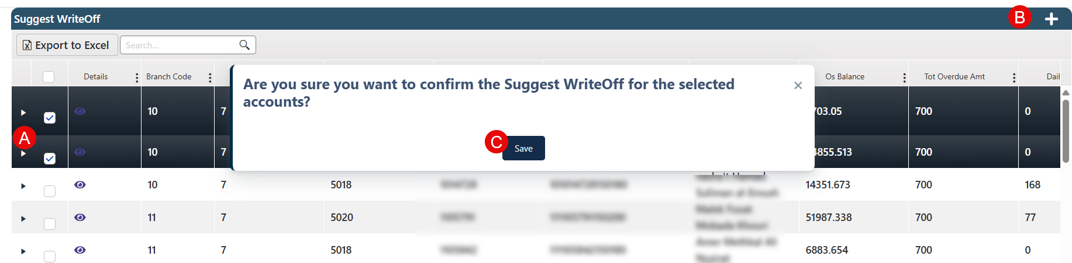

1. Department Supervisor: The supervisor receives the request, reviews it, and ensures that all required information is complete. The request is then forwarded to the Department Head.
2. Department Head: The head of the department performs a secondary review and either provides initial approval or rejects the request. If approved, the request is sent to the Financial Committee.
3. Financial Committee: The committee reviews the proposed accounts from a financial perspective and makes a decision. The request is then sent to the final decision point.
4. Decision Point: If the Financial Committee approves the request, the system proceeds with executing the write-off. If the request is rejected, the process is canceled, and the initiating user is notified.

**Comment:** Once the write-off is approved and finalized, the system activates a new tab on the customer follow-up page displaying detailed write-off information. Additionally, a dedicated **Write-Off Report** will be available under the **Reports** section.

## Workflow Status

The Workflow Status page provides a detailed log-style view of all tasks processed through the system. It displays each task's transition history, current status, and progress stage. This page acts as a comprehensive activity tracker, ensuring that users can follow up on request lifecycles and actions taken.

Layout

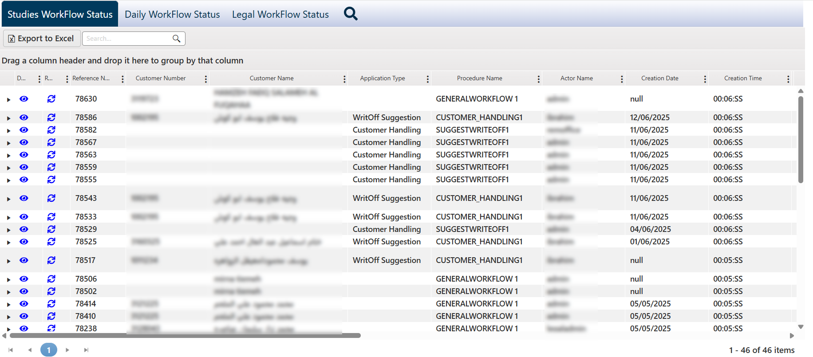

The page is organized into three tabs, each dedicated to a specific type of task. While the functionality remains consistent across all tabs, each tab filters and displays workflow activities relevant to its respective scope:

* Studies Workflow Status: Monitors tasks related to study requests.
* Daily Workflow Status: Displays tasks assigned to the active user for the current day.
* Legal Workflow Status: Appears only when the system is integrated with the legal case management module provided by Bank-BPM, and tracks tasks related to legal workflows.

By clicking the Details button, users can access the full lifecycle of the request, with the most recent stage highlighted as the current one.

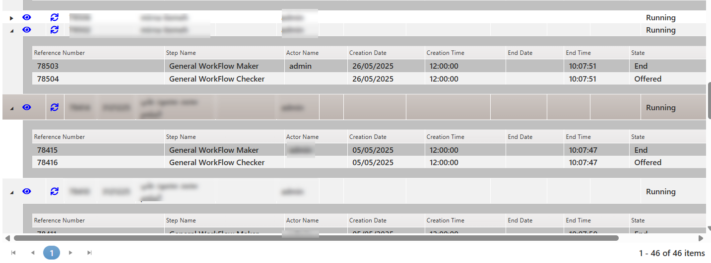

Clicking the View button opens all associated comments and attachments, including timestamps and uploader details.

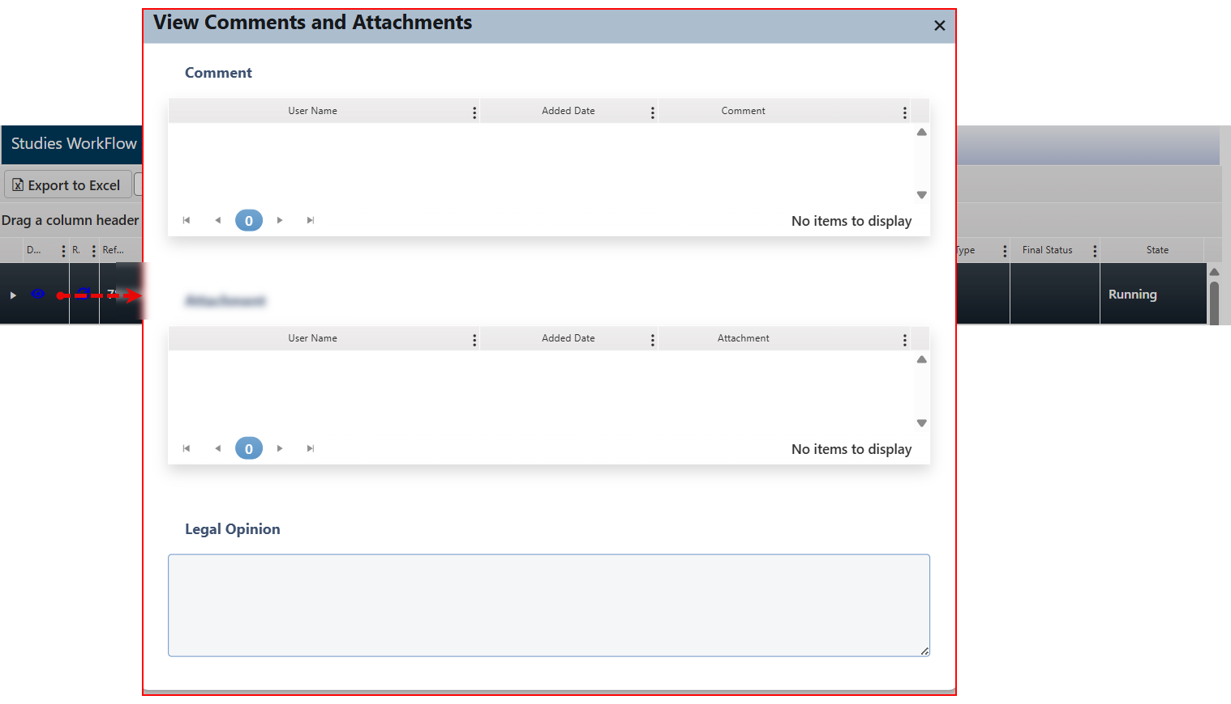

Additionally, the Reassign button allows users to manage task responsibility—whether by reassigning to another user, canceling the current assignment. Or close the screen

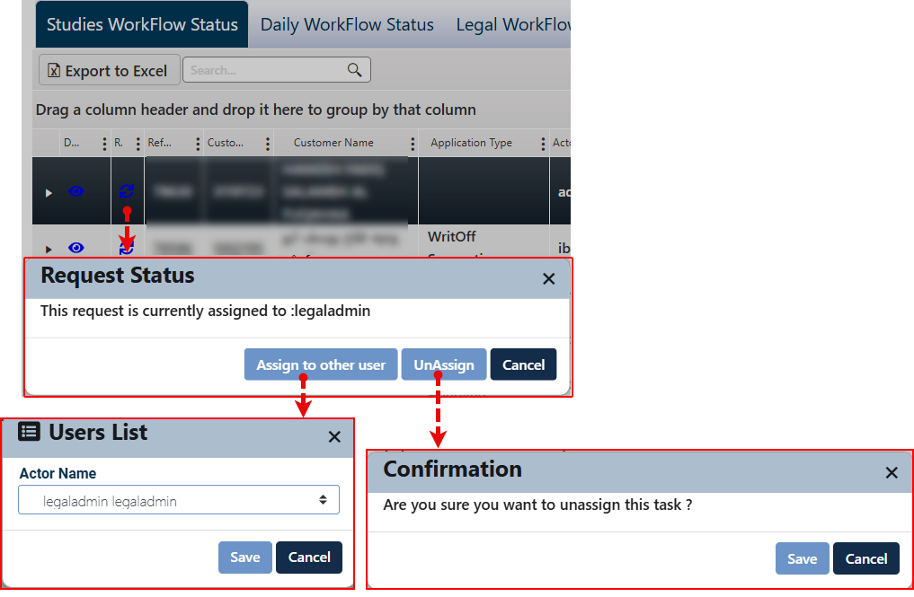

## Administration

### Job Basket Checker

This page is available exclusively to users with Checker privileges, and it is designed to monitor and approve administrative tasks that require the checker validation before execution.

Layout:

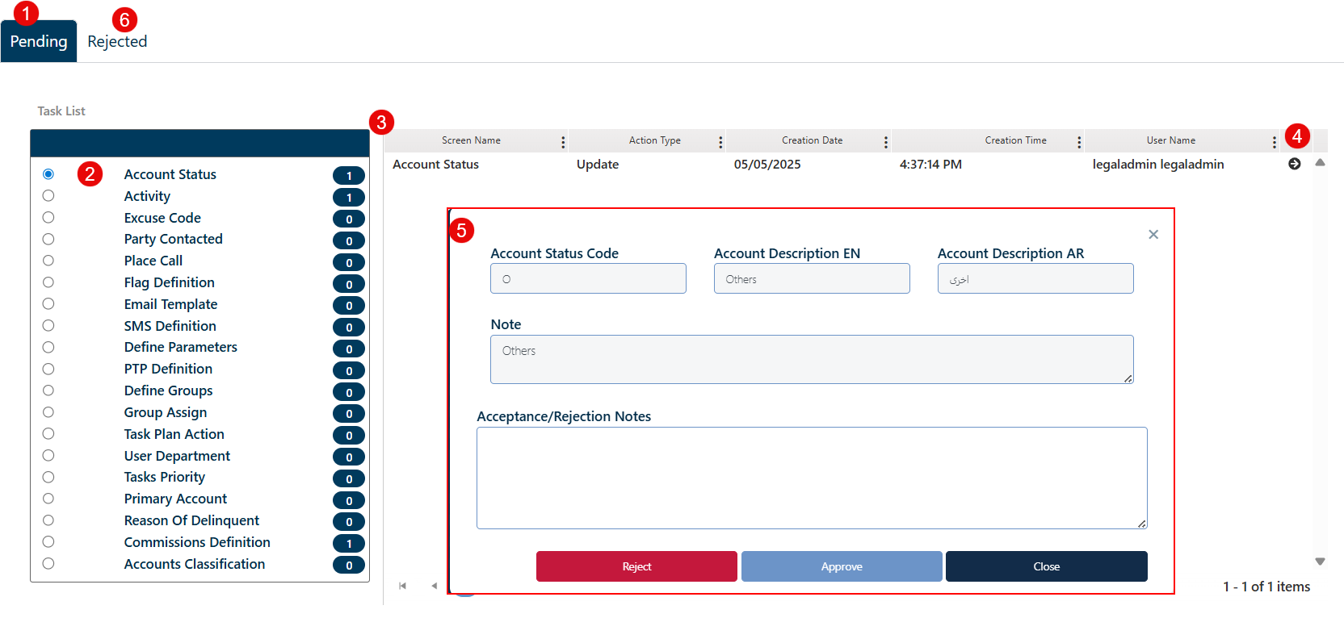  
**Page Layout Overview**

The page consists of the following key components:

1. Tabs

* Pending (①): Displays all tasks that are awaiting Checker review and action.
* Rejected (⑥): Lists all tasks that have been rejected by the Checker, providing a reference log for auditing and follow-up.

1. Task Type List: On the left panel (②), a categorized list of task types is displayed, each showing a count of pending requests. Clicking a task type filters the tasks accordingly.
2. Tasks grid viewer (③) listing all the tasks and key details about them.
3. Task viewer (④): to view each task to the checker to operate.
4. Task details screen that contains related control buttons (⑤): viewing the selected task’s details to the checker allowing him to :

* Reject: rejects the request and moves it to the "Rejected" tab.
* Approve: Executes the task in the system.
* Close: Closes the task window without taking action.
* Provide Acceptance/Rejection Notes

### Definition Screens

The Definition Screens enable users to configure essential tools and parameters that support various collection and follow-up services. This functionality allows for standardized setup and streamlines processes throughout the system.

Layout:

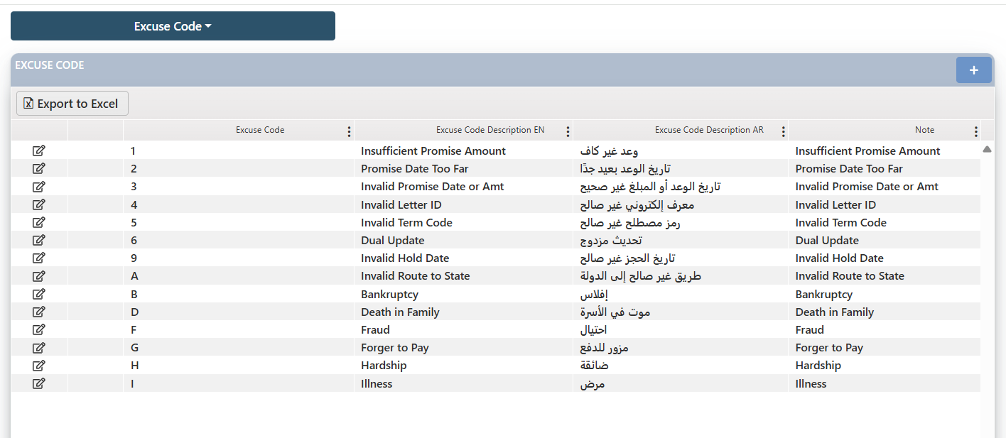

The user first needs to choose which service to define and then proceed.

Comment: The services that can be defined through these screens are subject to the project requirements and can include the following:

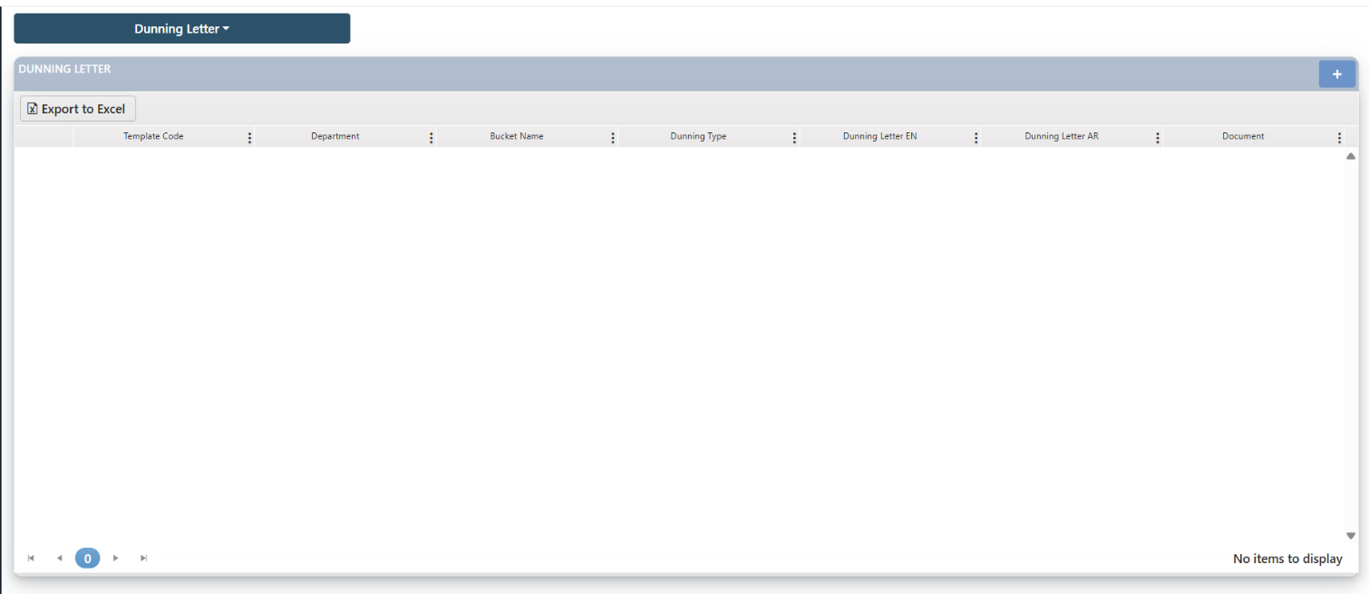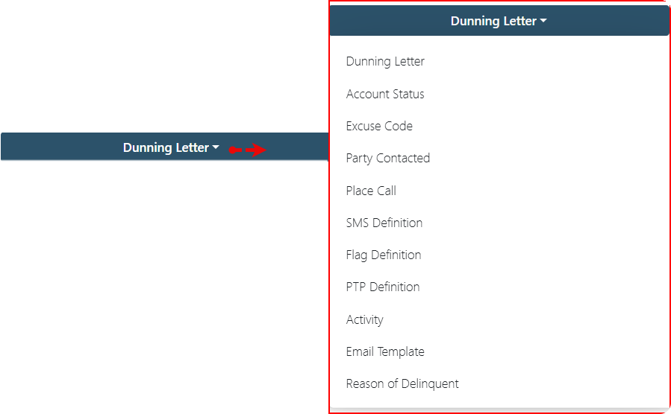

* The processes on this page allow users to define (add), edit, and delete records. It is important to note that the delete feature is available only for user entries, not for system default values.

#### Dunning Letter

This screen is used to define the dunning letter that will be sent to delinquent customers, either manually or by mail. The letter is created in advance and uploaded into the system along with descriptive information. All uploaded letters are listed in the screen, with an option to delete each one.

Layout:

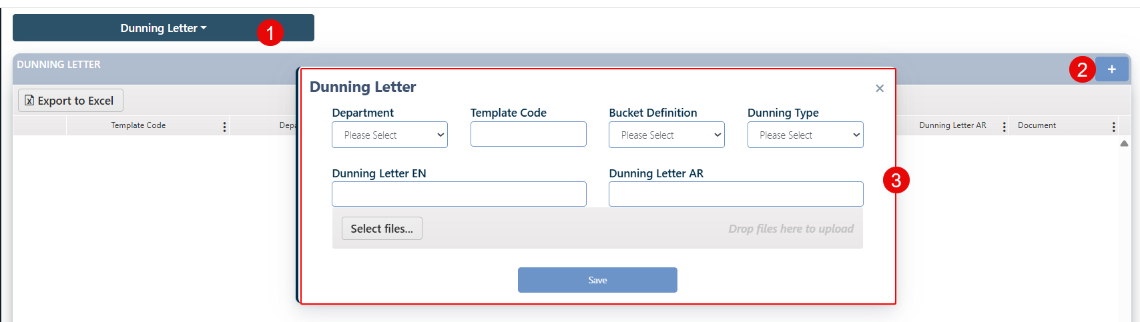

To define a dunning letter the user needs to:

1. Click on the add button (+)
2. In the related Screen which will appear, the user needs to fulfill the fields:
   1. Select the department
   2. Insert the template Code
   3. Select the Bucket Definition
   4. Select the dunning type a Select client or guarantee
   5. Insert the name of the Dunning Letter - EN
   6. Insert the name of the Dunning Letter - AR
3. Click on the save button
4. This request will be sent to the JobBasket Checker for the authorized user to either confirm and approve it or reject it.
5. If the request is approved by the checker, then the record will be listed in the screen.

**Edit**: The user can edit any existing record by clicking the Edit button next to it. After making the necessary modifications using the active fields, the user must click the Update button to submit the changes. This request is then routed to the JobBasket Checker, where an authorized user can either approve or reject the update.

* + - If approved, the changes will be immediately reflected in the record.
    - If rejected, the request will be canceled and moved to the Rejected Tasks tab for reference.

**Delete**: The user can delete any existing record "added by the user" by clicking the Delete button next to it. Upon confirmation, a deletion request is generated and routed to the JobBasket Checker, where an authorized user can either approve or reject the request.

* + - If approved, the record will be permanently removed from the system.
    - deletion request will be canceled and moved to the Rejected Tasks tab for reference.

#### Account Status

This screen is used to display, define, or delete the statuses assigned to customer accounts. Some of these statuses are system-defined and fixed, while others can be defined by the user based on business needs. The fixed system-defined account statuses cannot be deleted, but the user is allowed to modify them.

Layout:

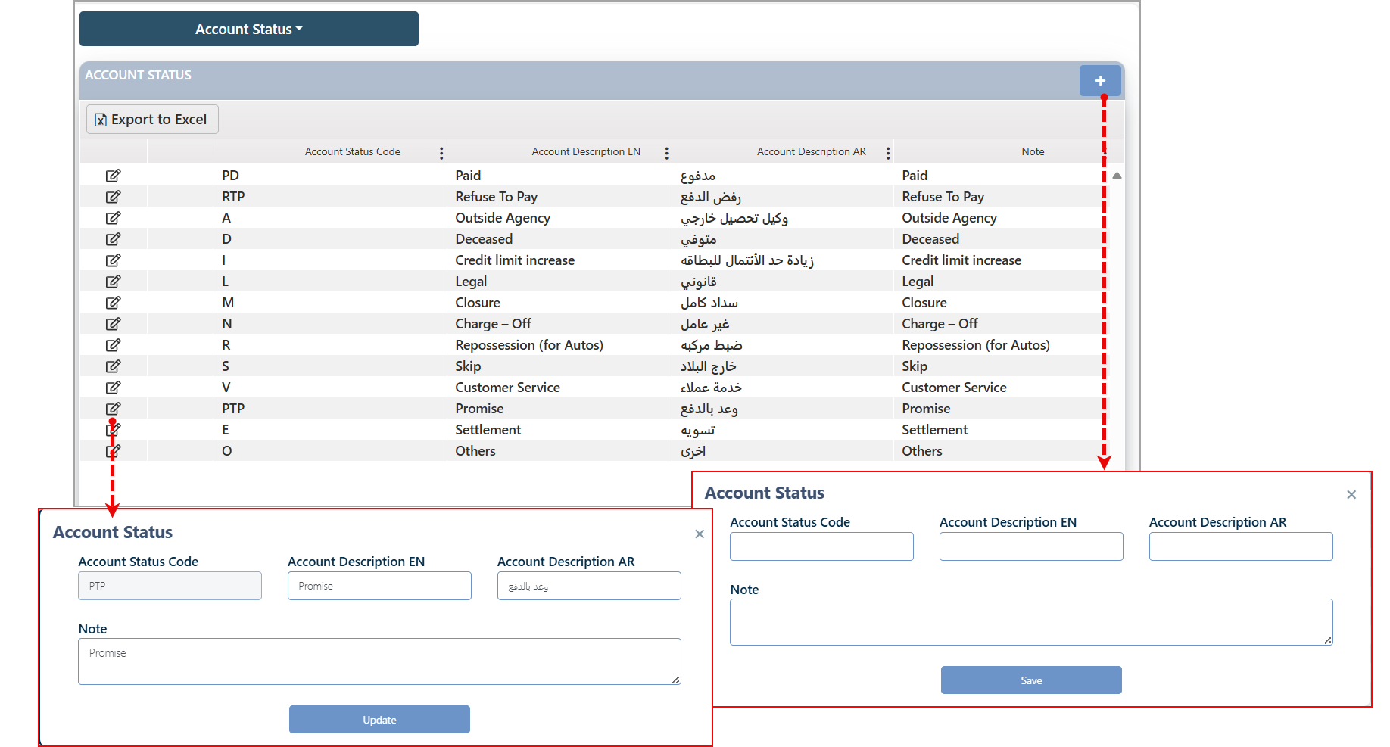

**Define New Account Status**

To define account status record, the user needs to:

1. Click on the add button (+)
2. In the related Screen which will appear, the user needs to fulfill the fields on the screen.
3. Click on the save button
4. This request will be sent to the JobBasket Checker for the authorized user to either confirm and approve it or reject it.
5. If the request is approved by the checker, then the record will be listed in the screen.

**Edit**: The user can edit any existing record by clicking the Edit button next to it. After making the necessary modifications using the active fields, the user must click the Update button to submit the changes. This request is then routed to the JobBasket Checker, where an authorized user can either approve or reject the update.

* + - If approved, the changes will be immediately reflected in the record.
    - If rejected, the request will be canceled and moved to the Rejected Tasks tab for reference.

**Delete**: The user can delete any existing record "added by the user" by clicking the Delete button next to it. Upon confirmation, a deletion request is generated and routed to the JobBasket Checker, where an authorized user can either approve or reject the request.

* + - If approved, the record will be permanently removed from the system.
    - If rejected, the deletion request will be canceled and moved to the Rejected tasks tab for reference.

#### Excuse Code

This screen is used to view, define, or edit excuse codes that are utilized across the system in any section where an excuse is required for non-payment or payment difficulties.

Layout:

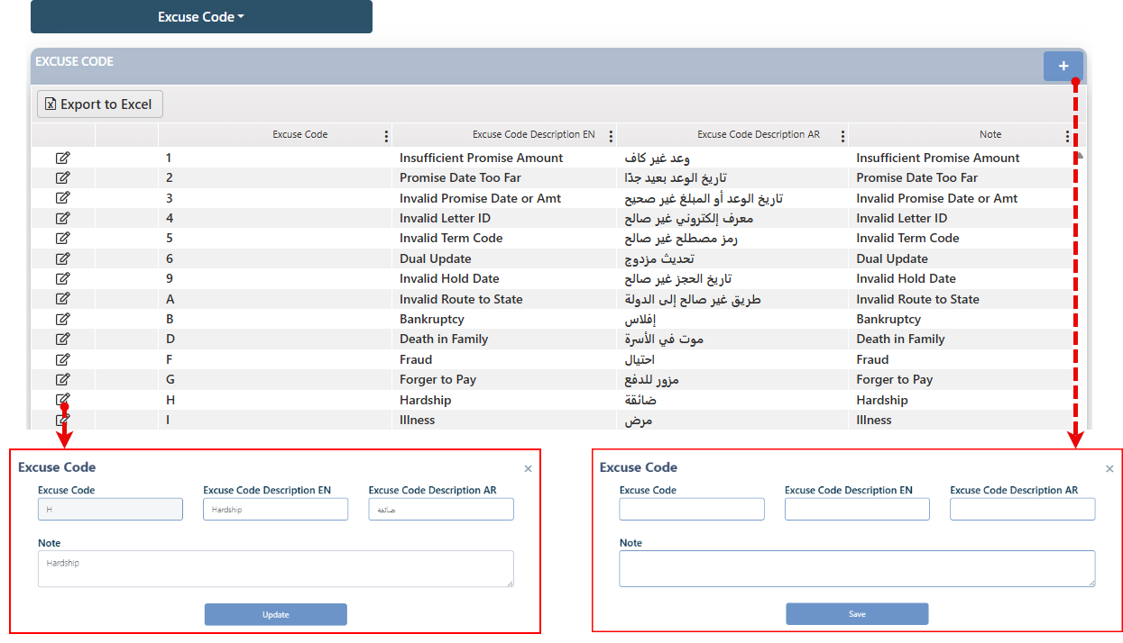

To define a related record, the user needs to :

1. Click on the add button (+)
2. In the related Screen which will appear, the user needs to fulfill the fields in the screen
3. Click on the save button
4. This request will be sent to the JobBasket Checker for the authorized user to either confirm and approve it or reject it.
5. If the request is approved by the checker, then the record will be listed in the screen.

**Edit**: The user can edit any existing record by clicking the Edit button next to it. After making the necessary modifications using the active fields, the user must click the Update button to submit the changes. This request is then routed to the JobBasket Checker, where an authorized user can either approve or reject the update.

* + - If approved, the changes will be immediately reflected in the record.
    - If rejected, the request will be canceled and moved to the Rejected Tasks tab for reference.

**Delete**: The user can delete any existing record "added by the user" by clicking the Delete button next to it. Upon confirmation, a deletion request is generated and routed to the JobBasket Checker, where an authorized user can either approve or reject the request.

* + - If approved, the record will be permanently removed from the system.
    - If rejected, the deletion request will be canceled and moved to the Rejected tasks tab for reference.

#### Party Contacted

This screen allows the user to add contact parties that are involved in communication throughout the system's processes. Each contact party represents a type of recipient (e.g., Customer, Guarantor, Lawyer). The screen displays a list of all approved contact parties, with the ability to:

|  |  |  |
| --- | --- | --- |
| * Create a new contact party | * Edit an existing contact party | * Delete a contact party |

Layout:

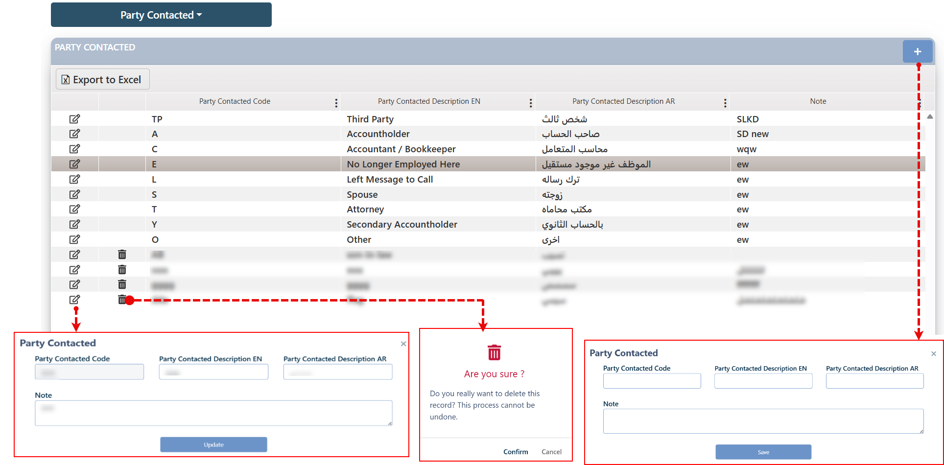

To define a related record, the user needs to:

1. Click on the add button (+)
2. In the related Screen which will appear, the user needs to fulfill the fields in the screen
3. Click on the save button
4. This request will be sent to the JobBasket Checker for the authorized user to either confirm and approve it or reject it.
5. If the request is approved by the checker, then the record will be listed in the screen.

**Edit**: The user can edit any existing record by clicking the Edit button next to it. After making the necessary modifications using the active fields, the user must click the Update button to submit the changes. This request is then routed to the JobBasket Checker, where an authorized user can either approve or reject the update.

* + - If approved, the changes will be immediately reflected in the record.
    - If rejected, the request will be canceled and moved to the Rejected Tasks tab for reference.

**Delete**: The user can delete any existing record "added by the user" by clicking the Delete button next to it. Upon confirmation, a deletion request is generated and routed to the JobBasket Checker, where an authorized user can either approve or reject the request.

* + - If approved, the record will be permanently removed from the system.
    - If rejected, the deletion request will be canceled and moved to the Rejected tasks tab for reference.

#### Place Call

This screen allows the user to define the place of the call. It displays all locations currently registered in the system and provides the ability to add, edit, or delete call places.

Layout:

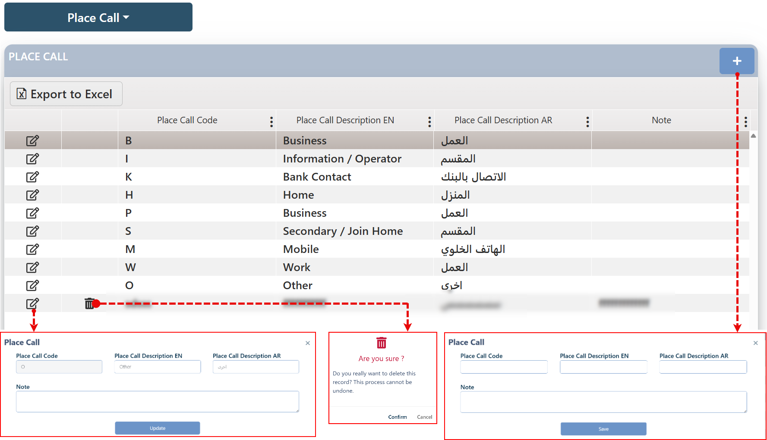

To define a related record, the user needs to:

1. Click on the add button (+)
2. In the related Screen which will appear, the user needs to fulfill the fields in the screen
3. Click on the save button
4. This request will be sent to the JobBasket Checker for the authorized user to either confirm and approve it or reject it.
5. If the request is approved by the checker, then the record will be listed in the screen.

**Edit**: The user can edit any existing record by clicking the Edit button next to it. After making the necessary modifications using the active fields, the user must click the Update button to submit the changes. This request is then routed to the JobBasket Checker, where an authorized user can either approve or reject the update.

* + - If approved, the changes will be immediately reflected in the record.
    - If rejected, the request will be canceled and moved to the Rejected Tasks tab for reference.

**Delete**: The user can delete any existing record "added by the user" by clicking the Delete button next to it. Upon confirmation, a deletion request is generated and routed to the JobBasket Checker, where an authorized user can either approve or reject the request.

* + - If approved, the record will be permanently removed from the system.
    - If rejected, the deletion request will be canceled and moved to the Rejected tasks tab for reference.

#### SMS Definition

In this screen the user can define the SMS message that will be used as a predefined template for sending. The user is granted permission to add, edit, and delete SMS templates. These inputs are used in the Customer follow-up page.

Layout:

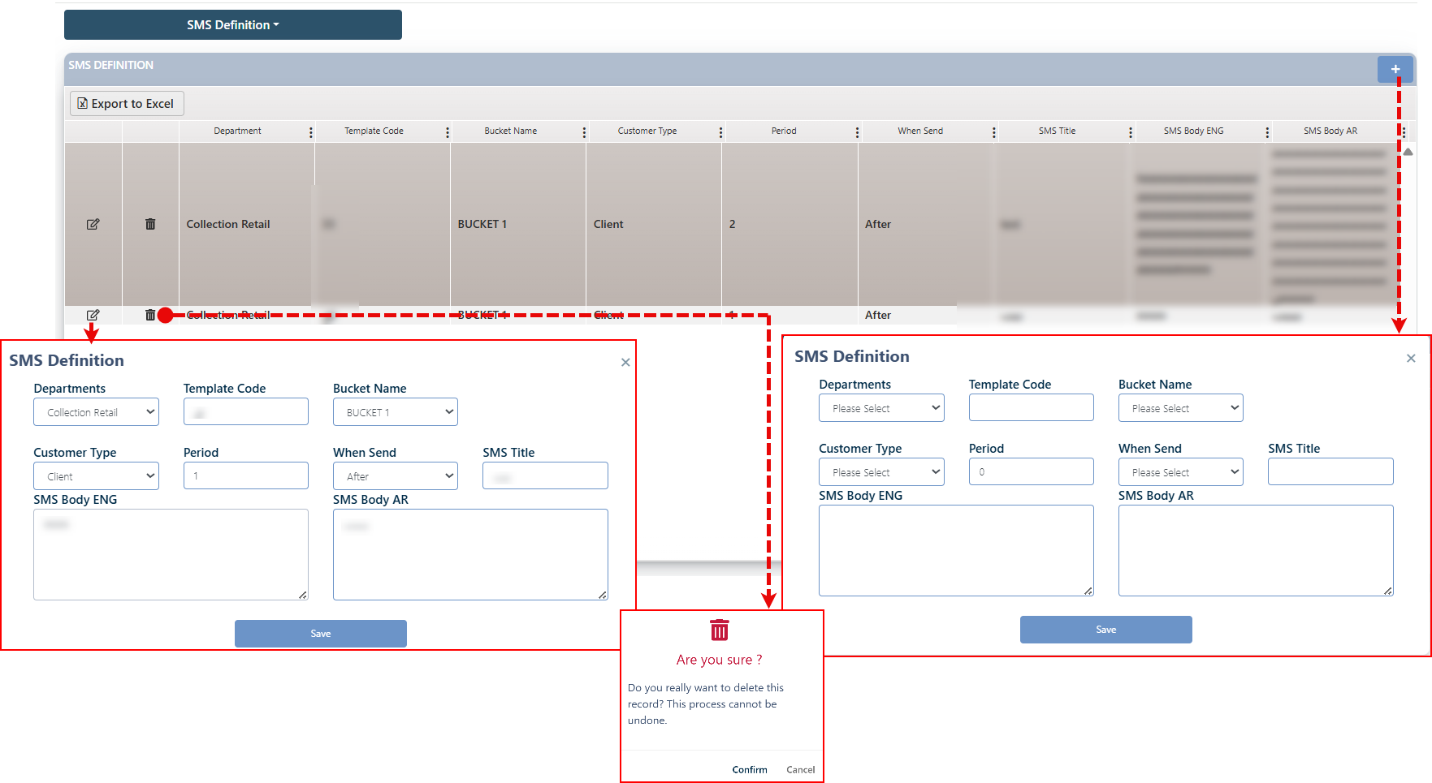

To define a related record, the user needs to:

1. Click on the add button (+)
2. In the related Screen which will appear, the user needs to fulfill the fields in the screen
3. Click on the save button
4. This request will be sent to the JobBasket Checker for the authorized user to either confirm and approve it or reject it.
5. If the request is approved by the checker, then the record will be listed in the screen.

**Edit**: The user can edit any existing record by clicking the Edit button next to it. After making the necessary modifications using the active fields, the user must click the Update button to submit the changes. This request is then routed to the JobBasket Checker, where an authorized user can either approve or reject the update.

* + - If approved, the changes will be immediately reflected in the record.
    - If rejected, the request will be canceled and moved to the Rejected Tasks tab for reference.

**Delete**: The user can delete any existing record "added by the user" by clicking the Delete button next to it. Upon confirmation, a deletion request is generated and routed to the JobBasket Checker, where an authorized user can either approve or reject the request.

* + - If approved, the record will be permanently removed from the system.
    - If rejected, the deletion request will be canceled and moved to the Rejected tasks tab for reference.

#### Flag Definition

In this screen, the user defines a flag to be used within the system, specifically in the Customer follow-up page. Permissions are granted to add, modify, and delete flags, but note that deletion is only available for flags created by the user.

Layout:

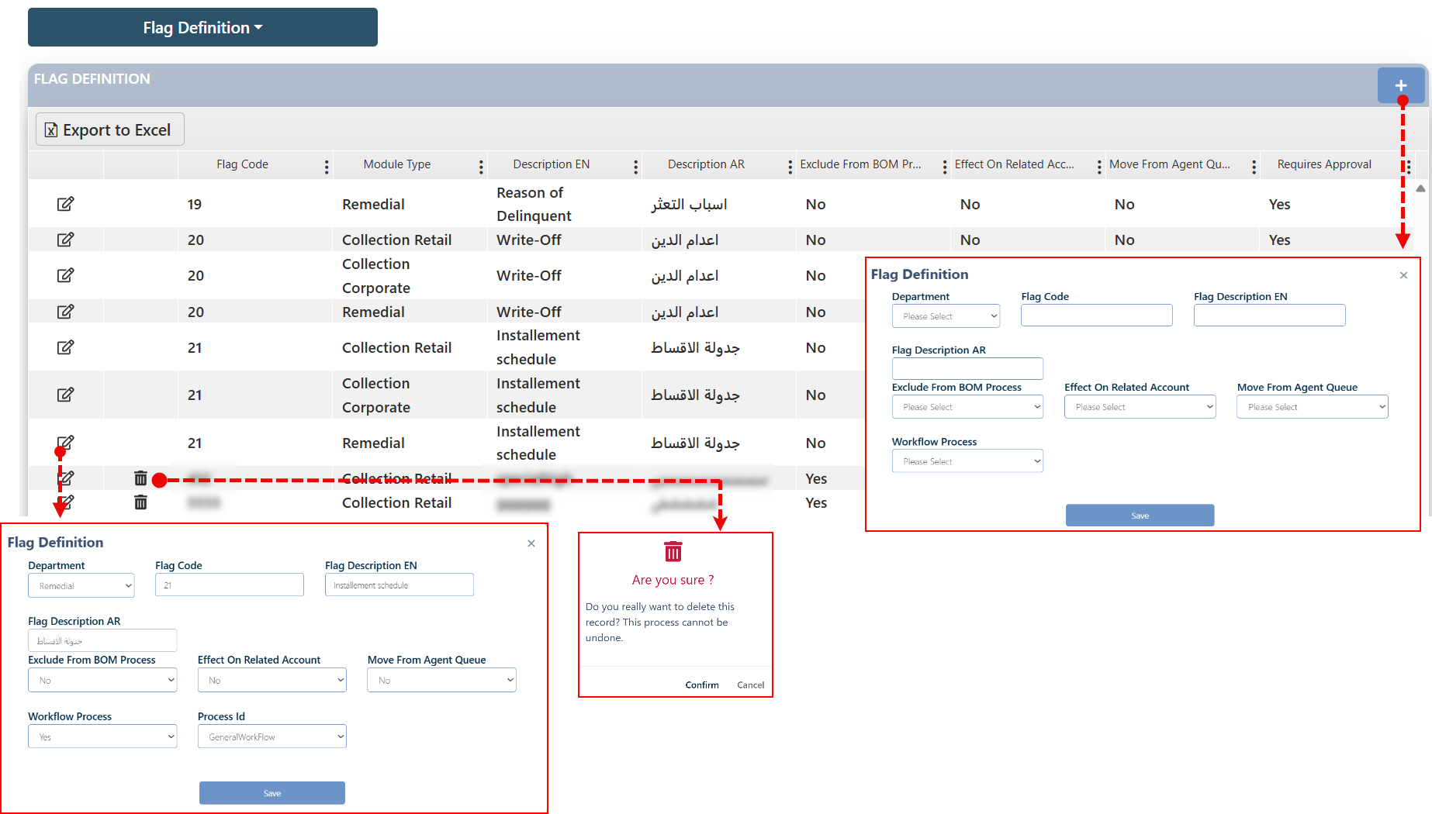

To define a related record, the user needs to:

1. Click on the add button (+)
2. In the related Screen which will appear, the user needs to fulfill the fields in the screen
3. Click on the save button
4. This request will be sent to the JobBasket Checker for the authorized user to either confirm and approve it or reject it.
5. If the request is approved by the checker, then the record will be listed in the screen.

**Edit**: The user can edit any existing record by clicking the Edit button next to it. After making the necessary modifications using the active fields, the user must click the Update button to submit the changes. This request is then routed to the JobBasket Checker, where an authorized user can either approve or reject the update.

* + - If approved, the changes will be immediately reflected in the record.
    - If rejected, the request will be canceled and moved to the Rejected Tasks tab for reference.

**Delete**: The user can delete any existing record "added by the user" by clicking the Delete button next to it. Upon confirmation, a deletion request is generated and routed to the JobBasket Checker, where an authorized user can either approve or reject the request.

* + - If approved, the record will be permanently removed from the system.
    - If rejected, the deletion request will be canceled and moved to the Rejected tasks tab for reference.

#### PTP Definition

On this screen, users can view and modify the evaluation criteria related to the Promise to Pay (PTP) feature.

Layout:

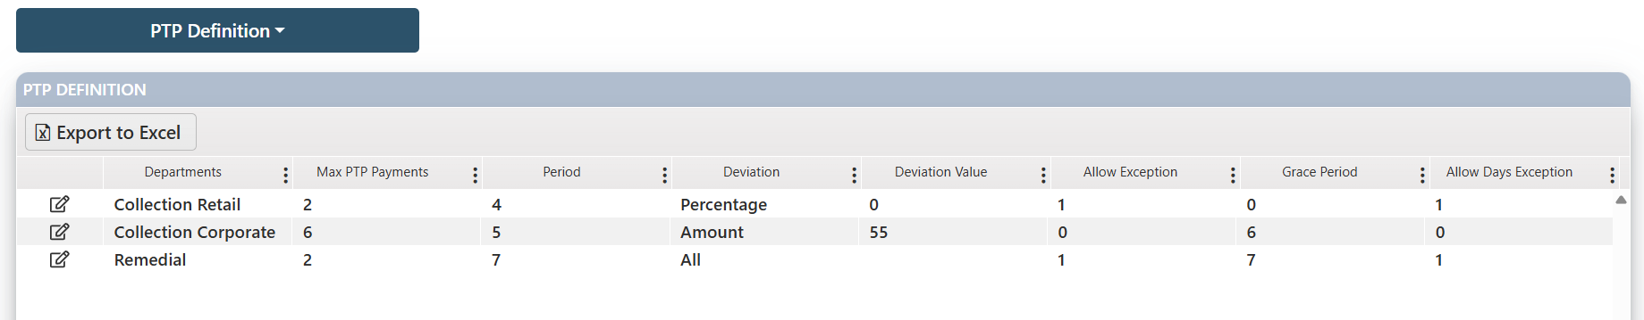

**Edit**: The user can edit any existing record by clicking the Edit button next to it. After making the necessary modifications using the active fields, the user must click the Update button to submit the changes.

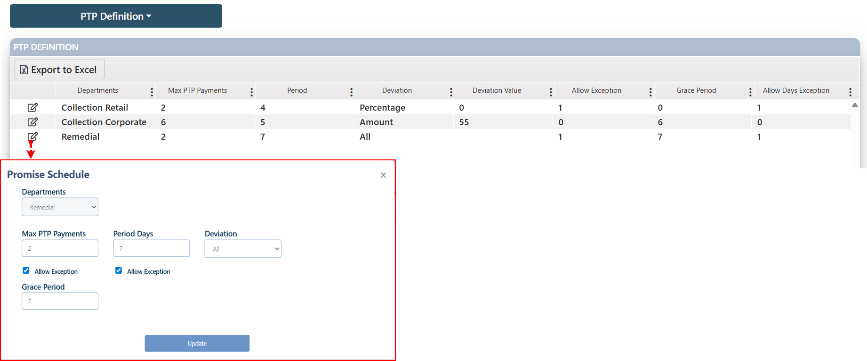

This request is then routed to the JobBasket Checker, where an authorized user can either approve or reject the update.

* + - If approved, the changes will be immediately reflected in the record.
    - If rejected, the request will be canceled and moved to the Rejected Tasks tab for reference.

#### Activity

Layout:

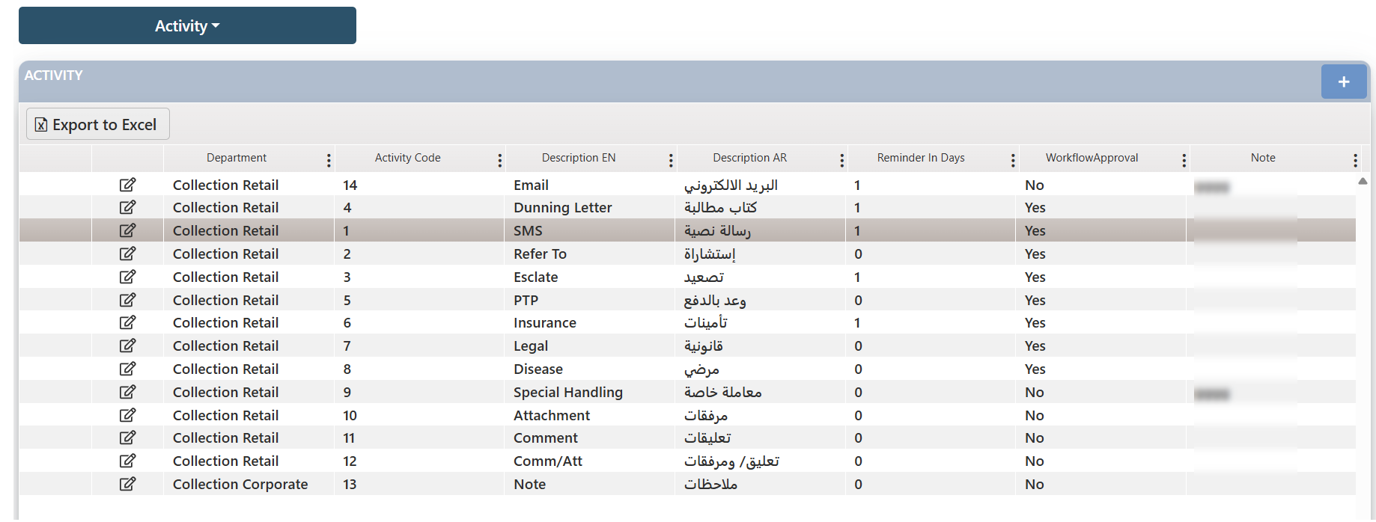

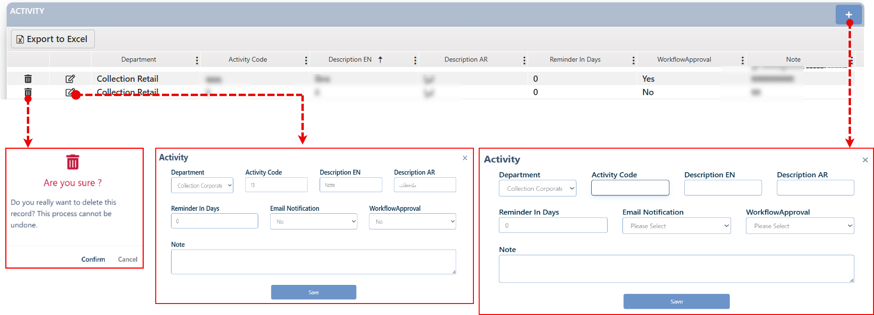

To define a related record, the user needs to:

1. Click on the add button (+)
2. In the related Screen which will appear, the user needs to fulfill the fields in the screen
3. Click on the save button
4. This request will be sent to the JobBasket Checker for the authorized user to either confirm and approve it or reject it.
5. If the request is approved by the checker, then the record will be listed in the screen.

**Edit**: The user can edit any existing record by clicking the Edit button next to it. After making the necessary modifications using the active fields, the user must click the Update button to submit the changes. This request is then routed to the JobBasket Checker, where an authorized user can either approve or reject the update.

* + - If approved, the changes will be immediately reflected in the record.
    - If rejected, the request will be canceled and moved to the Rejected Tasks tab for reference.

**Delete**: The user can delete any existing record "added by the user" by clicking the Delete button next to it. Upon confirmation, a deletion request is generated and routed to the JobBasket Checker, where an authorized user can either approve or reject the request.

* + - If approved, the record will be permanently removed from the system.
    - If rejected, the deletion request will be canceled and moved to the Rejected tasks tab for reference.

#### Email Template

On this screen, users can define email templates to be used in the system for communicating with customers, with permissions to add, edit, and delete these templates.

Layout:

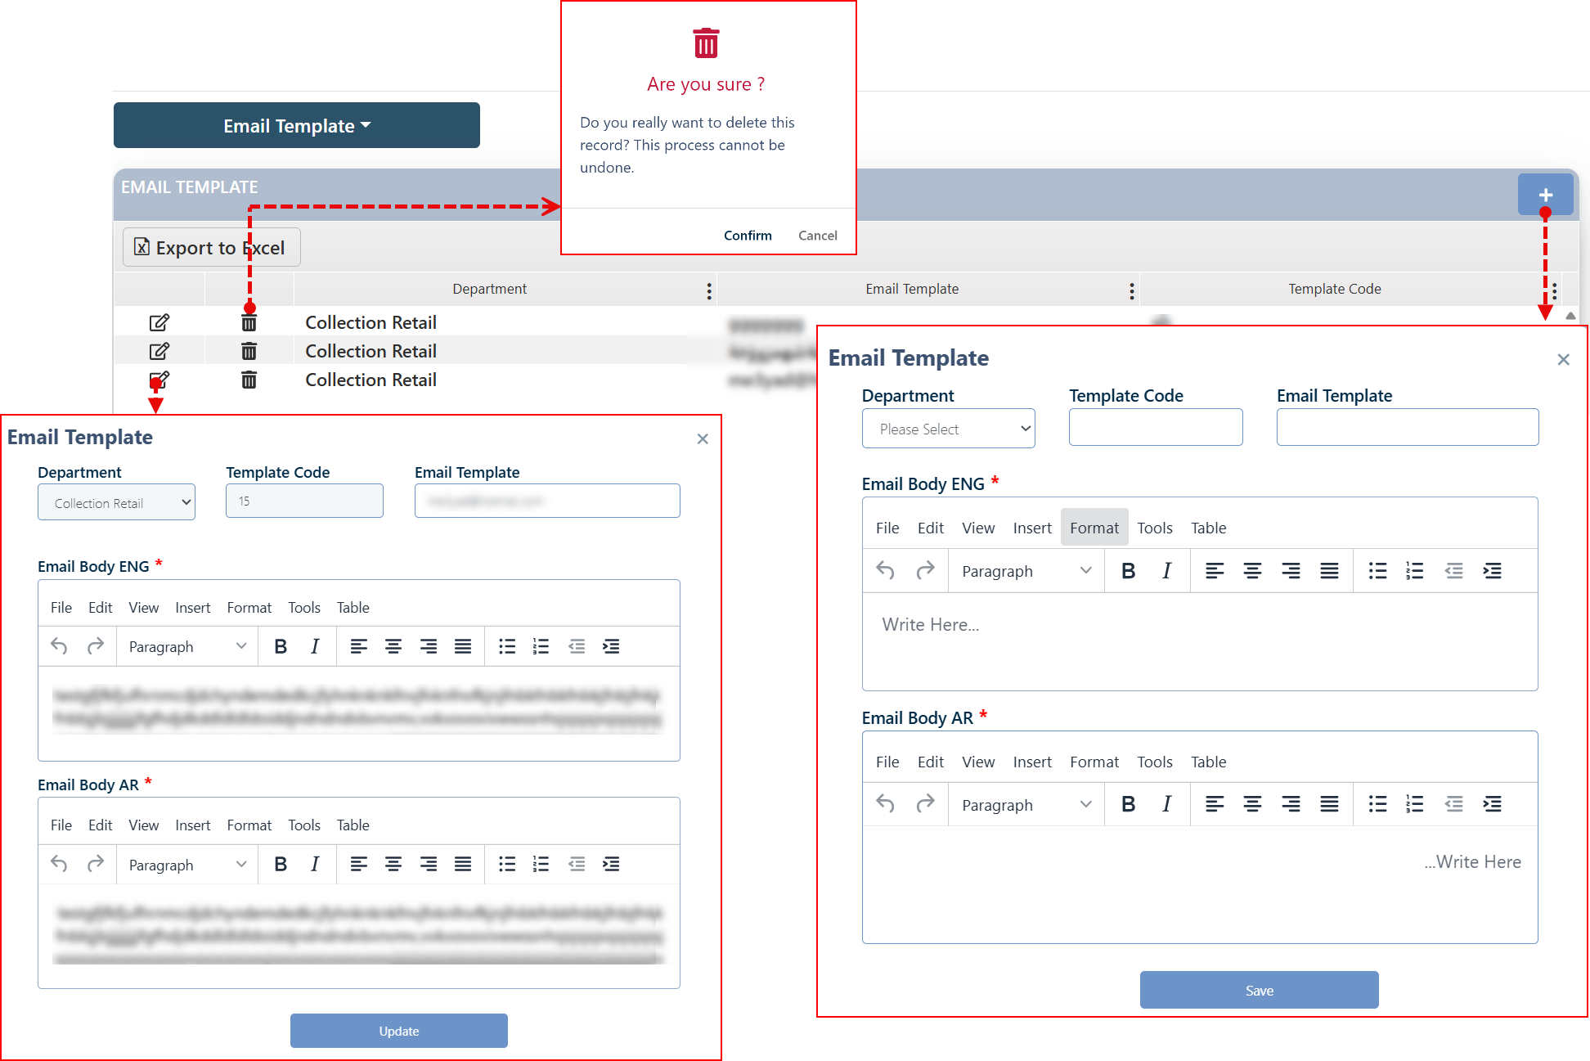

To define a related record, the user needs to:

1. Click on the add button (+)
2. In the related Screen which will appear, the user needs to fulfill the fields in the screen.
3. Click on the save button
4. This request will be sent to the JobBasket Checker for the authorized user to either confirm and approve it or reject it.
5. If the request is approved by the checker, then the record will be listed in the screen.

**Edit**: The user can edit any existing record by clicking the Edit button next to it. After making the necessary modifications using the active fields, the user must click the Update button to submit the changes. This request is then routed to the JobBasket Checker, where an authorized user can either approve or reject the update.

* + - If approved, the changes will be immediately reflected in the record.
    - If rejected, the request will be canceled and moved to the Rejected Tasks tab for reference.

**Delete**: The user can delete any existing record "added by the user" by clicking the Delete button next to it. Upon confirmation, a deletion request is generated and routed to the JobBasket Checker, where an authorized user can either approve or reject the request.

* + - If approved, the record will be permanently removed from the system.
    - If rejected, the deletion request will be canceled and moved to the Rejected tasks tab for reference.

#### Reason of Delinquent

On this screen, users can define the reasons for delinquency listed in the system, with permissions to add, edit, and delete these reasons. These inputs are used in the Customer Tracking screen.

Layout:

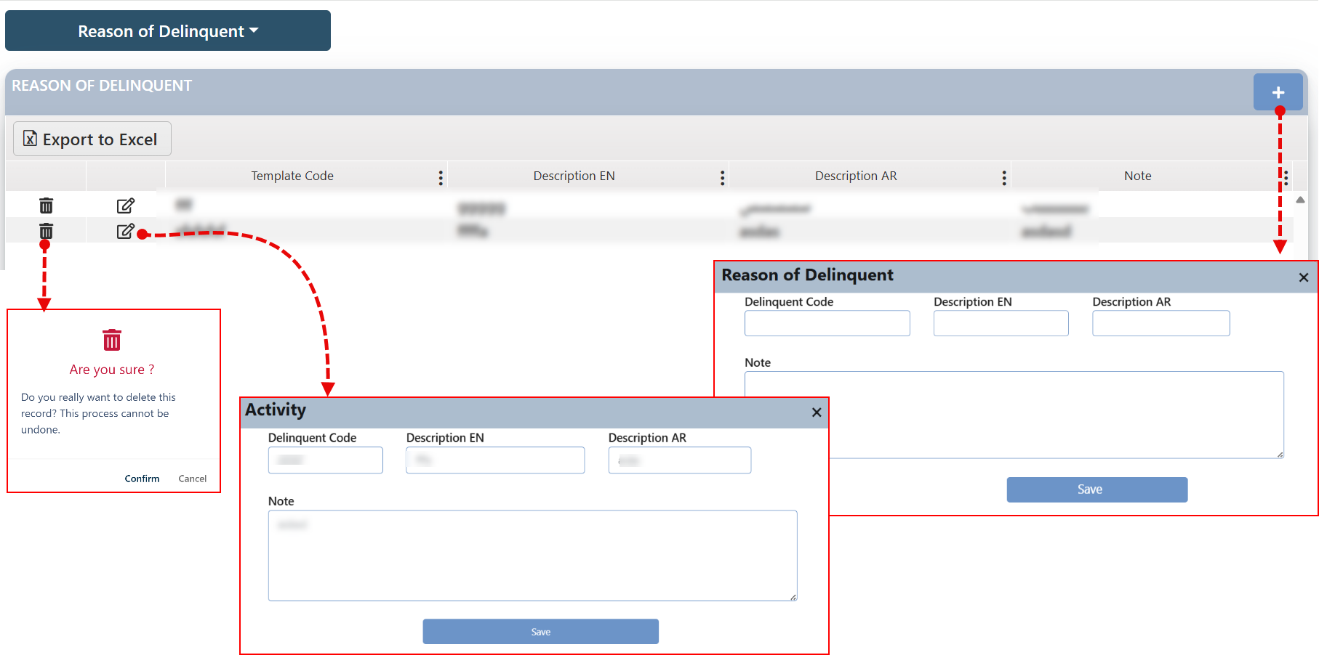

To define a related record, the user needs to:

1. Click on the add button (+)
2. In the related Screen which will appear, the user needs to fulfill the fields in the screen
3. Click on the save button
4. This request will be sent to the JobBasket Checker for the authorized user to either confirm and approve it or reject it.
5. If the request is approved by the checker, then the record will be listed in the screen.

**Edit**: The user can edit any existing record by clicking the Edit button next to it. After making the necessary modifications using the active fields, the user must click the Update button to submit the changes. This request is then routed to the JobBasket Checker, where an authorized user can either approve or reject the update.

* + - If approved, the changes will be immediately reflected in the record.
    - If rejected, the request will be canceled and moved to the Rejected Tasks tab for reference.

**Delete**: The user can delete any existing record "added by the user" by clicking the Delete button next to it. Upon confirmation, a deletion request is generated and routed to the JobBasket Checker, where an authorized user can either approve or reject the request.

* + - If approved, the record will be permanently removed from the system.
    - If rejected, the deletion request will be canceled and moved to the Rejected tasks tab for reference.

### Define Parameters

This screen is used to define variables in the system that will be utilized in the Group Definition screen. Upon accessing this screen, all previously defined variables are displayed, with options to edit each one, add new variables, and delete user-defined variables (note that system-defined variables cannot be deleted). Any addition, modification, or deletion of variables is subject to approval by a user with the Checker role.

Layout:

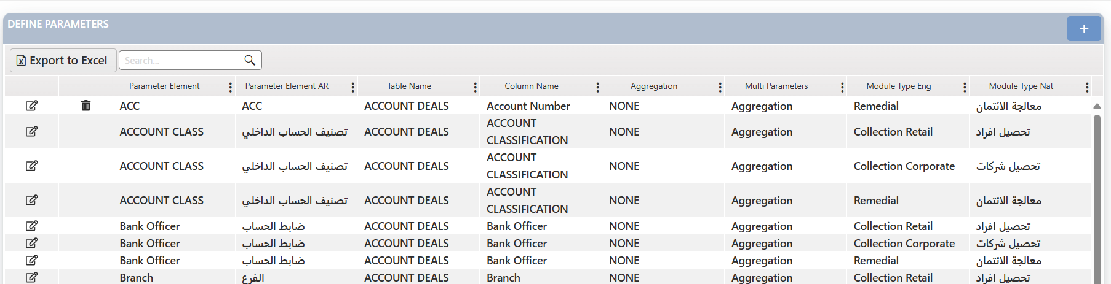

To define new Parameter record, the user needs to:

1. Click on the add button (+)
2. In the related Screen which will appear, the user needs to fulfill the fields in the screen

Comment: Enter the variable details according to the selected method.

* Aggregation Method:

a. Table Name: Select the table that will be affected by the value.  
b. Column Name: Specify the column from the previously selected table.  
c. Function: Depends on the previous selections and can be one of the following:

MIN, MAX, SUM, AVG, COUNT, TOP or LOW.

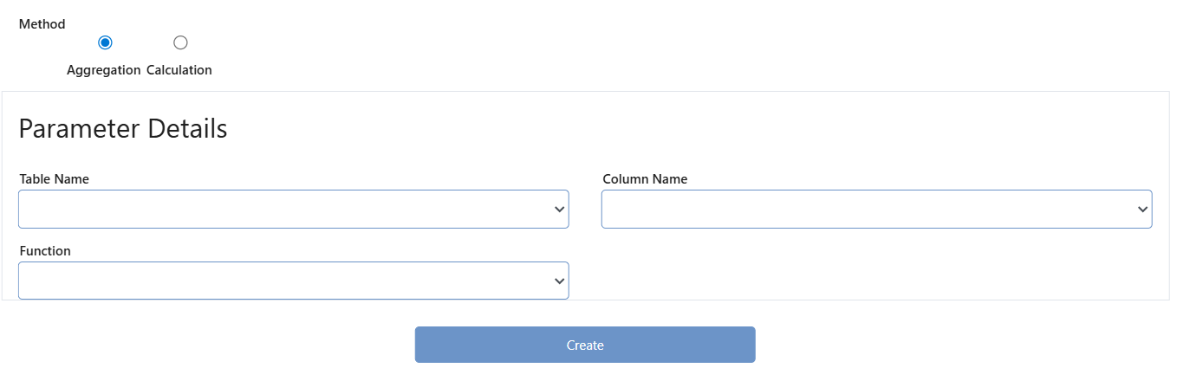

* Calculation Method: Select the influencing element, then click the button, and enter the required mathematical operations (+, -, /, *) based on the variable’s purpose.

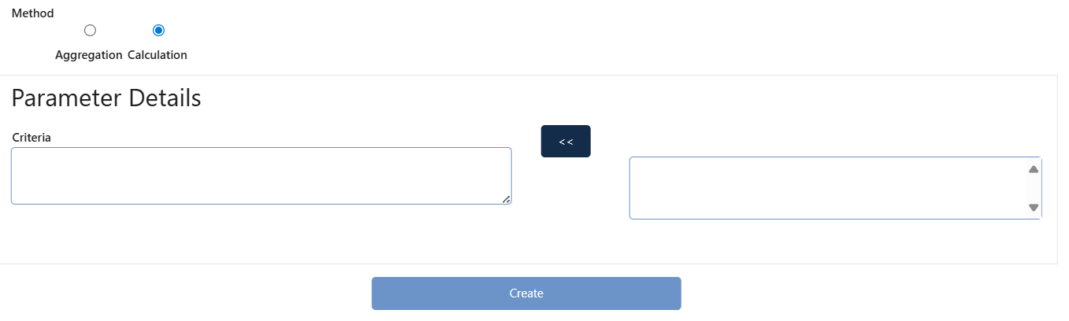

1. Click on the create button
2. This request will be sent to the JobBasket Checker for the authorized user to either confirm and approve it or reject it.
3. If the request is approved by the checker, then the record will be listed in the screen.

**Edit**: The user can edit any existing record by clicking the Edit button next to it. After making the necessary modifications using the active fields, the user must click the Update button to submit the changes.

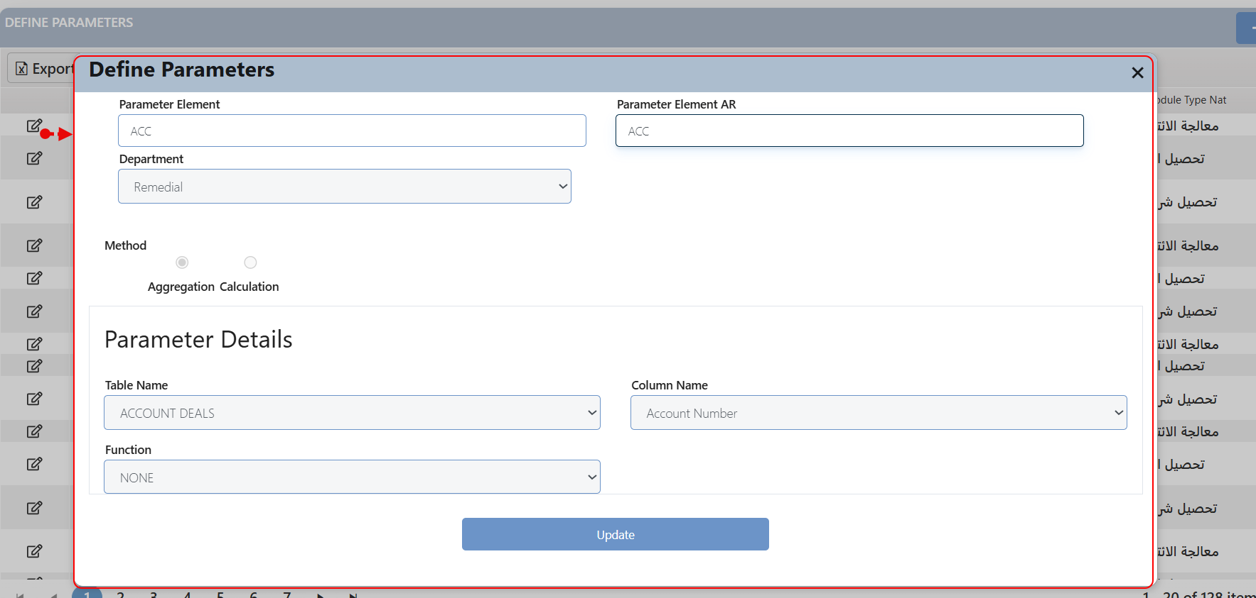

This request is then routed to the JobBasket Checker, where an authorized user can either approve or reject the update.

* + - If approved, the changes will be immediately reflected in the record.
    - If rejected, the request will be canceled and moved to the Rejected Tasks tab for reference.

**Delete**: The user can delete any existing record "added by the user" by clicking the Delete button next to it.

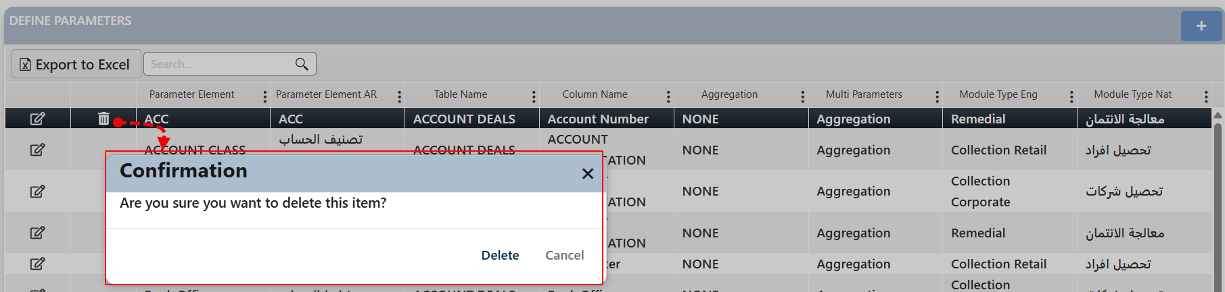

Upon confirmation, a deletion request is generated and routed to the JobBasket Checker, where an authorized user can either approve or reject the request.

* + - If approved, the record will be permanently removed from the system.
    - If rejected, the deletion request will be canceled and moved to the Rejected tasks tab for reference.

### Define Groups

Through this screen, the user can add groups of different types, each of which distributes tasks among collectors in a different way. Each group, according to its type, is directed to one or more collectors using pre-created variables and some logical links that are available from the group input screen - the query builder.

Layout:

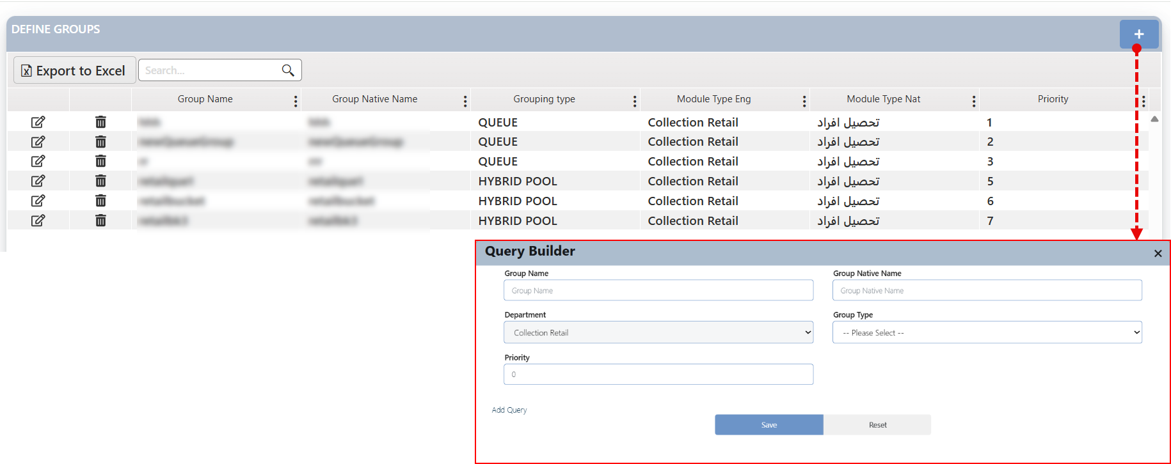

To define new Parameter record, the user needs to:

1. Click on the add button (+).
2. In the related screen which will appear, the user needs to fulfill the fields in the screen.

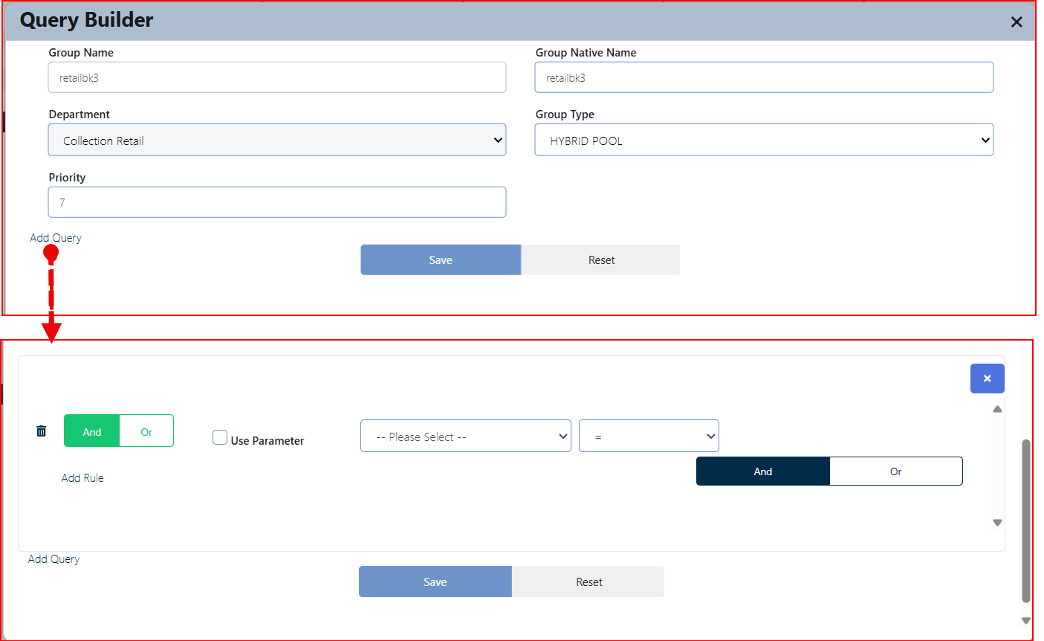

On this screen, the user enters the required information step by step. The user can also add a condition or query to the group using the Query Builder.

1. The user needs to insert the group name in both languages.
2. Theu ser needs to choose the group type, It is important to note that there are different group types: Queue, Pool, Hybrid Pool, Manual Allocation, Auto Hold Accounts
3. Start in building the query by selecting the desired group type
4. Define if you need to use parameters, if yes a new field will appear to insert the parameter value.

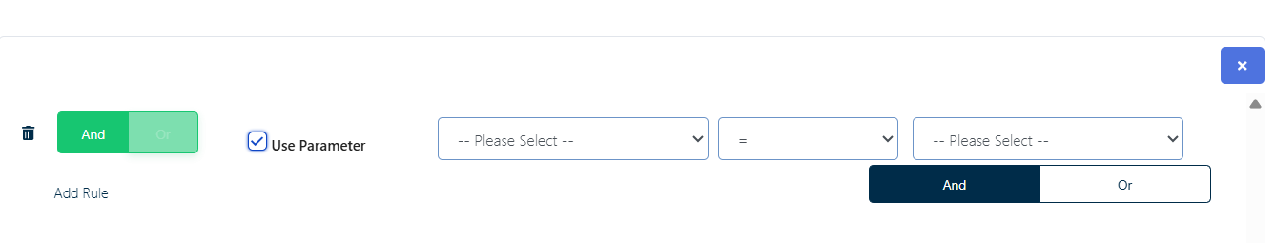

1. Select the parameter that will be considered in the rule definition
2. Choose the appropriate operator from the second dropdown list.
3. Select the parameter value using the third dropdown list.
4. To complete the first part of the rule, click the “Add” button or use logical operators such as “AND” / “OR.”
5. Click on the add Rule button to write another rule
6. If the user needs to delete a specific rule, they can do so by clicking the delete icon next to it.
7. Once all conditions are set, click the “Save” button.
8. This request will be sent to the JobBasket Checker for the authorized user to either confirm and approve it or reject it.
9. If the request is approved by the checker, then the record will be listed in the screen.

**Edit**: The user can edit any existing record by clicking the Edit button next to it. After making the necessary modifications using the active fields, the user must click the Update button to submit the changes.

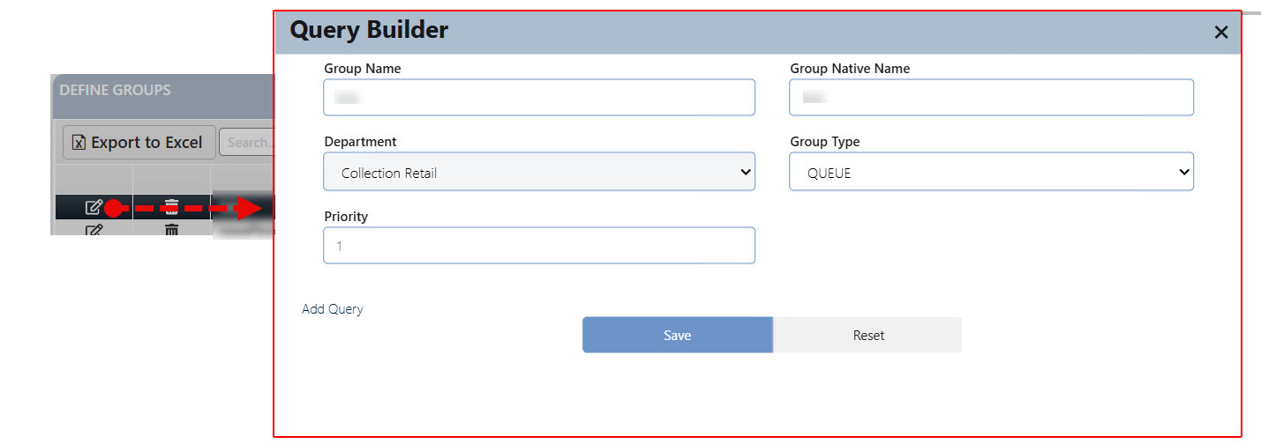

This request is then routed to the JobBasket Checker, where an authorized user can either approve or reject the update.

* + - If approved, the changes will be immediately reflected in the record.
    - If rejected, the request will be canceled and moved to the Rejected Tasks tab for reference.

**Delete**: The user can delete any existing record "added by the user" by clicking the Delete button next to it. Upon confirmation, a deletion request is generated and routed to the JobBasket Checker, where an authorized user can either approve or reject the request.

* + - If approved, the record will be permanently removed from the system.
    - If rejected, the deletion request will be canceled and moved to the Rejected tasks tab for reference.

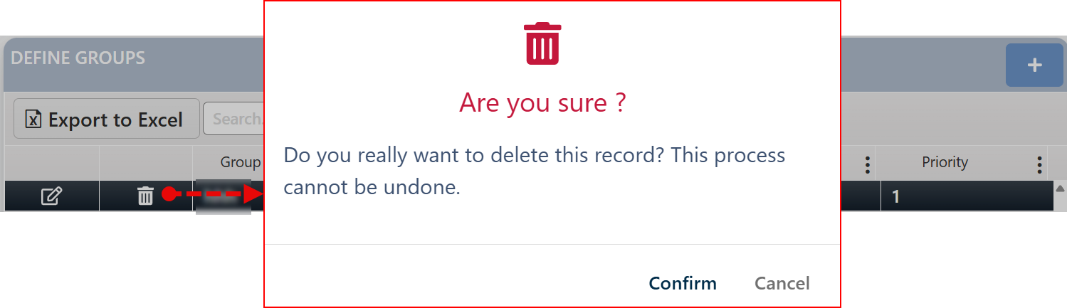

### Account Classification

This screen is used to define the classification of accounts by setting specific conditions through a query statement created using the Query Builder.

Layout:

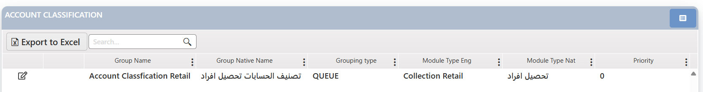

To initiate the classification process, the user clicks the 'Classification' button located at the top of the page, confirms the action, and the system will process and reflect the request accordingly.

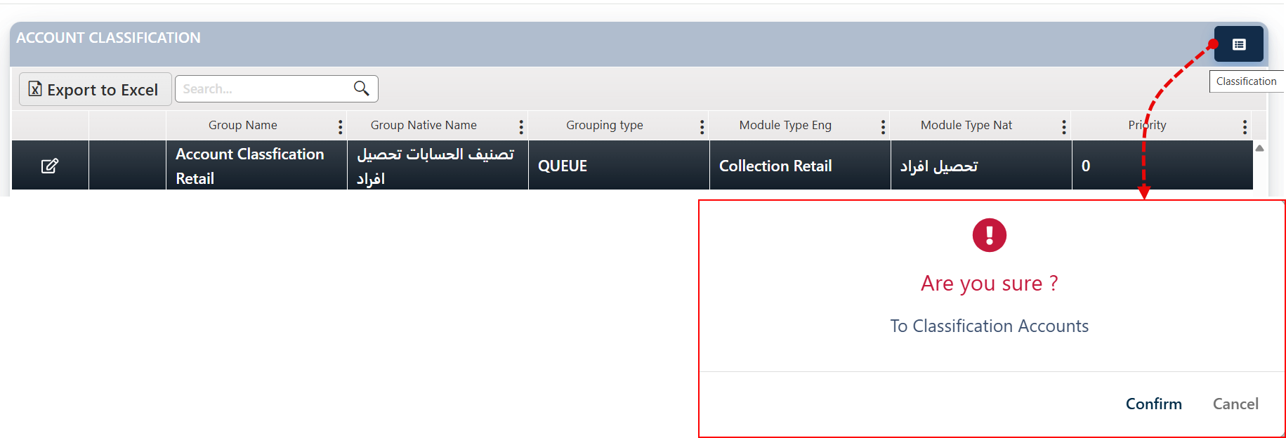

To update the classification criteria for a particular group, click the Edit button next to it. This opens the Query Builder, allowing you to modify the existing query that defines the distribution rule.

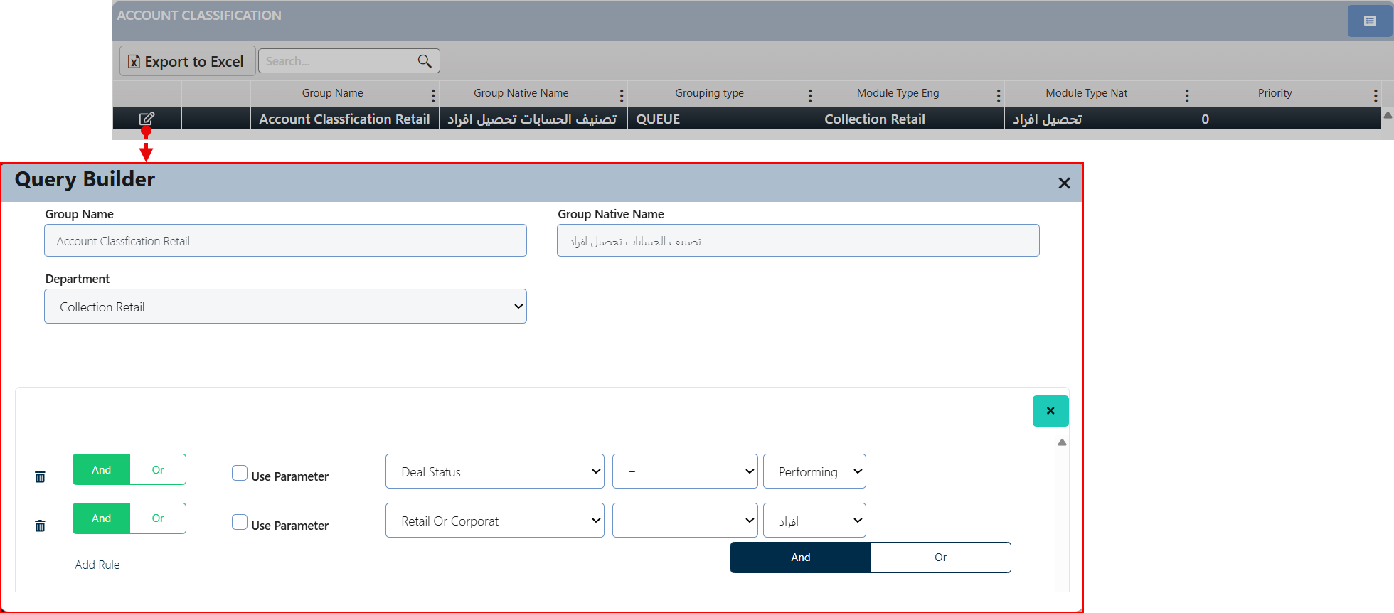

The user can edit the classification record by clicking the Edit button next to it. After making the necessary modifications using the active fields, the user must click the save button to submit the changes.

Comment: To learn more about the Query Builder, please review ” Add Query Process (Query Builder) “

This screen includes two control buttons that allow the user to finalize the modification process.

* The Save. The request will then move to the checker’s screen for approval.
* The Reset button cancels the last query entered into the database.

Comment: Click Save to save the changes without redistributing the accounts according to the new rule. However, if you click Reset, the changes will be saved, and the accounts will be reassigned according to the new rule.

### Group Assign

In this page the user can assign groups to the departments listed in the system and distributing users among these groups, while specifying the dependency of each group (i.e., identifying the department to which the group belongs) and the workload assigned to each user.

Layout:

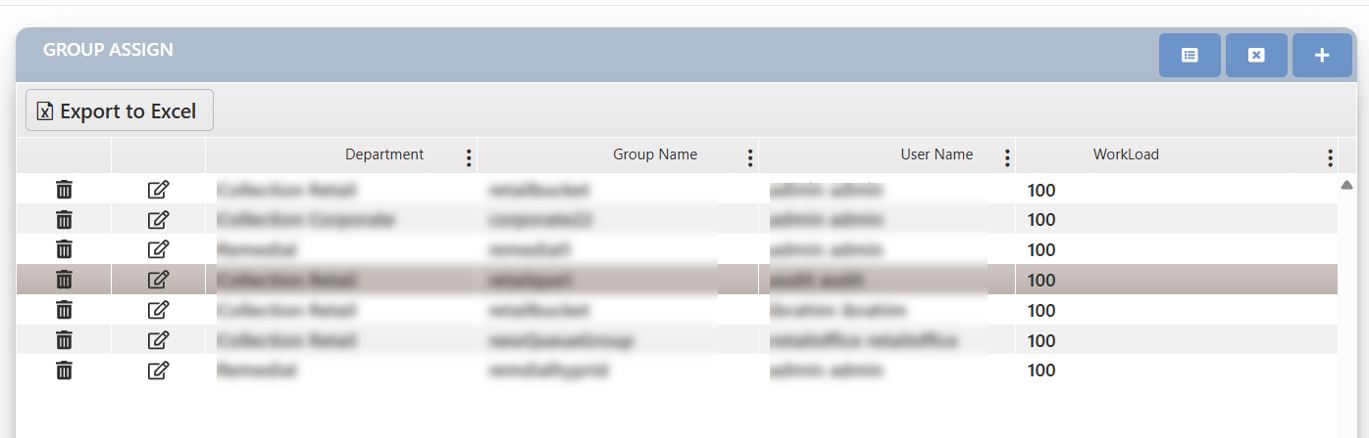

Within this page, the user can technically perform the following actions:

|  |  |  |  |  |
| --- | --- | --- | --- | --- |
|  |  |  |  |  |
| Delete Group Assignment | Modify Group Assignment | Allocate New Tasks | Reallocate Tasks | New Group Assignment |

**New Group Assignment:**

1. Click the Add button (➕), which opens the Group Assign screen.
2. In the Group Assign screen, the user enters the following information:

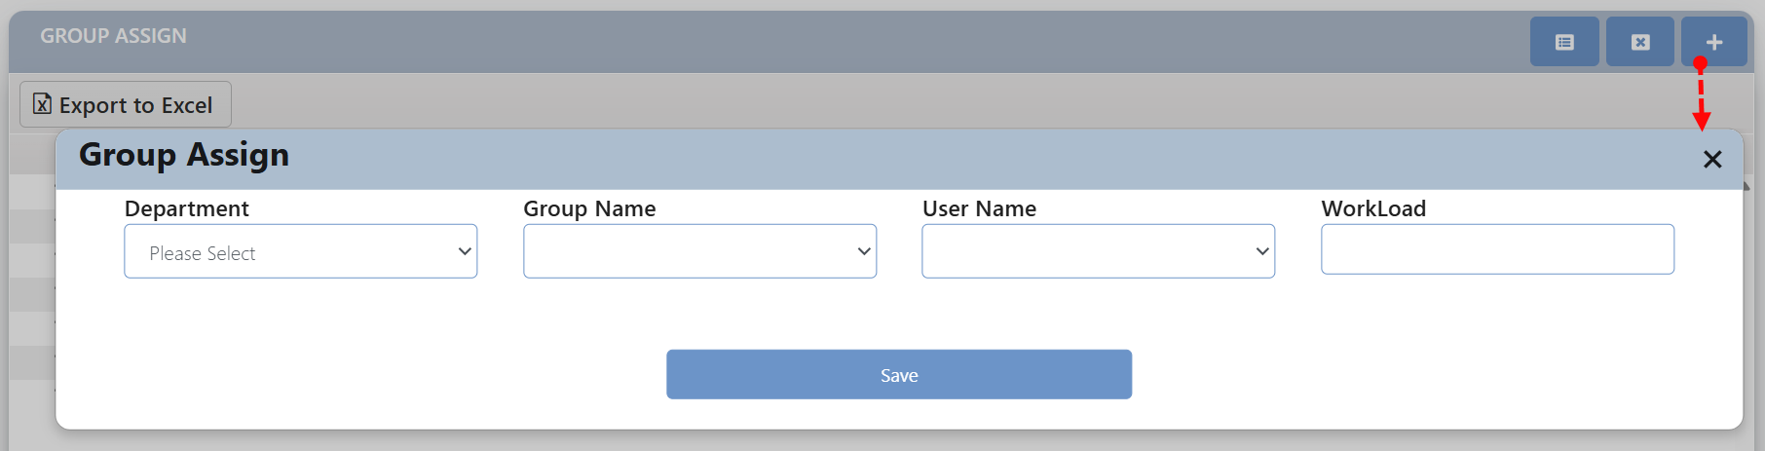

* 1. Select the name of the department that the group will work on its tasks.
  2. Select the group name.
  3. Select the user to be assigned to the group.
  4. Specify the workload for the user — this field appears for groups of types (Pool, Hybrid).

1. Click the Save button; the request will then be sent to the checker’s JobBasket page to decide on the process.
2. If approved, the assignment will be completed, and the record will appear in the display section for assignments (the groups that have been assigned). If rejected, the assignment process will be canceled.

**Reallocate Tasks**

The task assignment process is system-driven and scheduled to run automatically on a daily, weekly, or monthly basis, depending on business requirements.

This functionality enables authorized users to initiate a full redistribution of accounts at the department level, effectively overriding previous assignments and applying new distribution logic based on updated criteria and group configurations. The redistribution operation is executed in the backend and targets only the selected group within the currently active department.

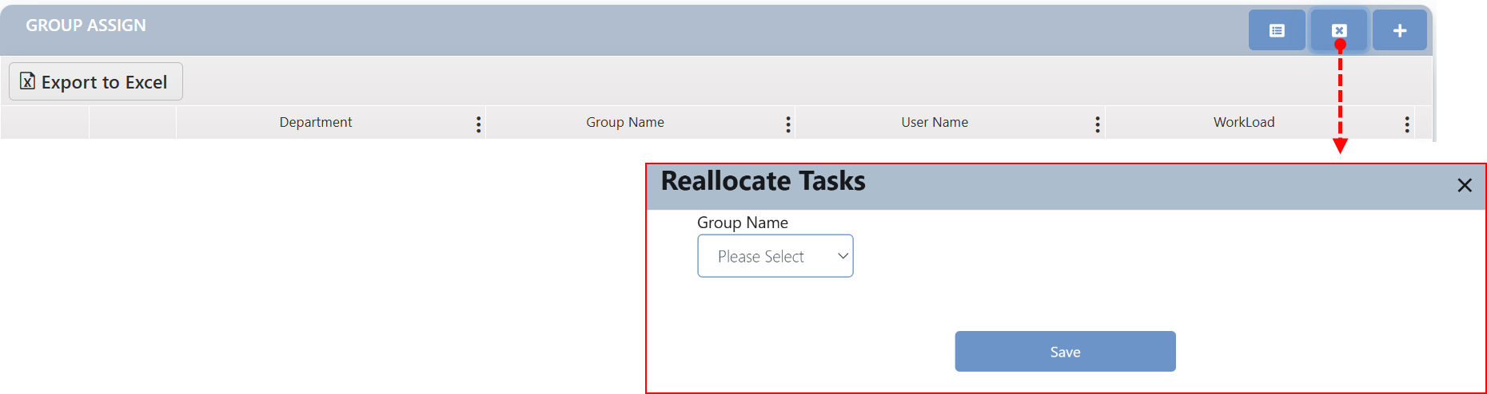

To proceed, the user is required to select the appropriate group from the list and confirm the action by clicking the Save button.

**Allocate New Tasks**

To distribute new accounts (i.e., accounts added since the last execution of the assignment process) only, and not all accounts. It represents the next step following the group assignment.

By clicking this button, the system redistributes the newly added tasks across the defined groups based on the currently active department.

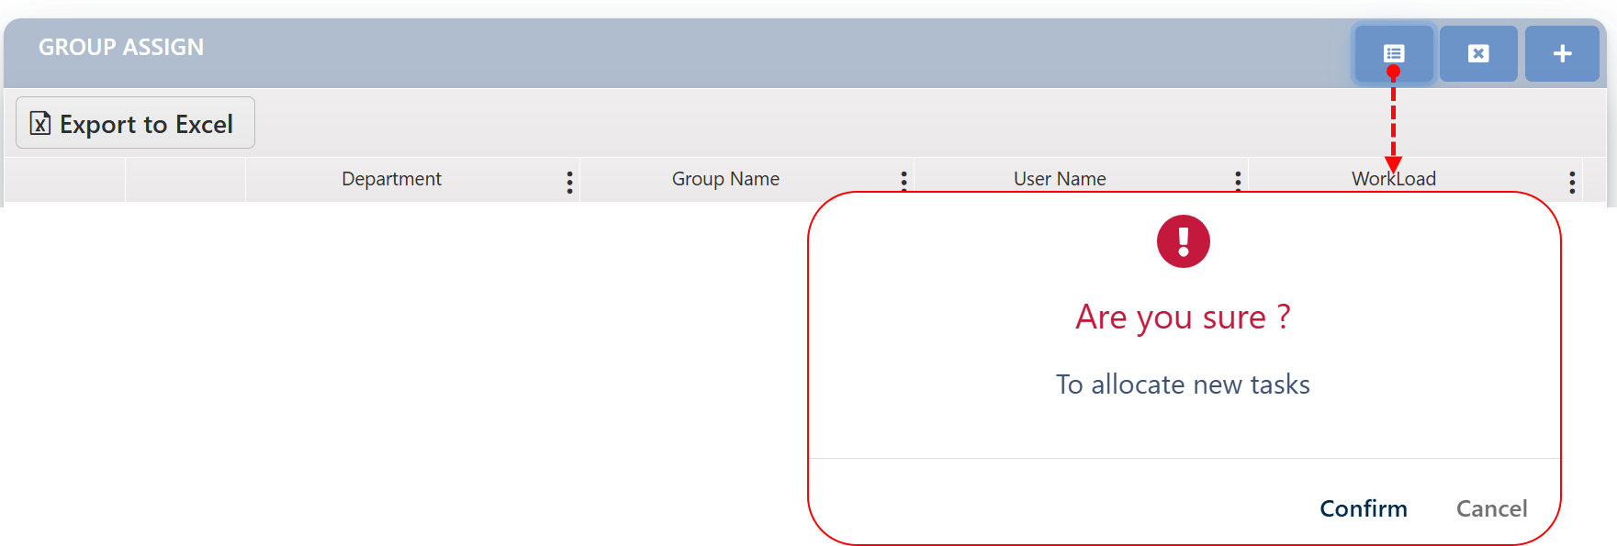

**Modify Group Assignment**

The user can edit any existing record by clicking the Edit button next to it. After making the necessary modifications using the active fields, the user must click the Update button to submit the changes.

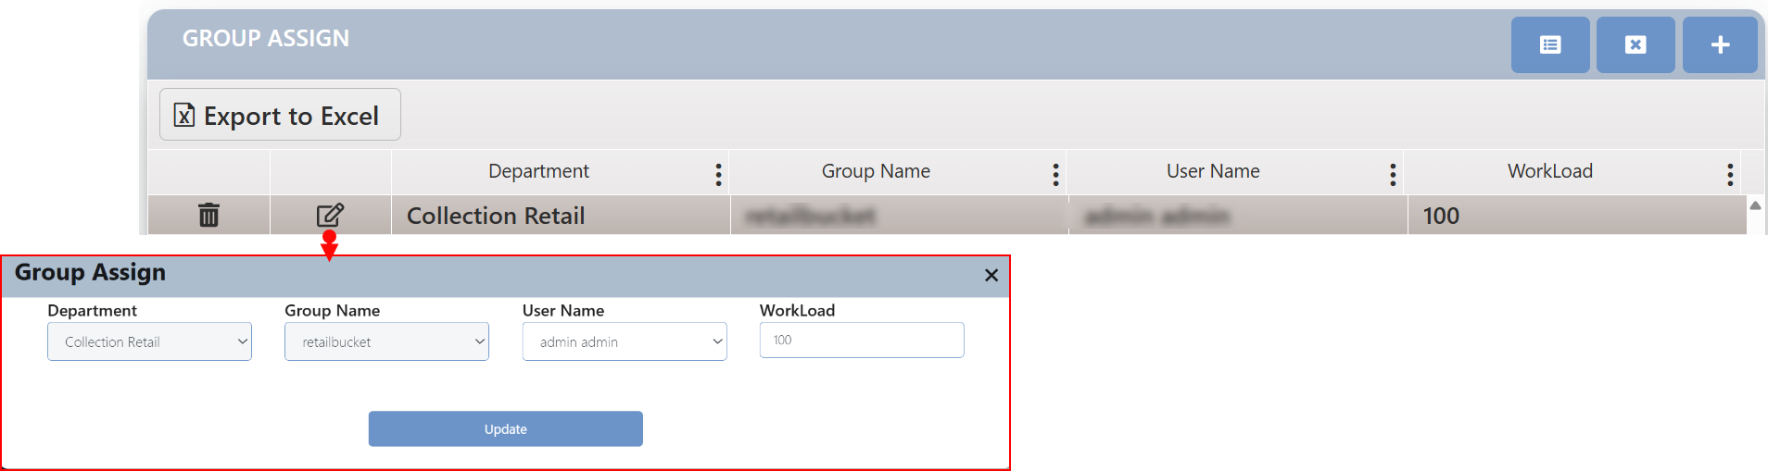

This request is then routed to the JobBasket Checker, where an authorized user can either approve or reject the update.

* + - If approved, the changes will be immediately reflected in the record.
    - If rejected, the request will be canceled and moved to the Rejected Tasks tab for reference.

**Delete Group Assignment**

The user can delete any existing record "added by the user" by clicking the Delete button next to it. Upon confirmation, a deletion request is generated and routed to the JobBasket Checker, where an authorized user can either approve or reject the request.

* + - If approved, the record will be permanently removed from the system.
    - If rejected, the deletion request will be canceled and moved to the Rejected tasks tab for reference.

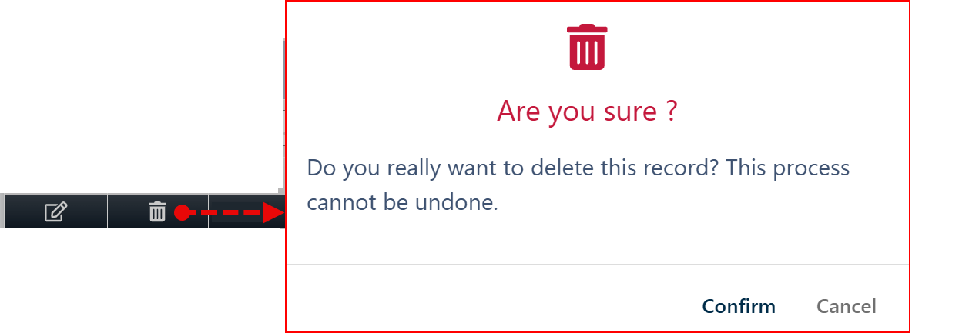

### Commissions Definition

This screen is used to define the commission percentage assigned to the external collector, specifically for setting the commission rate for lawyers. Authorized users can create a new commission entry, modify existing commission details, or delete a previously defined commission.

Layout:

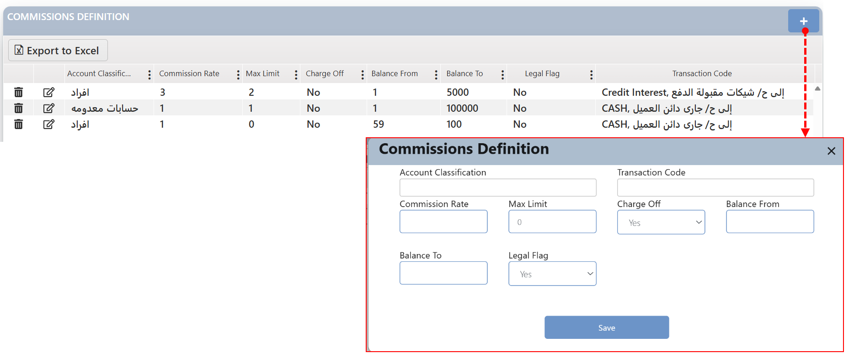

**Define new commission**

To define new commission record, the user needs to:

1. Click on the add button (+)
2. In the related Screen which will appear, the user needs to fulfill the fields on the screen.
3. Click on the save button
4. This request will be sent to the JobBasket Checker for the authorized user to either confirm and approve it or reject it.
5. If the request is approved by the checker, then the record will be listed in the screen.

**Edit**: The user can edit any existing record by clicking the Edit button next to it. After making the necessary modifications using the active fields, the user must click the Update button to submit the changes. This request is then routed to the JobBasket Checker, where an authorized user can either approve or reject the update.

* + - If approved, the changes will be immediately reflected in the record.
    - If rejected, the request will be canceled and moved to the Rejected Tasks tab for reference.

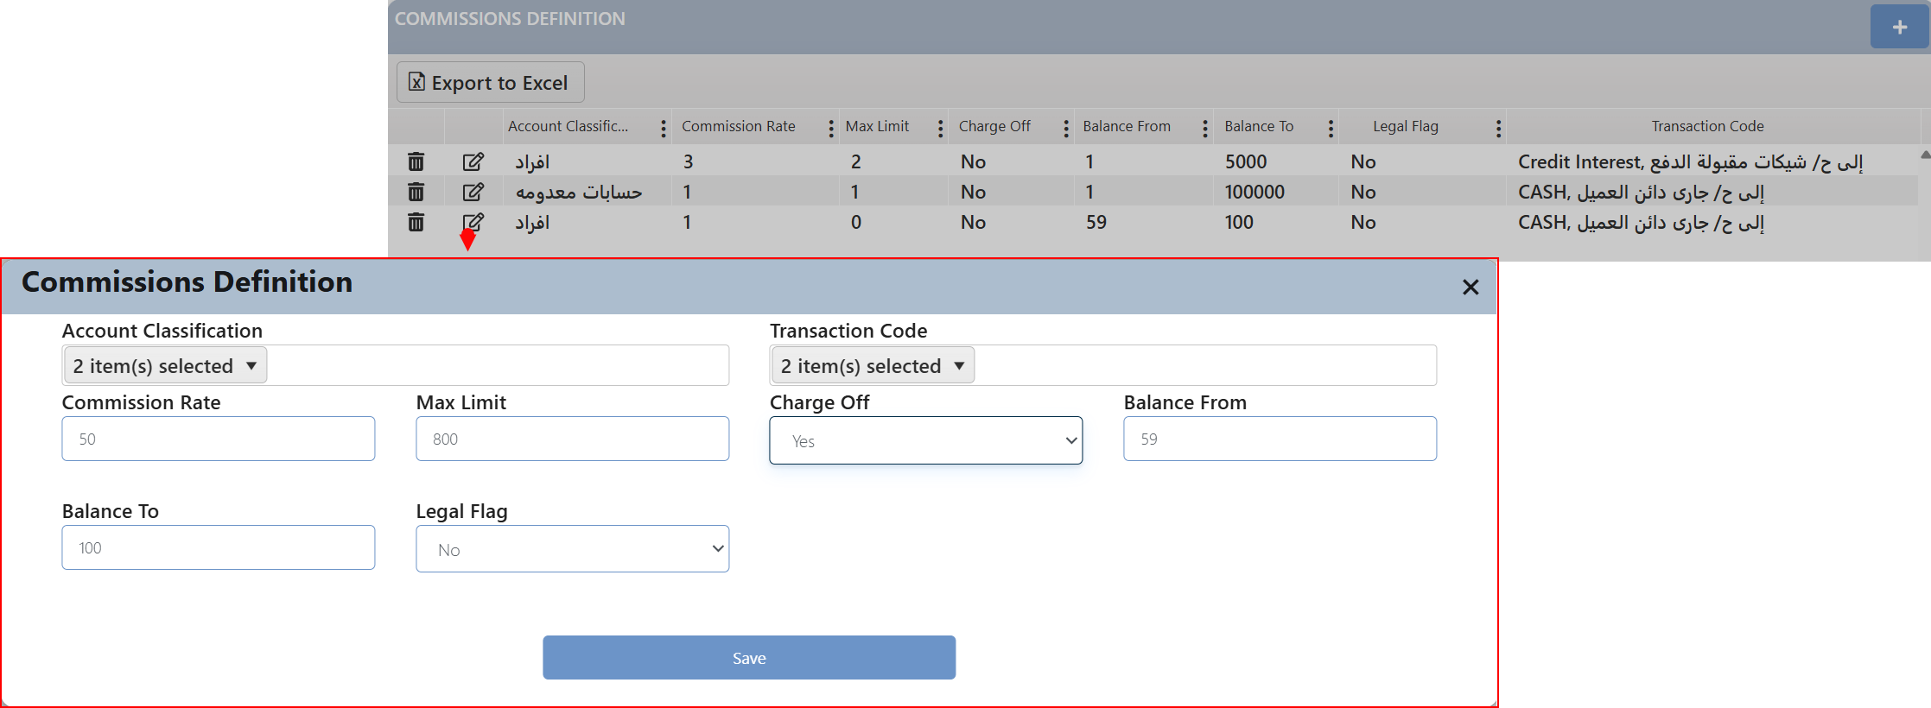

**Delete**: The user can delete any existing record "added by the user" by clicking the Delete button next to it. Upon confirmation, a deletion request is generated and routed to the JobBasket Checker, where an authorized user can either approve or reject the request.

* + - If approved, the record will be permanently removed from the system.
    - If rejected, the deletion request will be canceled and moved to the Rejected tasks tab for reference.



### Incentive Definition

This screen is used to define and configure the criteria and calculation mechanisms for incentives based on different account categories. It allows management to input and update percentages and limits (minimum and maximum) related to the incentives granted to account officers for performing rescheduling or restructuring tasks. Within this screen, the user can add a new incentive definition, edit the properties of an existing incentive rule, or delete a previously defined record.

Layout:

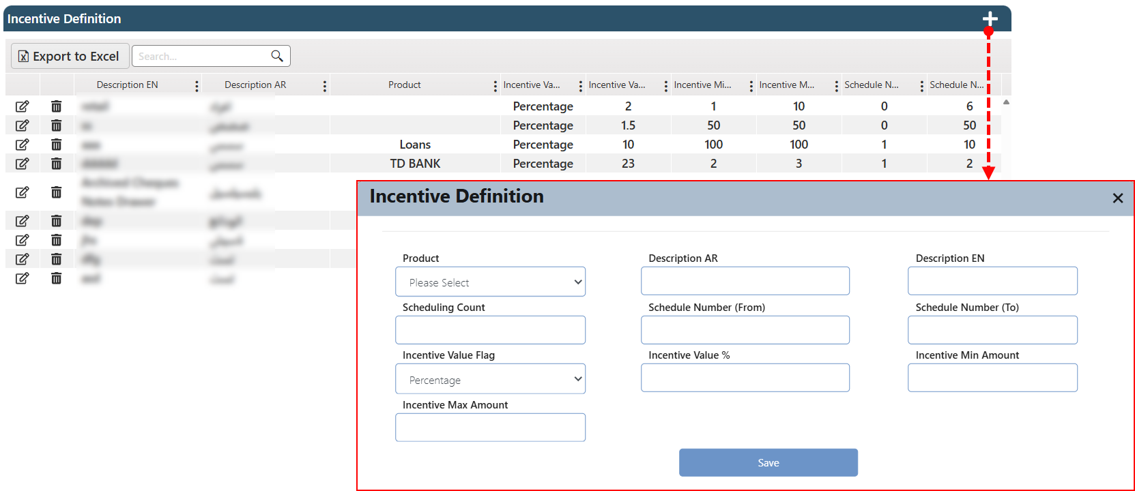

**Define New Incentive Record**

To define new commission record, the user needs to:

1. Click on the add button (+)
2. In the related Screen which will appear, the user needs to fulfill the fields on the screen.
3. Click on the save button
4. This request will be sent to the JobBasket Checker for the authorized user to either confirm and approve it or reject it.
5. If the request is approved by the checker, then the record will be listed in the screen.

**Edit**: The user can edit any existing record by clicking the Edit button next to it. After making the necessary modifications using the active fields, the user must click the Update button to submit the changes. This request is then routed to the JobBasket Checker, where an authorized user can either approve or reject the update.

* + - If approved, the changes will be immediately reflected in the record.
    - If rejected, the request will be canceled and moved to the Rejected Tasks tab for reference.

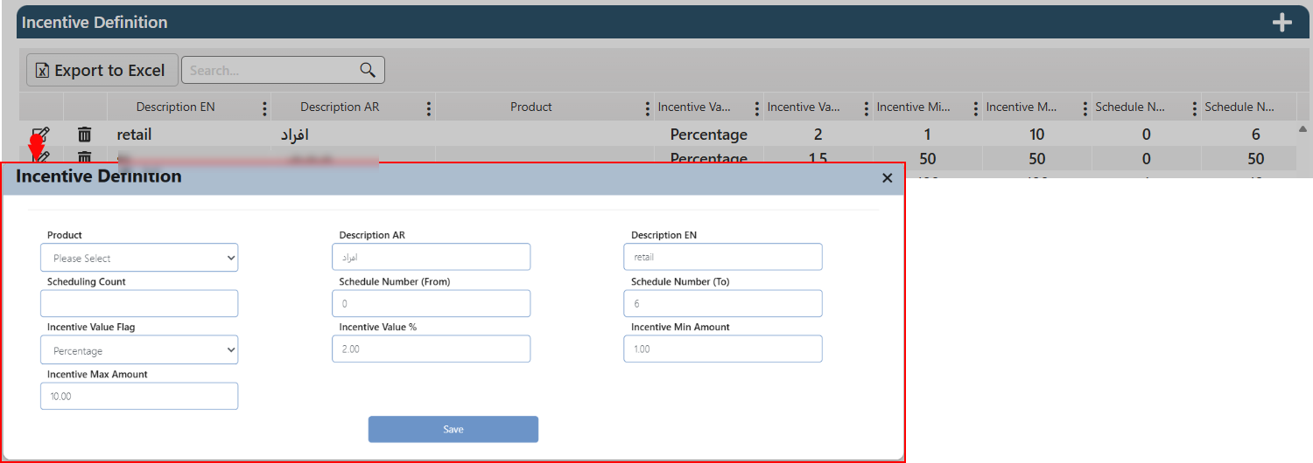

**Delete**: The user can delete any existing record "added by the user" by clicking the Delete button next to it. Upon confirmation, a deletion request is generated and routed to the JobBasket Checker, where an authorized user can either approve or reject the request.

* + - If approved, the record will be permanently removed from the system.
    - If rejected, the deletion request will be canceled and moved to the Rejected tasks tab for reference.



### Incentive

This is the incentive view screen; by clicking the View button on the screen, a detailed record of the incentives will be displayed along with a summary of the incentives allocated to each employee.

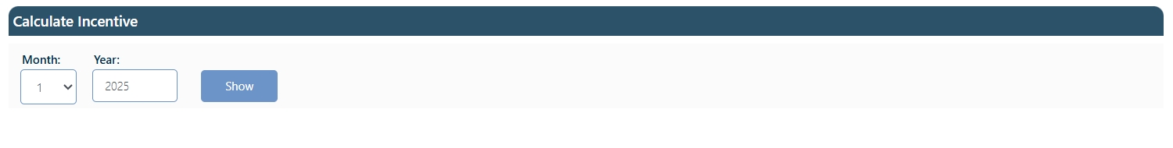

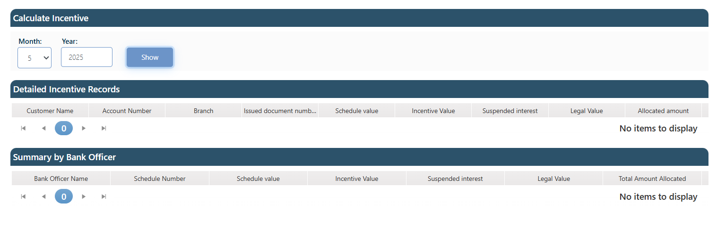

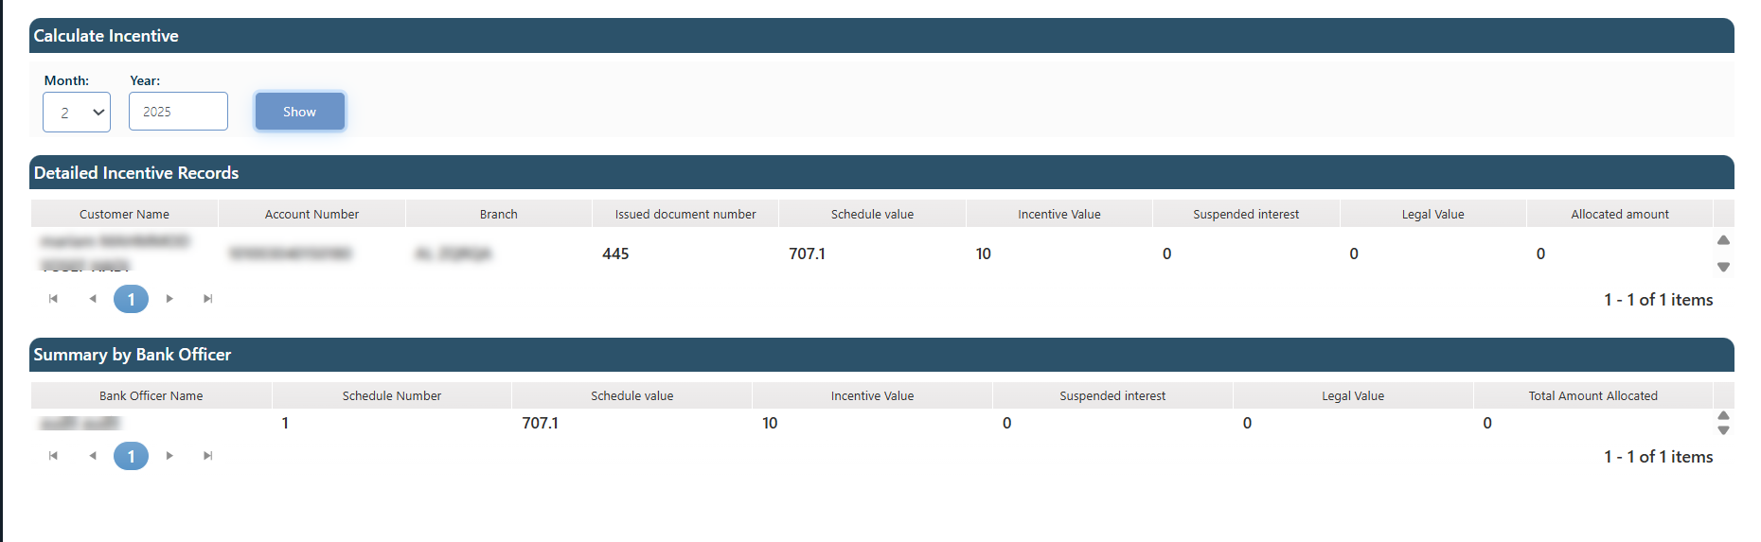

### Calculated Commissions

The screen displays attorney fees based on the month, and year specified by the user.

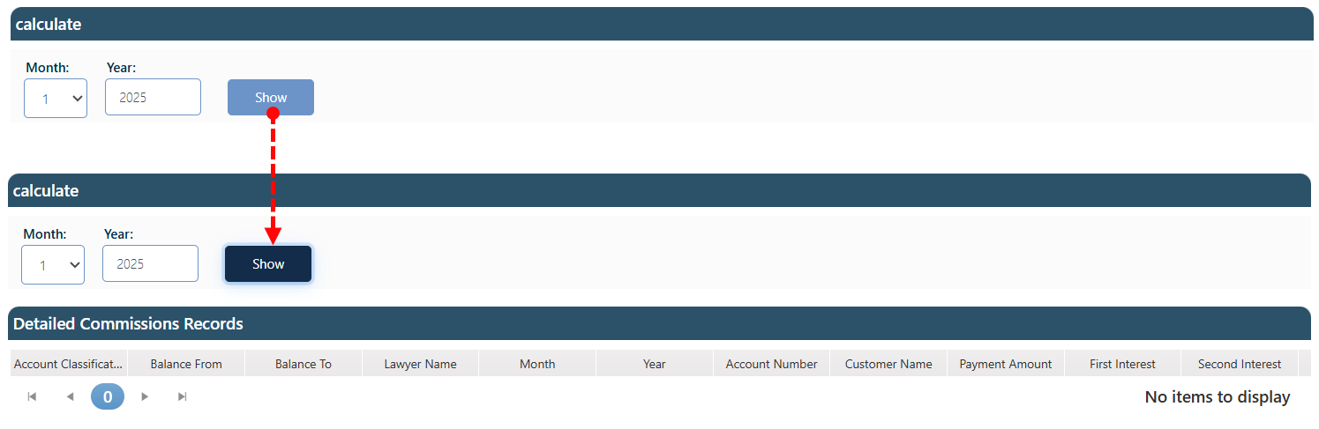

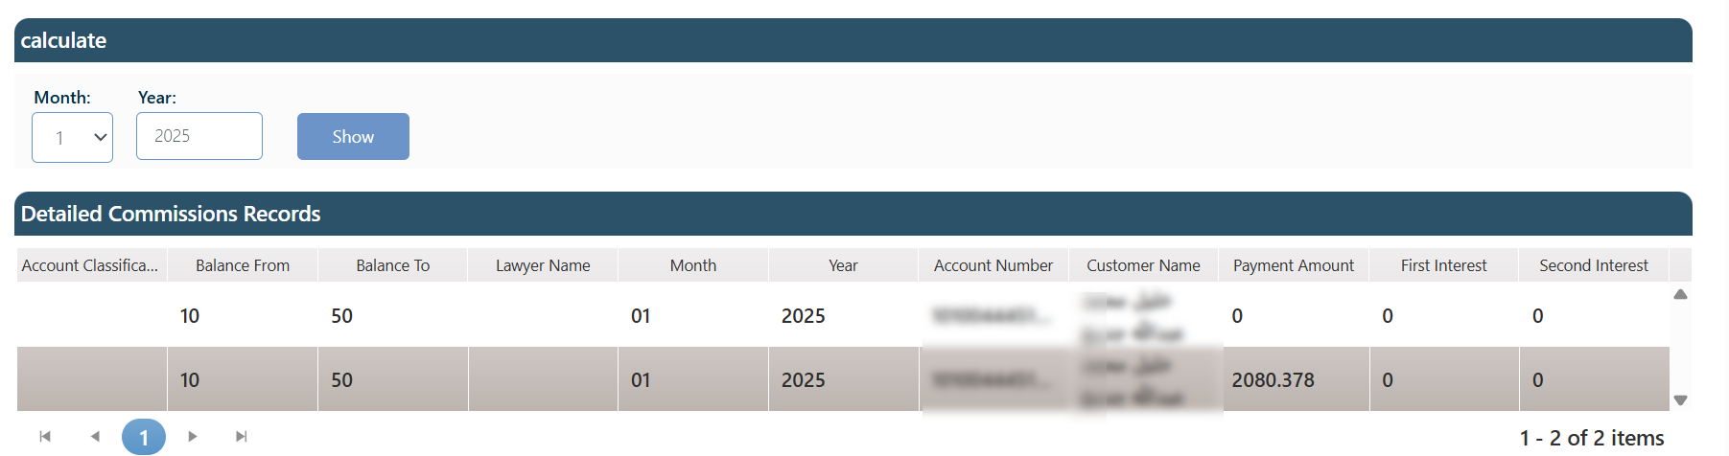

### Task Action Plan

This screen assists the collector in creating a follow-up plan for the client. Using this screen, the manager can suggest the next step for the collector as part of the follow-up process. These suggestions can be considered as recommendations during the follow-up phase. The impact of this action appears on the customer follow-up screen, specifically in the Task Planning section.

Layout:

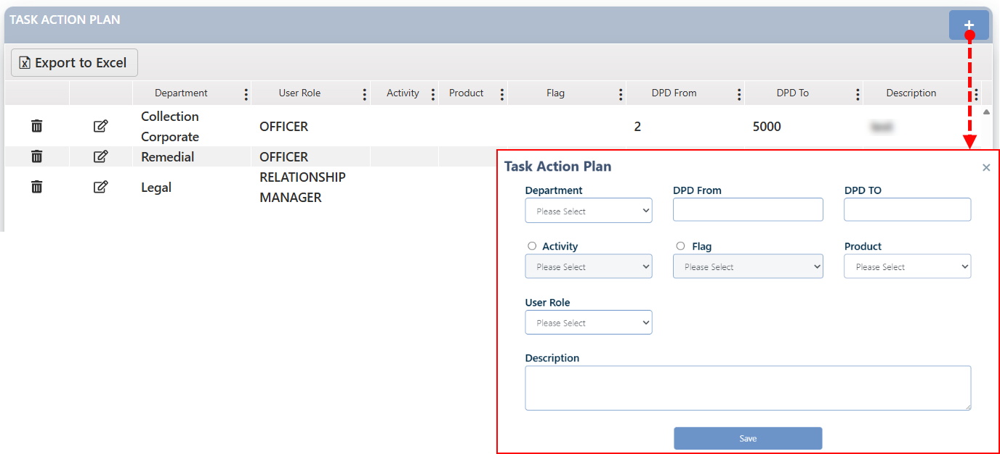

**Define New Action Plan Record**

To define new commission record, the user needs to:

1. Click on the add button (+)
2. In the related Screen which will appear, the user needs to fulfill the fields on the screen.
3. Click on the save button
4. This request will be sent to the JobBasket Checker for the authorized user to either confirm and approve it or reject it.
5. If the request is approved by the checker, then the record will be listed in the screen.

**Edit**: The user can edit any existing record by clicking the Edit button next to it. After making the necessary modifications using the active fields, the user must click the Update button to submit the changes. This request is then routed to the JobBasket Checker, where an authorized user can either approve or reject the update.

* + - If approved, the changes will be immediately reflected in the record.
    - If rejected, the request will be canceled and moved to the Rejected Tasks tab for reference.

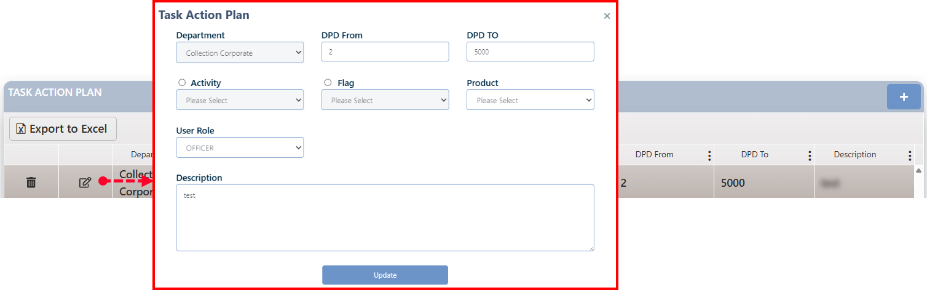

**Delete**: The user can delete any existing record "added by the user" by clicking the Delete button next to it. Upon confirmation, a deletion request is generated and routed to the JobBasket Checker, where an authorized user can either approve or reject the request.

* + - If approved, the record will be permanently removed from the system.
    - If rejected, the deletion request will be canceled and moved to the Rejected tasks tab for reference.



### Manager Def

This screen is designed to define a user of type "Manager" and assign their respective team.

Layout:

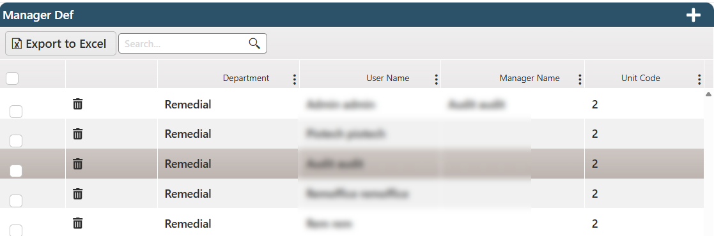

The authorized user selects team members by clicking the selection button next to each user, then clicks the Add button at the top of the screen.

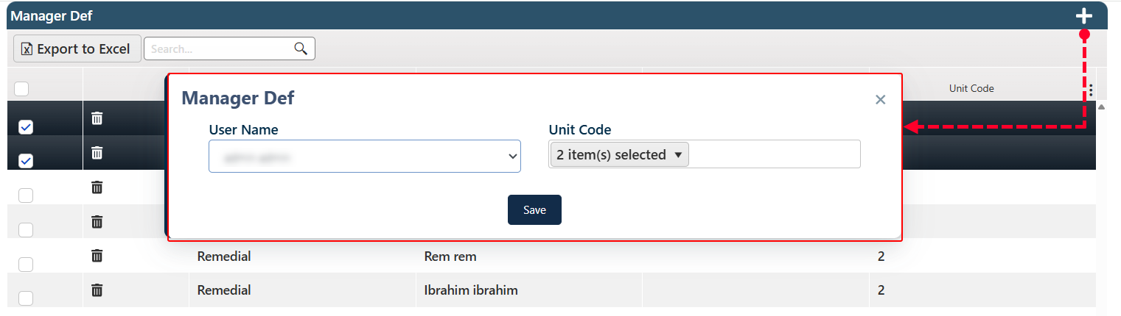

From this screen, the user specifies the Manager's name and assigns a code to their unit. Once the Save button is clicked, the information will be reflected in the system — even if the selected users were previously assigned under a different manager.

**Delete**: The user can delete any existing record "added by the user" by clicking the Delete button next to it. Upon confirmation, a deletion request is generated and routed to the JobBasket Checker, where an authorized user can either approve or reject the request.

* + - If approved, the record will be permanently removed from the system.
    - If rejected, the deletion request will be canceled and moved to the Rejected tasks tab for reference.

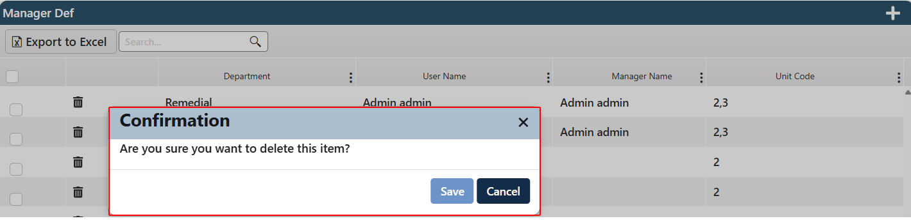

### Tasks Priority

This page is dedicated to managing task prioritization within the task job basket based on predefined factors such as client sector (individuals or companies), dates of upcoming appointments, broken promises to pay, and other conditions configured in the system. Users can also define the sorting order (ascending or descending) for each prioritization factor.

Layout:

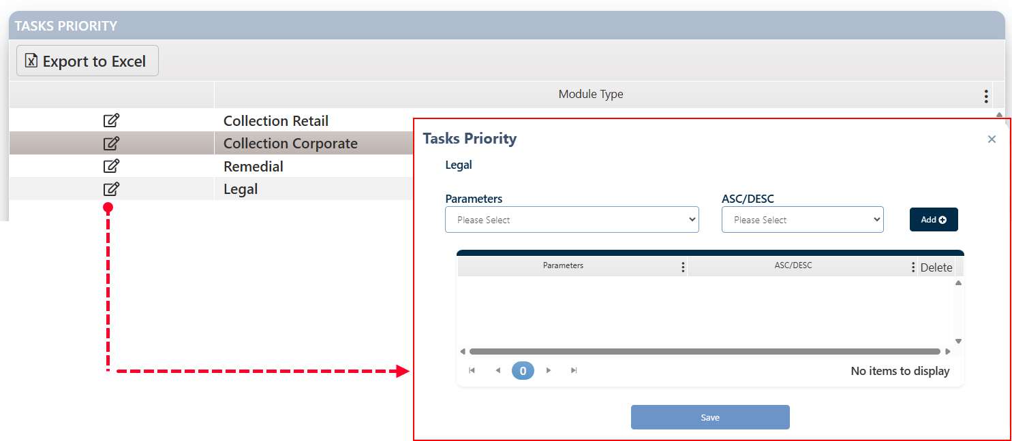

To modify task priorities for a specific department, the user should Click the Edit button next to the desired department.

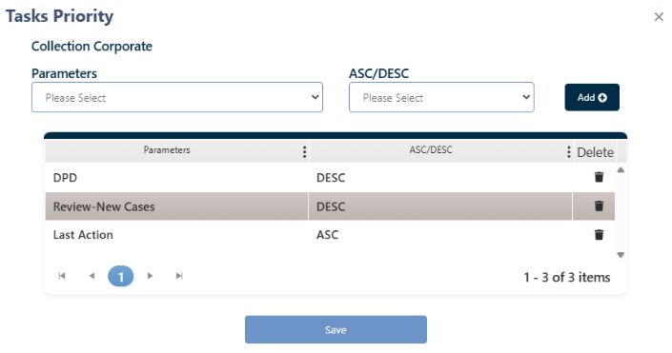This will open the Task Priorities screen.

Enter the relevant priority management inputs and select the sorting order (ascending/descending) for each factor, then click the Add button.

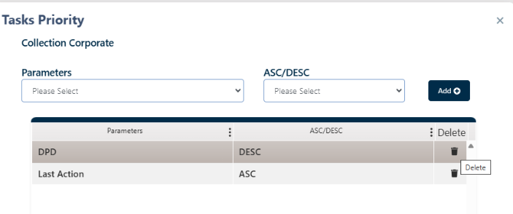

The selected factor will appear in the display area, and the user will have the option to delete each factor individually.

Once all factors have been entered, the user must click the Update button to submit the changes. This request is then routed to the JobBasket Checker, where an authorized user can either approve or reject the update.

* + - If approved, the changes will be immediately reflected in the record.
    - If rejected, the request will be canceled and moved to the Rejected Tasks tab for reference.

### Not Assign Tasks

This screen shows all tasks that are still unassigned to any user (collector) for follow-up. Essentially, it represents the basket of tasks awaiting assignment.

Layout:

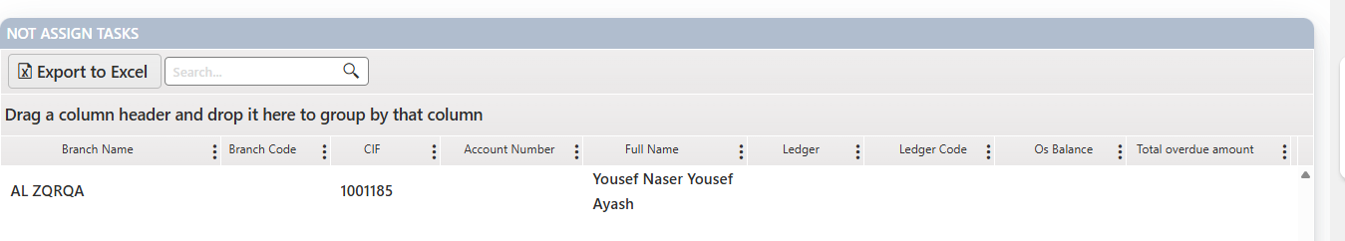

### Primary Account

This screen is used to define the Primary Account at the department level. This definition directly impacts the account distribution process in the job basket if the Primary Account is one of the prioritization criteria configured in the Task Priorities screen.

Layout:

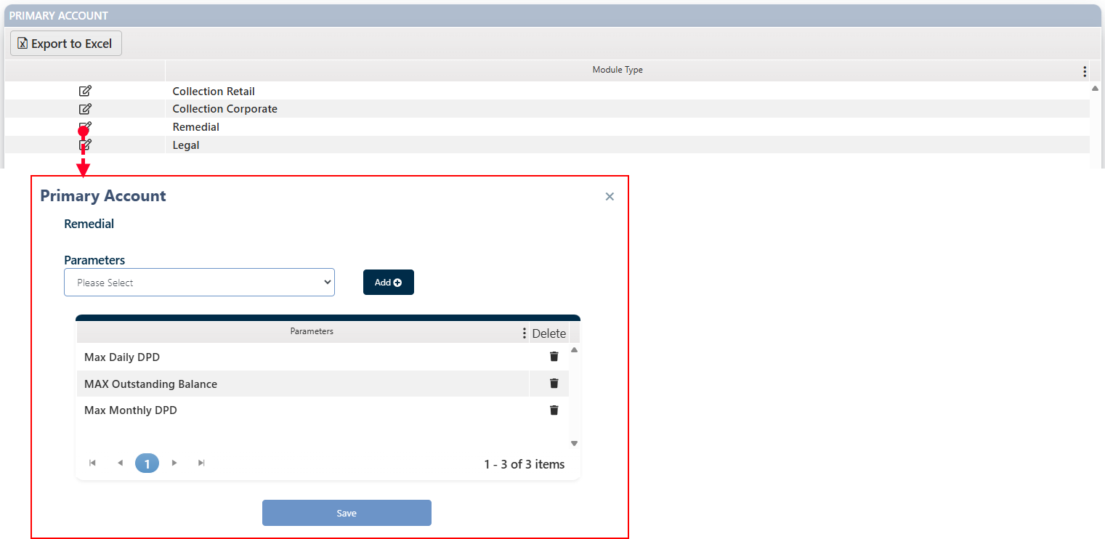

The screen displays the departments defined in the system. To define the Primary Account for each department, the user should click the Edit button next to the department name, select the desired account from the input field, then click the Add button. The selected account will appear in the display area on the same screen, with the option to delete each entry individually.

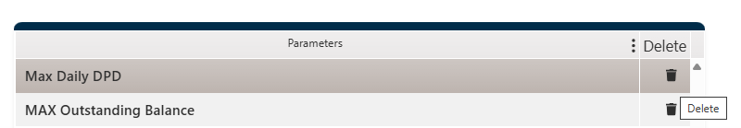

Once all factors have been entered, the user must click the Update button to submit the changes. This request is then routed to the JobBasket Checker, where an authorized user can either approve or reject the update.

* + - If approved, the changes will be immediately reflected in the record.
    - If rejected, the request will be canceled and moved to the Rejected Tasks tab for reference.

### Change Password

This screen allows the user to change their current password.

Layout:

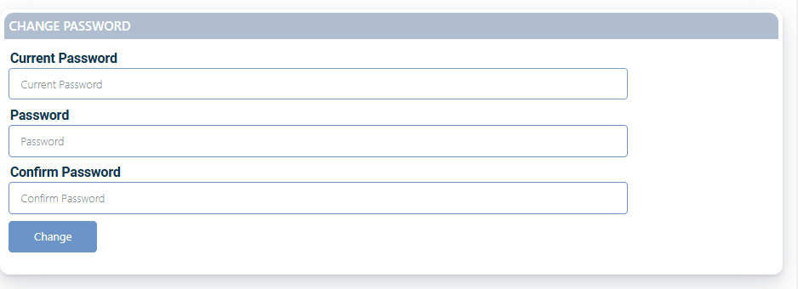

To successfully update the password, please follow these steps:

1. Enter the current password.
2. Enter the new password.
3. Confirm the new password by retyping it.
4. Click the "Change" button.

### Financial Provision

This page is used to manage and update the financial provision values associated with customer accounts. It enables users to upload provision files, review records, and approve or reject financial provision entries based on predefined criteria.

Layout:

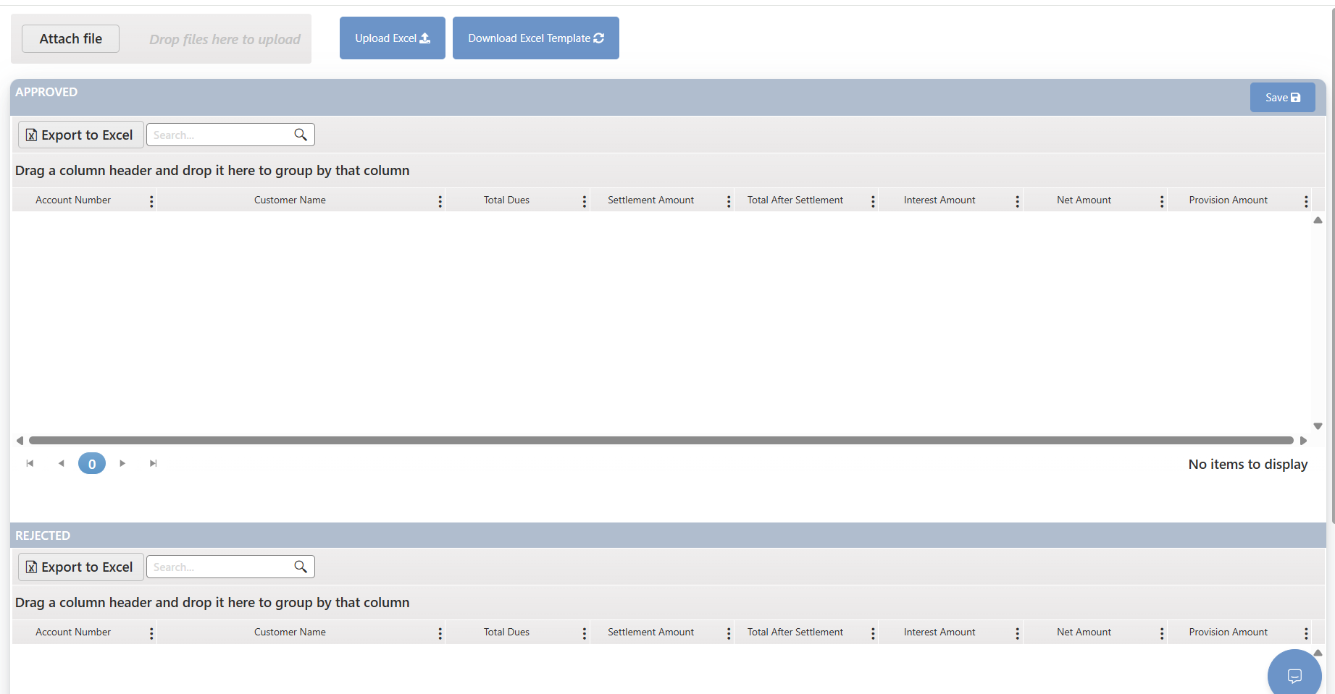

1. Download Excel Template
   * Click on Download Excel Template to get the standard file format.
   * This ensures your data entries comply with the required structure and fields for system upload.

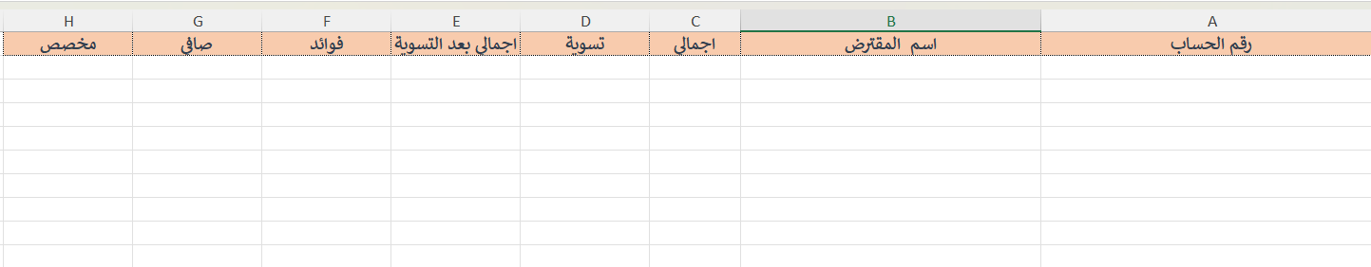

1. Prepare the File
   * Fill in the necessary data in the downloaded Excel template.
   * Ensure all values meet the required validation rules to avoid rejection during processing.
2. Upload the File: Use one of the following methods:
   * Click Attach File and select your prepared Excel file.
   * Or drag and drop the file into the designated upload area.
3. System Processing
   * Once uploaded, the system will automatically process the file.
   * Based on internal validation rules:
     + Approved records will appear under the Approved tab.
     + Rejected records (due to data issues or failed validations) will appear under the Rejected tab for further review.

## General System Features

### Access The System.

Comment: Contact your system administrator to provide you with the dedicated link and request assistance regarding your login information.

1. 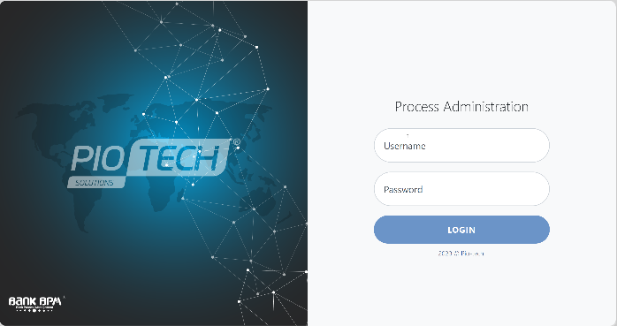Use the link provided to open the system.
2. The screen below will be the login page.
3. Enter the Username of your account in the "Username" field.
4. Enter the password in the "Password" field.
5. The system will navigate to the system homepage.
6. The system will navigate to the home page, which by default displays the Credit Portfolio section, as shown below:

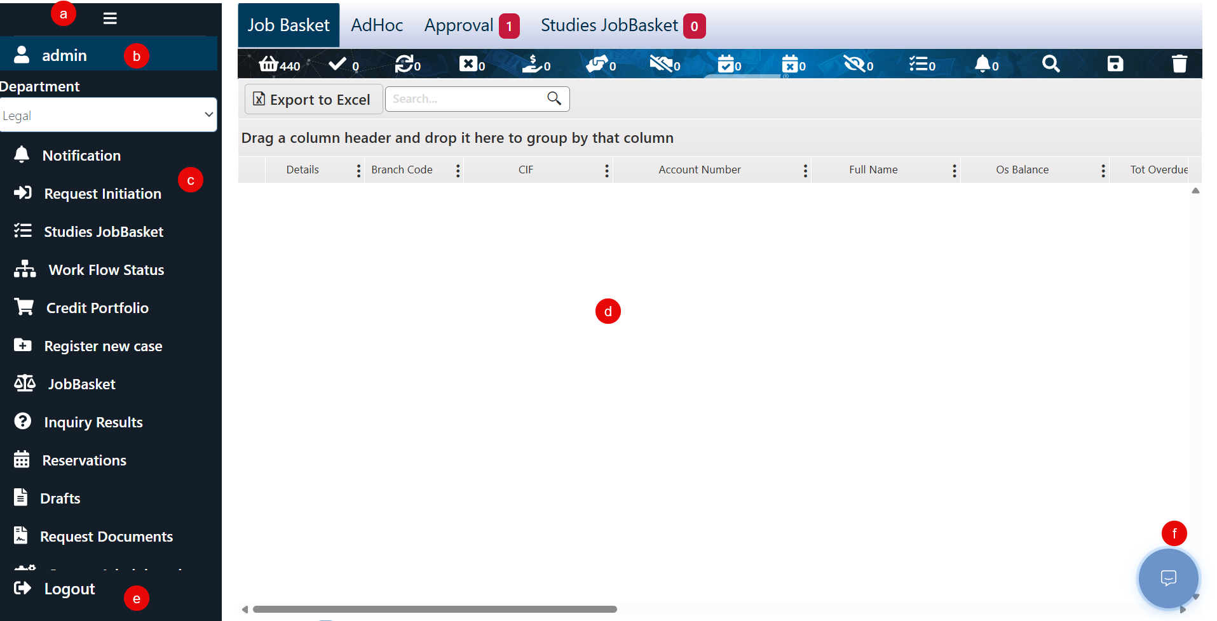

1. To view / hide the menue
2. Show the curent user name
3. The main menue that show the curent user uthrised pages to use
4. Work sapace for each page
5. To log out of the sysytem
6. Chatting tool between system users.

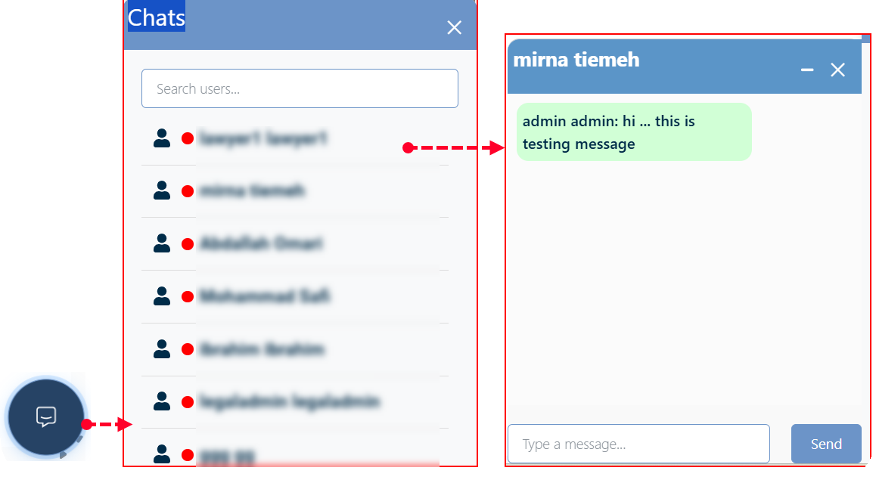

### Filtering Mechanisms

Some system pages have large data, so you should use the filtering mechanism to find the required record easily.

There are many activities you can perform from this menu:

* Sort Data view Ascending Or Descending
* Hide or View existed Columns
* Add Data filtering Craiteria

#### Data View Sorting - Ascending Or Descending

To sort the contents of the information in ascending or descending order based on a specific field, the user needs to click on the field's name. The data will then be automatically rearranged according to the selected sorting.

The first click will sort the data in ascending order.



The second click will sort the data in descending order.



The third click (or by default) will return the data to its original/default order.



Or , The user has the option to utilize specified filtering criteria to choose the order they wish to set.

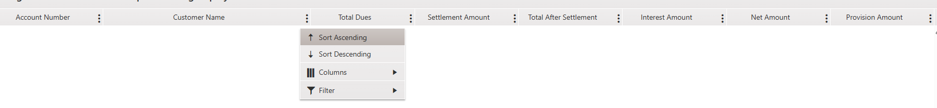

#### Hide or View existed Columns

1. Hover over the table header that contains the fields.
2. Click the three dots (⋮) next to any field name.
3. From the customization options, select "Columns".
4. A list of available fields will appear.
5. Check the box next to the field name to show it, or uncheck it (by clicking again) to hide it.
6. The grid view will instantly update based on your selection.

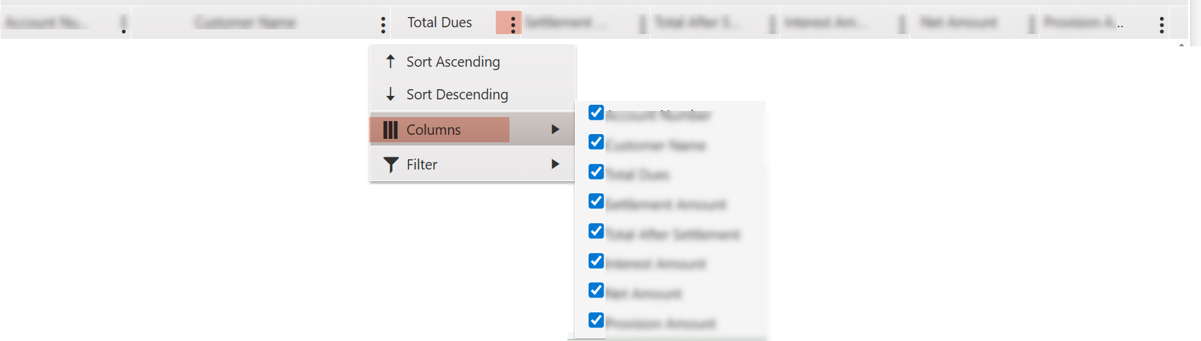

#### Add View Filters Craiteria on The Column Level

1. Hover over the table header that contains the fields.
2. Click the three dots (⋮) next to any field name.

From the customization options, select " **Filter”**

1. this button allows you to filter data to display only the data of your criteria.

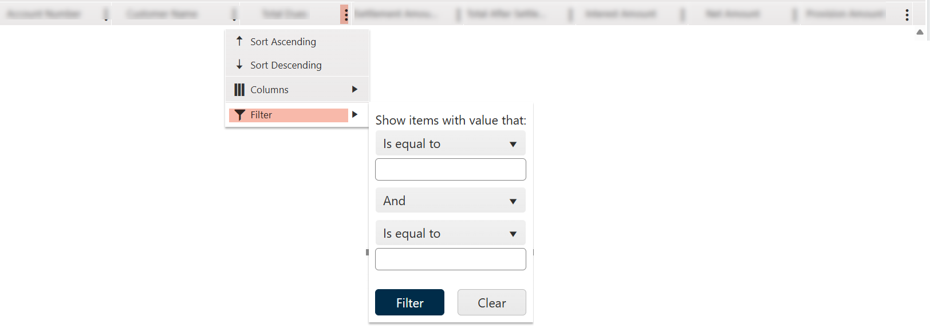

1. Expand the dropdown list to display all available filtering criteria.
2. Enter the desired filter value in the provided field.
3. To refine your search, you can add additional filters and combine them using logical operators such as AND or OR.
4. Once all filter conditions are set, click the Filter button to apply them.
5. To remove all applied filters and reset the view, click the Clear button.

### Page Navigation Bar

In case the table has a large amount of data, the following bar appears at the bottom of the table:



You can control the page size by clicking the drop-down list and selecting the preferred data size.

You can select any page by clicking the page number.

* + - 1. ⏮ First Page: Navigates to the first page of the table.
      2. ◀ Previous Page: Moves to the page immediately before the current one.
      3. Click on a page number to navigate directly to that page.
      4. ▶ Next Page: Advances to the next page.
      5. ⏭ Last Page: Jumps to the last page of the table.
      6. The number of records displayed in the current view is shown next to the total number of records available on the page. This helps users quickly understand how many records are currently visible out of the total.



### Add, Edit or Delete Records

n most system operations, authenticated users are allowed to perform add, edit, or delete actions on records. These actions follow a Maker/Checker approval process to ensure proper governance and data integrity.

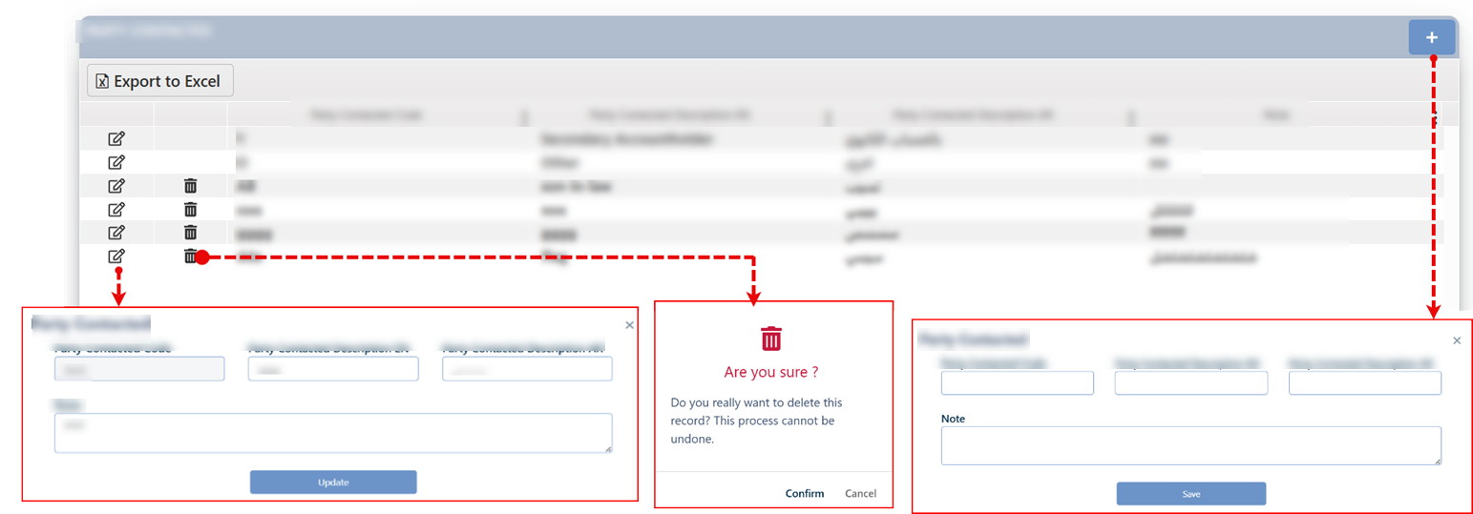

The operations are performed as follows:

* **Add a New Record**

To define a related record, the user must:

* 1. Click the **Add** button (**+**).
  2. In the related screen that appears, fill in the required fields.
  3. Click the **Save** button.
  4. The request will be sent to the **JobBasket Checker**, where an authorized user (Checker) can approve or reject the request, If approved, the record will be added and listed in the appropriate screen.
* **Edit an Existing Record**

To modify an existing record, the user must:

1. Click the Edit button next to the record.
2. Update the required information using the active fields.
3. Click the Update button to submit the changes.
4. The request is routed to the JobBasket Checker for approval or rejection.
   1. If approved, the changes are immediately applied to the record.
   2. If rejected, the request is canceled and moved to the Rejected Tasks tab for reference.

* **Delete a Record**

To delete a user-added record, the user must:

1. Click the Delete button next to the desired record.
2. Confirm the deletion when prompted.
3. A deletion request is then sent to the JobBasket Checker for approval or rejection.
   1. If approved, the record is permanently removed from the system.
   2. If rejected, the request is canceled and moved to the Rejected Tasks tab for reference.

### Add Query Process (Query Builder)

The user can add a condition or query when creating a group or configuring any other service that relies on conditions, using the Query Builder tool. The Query Builder offers a user-friendly yet technically robust interface that dynamically interacts with system parameters, enabling users to construct and modify conditional logic with ease and precision.



1. Click on the 'Add Query' button; the system will respond by rendering the associated control elements dynamically, allowing the user to define and manage query conditions efficiently.
2. Start in building the query by selecting the desired group type
3. Define if you need to use parameters, if yes, a new field will appear to insert the parameter value.



1. Select the parameter that will be considered in the rule definition
2. Choose the appropriate operator from the second dropdown list.
3. Select the parameter value using the third dropdown list.
4. To complete the first part of the rule, click the “Add” button or use logical operators such as “AND” / “OR.”
5. Click on the add Rule button to write another rule
6. If the user needs to delete a specific rule, they can do so by clicking the delete icon next to it.
7. Once all conditions are set, click the “Save” button.
8. This request will be sent to the JobBasket Checker for the authorized user to either confirm and approve it or reject it.

### Mandatory Fields

The system dynamically identifies the mandatory fields within the screens based on the nature of the action and user permissions. When attempting to perform an operation (such as Save, Create, or proceed to the next step) without completing the required fields, the system responds as follows:

* Highlights the incomplete fields with a red border.
* Displays an alert message prompting the user to review the required fields.
* Shows an asterisk (*) next to the field labels that require input.

By default, these indicators may not appear immediately; they are triggered by user interaction to ensure a smoother and clearer user experience only when necessary.

Samples:

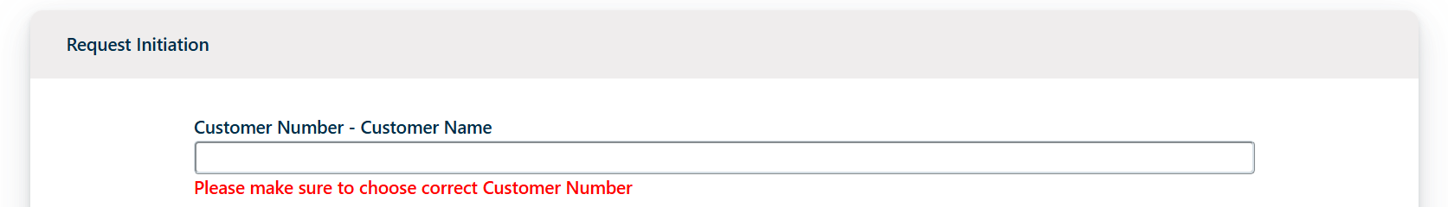

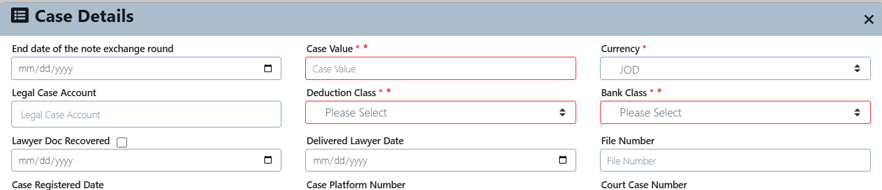

### Calander

1. Click on the Calendar Icon next to the date field.
2. Select the Desired Date by navigating through months or years as needed. Click on the year section so the screen will view list of years and related months to select from:

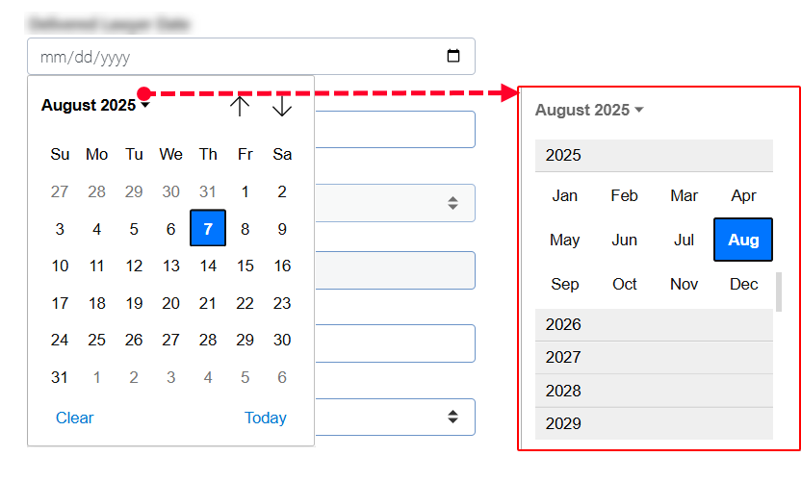

1. To easily select the current day date, click on Today button.
2. If needed, manually type the date in the appropriate format (e.g., DD/MM/YYYY).
3. To clear the date, use the Clear or Backspace/Delete key, depending on the system configuration.

### Active Page Content Report

The system allows users to export the content of the active page's grid view by clicking the "Export to Excel" button. This feature enables users to create a current status report that includes all the data displayed on the active page.

Layout:

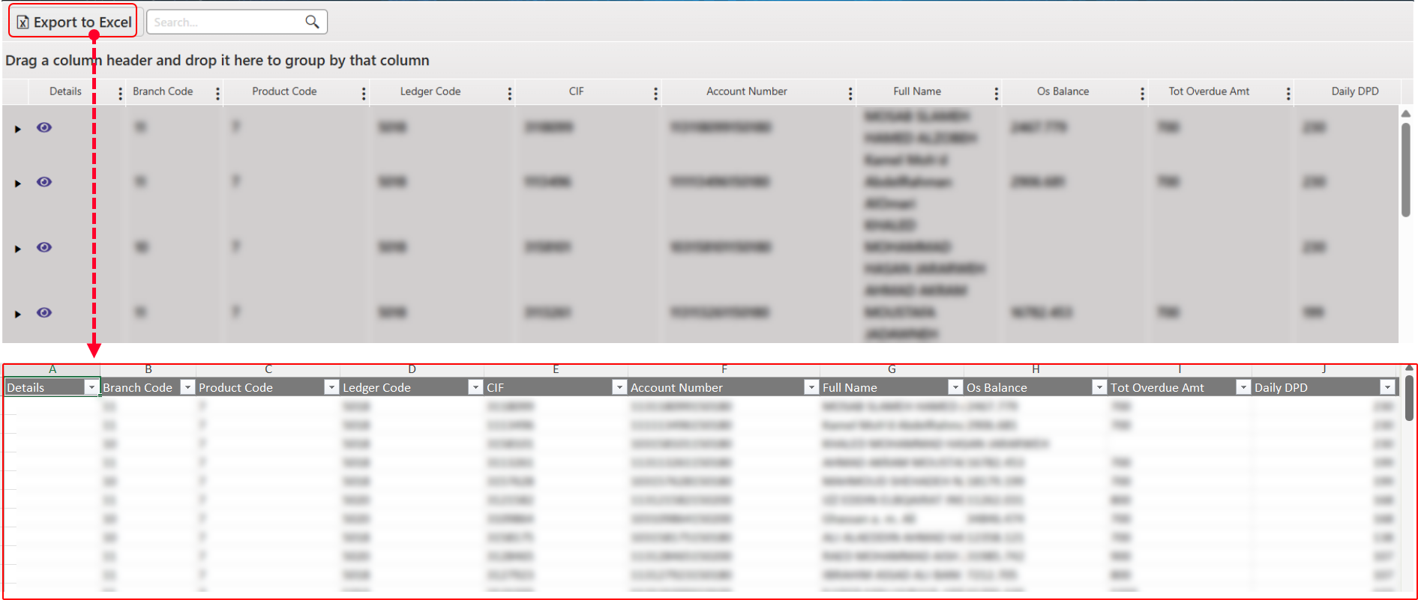

End of the Document

* This guide encompasses all the functions and screens available in the system, regardless of whether they are currently accessible to the customer. The visibility of these features to the current user depends on the permissions granted or the functions purchased by the entity implementing the system.

Last Update Date: **Sunday, September 21, 2025**